PREAMBLE

A Resolution of the Township of Union, Licking County, Ohio, enacted in accordance with a Comprehensive Plan and the provisions of Chapter 519, Ohio Revised Code as amended, dividing the unincorporated portion of the Township into zones and districts, encouraging, regulating, and restricting therein the location, construction, reconstruction, alteration and use of structures and land; promoting the orderly development of residential, business, industrial, recreational, and public areas; providing for adequate light, air, and convenience of access to property by regulating the use of land and buildings and the bulk of structures in relationship to surrounding properties; limiting congestion in the public Right-of-Way; providing the compatibility of different land uses and the most appropriate use of land; providing for the administration of this resolution, defining the powers and duties of the administrative officers as provided hereafter, and prescribing penalties for the violation of the provisions in this resolution and of any amendment thereto, all for the purpose of protecting the public health, safety, comfort and general welfare; and for the repeal thereof. Therefore, be it resolved by the Board of Township Trustees of Union Township, Licking County, State of Ohio:
TABLE OF CONTENTS
ARTICLE I – Purpose and scope 1
ARTICLE II – Definitions 5
ARTICLE III – administration 43
ARTICLE IV – Appeals and variances 47
ARTICLE V – conditional use permits 53
ARTICLE VI – nonconformities 57
ARTICLE VII – amendment 64
ARTICLE VIII – enforcement 72
ARTICLE IX – standard zoning district regulations 78
ARTICLE X – use tables 87
ARTICLE XI – residential districts 106
11.01 AGRICULTURE (A). 106
11.02 PRESERVATION RESIDENTIAL (PR) 110
ARTICLE XII – commercial and industrial districts 115
12.01 GENERAL BUSINESS (GB). 115
12.02 SPORTS ENTERTAINMENT (SE). 119
12.03 TRANSITIONAL INDUSTRIAL (TI) 122
12.04 HEAVY INDUSTRIAL (I). 126
ARTICLE XIII – airport hazard zone overlay district (AHZ) 131
ARTICLE XIV – gateway corridor overlay district (GCO) 133
ARTICLE XV – Planned Unit Development (PUD) 169
ARTICLE XVI - General Development standards 187
ARTICLE XVII – adult entertainment facilities 221
ARTICLE XVIII – extraction of natural resources 227
ARTICLE XIX – landscaping 231
ARTICLE XX – parking and off-street loading requirements 237
ARTICLE XXI – signs 247

ARTICLE I
Purpose and Scope

  - Title
  - Purpose
  - Interpretation
  - Jurisdiction

______________________________________________________________________________

1.01 TITLE

This Code shall be known and may be cited as the "Union Township, Licking County, Ohio Zoning Code."

1.02 PURPOSE

This Code is enacted to promote the health, safety, and general welfare; lessening danger and congestion of public transportation and travel; securing safety from fire and other dangers; promoting conscientious management of land; avoiding undue concentration of population; providing adequate light and air, police protection, transportation, water, sewerage, schools, parks, recreational facilities, and other public requirements, and preventing undue encroachment thereon; conserving the value of buildings and encouraging the most appropriate use of land; encouraging the mindful industrial, commercial, and residential growth of the community; and promoting the development of the community in accordance with the comprehensive plan.

1.03 INTERPRETATION

- Validity of Other Laws. Where this Code imposes a greater restriction on the use of structures, land, height, or bulk of structures, or requires larger open spaces or yards than are imposed by other Resolutions, laws, or regulations, the provisions of this Code shall govern. However, nothing in this Code shall be construed to prevent the enforcement of other Resolutions, laws, or regulations which prescribe more restrictive limitations. The provisions of this Code providing for the residential use of property, and limitations on occupancy, density, and intensity of such uses, shall be applied equally and without discrimination based on race, color, religion, sex, handicap, familial status, or national origin consistent with the provisions of the Federal Fair Housing Act.

- Severability. In case any portion of this Code shall be invalid or unconstitutional, as declared by a court of competent jurisdiction, the remainder of this Code shall not thereby be invalid but shall remain in full force and effect.

1.04 JURISDICTION

- Territorial Jurisdiction. This Code shall be in full force and effect within the legal, unincorporated boundaries of Union Township, Licking County, Ohio. Property owned, leased, or operated by the Township, or any other affiliated public or governmental body or agency, shall be subject to the terms of this Code.

- Regarding Section 519.21 of the Ohio Revised Code.

  - Pursuant to Section 519.21 of the Ohio Revised Code (ORC), the zoning authority of Union Township shall be limited as follows:
    - Except as otherwise provided below and ORC 519.21, nothing contained herein shall prohibit the use of any land for agricultural purposes or the construction or use of buildings or structures incident to the use for agricultural purposes of the land on which such buildings or structures are located, and no zoning certificate shall be required for any such use, building or structure. However, the Township may allow the conversion of an agricultural use to another use permissible in the respective district.
    - Nothing contained in this Code shall prevent the location, erection, construction, reconstruction, change alteration, maintenance, removal, use or enlargement of any building or structure of any public utility or railroad, whether publicly or privately owned, or the use of land by any public utility or railroad for operation of its business. For purposes of this code, cellular towers are not considered to be a public utility.
    - Nothing contained in this Code shall be interpreted to prohibit the sale or use of alcoholic beverages in areas where the establishment and operation of any retail business, hotel, or restaurant is permitted.
    - Nothing contained in this Code shall be interpreted to prohibit the use of any land owned or leased by an industrial firm for the conduct of oil or natural gas well drilling or production activities or location of associated facilities or equipment when such oil or natural gas obtained by the industrial firm is used for the operation of its own plants.
  - Section 519.21(B) of the Ohio Revised Code allows a township zoning resolution, or an amendment thereof, to regulate agricultural use within any platted subdivision approved under Section 711.05, 711.09, or 711.10 of the Ohio Revised Code, or any area consisting of fifteen (15) or more lots approved under Section 711.131 (711.13.1) of the Ohio Revised Code, that are contiguous to one another and adjacent to one another and adjacent to one side of a dedicated public road, and the balance of which are contiguous to one another and adjacent to the opposite side of the same public road.
    - Pursuant to Section 519.21(B) of the Ohio Revised Code, animal and/or poultry husbandry, including the raising, boarding, housing, or grazing of horses, cattle, sheep, goats, swine, poultry, or similar animals shall not be permitted on lots meeting the standards of ORC 519.21(B) above, and which are also one (1) acre or less in size. The processing of any such animals or their products shall also not be permitted.
    - Dairying and animal and/or poultry husbandry shall not be permitted on lots greater than one (1) acre but not greater than five (5) acres if such lots meet the standards of ORC 519.21(B) above, and if at least thirty-five percent (35%) of the lots in the subdivision are developed with at least one (1) building, structure, or improvement that is subject to real property taxation or that is subject to the tax on manufactured homes pursuant to Section 4503.06 of the Ohio Revised Code. After thirty-five percent (35%) of the lots are so developed, any existing animal and/or poultry husbandry operation shall be considered a non-conforming use pursuant to Article VI of this Code.
    - Permanently Sited Manufactured Homes, as defined in Article II, Definitions, of this Code, shall be considered a permitted use in any district that permits Single-Family Dwellings.

ARTICLE II
Definitions

2.01 Interpretation.
2.02 Definitions.

2.01 INTERPRETATION.

For the purpose of this Code, certain terms and words are to be defined as found in this Article. Words and terms not specifically defined carry their customarily understood meanings. Words used in the present tense include the future tense. The singular form shall include plural, and plural shall include singular. The word “shall” is intended to be mandatory. “Occupied” or “used” shall be considered as though followed by the words “or intended, arranged, or designed to be used or occupied.”

Terms related to specific Articles or sections may be defined within the specific portions of the Resolution where these general requirements are found.

2.02 DEFINITIONS.

ACCESS POINT – The connecting area of a lot where a vehicle gains egress and ingress from a driveway to a public roadway.

ACCESSORY DWELLING UNIT (ADU) – A smaller, secondary Dwelling Unit on the same lot or within a primary Dwelling Unit. An ADU is an independent Dwelling Unit that provides for the basic requirements of shelter, heating, cooking, and sanitation.

ADU, ACCESSORY SUITE: An ADU that is adjacent and connected to or located completely within the primary dwelling unit, including but not limited to the basement, attic, attached garages, or an addition to primary structure.

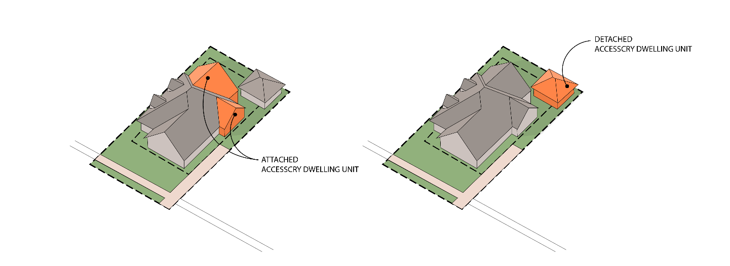
ADU, DETACHED: An ADU located in a structure that is detached from primary dwelling unit, including but not limited to a detached garage or a newly constructed structure.
ACCESSORY STRUCTURE, OR USE – A use or structure subordinate to the principal use of a building on the lot or tract and serving a purpose customarily incidental to the use of the principal building. Accessory structures are located on the same lot as the primary structure and are not designed for human occupancy as a dwelling or commercial use. Examples of accessory structures are detached private garages, storage or garden sheds, pool houses, metal storage buildings, hot tubs and other similar type buildings. This definition does not include gardens, patios, uncovered porches, and decks that are less than three and one half (3 ½) feet above the average finished Grade.

ADEQUATE BUFFERING – Means a combination of landscaping and other buffering materials as provided in Section 19.08 that provide a one hundred (100) percent opacity between the ground level to effectively screen the buffered area on a year-round basis to protect the adjoining property owners from noise, glare, dust, and visual nuisances.

ADULT BOOKSTORE – A commercial establishment where at least fifty-one percent (51%) of its interior floor area or retail merchandise is devoted to the sale, rent, lease, inspection, or viewing of books, films, video cassettes, DVDs, magazines, other periodicals or digital presentations whose dominant theme is the actual or simulated Specified Sexual Activities, display or exhibition of specified anatomical areas, removal of articles of clothing, or total nudity.

ADULT CABARET – A restaurant, coffee house, bar or cabaret which features topless dancers, strippers, male or female impersonators, or similar entertainers who provide live adult entertainment for commercial purposes.

ADULT ENTERTAINMENT BUSINESS – Any adult bookstore, adult cabaret, adult mini-theater, or adult motion picture theater.

ADULT ENTERTAINMENT– Any motion picture, live performance, display, or dance of any type whose dominant theme is actual or simulated Specified Sexual Activities, display or exhibition of anatomical areas, removal of articles of clothing, or total nudity, offered for commercial purposes.

ADULT MINI-THEATER – An enclosed building with a capacity of less than fifty (50) persons used for displaying adult entertainment through films, video, or other motion pictures for commercial purposes.

ADULT MOTION PICTURE THEATRE – An enclosed building with a capacity of fifty (50) or more persons used for displaying adult entertainment through films, video, or other motion pictures for commercial purposes.

ADVANCED MANUFACTURING - A use that involves computer technology, robotics, or other innovation to improve a product or process.

AGRICULTURE – In accordance with Section 519.01 of the Ohio Revised Code, “Agriculture” includes farming; ranching; algaculture, meaning the farming of algae; aquaculture; apiculture; horticulture; viticulture; animal husbandry, including, but not limited to, the care and raising of livestock, equine, and fur-bearing animals; poultry husbandry and the production of poultry and poultry products; dairy production; the production of field crops, tobacco, fruits, vegetables, nursery stock, ornamental shrubs, ornamental trees, flowers, sod, or mushrooms; timber; pasturage; any combination of the foregoing; and the processing, drying, storage, and marketing of agricultural products when those activities are conducted in conjunction with, but are secondary to, such husbandry or production.

AGRICULTURAL BUILDING – A structure on agricultural land designed, constructed, and used to house farm implements, livestock, or agricultural produce or products used by the owner, lessee, or sub-lessee or their immediate families, their employees, and persons engaged in the pickup or delivery of agricultural produce or products grown or raised on the premises.

AGRICULTURAL ENTERTAINMENT (AGRITOURISM) – Agritourism means an agriculturally-related educational, entertainment, historical, cultural, or recreational activity, including you-pick operations or farm markets, conducted on a farm that allows or invites members of the general public to observe, participate in, or enjoy that activity. Agritourism may include: country-themed stores for the sale of goods and souvenirs, dining, tours (self-guided or guided), wagon rides, trail rides, corn mazes, pick yourself operations, classes (gardening, cooking, crafts, etc.), fishing, bed and breakfast, in addition to guests partaking in other farm activities.

AGRICULTURAL RELATED BUSINESS – Feed mills, dairy supplies, poultry processing, creameries. This does not include commercial auction yards for automobiles, furniture, antiques, and other non-agricultural goods), kennels, veterinarians, and other businesses supporting local Agriculture.

AIRPORT – Means the Newark-Health Airport, and includes any complex of runways and buildings for the takeoff, landing, and maintenance of civil aircraft that is approved and/or properly licensed by the Federal Aviation Authority or applicable agency.

AIRPORT HAZARD – Any structure, tree, or use of land that would exceed the federal obstructions standards and that obstructs the airspace required for the flight of aircraft in landing or taking off at an airport or is otherwise hazardous to such landing or taking off of aircraft.

ALLEY – A secondary access way that is a public right-of-way dedicated to public use for travel or transportation and affording vehicular access to abutting property.

ALTERATION – Any change or rearrangement in the supporting members of an existing structure; enlargement, addition, relocation, repair, remodeling; change in number of living units; development of or change in an open area; development of or change in a sign, by painting or otherwise; or other change in a facility, but excluding painting except as provided above for signs; ordinary maintenance for which no building permit is required; and demolition or removal.

ANIMAL SERVICES FACILITIES - Any facility maintained by or for the use of a licensed veterinarian in the diagnosis, treatment, or prevention of animal diseases, and where the animals are not boarded or kept overnight except as necessary in the medical treatment of the animal. Animal care facilities may also include animal grooming establishments.

APPEAL – A request by an aggrieved party for a review of any adverse decision by the Board of Zoning Appeals.

ARCHEOLOGY – Means the scientiﬁc study of material remains (such as tools, pottery, jewelry, stone walls, and monuments) of past human life and activities.

ASSISTED LIVING FACILITY – A residential facility designed to meet housing and care needs of older persons and individuals with disabilities in a residential rather than institutional environment, while maximizing independence, choice, and privacy. Assisted living programs provide personal care for persons with needs for assistance in the activities of daily living and can respond to unscheduled needs for assistance. Services typically provided include: meals, housekeeping, laundry and linen service, medication monitoring, transportation, and activities. Assisted living settings also typically provide features that enhance resident autonomy, such as lockable doors, full bathrooms, temperature control, and single occupancy, and may provide limited cooking facilities in individual units. Assisted Living Centers exclude nursing homes and other special housing facilities as elsewhere defined.

AUTOMOBILE-ORIENTED USES – A use that includes services rendered directly on, to, or for vehicles or where the patron does not exit the vehicle. Such uses include but are not limited to car washes (all types), gas stations (including convenience market), facilities specializing in oil changes, car repair, and other similar auto service facilities. The sale of vehicles (new and used) is not included in this definition. Any facility that provides a fixed parcel pickup location is not included within this definition. It also does not include Drive-Thrus or Pick Up – Banking Windows.

AUTOMOBILE OIL CHANGING FACILITY – A facility where oil is removed from a vehicle and new oil is placed into the vehicle without any repair services to the vehicle being provided.

AUTOMOBILE REPAIR – Any building or portion of a building used for the servicing and minor repair of automobile including but not limited to shall include the installation of exhaust systems, repair of the electrical system, transmission repair, brake repair, radiator repair, and tire repair.

AWNING – A hood, canopy, or cover that projects from the wall of a building and which can be retracted, folded or collapsed against the face of the supporting Building.

AQUIFER – An underground area with a particularly large concentration of groundwater. Most often, Aquifers are found in those underground areas of porous rock or sand. Many rural well systems draw from Aquifers. For planning purposes, an Aquifer if often evaluated on its recharging rate and cleanliness.

BANK – A financial institution licensed to receive deposits and make loans. Such use may also include financial services including but not limited to wealth management, currency exchange, and safe deposit boxes.

BASE FLOOD - the Flood having a 1% chance of being equaled or exceeded in any given year. The base Flood may also be referred to as the 100-year Flood.

BASEMENT – The portion of a building where the floor is not less than 2 feet below and the ceiling is not more than 4 feet, 6 inches above the average Grade.

BED AND BREAKFAST – A residential use consisting of one dwelling unit with no more than eight (8) rooms or suites that are rented to the public for overnight or weekly accommodation for a fee. Only the breakfast meal may be prepared for the guests by the proprietor and no other meals are provided by the proprietor. The rented rooms do not contain cooking facilities and do not constitute separate dwelling units.

BEVERAGE SALES, ALCOHOLIC - A facility that is primarily devoted to the serving of alcoholic beverages. Food can be served but is incidental to the sale of beverages.

BEVERAGE SALES, MICROBREWERY – A limited production brewery, typically producing specialty beers and selling them on-site or for local distribution.

BIO-TECHNOLOGY – A facility designed to manipulate living organisms or their components to produce useful, common commercial products such as but not limited to pest resistant crops, new bacterial strains, and novel pharmaceuticals. This type of use is typically fully enclosed by four solid walls and a roof.

BOARD OF ZONING APPEALS (BZA) – Means the Board of Zoning Appeals established in Article III.

BODY ART ESTABLISHMENT – A building or portion of a building in which a practitioner performs body piercing, tattooing, branding, or application of permanent cosmetics.

Remainder Intentionally Left Blank
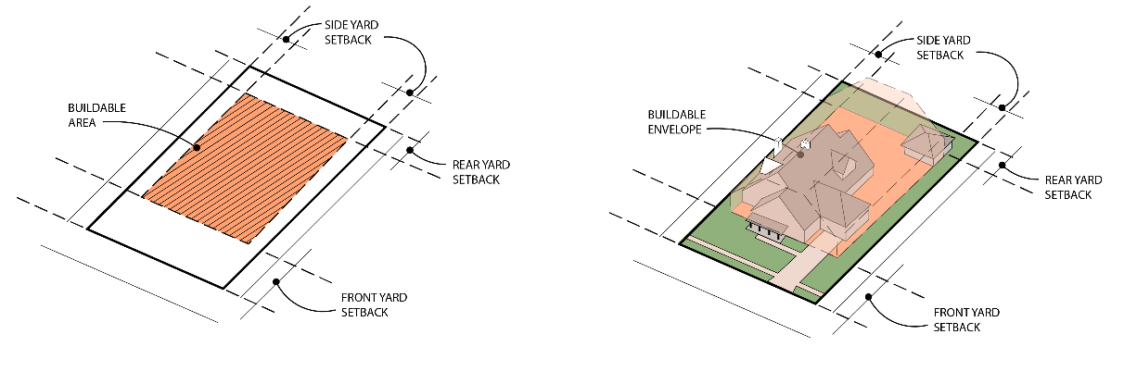
BUILDABLE AREA – The area of a lot, exclusive of the required front, side, and rear setbacks, where a building can be constructed.

BUILDING – A combination of materials to form a construction that is safe and stable and adapted to permanent or continuous occupancy for public, institutional, residential, business, or industrial purposes.

BUILDING ENVELOPE – A term to describe the area of a Lot that is demarcated within the Front, Side, and Rear Setback Lines.

BUILDING LINE – A line parallel to the right-of-way line and at a distance therefrom equal to the required depth of the front setback (as determined by the applicable zoning district) and extending across the full width of the lot.

BUSINESS – Any profit-making activity which renders services primarily to other commercial, institutional, or industrial enterprises, or which services and repairs appliances and machines used in other businesses.

BUSINESS, RETAIL – A use primarily engaged in the selling of merchandise including but not limited to clothes, food, furniture, guns, household goods, gifts, specialty items, and other similar goods, and the rendering of services that is incidental to the sale of the goods.

BUSINESS, LARGE RETAIL – A Retail or Wholesale business that is twenty thousand (20,000) square feet or larger.

BUSINESS, MEDIUM RETAIL – A Retail or Wholesale Business that is five thousand (5,000) square feet up to twenty thousand (20,000) square feet in area.

BUSINESS, SMALL RETAIL – A Retail or Wholesale business that is less than five thousand (5,000) square feet in area and typically services nearby neighborhoods.

BUSINESS, WHOLESALE – A use that generally sells commodities in large quantities or by single items to the general public, business members, retailers, or other wholesale establishments.

CAMPGROUNDS – Any tract of land upon which two or more portable camping units are placed, and includes any roadway, building, structure, vehicle or enclosure used or intended for use as a part of the facilities of such camp. A tract of land which is subdivided for lease or other contract of the individual lots is a campground if two or more portable camping units are placed thereon for temporary habitation. "Campground" does not include any tract of land used solely for the storage or display for sale of portable camping units.

CANNABIS STORES – A business that is licensed under the state laws of Ohio to sell cannabis and marijuana products for medical purposes.

CEMETERY – Land used for or intended to be used for the burial of human or animal remains and dedicated for cemetery purposes, including crematories, mausoleums, and mortuaries, if operated in connection with and within the boundaries of the cemetery.

CERTIFICATE OF ZONING COMPLIANCE – A certificate issued by the Zoning Inspector confirming that the requirements of this Code have been met and the building can be occupied.

CODE – The reference of this “Code” or this “Zoning Code” means this Planning and Zoning Code of Union Township, Licking County, Ohio. May also be referred to as this “Resolution.”

CO – LOCATION – The use of a telecommunication tower by more than one (1) telecommunications provider.

COMMUNITY GARDEN – An area for cultivation of fruits, flowers, vegetables, or ornamental plants by more than one person or family generally organized and managed by a public or not-for-profit organization.

COMMENCE WORK – The time at which physical improvements begin to be made to a property or structure so that it may be utilized for its intended purpose stated in the zoning permit.

COMMERCIAL RECREATIONAL FACILITY, LARGE – A facility that is enclosed by four solid walls and a roof for the provision of athletic and amusement facilities involving the active participation of the user – public in a sports related activity and includes but is not limited to racquet courts, billiards, bowling alleys, ax throwing, miniature golf courses and arcades. Large Commercial Recreational Facilities are greater than five thousand (5,000) square feet.

COMMERCIAL RECREATIONAL FACILITY, OUTDOOR– A facility that is not fully enclosed by four solid walls for the provision of athletic and amusement facilities involving the active participation of the user – public in a sports related activity and includes but is not limited to fields for soccer fields, football, baseball, and lacrosse as well as for tennis and other racquet courts.

SMALL, OUTDOOR COMMERCIAL RECREATIONAL FACILITY – Less than five thousand (5,000) square feet.

LARGE, OUTDOOR COMMERCIAL RECREATIONAL FACILITY – Five thousand (5,000) square feet or larger.

COMMERCIAL RECREATIONAL FACILITY, SMALL – A facility that is fully enclosed by four solid walls and a roof for the provision of athletic and amusement facilities involving the active participation of the user – public in a sports related activity and includes but is not limited to racquet courts, billiards, bowling alleys, ax throwing, miniature golf courses and arcades. Small Commercial Recreational Facilities are smaller than 5,000 square feet.

COMMUNICATION FACILITITES – A lot or an area of a lot that includes a telecommunication tower, radio tower, or other similar communication tools including any associated appurtenances.

COMMUNITY SERVICES – Institutional uses that include but are not limited to community centers, museums, galleries, libraries, and other similar facilities.

CONDITIONAL USE(S) – A desirable use within a Zoning District that may more intensely affect the surrounding area than would a permitted use in said District. Such uses may require supplementary conditions and safeguards to ensure they blend with the surrounding area.

CONTRACTOR OFFICE – A facility or area for the storage of materials, equipment, and commercial vehicles utilized by building and construction contractors, craftsmen and tradesmen, and may include accessory offices related to such activities.

COUNTY – Means Licking County, Ohio.

COUNTY ENGINEER – Means the Professional Engineer who is employed by the County and authorized by the County to act within the specifications of this Code.

DATA CENTER – Real and personal property consisting of buildings or structures specifically designed or modified to house networked computers and data and transaction processing equipment and related infrastructure support equipment, including, without limitation, power and cooling equipment, used primarily to provide, as a service to persons other than the company operating the data center, data and transaction processing services, outsource information technology services and computer equipment colocation services, or, used primarily to provide, to a single user, including the user's affiliates, customers, lessees, vendors and other persons authorized by the user, data and transaction processing services.

DAY-CARE CENTERS – Any place in which child day care or publicly funded child day care is provided for thirteen (13) or more children at one time or any place that is not the permanent residence of the licensee or administrator. In counting children for purposes of this Code, any children under six (6) years of age who are related to a licensee, administrator, or employee and who are on the premises of the center shall be counted.

DAY-CARE HOME, FAMILY LARGE – a permanent residence of the administrator in which childcare or publicly funded childcare is provided for seven (7) to twelve (12) children at one time or a permanent residence of the administrator in which childcare is provided for four (4) to twelve (12) children at one time if four (4) or more children at one time are under two (2) years of age. In counting children for the purposes of this division, any children under six (6) years of age who are related to a licensee, administrator, or employee and who are on the premises of the Type A home shall be counted. “Type A Family Day-Care Home” and “Type A home” do not include any child day camp (ORC Section 5104.01(RR)). This definition does not include a residence in which the needs of children are administered to if all of the children whose needs are being administered to are siblings of the same immediate family and the residence is the home of the siblings. This definition shall not be construed to include child day camps.

DAY-CARE HOME, FAMILY SMALL – a permanent residence of the provider in which childcare is provided for one (1) to six (6) children at one time and no more than three (3) children under two (2) years of age at one time. In counting children for the purposes of this division, any children under six (6) years of age who are related to the provider and who are on the premises of the Type B home shall be counted. “Type B Family Day-Care Home” and “Type B home” do not include any child day camp (ORC Section 5104.01(SS)). This definition does not include a residence in which the needs of children are administered to if all of the children whose needs are being administered to are siblings of the same immediate family and the residence is home of the siblings. This definition shall not be construed to include child day camps.

DENSITY, NET – The number of dwelling units permitted to be developed on a net acre of land. A net acre of land is the total acreage minus any wetlands, water bodies, public parks, open spaces, roads, or other public rights-of-way.

DEVELOPMENT – Any man-made change to improved or unimproved real estate, including but not limited to Buildings or other structures, mining, dredging, filling, grading, paving excavation or drilling operations or storage of equipment or materials located within the area of special Flood hazard.

DRIVEWAY (ACCESS POINT) – A private drive giving access from a public way to a detached single-family dwelling on abutting ground or to a group of multifamily, commercial, or industrial Buildings, which is not a dedicated Public Road and for the maintenance of which the Township or the County shall not be responsible.

DRIVE-THRU - A use where a patron places an order on site or in advance and waits for a product to be prepared without the need to exit his/her vehicle. Such uses include but are not limited to drive-thru or drive-in restaurants with ordering areas, drive-in movie theaters. A drive-thru facility does not include any vehicle repair facility, gas stations, fixed parcel pick up, and pick up - banking window.

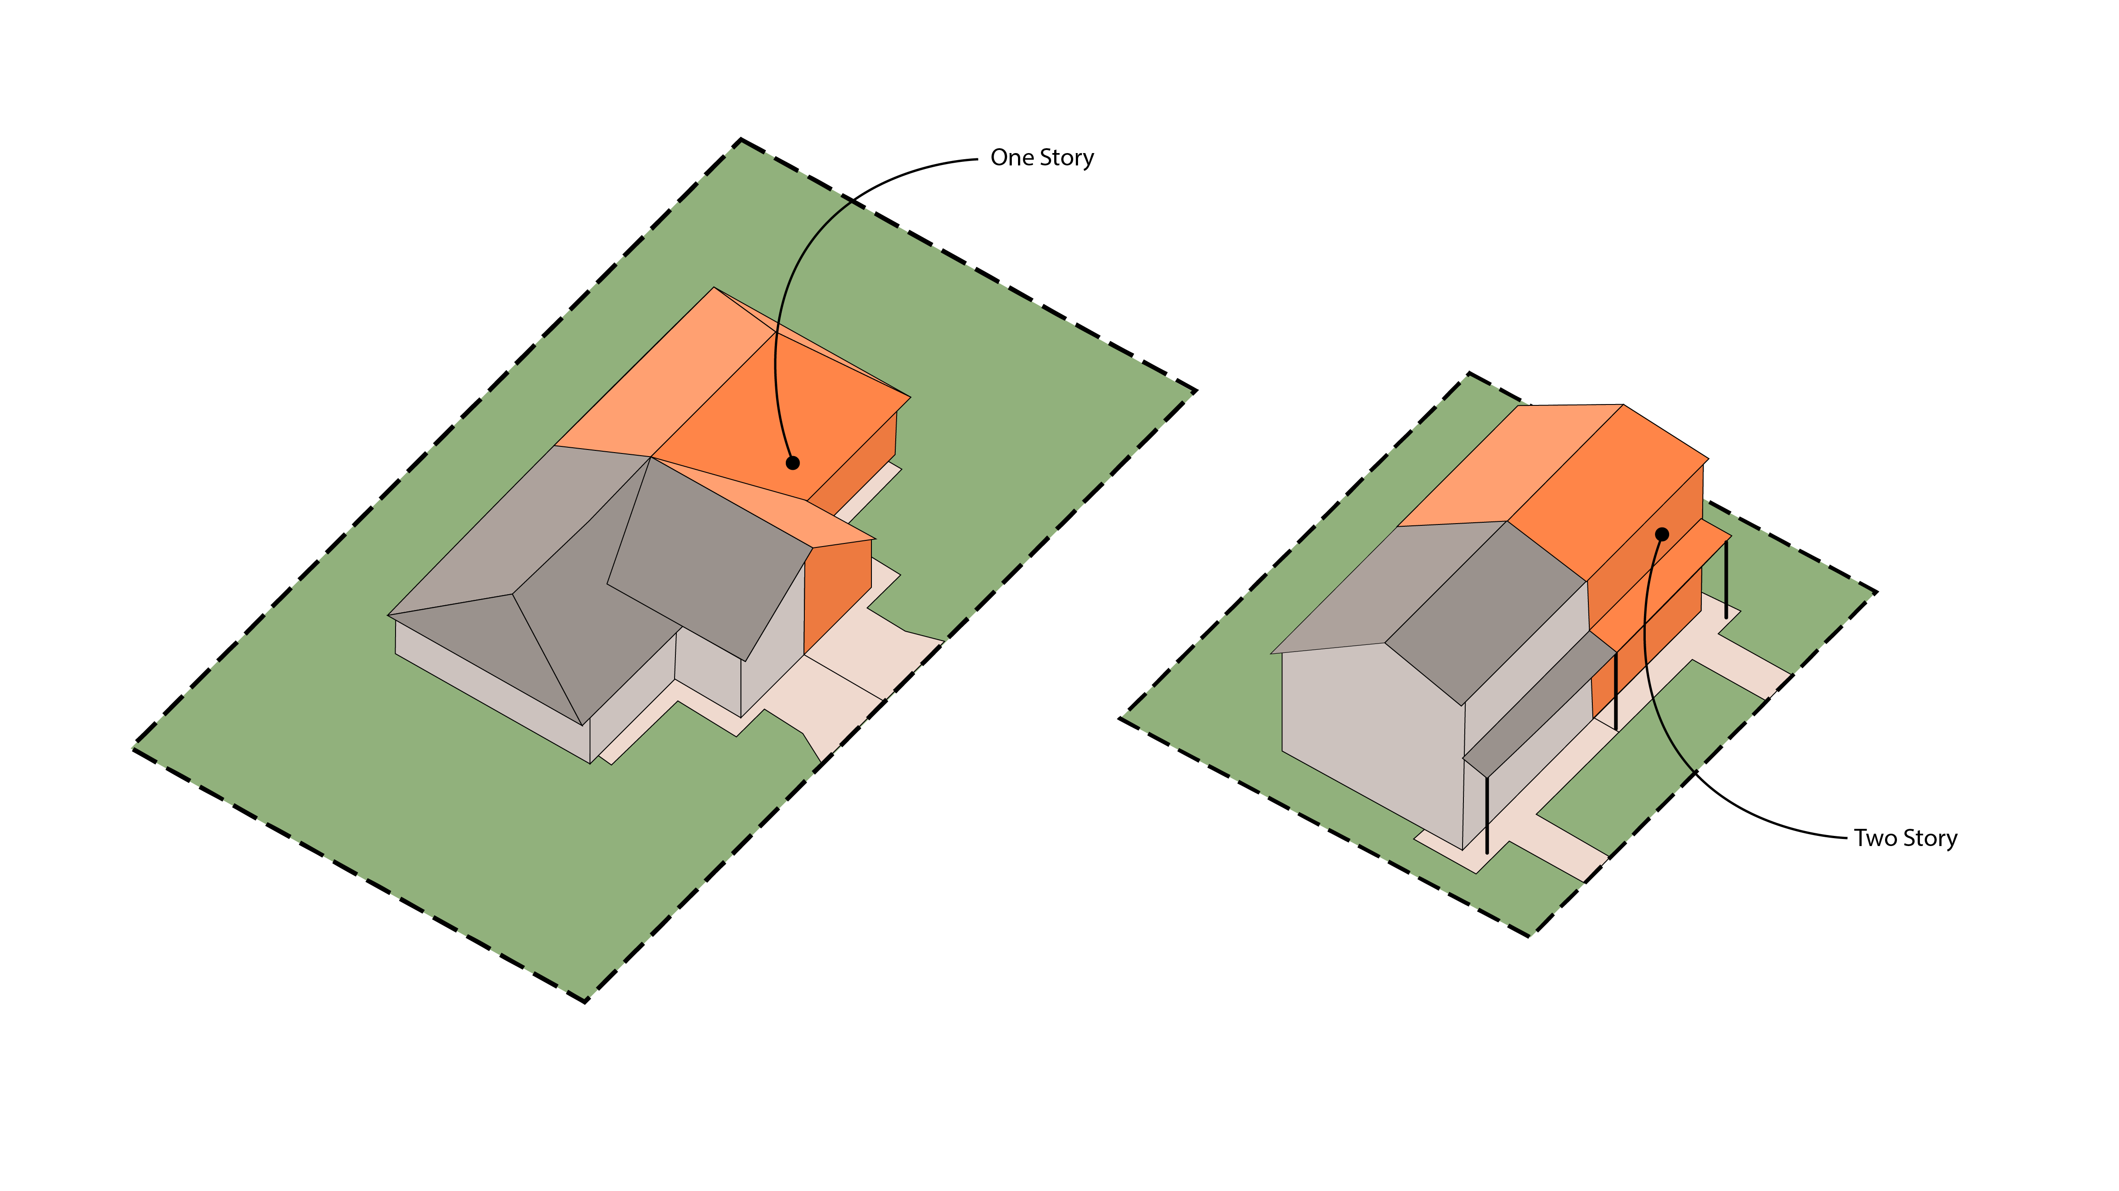
DWELLING, DUPLEX – A building designed for two dwelling units where each dwelling shares one common wall and/or ceiling and the remaining sides of the building are surrounded by open areas or street lines.

DWELLING, MULTI-UNIT – A building designed or used primarily as a residence with four (4) or more dwellings units.

DWELLING, ONE UNIT – A building designed exclusively for one detached Dwelling Unit that is situated on a parcel with no other principal structures and having a Front, Side, and Rear Yard.
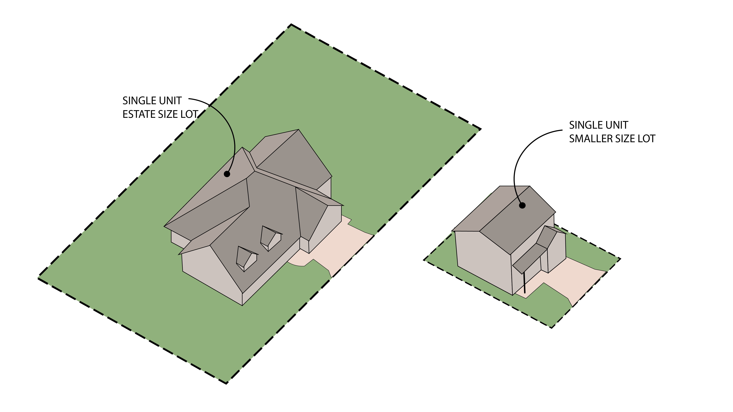

DWELLING, TRI-PLEX – A building containing three (3) dwelling units, designed for occupancy by not more than three (3) families.
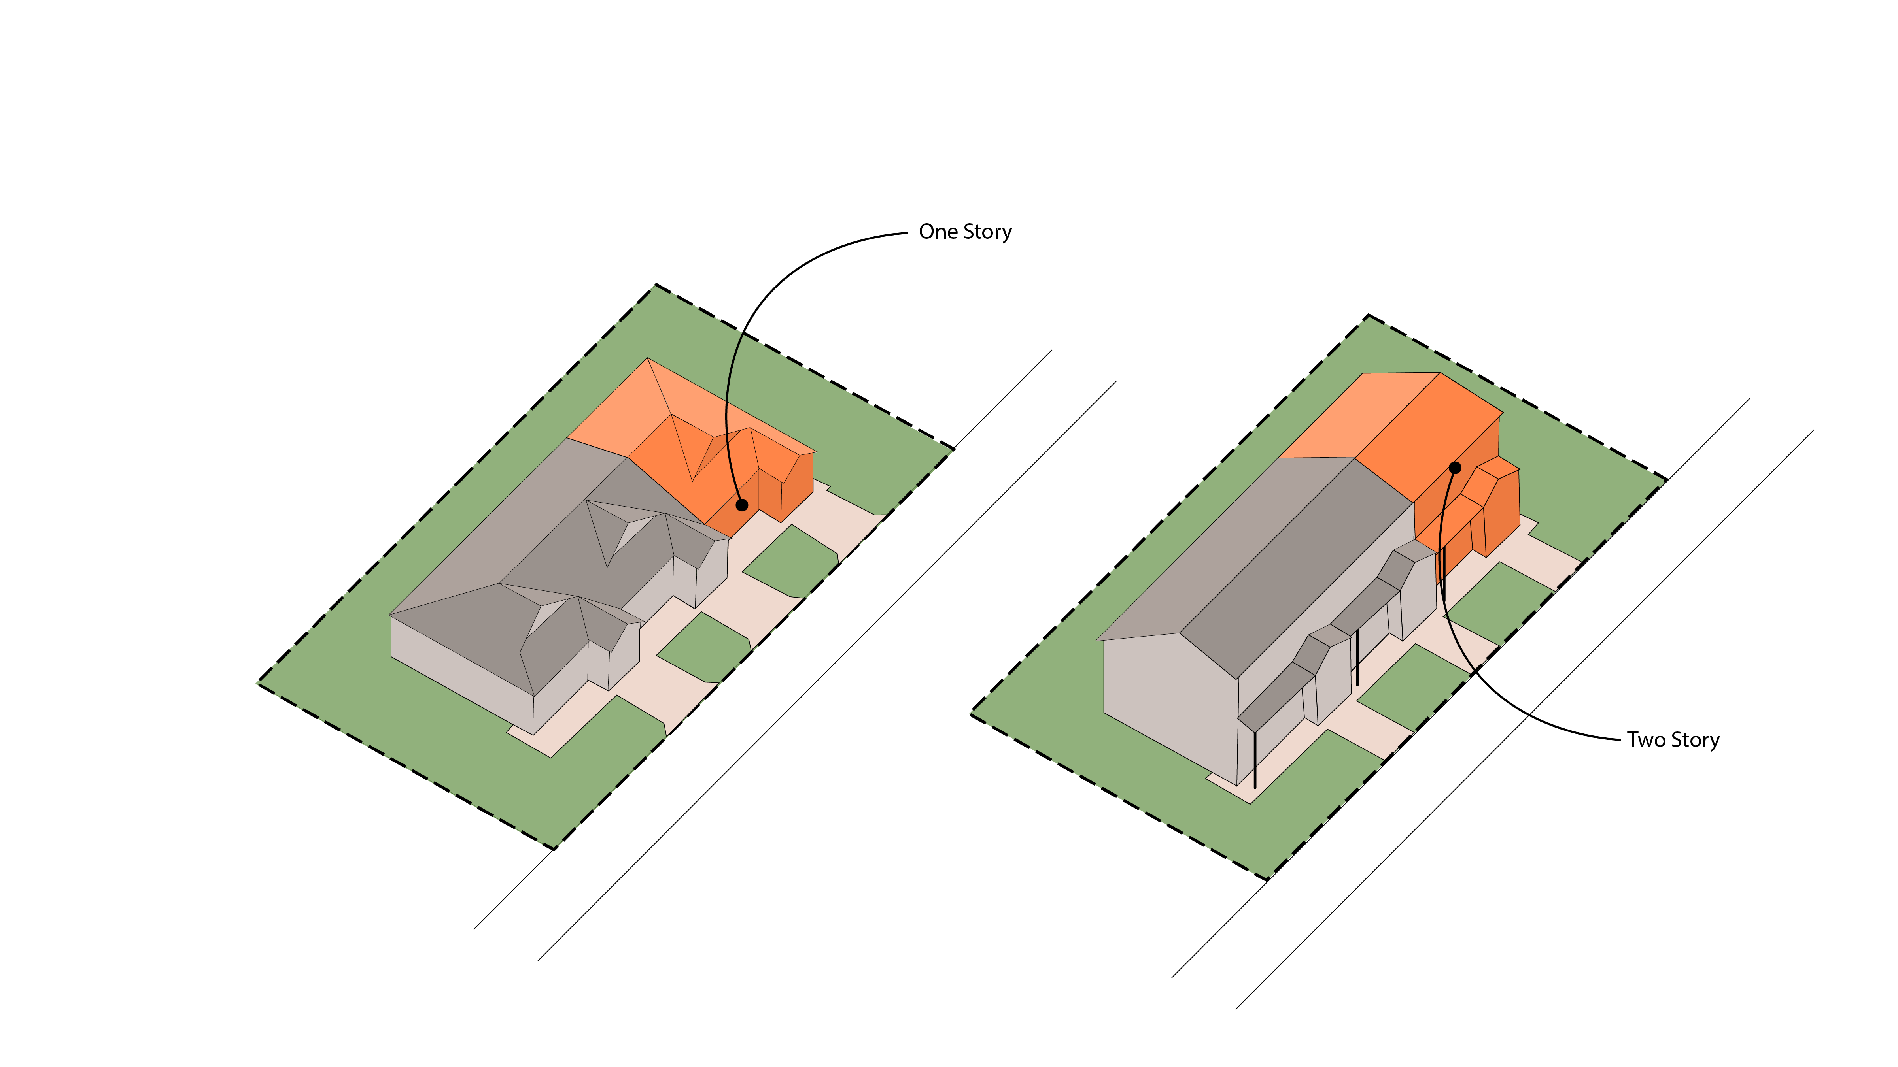
DWELLING UNIT – Any room or group of rooms located within a structure and forming a single habitable unit with facilities which are used, or are intended to be used, for living, sleeping, cooking, and eating, which is designed or used for residential purposes. This definition does not include a cabin, hotel, or motel.

DWELLING UNIT, ACCESSORY – See, Accessory Dwelling Unit.

DWELLING UNIT, ONE BEDROOM UNIT – A Dwelling Unit that is contained within a Multi-Unit Dwelling or Mixed-Use Building as defined herein that contains only one bedroom.

DWELLING UNIT, STUDIO – A Dwelling Unit that is contained within a Multi-Unit Dwelling or Mixed-Use Building as defined herein that combines a number of different types of rooms, such as living room, bedroom and kitchen, into a single room.

DWELLING UNIT, THREE BEDROOM UNIT – A Dwelling Unit that is contained within a Multi-Unit Dwelling or Mixed-Use Building as defined herein that contains three bedrooms.

DWELLING UNIT, TWO BEDROOM UNIT – A Dwelling Unit that is contained within a Multi-Unit Dwelling or Mixed-Use Building as defined herein that contains two bedrooms.

EARLY CHILDHOOD EDUCATION CENTER – An education establishment that provides learning space to children prior to beginning their compulsory education. This facility may also provide for the extended care of infants and young children.

ELDERLY/RETIREMENT HOUSING – A residential complex containing multifamily dwellings designed for and principally occupied by senior citizens. Such facilities may include a congregate meals program in a common dining area but exclude institutional care such as medical or nursing care and are distinguished from life care retirement centers as elsewhere defined.

EMERGENCY AND PROTECTIVE SHELTER – A facility which provides room and board for the protection, counseling, and pre-placement screening for abused, displaced, or transient children or adults.

ENCROACHMENT – The intrusion on another person’s property or public right-of-way, intentional or unintentional.

ENVIRONMENTALLY SIGNIFICANT RESOURCES – The naturally occurring substances that are considered valuable in their relatively unmodified (natural) form. These may include but are not limited to sources of water, timber, geological formations, mineral deposits, and wildlife.

EQUESTRIAN CENTER – An establishment primarily engaged in the operation of a riding academy or riding stables.

EQUIPMENT REPAIR, LARGE – A facility that is fully enclosed by four solid walls and a roof that is used for the repair of contactor’s equipment, heavy machinery, repair equipment, motor vehicles or trucks.

EQUIPMENT REPAIR, SMALL – A facility that is fully enclosed by four solid walls and a roof that is used to repair small tools and equipment such as lawn mowers, small tractors, and other small equipment.

FAÇADE – The face of a building, especially the principal front that looks onto a street or open space.

FARM MARKET – Markets from which fifty percent (50%) or more of the gross income received is derived from produce raised or grown upon farms owned or operated by the market operation in a normal crop year.

FEDERAL EMERGENCY MANAGEMENT AGENCY (FEMA) – The federal agency with the overall responsibility for administering the National Flood Insurance Program.

FENCE – Any structure composed of wood, wire, metal, stone, plastic or other natural or permanent material erected in such a manner and positioned as to enclose or partially enclose any portion of a lot.

FENCE, OPEN – Any fence that has 62 percent or more of its vertical surface area open to light or air. An example of this type of fence is a Kentucky 3-Board Fence.

FENCE, PARTIALLY OPEN – Any fence that has at least 50 percent of its vertical surface area open to light or air. An example of this type of fence is a picket fence.

FENCE, PICKET – A partially open fence made of upright poles or slats where the space between the poles/slats is greater than the width of the poles/slats.

FENCE, SOLID – Any fence that is designed to inhibit public view and provide seclusion, when viewed at right angles, and having more than fifty (50) precent of its vertical surface area closed to light and air.

FENCE, WROUGHT IRON – A fence constructed of metal, including aluminum, iron or steel, pipe, tubes, or bar stock and having some type of decorative features or design. Wrought iron fences shall not have pointed ends exposed but may have finials with blunt ends.

FIRE DEPARTMENT – Refers to the West Licking Joint Fire District and/or Granville Township Fire Department.

FIRE HAZARDS – Any activity involving the use of storage or flammable or explosive materials shall be protected by adequate firefighting and fire prevention equipment and by such safety devices as are normally used in the handling of any such material. Such hazards shall be kept removed from adjacent activities to a distance, which is compatible with the potential danger and shall meet all requirements of the Ohio Fire Code and Ohio Building Code.

FIRE LANE – Locations determined by the West Licking Joint Fire District and/or Granville Township Fire Department; shall be a minimum of twenty-five (25) feet in width; and shall be properly signed and striped.

FLEA MARKET – An outdoor commercial activity, not including shopping centers, individual retail operations, or sales conducted by a non-profit or charitable organization, that is open to the general public and composed of five or more semi-enclosed or outdoor stalls, rooms, stands, or spaces used for the purpose of display and sale, exchange, or barter of merchandise.

FLEX-OFFICE LABORATORIES – A space for a combination of office and laboratory uses that has built out capabilities to meet individual needs.

FLEX-OFFICE – RETAIL - A space with store fronts with small rear warehousing that has built out capabilities to meet individual needs.

FLEX-OFFICE WAREHOUSES – A space for a combination of office and warehouse uses that has built out capabilities to meet individual needs.

FLOOR AREA – The sum of the gross horizontal areas of one or several floors of a building, measured from the exterior faces of the exterior walls or from the centerline of common walls separating two buildings. Floor area for the purpose of these regulations will not include basement, elevator and stair bulkheads, attic space, terraces, breezeways, open porches, and uncovered steps.

FLOOR AREA, LIVABLE – The portion of floor area of a dwelling unit that is constructed, completed, and usable for living purposes with normal living facilities which includes sleeping, dining, cooking, entertainment, common space, areas for personal hygiene, or combination thereof. Unheated rooms, unfinished garages, basements, or rooms used exclusively for utilities or storage shall not be considered as livable floor area. In no case shall an area less than 6 feet in height be considered livable floor area.

FOOD CART – A small, wheeled vehicle typically pushed by hand, bicycle or propelled in some similar muscular manner to move it from place to place in order to offer already prepared or prepackaged food or ice cream for sale to the public. Any vehicle that is capable of preparing food within it shall not be included in the definition of a food cart.

FOOD TENT – An open–aired, temporary structure with four legs and a canvas top used to prepare and sell food at special events where large groups of people are situated in a park, parade, fraternal organization, or other similar venue.

FOOD TRUCK – A vehicle from which food for human consumption is sold and dispensed. Said food can be prepackaged or prepared within the vehicle. Such vehicle may be self-propelled or towed by another vehicle and must be licensed in the state of Ohio.

FRONTAGE – Property Lines that abut road Right-of-Way for a Roadway wherein a Federal, State, or Local government agency has purchased access rights or otherwise acquired access rights by the government agency (aka limited access roadway) shall not be considered Frontage or included within any calculation of Lot Frontage.

FUNERAL SERVICES FACILITIES – A Building or part thereof used for human funeral services. Such building may contain space and facilities for (a) embalming and the performance of other services used in the preparation of the dead for burial; (b) the storage of caskets, funeral urns, and other related funeral supplies; and (c) the storage of funeral vehicles. Funeral services facilities exclude crematoriums.

GARAGE, PRIVATE – An accessory building or an accessory portion of the main building enclosed on all sides and designed or used for the shelter or storage of passenger vehicles and located on the same lot as the dwelling for which it is accessory.

GARAGE, PUBLIC – A building or portion of a building in which more than two motor vehicles are or are intended to be housed under arrangements made with patrons for renting or leasing such space and accommodation in which no repair work is carried out.

GOVERNMENTAL SERVICES – Any service provided by a governmental agency including but not limited to fire and safety protection services and other administrative services associated with a governmental agency.

GRADE – The elevation of the ground at any given point.

GRADE, FINISHED - The elevation of the finished surface of the ground adjoining the base of all exterior walls of a building or the elevation of the finished surface of the ground at the base of a structure, exclusive of any artificial embankment at the base of such building or structure. If the ground is not entirely level, the finished grade shall be determined by averaging the grade of the ground at each corner of the building or structure.

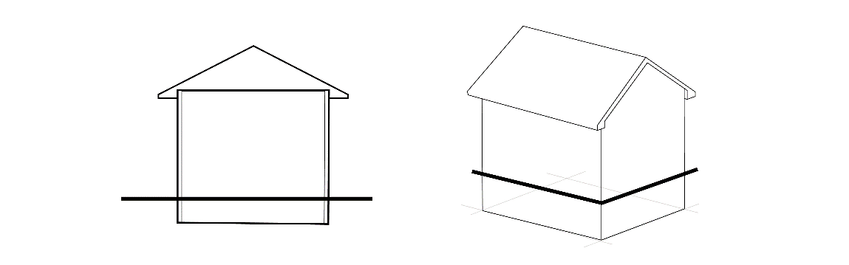

HABITABLE – Any room designed and used for living, sleeping, eating, cooking, or combinations thereof. The following are not to be considered habitable: bathrooms, toilet compartments, closets, halls, storage rooms, unfinished basements, laundry and utility rooms, garages, and similar areas.

HEALTH CARE FACILITIES – General and specialized hospitals and associated clinics providing health related services and involving the overnight or long term stay of patients.

HEIGHT, BUILDING – The vertical distance between the finished grade of the building and the highest point of the roof.

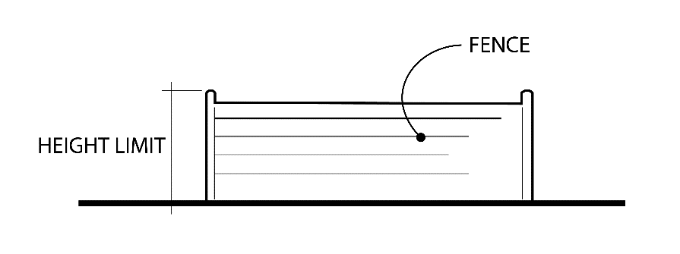
HEIGHT, FENCE – The vertical distance between the highest point of the fence and the finished grade.
HEIGHT, SIGN – See, Article 21.

HOME DAY-CARE FAMILY, LARGE – See, Day-Care Home, Family Large

HOME DAY-CARE FAMILY, SMALL – See, Day-Care Home, Family Small

HOME OCCUPATION - An accessory use which is an activity, profession, occupation, service, craft or revenue – enhancing hobby conducted by a person on the same premises as his principal place of residence which is clearly subordinate and incidental to the use of the premises for residential purposes. Home occupations may include, but are not limited to, home offices for insurance agents, financial planners, real estate agents, consultants, lawyers, architects, engineers, accountants, or other similar professional services, sewing, tailoring, teaching of music, dance lessons, or tutoring, or other similar uses that do not change the character of the residential neighborhood. Family Day Care Homes, Types A and B shall not be considered to be home occupations and shall be treated as either a Permitted or Conditional Use as listed in the applicable zoning district.

HOME OCCUPATION, MAJOR – See, Section 16.20.

HOME OCCUPATION, MINOR – See, Section 16.20.

HOTEL – An establishment consisting of a group of attached or detached living or sleeping units with bathroom and closet space, located on a single lot, and designed for use by transient automobile travelers. A hotel furnishes customary services such as maid service and laundering of linens, telephone, secretarial or desk service and the use of furniture. Ingress and egress to and from all rooms is made through an inside lobby.

HOTEL, BOUTIQUE – A small hotel with less than 50 rooms that is located in a pedestrian oriented business area. These hotels typically have a strong artisan sense and focus on the design of the building and rooms.

IMPERVIOUS SURFACE – All areas of a lot that have been, or are proposed to be paved and/or covered with buildings and materials that do not readily and freely absorb and/or allow water to penetrate, including, but not limited to, concrete, asphalt, rooftop, blacktop, brick, blocks, and pavers.

IMPROVEMENTS – Means any addition to the natural state of land which increases its value or utility, including buildings, street pavements, sidewalks, crosswalks, water mains, sanitary sewers, landscaping, street lighting, street trees, public utilities, paved parking areas, and other appropriate items.

IMPROVEMENTS, SITE – Means the improvements made to the land outside the exterior limits of a structure or structures.

IMPROVEMENTS, PUBLIC – Means all improvements financed entirely or in part by public funds or which have been dedicated to public use by plat, easement, or deed of transfer.

INDUSTRIALIZED UNIT - A building unit or assembly of closed construction fabrication in an off-site facility, which is substantially self-sufficient as a unit or as part of a greater structure, and that requires transportation to the site of intended use, including units installed on the site as independent units, as part of a group of units, or incorporated with standard construction methods to form a completed structural entity but does not include a permanently sited manufactured home or mobile home as defined in this Code.

INSTITUTIONAL USES – Those uses organized, established, used, or intended to be used for the promotion of public, civic, educational, charitable, cultural or social or philanthropic activity and include but are not limited to art galleries, art studios, libraries, etc.

JUNK YARDS AND SCRAP METAL PROCESSING FACILITIES – An establishment or place of business that is maintained or operated for the purpose of storing, keeping, buying, selling or exchanging old or scrap copper, brass, rope, rags, trash, waste, batteries, paper, rubber, iron, steel, or other old or scrap materials and where such business or operation is not completely conducted within an enclosed building.

KENNEL, AGRICULTURE – Any Building or Structure, including the surrounding fenced land, used for the breeding, care (excluding Animal Service Facilities) and/or the raising of domesticated dogs and/or cats for let, hire, board, training, housing, grooming, and/or other Use on a commercial basis for compensation. Said Use is an Agricultural Use under Section 519.01 of the Ohio Revised Code and is considered animal husbandry. Animal Service Facilities or Commercial Kennels shall not be construed to be a Kennel under this definition.

KENNEL, COMMERCIAL – Any Building or Structure, including the surrounding fenced land, used for the care and board of five or more domesticated dogs or cats more than four months of age that is open to the public for let, hire, board, training, housing, or grooming on a commercial basis for compensation. The function of the business is not the breeding or raising of dogs or cats.

LANDSCAPE/HARDSCAPE BUSINESS – A place where employees are housed and/or vehicles, machinery and materials such as trees, shrubs, flowers or other living vegetation, as well as irrigation systems, stone, brick pavers or other non-living components of a landscape design are stored. Typically, workers are dispatched from this site and said materials are transported to another location for installation.

LANDSCAPING – The improvements of a lot with grass, shrubs, trees, and other vegetation and/or ornamental objects.

LEGAL DESCRIPTION – The geographical description of real estate that identifies the precise location, boundaries, and easements for the purpose of a legal transaction, such as a transfer of ownership. A legal description can include either a metes and bounds description or a subdivision plat.
LICKING COUNTY PLANNING COMMISSION (LCPC) – The planning commission of Licking County, Ohio.

LIGHT TRESPASS – Unwanted light illuminating an area or property with brightness in excess of the regulations found under Section 16.24.

LIGHTING, EVENT – An outdoor illuminating device, outdoor lighting or reflective surface, lamp, or similar device, permanently installed or portable, used for illumination or decoration within the Temporary Entertainment Use.

LIGHTING, OUTDOOR – An outdoor illuminating device; outdoor lighting or reflective surface; lamp; or similar device, permanently installed or portable, used for illumination or decoration. Such devices shall include but are not limited to lights used for buildings and structures, recreational areas, parking lot lighting, landscape lighting, architectural lighting, product display lighting, building overhangs, canopy lighting, and security lighting.

LIGHTING, SECURITY – Lighting that is intended to reduce the risk of personal attack; discourage intruders, vandals, or burglars; and facilitate active surveillance for an area by designated surveillance personnel or by remote camera. Said lighting is fully shielded and located in a specific area such as doors, entrances, parking lots, etc.

LIGHTING, SPORTS STADIUM – Sport stadium lights are powerful, mounted fixtures at tall heights with small beam angles usually between 12-60 degrees. Due to these smaller beam angles, higher light intensity allows bright light to reach the ground from the elevated fixture. These lights are focused inward within the sports stadium area to provide lighting for playing fields, bleachers, concession stands, and aisles. The fixtures are designed and are installed to restrict light and glare beyond the outer limits of the stadium.

LIFE CARE RETIREMENT CENTER – A residential facility containing dwellings designed for and principally occupied by senior citizens in a planned retirement community which includes a residential complex, an activity or community center, and a medical or nursing facility which is licensed by the State of Ohio as an Intermediate Care Facility or a Skilled Nursing Center.

LOADING SPACE, OFF – STREET – An off-street space or berth on the same lot with a building or contiguous to a group of buildings, for the temporary parking of a commercial vehicle while loading or unloading merchandise or materials, and which abuts upon a street, alley, or other appropriate means of access.

LOGISTICS – A large building where material, products, or other manufactured goods are acquired, stored, and transported to their final destination. There is no production, processing, assembling, or packaging of products or materials in these buildings.

LOT – A division of land separated from other divisions for purposes of sale, lease, or separate use, described on a recorded subdivision plat, recorded map or by metes and bounds.

LOT, CORNER – A lot situated at the intersection of two streets, or which fronts a street on two or more sides forming an interior angle of less than 135 degrees. (Also see, LOT LINE, FRONT)

LOT, COVERAGE – The total area of those portions of a lot that are covered by a building or structures, paved areas, and other impervious surfaces.

LOT, INTERIOR – A lot that abuts no more than one street and that fronts a street on not more than one side.

LOT, MINIMUM AREA – The area of a lot computed exclusive of any portion of the right-of-way or any public thoroughfare.

LOT LINE – A line bounding or demarcating a plot of land or ground. May also be referred to as a Property Line.

LOT LINE, FRONT – The Property Line fronting a public roadway Right-of-Way. For the purposes of a Corner Lot, both Property Lines abutting a public Right-of-Way shall be considered a Front Lot Line. Road Right-of-Way for roadways wherein a Federal, State, or Local government agency has purchased or otherwise acquired the access rights and the roadway cannot be used for access to the property (aka limited access roadway) shall not qualify or be used as a Front Lot Line (“Frontage”).

LOT LINE, REAR – The lot line that is opposite the front lot line and farthest from it.

LOT LINE, SIDE – The lot line running from the front lot line to the rear lot line. This line is also the line dividing two interior lots.

LOT OF RECORD – Any lot or parcel of land that was lawfully created by a subdivision plat of record or by a metes and bounds description and recorded in the County Recorder’s Office prior to the effective date of this Code.

LOT WIDTH – The width of a lot at the building line measured at right angles to its depth.

LUMBERYARD – A building where bulk supplies of lumber and other building materials are stored, offered, or kept for retail sale and may include storage inside of the building. Any components of this use that include the outdoor storage of said materials shall fall within the definition of an outdoor service facility.
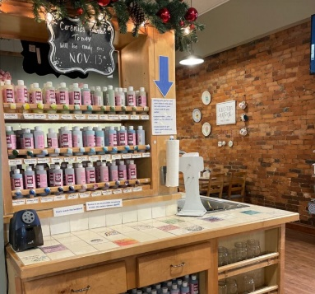
MACHINE SHOP – A facility performing cutting, grinding, turning, honing, milling, deburring, lapping, electrochemical machining, etching, or other similar operations.

MAKER SPACE, LARGE – A facility that is 5,000 square feet or larger and serves as shared co-working space for independent craftsmen to produce woodwork, furniture, pottery, glass, or other related items. The facility can also have shared office space.

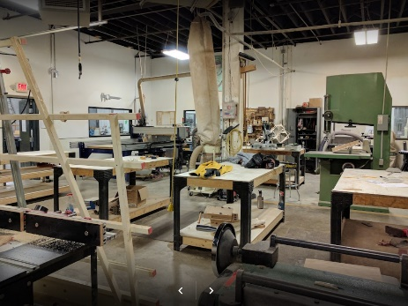
MAKER SPACE, SMALL – A facility that does not exceed 5,000 square feet that is utilized for the preparation, display, and sale of individually crafted artwork, jewelry, furniture, sculpture, pottery, glass, woodworking, or other related items. No odor, fumes or excess noise may be produced at the facility.

MANEUVERING AISLE – A paved area in an off-street parking lot or loading area which provides access to parking, stacking, or loading spaces, exclusive of driveways and is used for and/or is necessary for turning, backing or driving forward a motor vehicle into such parking space. This area is not used as space for the parking or storage of motor vehicles or for loading or unloading.

MANUFACTURED HOME – A building unit or assembly of closed construction fabricated in an off-site facility, which conforms with the federal construction and safety standards established by the Secretary of Housing and Urban Development pursuant to the “Manufactured Housing Construction and Safety Standards Act of 1974” and that has a label or tag permanently affixed to it certifying compliance with all applicable federal construction and safety standards.

MANUFACTURED HOME COMMUNITY – Any tract of land upon which three (3) or more manufactured homes used for habitation are parked, either free of charge or for revenue purposes, and include any roadway, building, structure, vehicle, or enclosure used or intended for use as a part of the facilities of such park. A tract of land which is subdivided and the individual lots are not for rent or rented but are for sale or sold for the purpose of installation of manufactured homes on the lots is not a manufactured home park, even though three (3) or more manufactured homes are parked thereon, if the roadways are dedicated to the local government authority. Manufactured home park does not include any tract of land used solely for the storage or display for sale of manufactured homes.

MANUFACTURED HOME, PERMANENTLY SITED – A manufactured home, as defined
herein, that meets all the following criteria:
A. The structure is affixed to a permanent foundation such as masonry or concrete and is connected to appropriate facilities.
B. The structure, excluding any addition, has a width of at least twenty-two (22) feet at one point, a length of at least twenty-two (22) feet at one point, and a total living area of at least nine hundred (900) square feet, excluding garages, porches, or attachments.
C. The structure has a minimum 3:12 roof pitch, conventional residential siding, and a six (6) inch minimum eave overhang, including appropriate guttering.
D. The structure was manufactured after January 1, 1995.
E. The structure is not located within a manufactured home park.
F. Otherwise complies with the Manufactured Housing Construction and Safety Standards Act of 1974 and has a label or tag permanently affixed to it, certifying compliance with all applicable federal construction and safety standards.

MANUFACTURING - Any industry that makes products from raw materials using manual labor or machinery. This definition also includes the compounding, processing, assembling, and packaging of goods.

MEDICAL MARIJUANA – As defined in ORC Section 3769.01(A)(2), effective March 22, 2020 and regulated under Chapter 3796 of the Ohio Revised Code and Chapters 3796:1-3796:8 of the Ohio Administrative Code.

MIXED-USE BUILDING – A building that contains retail, office or entertainment uses on the ground floor and residential units on the upper floors.

MOBILE HOME – A building unit or assembly of closed construction that is fabricated in an off-site facility, is more than thirty-five (35) body feet in length, or, when erected on site, is three hundred twenty (320) or more square feet, which is built on a permanent chassis and is transportable in one (1) or more sections, and does not qualify as a permanently sited manufactured home or industrialized unit as defined in this Code. A mobile home shall not be considered to be a single-family detached dwelling for the purposes of this Code.

MONOPOLE – A support structure constructed of a single, self-supporting hollow metal tube securely anchored to a foundation.

MOTEL – An establishment consisting of a group of attached or detached living or sleeping units with bathroom and closet space, located on a single lot, and designed for use by transient automobile travelers. A motel furnishes customary services such as maid service and laundering of linens, telephone, secretarial or desk service and the use of furniture.

MOTOR VEHICLE – A passenger vehicle, truck, tractor, tractor – trailer, trailer, boat recreation
vehicle, semi-trailer, or any other vehicle propelled or drawn by mechanical power.

MOTOR VEHICLE RACING TRACK – A paved roadway used primarily for the sport of automobile racing. Said facilities may include seating, concession areas, suites, parking facilities, and any facility used for driving automobiles under simulated racing or driving conditions (test track, shakedown tracks, or other similar facilities), but does not include accessory offices, residences, or retail facilities. For purposes of this Code, it is a separate designation from Large Commercial Outdoor Recreation Facilities and shall only be considered a Permitted Use in the Sports and Entertainment District (SE).

MOTOR VEHICLE DIRT RACING TRACK – An unpaved roadway used for the sport of automobile racing. Said facilities may include seating, concession areas, suites, parking facilities, and any facility used for driving automobiles under simulated racing or driving conditions (test track, shakedown tracks, or other similar facilities), but does not include accessory offices, residences, or retail facilities. For purposes of this Code, it is a separate designation from Large Commercial Outdoor Recreation Facilities and shall only be considered a Conditional Use in the Sports and Entertainment District (SE).

MURAL – See, Sign, Wall Display

MURAL, GHOST – A type of sign that has a primary purpose of displaying an historical advertisement painted directly on the exterior of a structure.

MURAL, ORIGINAL ART – A type of wall display that has a primary purpose of displaying an original work of visual art produced by hand that is tiled or painted directly upon directly to an exterior wall of a structure. Original Art Mural does not include:
A. Mechanically produced or computer-generated prints or images, including but not limited to digitally printed vinyl; or
B. Murals containing electronical or mechanical components; or
C. Changing mural images.

MURAL, VINTAGE ART – A type of wall display that has a primary purpose of displaying an original work of visual art produced by hand that was tiled, painted directly upon or affixed directly to an exterior wall of a structure prior to the date of adoption of this Code.

MULTI-FAMILY BUILDING – A building that is designed for and used exclusively for four or more dwelling units.

NONCONFORMING STRUCTURE – Any building or structure lawfully existing on the effective date of these regulations or amendment thereto, which does not conform to the development standards of the district in which it is located.

NONCONFORMING USE – Any use that was lawfully conducted within any building or on any land on the effective date of these regulations or amendment thereto but is not listed as a permitted use of the district in which it is located.

NURSING HOME – A residential health care facility, licensed by the State of Ohio, which provides institutional lodging, nursing care, personal care and supervision to aged, chronically ill, physically infirm. or convalescent patients who are not related to the owner or administrator of the facility.

O.D.O.T. – The Ohio Department of Transportation.

OFFICE, ADMINISTRATIVE, BUSINESS, MEDICAL OR PROFESSION, LARGE – A building that is 5,000 gross square feet or larger in area and includes a set of rooms or tenant spaces used for commercial, professional, medical, or bureaucratic work.

OFFICE, ADMINISTRATIVE, BUSINESS, MEDICAL OR PROFESSION, SMALL – A building that is less than 5,000 gross square feet in area and includes a set of rooms or tenant spaces used for commercial, professional, medical, or bureaucratic work.

OFF-STREET PARKING GARAGE – A public or private structure that is principally utilized for the parking or storage of motor vehicles to meet the minimum parking requirements in this Zoning Code.

OPEN SPACE – An area required to be reserved in accordance with this Code for passive or active recreational purposes, an area for conservation of natural resources, reserved space for future school buildings, or some other similar green space. Such open space may include any required central green space utilized for the community. That part of a zoned property, including courts or yards, which are open and unobstructed from its lowest level to the sky, accessible to all tenants upon the zoning property. Open Space shall be limited to terrestrial features and shall not include ponds, stormwater retention facilities, or other water features.

OUTDOOR CONCERT FACILITY – A facility, including performance areas, seating, concessions, restroom facilities, and parking, for the public performance of music and/or dancing in an outdoor venue.

OUTDOOR RECREATION FACILITY – See, Commercial Recreation Facility, Outdoor.

OUTDOOR SEASONAL BUSINESS – A use that is conducted on a temporary basis and is outside of a fully enclosed building. Such uses shall include, but are not limited to, holiday tree sales, pumpkin sales, sidewalk sales, etc.

OUTDOOR SERVICE FACILITY – An area that is not fully enclosed by solid walls and a roof and where services are rendered or goods are permanently displayed, sold or stored. For the purposes of this Code, outdoor service facilities include, but are not limited to, restaurant patios, outdoor storage areas, and garden stores. This definition shall not include any use classified as an outdoor seasonal business as defined herein.

OWNER – Owner of record according to records contained in the County Recorder’s Offices.

OVERLAY ZONE – Zoning Districts that extend on top of more than one base Zoning District and are intended to protect certain critical features and resources. Where the standards of the Overlay Zone and base Zoning District are different, the more restrictive standards shall apply.

PARCEL – A piece of real estate described by metes and bounds in the deed of the land and recorded in the office the county recorder.

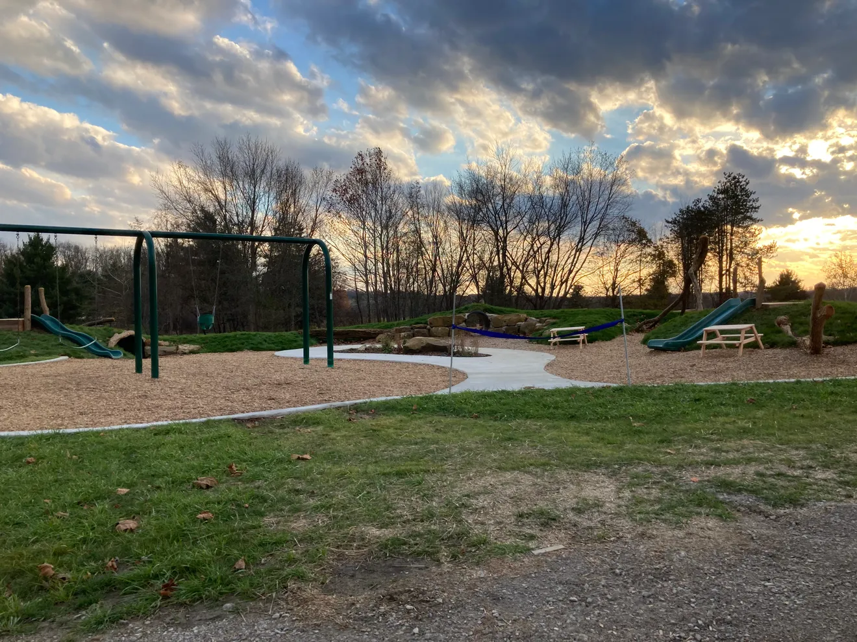
PARK, COMMUNITY OR REGIONAL – A park that is 20 acres or larger and designed to service a larger region beyond a specific neighborhood and may include playground apparatus and other space for active recreational purposes, along with some areas for passive use.

PARK, NEIGHBORHOOD – A park that is up to 20 acres in size, serving an area one to two miles in diameter and serving a population of less than 5,000 persons. Neighborhood parks are typically designed to service a specific neighborhood area and may include playground apparatus and other space for active recreational purposes, along with some areas for passive use.
Photo: Infirmary Mound Park Playground

PARKING AISLE – The traveled path through an off-street parking or facility between one or two rows of parked vehicles.

PARKING BAY – A row of parking spaces typically separated by a parking island or some other feature used to break up large surfaces covered in asphalt used for the parking surface.

PARKING AREA - An open area other than a street or other public way that is used for the parking of motor vehicles.

PARKING SPACE, OFF-STREET – Any parking space located wholly off any street, alley, or sidewalk, either in an enclosed building or on an open lot and where each parking space conforms to the standards as specified in this Code.

PENNANT – A flag or banner longer in the fly than in the hoist, usually tapering to a point.

PERMANENT SUPPORTIVE HOUSING – Community-based, long-term housing and supportive services, as appropriate, for homeless individuals with disabilities.

PERMITTED USE(S) – A use that is permitted within a District that is allowable by a matter of right when designated as such in a District, provided said use complies with all applicable setback and development standards and is issued a Zoning Permit from the Zoning Inspector, or their designee.

PERSONAL SERVICES – Uses that primarily provide services to a person or provide for the care and maintenance of personal goods. Such Uses include, but are not limited to, beauty shops, barber shops, salons, shoe repair shops, tailoring services, or garment repair services. This includes laundry or dry cleaning drop off/pick up services, but the process of dry cleaning is not included in this definition.

PICK-UP OR BANKING WINDOW – A window used to pick up food, a prescription or other similar product; parcel pick up; or where banking or financial services are conducted without a patron needing to exit his/her vehicle. Food orders and prescriptions are typically placed ahead of time online via the web or mobile device, and these windows are typically not utilized for placing and waiting for orders on site.

PLACES OF ASSEMBLY, LARGE – Any facility or business where 300 or more individuals gather to participate or observe programs or services or assemble for social purposes. This includes public halls, theatres, churches, worship facilities, and other similar meeting facilities.

PLACES OF ASSEMBLY, SMALL – Any facility or business where less than 300 individuals gather to participate or observe programs or services or assemble for social purposes. This includes public halls, theatres, churches, worship facilities, and other similar meeting facilities.

PLANTS, ASPHALT – A stationary source that manufactures asphalt concrete by heating and drying aggregate and mixing asphalt cements. This includes any combination of dryers; systems for screening; handling; storing and weighing dried aggregate; systems for loading; transferring; and storing mineral filler; systems for mixing; transferring and storing asphalt concrete; and emission control systems within a stational source.

PLANTS, CONCRETE – The production of concrete that uses a manufacturing process involving the mixing of a number of aggregates, sand, water, cement and/or other components. This use also includes the stockpiling of bulk materials required for the process and storage of the required equipment used in the operation.

POOL HOUSE – A non-residential structure used in accessory to a Private Family Swimming Pool.

PORTABLE HOME STORAGE UNIT – Any assembly of materials which is designed, constructed, or reconstructed to make it portable and capable of movement from one site to another and designed to be Used without a permanent foundation. Such Structures are typically utilized for temporarily storing household goods or other such materials on a residential property.

PRACTICAL DIFFICULTY – A standard utilized to determine whether an area variance should be granted. It is based on a number of criteria that are weighed against one another to determine if granting the variance will provide a reasonable use of the land without altering the essential character of the area.

PRESERVE OR PRESERVATION – The process, including maintenance, of treating an existing building to arrest or slow future deterioration, stabilize the structure and provide structural safety without changing or adversely aﬀecting the character or appearance of the structure.

PRIVATE CLUB OR LODGE – A nonprofit association of persons, who are bona-fide members paying annual dues, which owns, hires, or leases a building or portion thereof, and the use of such premises is restricted to members and their guests. It shall be permissible to serve food and meals on such premises provided that adequate dining room space and kitchen facilities are available. The sale of alcoholic beverages to members and their guests shall be allowed in conjunction with the operation of a dining room, for the purpose of serving food and meals, though such beverages may be served in a separate room or rooms, and provided that such sale of alcoholic beverages is in compliance with applicable local, state, and federal laws.

PRIVATE LANDING STRIP – A long flat piece of land from which private aircraft can take off and land that is properly licensed by the Federal Aviation Authority or applicable agency. It can be constructed of either grass or pavement.

PRIVATE FAMILY SWIMMING POOL – See, Swimming Pool, Private Family.

PROPERTY LINE – A line bounding or demarcating a plot of land or ground. May also be referred to as a Lot Line.

PUBLIC PROTECTION FACILITY – A facility operated by a public agency for the purposes of public safety including but not limited to fire stations, police stations, public safety dispatch facilities, civil defense, storm shelters, and other similar uses.

RECONSTRUCTION – The act or process of depicting, by means of new construction, the form, features, and detailing of a non-surviving site, landscape, building, structure, or object for the purpose of replicating its appearance at a speciﬁc period of time and in its historic location.

REHABILITATION – The process of returning a property to a state of utility, through repair or alteration, which makes possible an eﬃcient contemporary use while preserving those portions and features of the property which are signiﬁcant to its historic, architectural, and cultural values.

RESEARCH AND DEVELOPMENT – A use where individuals are employed to search for knowledge and test processes that might be used to create new technologies, products, services, or systems.

RESIDENTIAL FACILITY – A publicly or privately operated home or facility that is further categorized as:

RESIDENTIAL FACILITY CLASS 1– A facility that provides accommodations, supervision, personal care services, and mental health services for one or more unrelated adults within mental illness or one or more unrelated children with adolescents with severe emotional disturbances.

RESIDENTIAL FACILITY CLASS 2 - A facility that provides accommodations, supervision and personal care services to any of the following:
- One or two unrelated persons with mental illness.
- One or two unrelated adults who are receiving payments under the residential state supplement program.
- Three to sixteen unrelated adults.
Residential facilities exclude hospitals, facilities licensed under ORC 5123.19, an institution subject to certification under ORC 5103.03, hospice care programs, nursing homes, residential care facilities, homes for the aging, a facility operating an opioid treatment program, a terminal care facility for the homeless, a facility approved exclusively for the placement and care of the veterans per Section 104(a) of the Veterans Health Care Amendments of 1983, or the residence of a relative or guardian of a person with mental illness.

RESIDENTIAL FACILITY, LARGE - Any facility licensed as a Class 2 Residential Facility per ORC 5119.34 and provides accommodations and personal care services to six to sixteen unrelated persons. (See ORC 5119.341)

RESIDENTIAL FACILITY, SMALL – Any facility licensed as a Class 2 Residential Facility per ORC 5119.34 and provides accommodations and personal care services to one to five unrelated persons. (See ORC 5119.341)

RESIDENTIAL – OFFICE, ADMINISTRATION, BUSINESS, AND MEDICAL – A small office for administrative, business or medical services as defined in this section but located within a structure that was existing at the time of the effective date of this Code.

RESIDENTIAL – RETAIL – A small business retail as defined in this section but located within a structure that existed at the time of the effective date of this Code.

RESIDENTIAL TREATMENT FACILITY – A Residential Facility – Class 1 (ORC 5119.34) providing diagnostic or therapeutic services, counseling, or treatment and long-term room and board in a highly structured environment for its residents for alcoholism, drug abuse, or behavioral and/or mental disorders.

RESPONSIBLE PARTY – The owner of the property as determined by the County Auditor’s Tax List, the agent of the property owner authorized to be responsible for the premises, or the occupant of the property.

RESTAURANT – An establishment which offers food and/or drinks to the public, guests, or employees. The food may be prepared and consumed either on or off site.

RIGHT-OF-WAY – A strip of land occupied or intended to be occupied by transportation facilities, public utilities, street drainage ditches or other special public uses.

SATELLITE DISH ANTENNA, SMALL – Any antenna that is one meter or less in diameter and is designed to receive direct broadcast satellite service, including direct-to-home satellite service, or to receive or transmit fixed wireless signals via satellite. It further means any antenna that is one meter or less in diameter or diagonal measurement and is designed to receive video programming services via MMDS (wireless cable) or to receive or transmit fixed wireless signals other than via satellite.

SCHOOL, HIGH SCHOOL – A public or private institution providing secondary education prior to students starting college or obtaining a job. It typically includes grades 9 – 12.

SCHOOL, POST-SECONDARY – A public or private institution providing educational or training services to individuals who have completed high school.

SCHOOL, PRIMARY, INTERMEDIATE, OR MIDDLE – A public or private institution providing educational services to children in kindergarten through the eighth grade.

SCHOOL, TECHNICAL – A secondary or post-secondary school that provides designed training to students for a specific job or skilled trade.

SELF SERVICE STORAGE FACILITY– An individual compartment or stall used for the storage of customer’s goods or wares.

SERVICE ROAD, OR ACCESS ROAD – Means a minor Street parallel to a thoroughfare to afford abutting property owners access to the thoroughfare at limited points.

SETBACK – A required distance between a lot line and a principal structure established by the Zoning District in which the principal structure is located.

SETBACK, AVERAGE FRONT– The distance between a front lot line and principal building that is established by averaging the front setbacks of two existing structures on adjacent lots. In no case shall an average front setback exceed any applicable maximum setback requirement.

SETBACK, MAXIMUM – The largest distance permitted between a lot line and a principal structure. The Zoning Inspector shall not administratively approve the location of a principal structure that is more than this required distance.

SETBACK, MINIMUM – The smallest distance permitted between a lot line and a principal structure established by the Zoning District in which the principal structure is located. The Zoning Inspector may not administratively approve the location of a principal structure that is less than this required distance but may administratively approve the location of a principal structure that is more than this required distance. In such cases, the area between the required minimum setback and the principal structure is considered to be “yard” space as defined in this Code.

SEXUAL CONDUCT – Acts of sexual intercourse within its ordinary meaning, occurring upon any penetration, however slight. Any penetration of the vagina or anus, however slight, by an object. Any contact between persons involving the sex organs of one person and the mouth or anus of another. Masturbation, manual or instrumental, of oneself or of one person by another. Touching of the sex organs or anus, whether clothed or unclothed, of oneself or of one person by another.

SHIPPING CONTAINER - A structure designed for use as an individual shipping container designed to be mounted on a rail car as freight or designed as an enclosed truck trailer. These containers are typically prefabricated metal structures but also include other similar type containers such as shipping crates, boxes, or trailers constructed with other types of material.

SHOOTING RANGE, INDOOR – The use of a structure for archery and/or the discharging of firearms for the purposes of target practice or temporary competitions.

SHOOTING RANGE, OUTDOOR – The use of land for archery and/or the discharging of firearms for the purposes of target practice, skeet and trap shooting, mock war games, or temporary competitions, such as turkey shoots. Excluded from this use type shall be general hunting and unstructured and nonrecurring discharging of firearms on private property with the property owner’s permission.

SHORT-TERM RENTAL – Renting a home, or a space in a home, with five guestrooms or less that is reserved/rented wholly or partly for compensatory fee for less than thirty (30) consecutive days.

SHORT-TERM RENTAL, HOSTED – A Short-Term Rental in which the Dwelling Unit rents out a guestroom while the owner of the Short-Term Rental remains during the stay.

SHORT-TERM RENTAL, UNHOSTED – A Short-Term Rental in which the Dwelling Unit is wholly rented and the owner of the Short-Term Rental does not remain during the stay.

SIGHT TRIANGLE – The triangular area formed by a diagonal line connecting two points located on intersecting street rights-of-way or a right-of-way and the edge/curb of a driveway (See, Section 16.42).

SIGN – Any device for visual communication which is designed, intended or used to convey a message, advertise, inform or otherwise direct attention to a person, institution, organization, activity, business, place, object or product. Signs erected by the local, state or federal government for the purposes of discharging in any normal governmental function, such as traffic control or safety, are likewise excluded from the regulations of this Article. This definition includes all signs visible from any public right – of – way or adjacent property, including interior signs oriented towards the exterior façade of any Building or structure that includes any name, number, symbol, identification, description, display, illustration, object, graphic, sign structure, or part thereof, which directs attention to any object, product, place, activity, person, institution, organization, or business.

SIGN, ANIMATED – Any sign that uses movement or change of artificial and natural lighting or noise to depict action or create a special effect or scene.

SIGN, BILLBOARD - A type of free-standing sign that is mechanically produced or computer-generated prints or images, including but not limited to digitally printed vinyl and/or 3-D printed elements, that are typically attached or affixed to a pole or other type of free-standing support. Said signs are greater than 200 square feet.

SIGN, ENTRY FEATURE – A sign intended to provide the identity of a residential development or commercial development with more than one lot or tenant.

SIGN, FLASHING - A sign or graphic which in any manner, as a whole or in part, physically changes in light intensity or gives the appearance of such change.

SIGN, FREESTANDING – A sign erected on a pole, poles, pillars, or posts (pylon sign) or any monument type sign (sign with a base) which is wholly independent of any building or support.

SIGN, GAS INFLATABLE – Any device which is capable of being expanded by any gas and is typically tethered or otherwise anchored to the ground or structure and used on a permanent or temporary basis to attract attention to a product, event, or business.

SIGN, GROUND-MOUNTED – A type of free-standing sign that is supported by a monument style base and does not include any poles, pillars, or posts.

SIGN, PERMANENT – A sign intended to be erected, displayed or used, or in fact which is used for time period in excess of 30 days within any 180-day period.

SIGN, POLE – A type of free-standing sign that is supported by pole(s), pillars, posts or other free-standing support and is less than 200 square feet.

SIGN, PROJECTING – A sign which extends outward perpendicular to the building face.

SIGN, ROOF – Any sign erected upon or completely over the roof of any building.

SIGN, TEMPORARY – A display, banner, or other advertising device constructed of cloth, canvas, fabric, wood, or other temporary material, with or without a structural frame, including but not limited to portable signs, feathered flags, development signs, community event signs, garage sale signs, real estate signs, sandwich type signs, sidewalk or curb signs, and balloon or other air or gas filled figures.

SIGN, TRAILER – A sign that is constructed on a chassis intended for the mounting of wheels, thereby permitting the sign to be moved forward.

SIGN, WALL – A wall display that is less than 125 square feet.

SIGN, WALL DISPLAY – A sign attached to a building face, with the exposed face thereof in a plane parallel to the plane of the wall. Wall signs include, messages, graphics and other designs painted along with any letters or numerals mounted directly on buildings or awnings.

SIGN, WAY-FINDING – Any sign which provides direction or guidance to help navigate a person to a specific location of an institution, organization or business, or property.

SIGN, WINDOW – A sign, graphic, poster, symbol or other identification which is physically affixed to or painted on the glass or other structural component of the window.

SOLAR, ARRAY - A mechanically integrated assembly of modules or panels with a support structure and foundation, tracker and other components as required to form a direct-current power producing unit.

SOLAR ENERGY – Radiant energy (direct, diffused, or reflected) received from the sun at wavelengths suitable for conversion into thermal, mechanical, chemical, or electrical energy.

SOLAR ENERGY SYSTEM (SES) – An energy system that consists of one or more solar collection devices, solar energy-related equipment, and other associated infrastructure with the primary intention of generating electricity, storing electricity, or otherwise converting solar energy to a different form of energy. Solar energy systems may generate energy in excess of the energy requirements of a property if it is to be sold back to a public utility in accordance with the law.

SOLAR ENERGY SYSTEM, INTEGRATED – An SES where solar materials are incorporated into building materials, such that the two are reasonably indistinguishable, or where solar materials are used in place of traditional building components, such that the SES is structurally an integral part of a house, building, or other structure. An Integrated SES may be incorporated into, among other things, a building facade, skylight, shingles, canopy, light, or parking meter.

SOLAR ENERGY SYSTEM, GROUND-MOUNTED – An SES where an array is mounted on a rack or pole that is ballasted on, or is attached to, the ground.

SMALL-SCALE GROUND-MOUNTED SOLAR ENERGY SYSTEM (SMALL SCALE SES) – A ground mounted SES with a footprint of between one (1) and five (5) acres.

INTERMEDIATE-SCALE GROUND-MOUNTED SOLAR ENERGY SYSTEM (INTERMEDIATE SCALE SES) – A ground mounted SES with a footprint of between five (5) and fifteen (15) acres.

LARGE SCALE GROUND MOUNTED SOLAR ENERGY SYSTEM (LARGE SCALE SES) – A ground mounted SES with a footprint of more than fifteen (15) acres.

SOLAR ENERGY SYSTEM, ROOF MOUNTED – An SES mounted to the roof of a building or structure. Roof-mount systems are accessory to the primary use of a property.

SPECIFIED SEXUAL ACTIVITIES – Simulated or actual display of human genitals in a state of sexual stimulation or arousal, acts of masturbation, sexual intercourse, sodomy, bestiality, necrophilia, sadomasochistic abuse, fellatio, or cunnilingus and fondling or erotic touching of human genitals, pubic region, buttocks, or female breasts.

STAGING AREA – A physical location used to store equipment and materials related to the setup, construction, operation, and/or tear down of an activity or event.

START OF CONSTRUCTION – The first placement of permanent construction of a structure (other than a mobile home) on a site, such as the pouring of slabs or footings or any work beyond the state of excavation. Permanent construction does not include land preparation, such as clearing, grading, and filling, nor does it include the installation of streets and/or walkways; nor does it include excavation for a basement, footings, piers or foundations or the erection of temporary forms; nor does it include the installation on the property of accessory buildings, such as garages or sheds not occupied as dwelling units or not as part of the main structure. For a structure (other than a mobile home) without a basement or poured footings, the “start of construction” includes the first permanent framing or assembly of the structure or any part thereof on its piling or foundation. For mobile homes not within a mobile home park or mobile home subdivision, “start of construction” means the affixing of the mobile home to its permanent site. For mobile homes within mobile home parks or mobile home subdivisions, “start of construction” is the date on which the mobile home is to be affixed (including, at a minimum, the construction of streets, either final site grading or the pouring of concrete pads, and installation of utilities) is completed.

STREET – A paved public vehicular right-of-way which provides access to abutting properties from the front.

STREET, EXPRESSWAY OR INTERSTATE – Highways which convey high volumes of traffic at high speeds, typically controlled access provided at interchanges. This classification acknowledges existing highways that are generally state or federally designed, funded, and maintained.

STREET, MAJOR ARTERIAL – Means a Street which conveys county to county or city to city travel at relatively higher speeds and typically tightly regulated access. These Streets are typically US highways or state routes.

STREET, MINOR ARTERIAL – Means a Street which is used for intra-county and city corridor travel that links Major Arterials, Interstates, and Expressways with substantial areas of development, and/or conveying substantial traffic volumes.

STREET, MAJOR COLLECTOR – Streets which connect Major and Minor Arterials to population and employment centers, serving more localized trips.

STREET, MINOR COLLECTOR – Streets which predominantly connect local streets with higher classification routes.

STRUCTURAL ALTERATIONS – Any change in the supporting members of a Building, such as bearing walls or partitions, columns, beams or girders, or any increase in the area or cubical contents of a building.

STRUCTURE – Anything constructed or erected, the use of which requires a permanent location on the ground or attached to something having a permanent location on the ground, including outdoor advertising signs, billboards, and farmers’ street-side stands.

SUBSTANTIAL IMPROVEMENT/ALTERATION – Any reconstruction, rehabilitation, addition, or other improvement of a structure, the cost of which equals or exceeds fifty (50) percent of the market value of the structure before the "start of 15 construction" of the improvement. This term includes structures, which have incurred "substantial damage", regardless of the actual repair work performed. The term does not, however, include:
1. Any project for improvement of a structure to correct existing violations of state or local health, sanitary, or safety code specifications that have been identified by the local code enforcement official and which are the minimum necessary to assure safe living conditions; or
2. Any alteration of a "historic structure," provided that the alteration would not preclude the structure's continued designation as a "historic structure".

SUBSTANTIALLY COMPLETE – The stage in which the work, described in the Zoning Permit, is finished to a point that the applicant/owner can occupy or utilize the land or building for its intended purpose.

SWIMMING POOL, COMMUNITY – A body of water in an artificial or natural receptacle or another container, whether located indoors or outdoors, used or intended to be used for public, semi-public, or private swimming by adults and/or children whether or not any charge or fee is imposed, operated by an owner, lessee, operator, licensee or concessionaires, exclusive of a family pool as defined herein, and shall include all structures, appurtenances, equipment, appliances, and other facilities appurtenant to and intended for the operation and maintenance of a swimming pool, and also, all swimming pools operated and maintained in conjunction with or by clubs, motels, hotels, apartments and condominiums, and community associations.

SWIMMING POOL, PRIVATE FAMILY – A swimming pool used or intended to be used solely by the owner or lessee thereof and family, and by friends invited to use it without payment of any fee, and normally capable of containing water to a depth at any point greater than three (3) feet.

SWIMMING POOL, STORABLE – A pool capable of holding water to a maximum depth of forty-two inches (42") and is constructed of non-metallic, molded polymeric or fabric walls supported on a rigid frame or by an inflatable ring and entirely on or above ground, and is designed and constructed to be readily disassembled for storage and re-assembled to its original integrity.

TELECOMMUNICATION TOWER – A structure situated on a site used to support antennas and radio or cellular communications equipment. Antennas used by amateur radio operators are excluded from this definition.

TELECOMMUNICATION TOWER, ATTACHED – Any structure that will be attached to a Building or other structure that meets the criteria for a telecommunication tower, as defined herein.

TELECOMMUNICATIONS TOWER, FREE STANDING – Any free-standing structure that meets the criteria for a telecommunication tower, as defined herein.

TEMPORARY ENTERTAINMENT USE – A use for providing amusement or enjoyment in an indoor facility, outdoor facility, or outdoor area on private property through an activity that provides a leisure activity either for profit or not for profit and for a specified limited duration not to exceed ninety (90) days (three months). Said use and any associated parking, vehicle or pedestrian queueing, or storage does not occur within the public right-of-way. Each Temporary Entertainment Use requires a Conditional Use Permit as detailed in this Code.

TEMPORARY STRUCTURE, CONSTRUCTION TRAILER/OFFICE – Any structure that is not permanent and is located on a construction site for purposes of storing materials and tools or for offices for construction management.

THOROUGHFARE PLAN – Means the Licking County Thoroughfare Plan now or hereafter adopted, which may be considered a component of the Union Township Comprehensive Plan, which sets forth the location, alignment, and/or classification of existing and proposed Streets.

TOWNSHIP – Refers to Union Township, Licking County, Ohio.

TRAFFIC MANAGEMENT PLAN – A Traffic Management Plan, or "TMP," is a plan developed and established to anticipate, prepare for, manage, and control vehicular traffic in a manner that maintains the functionality, capacity, traffic flow, and safety of the public roadway. The TMP identifies, coordinates, and manages the needs and actions of several agencies responsible for road traffic management and safety on a given road network. This may include the Township Road Superintendent, Licking County Engineer, Ohio Department of Transportation, Licking County Sheriff's Office, and the State Highway Patrol. The purpose of this approach is to limit the effects of events that can lead to serious deterioration of traffic conditions, including functionality, capacity, traffic flow, and safety. The objective is coordinated action by the various authorities and services that participate in the operation of the roadway. To anticipate the arrangements for controlling and guiding traffic flows in real-time and for informing road users about the traffic situation in a consistent and timely way before and during their trip. The situations covered can be unforeseeable (incidents, accidents) and/or predictable (recurrent or non-recurrent events). The measures are always applied temporarily – although "temporary" may be lengthy, such as an event, construction, or long-term maintenance activity. The TMP determines the placement of barricades, warning lights, signs, off-street parking, and/or personnel for the duration of the event or incident that impedes the normal traffic flow for the roadway.

TRAFFIC QUEUEING – A line of motor vehicles awaiting their turn to be attended to or to proceed.

TRANSITIONAL LIVING CENTER – A facility that provides short-term room and board in a supervised living environment utilizing counseling and rehabilitation services for persons with a history of juvenile delinquency, behavioral disorders, alcoholism, or drug abuse.

TREE, LARGE – Any tree species which normally attains a full-grown height above 60 feet.

TREE, MEDIUM – Any tree species which normally attains a full-grown height between 30-60
feet.

TREE, SMALL – Any tree species which normally attains a full-grown height of under 30 feet.

TRUCK SERVICE CENTER – A commercial facility which provides refueling, parking, and often ready-made food for motorists and truck drivers. These facilities sometimes also include showers for truck drivers.

TRUSTEES, BOARD OF TOWNSHIP – The three-member board elected at the general elections in off-numbered years for terms of four years. Two Trustees are elected the year after presidential elections, and one trustee the year following gubernatorial elections.

UNNECCESSARY HARDSHIP – A standard utilized to determine whether a use variance should be granted. It is based on the deprivation of an owner’s right to the beneficial use of property that is caused by the strict enforcement of this Code. It must involve unique characteristics of the property itself and does not include economic difficulties of the owner/applicant.

USE – The purpose for which a Building or land may be arranged, designed, or intended to be
occupied or maintained.

VARIANCE – A modification of the strict terms of this Code due to the strict enforcement
of these regulations resulting in a practical difficulty or Unnecessary Hardship and where such modification will not be contrary to the public interest.

VARIANCE, AREA – A type of variance that is from a regulation based on the dimensions or physical requirements of applicable zoning regulations such as setbacks, height, or other similar requirement. This type of variance is typically reviewed using a Practical Difficulty standard.

VARIANCE, USE – A type of variance to allow a use that is otherwise prohibited within the district. This type of variance is typically reviewed using an Unnecessary Hardship standard.

VEHICLE, CHARGING STATION – The design and construction of a parking space with Electric Vehicle Supply Equipment that supplies electric energy for the recharging of electric vehicles.

VEHICLE, RECREATIONAL – Any motorized or non-motorized vehicle that is used for recreational purposes including, but not limited to all-terrain vehicles, dune buggies, motor bikes, recreational vehicle trailers, snowmobiles, trail bikes, and various watercraft including canoes, kayaks, boats and jet skis.

VEHICULAR SALES, EQUIPMENT – An open area or building used for the display, sale or rental of farm, construction, or other similar machinery.

VEHICULAR SALES, MOTORCYLCES – An open area or building used for the display, sale, or rental of new or used motorcycles and where only incidental repair work is done.

VEHICULAR SALES, NEW AND USED CARS – An open area other than a street, used for the display, sale, or rental of new or used motor vehicles in operable condition and where only incidental repair work is done.

VEHICULAR SALES, RECREATIONAL – An open area or building used for the display, sale, or rental of new or used recreational vehicles and where only incidental repair work is done.

WALL, DECORATIVE – An architecturally designed wall that is intended to prohibit public view and provide seclusion, has more than 50 percent of its vertical surface area closed to light and air, and is not designed for purposes of retaining soil.

WALL, RETAINING – An engineered wall that is designed and intended to support soil laterally so that it can be retained at different levels on the two sides.

WALLSCAPE – A type of wall display that greater than 125 square feet and is mechanically produced or computer generate prints or images, including but not limited to digitally printed vinyl and/or 3-D printed elements, which are typically attached to the side of a building.

WATER, WASTEWATER, TRANSPORTATION AND OTHER GOVERNMENTAL SERVICES – Government services concerning the extraction, transportation, and treatment of water and waste water within the Township.

WIND ENERGY CONVERSION SYSTEM – An energy system consisting of a wind turbine, a tower, and associated control or conversion electronics.

WIND ENERGY CONVERSTION SYSTEM, INDIVIDUAL – A Wind Energy Conversion System consisting of a wind turbine, a tower, and associated control or conversion electronics, which has a single interconnection to the electrical grid, an aggregate rated capacity of not more than 100 kilowatts and is intended to primarily reduce on–site consumption of utility power.

WIND ENERGY CONVERSTION SYSTEM, TOWER – The support structure to which the nacelle and the rotor are attached.

WIND ENERGY CONVERSION SYSTEM, TOWER HEIGHT OF – The distance from the rotor blade at its highest point to the top surface of the tower foundation.

WIND FARM, SMALL – A Wind Energy Conversion System consisting of wind turbine(s), tower(s) and associated control or conversion electronics, which have an aggregate rated capacity of 100kW or more, but less than 50 megawatts and has a single interconnection to the electrical grid. Any Wind Energy Conversion System that is 5 megawatts or larger shall be reviewed by the Ohio Power Siting Board and shall not be subject to the regulations within this Zoning Resolution.

YARD – An open space on a lot with a building that is unoccupied and unobstructed by any portion of a principal structure. Fences and other accessory structures may be permitted within a yard as regulated in this Code.

FRONT YARD – The horizontal distance between the right-of-way line and the nearest foundation or structural appurtenance of the principal structure.

REAR YARD – The horizontal distance between the rear lot line and the nearest foundation or structural appurtenance of the principal structure.

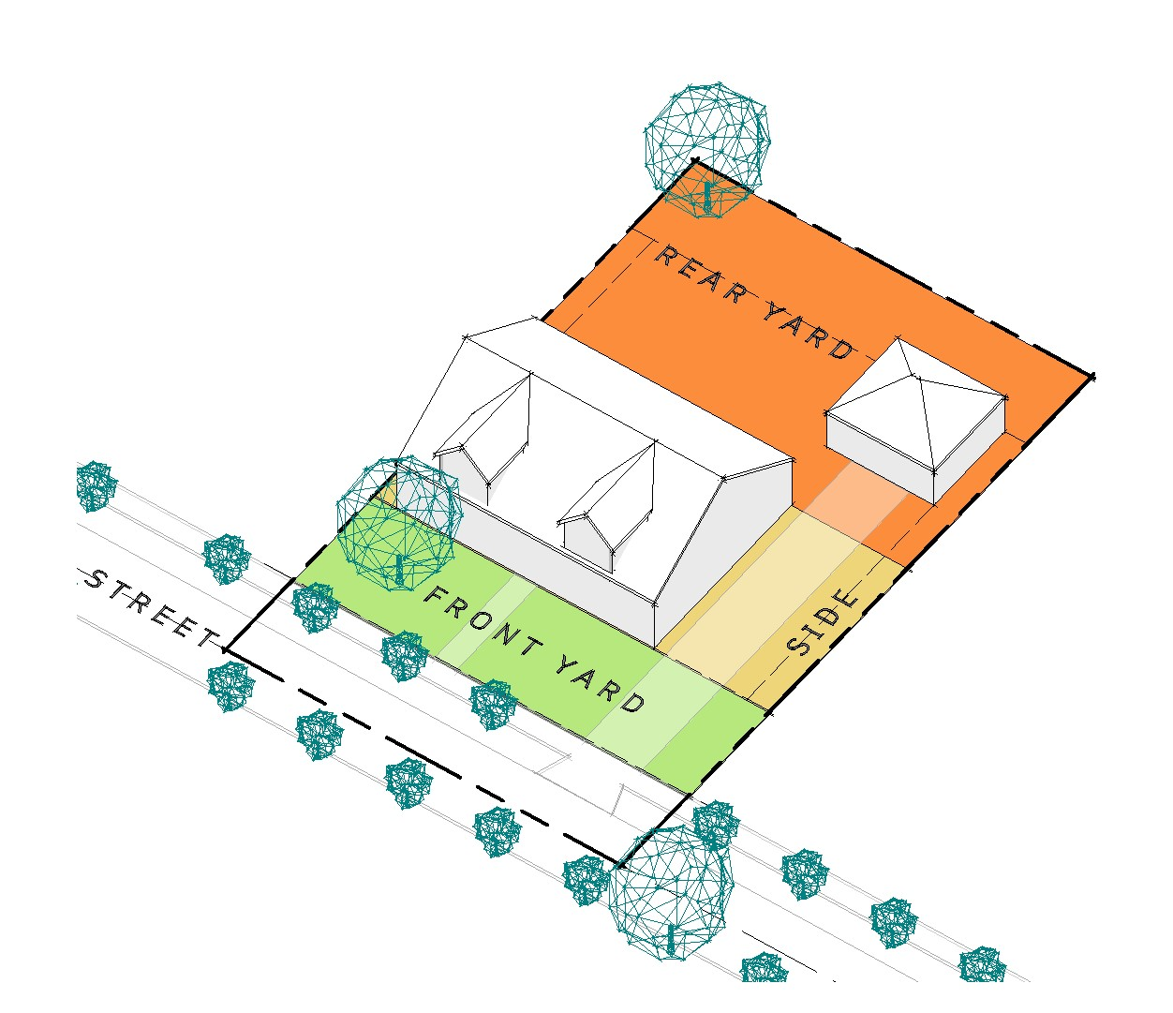
SIDE YARD – The horizontal distance between the side lot line and the nearest foundation or structural appurtenance of the principal Building.
ZONING DISTRICT – Any section of the Zoning Map and/or legal description in which the zoning regulations are uniform.

ZONING INSPECTOR - The authorized representatives appointed by the Trustees to issue Zoning Permits and perform other duties as specified in this Code.

ZONING MAP – A map of Union Township, Licking County, Ohio that legally denotes the boundaries of the Zoning District as they apply to the properties within the Township. The official zoning map shall be kept on file in the administrative offices.

ZONING PERMIT – A document issued by the zoning administrator authorizing the construction or alteration of a building, structure, or use consistent with this Code.

ARTICLE III
Administration

3.01 Zoning Inspector
3.02 Duties of Zoning Inspector
3.03 Boards of Zoning Appeals and Zoning Commission
3.04 Proceedings of Zoning Commission

3.05 Duties of Zoning Commission
3.06 Proceedings of the Board of Zoning Appeals
3.07 Duties of the Board of Zoning Appeals

3.01 OFFICE OF ZONING INSPECTOR

A Zoning Inspector designated by the Board of Township Trustees shall administer and enforce this Code. The Zoning Inspector may be provided with the assistance of such other persons as the Board of Township Trustees may direct. The Township Zoning Inspector, before entering upon his/her duties, shall give bond as specified in Section 519.161 of the Ohio Revised Code.
3.02 DUTIES OF ZONING INSPECTOR

For purposes of this Code, the Zoning Inspector shall have the following duties:

- Upon finding that any of the provisions of this Code are being violated, the Zoning Inspector shall notify in writing the person responsible for such violation(s), ordering the action necessary to correct such violation.

- Order discontinuance of illegal uses of land, buildings, or structures. Order removal of illegal buildings or structures or illegal additions or structural alterations.

- Order discontinuance of any illegal work being done.

- Take any other action authorized by this Code to ensure compliance with or to prevent violation(s) of this Code. This may include the issuance of and action on Zoning Permits and such similar administrative duties as are permissible under the law.

3.03 BOARDS OF ZONING APPEALS AND ZONING COMMISSION

- A Board of Zoning Appeals and a Zoning Commission are hereby created, both of which shall consist of five members and two alternates for each board, each to be appointed by the Board of Township Trustees for a term of five years, except that the initial appointments of regular members shall be one member each for one, two, three, four and five year terms. Each member shall be a resident of the township. Members of the Board of Zoning Appeals or the Zoning Commission may be removed from office by the Board of Township Trustees for cause, upon written charges and after a public hearing. The Board of Township Trustees shall fill vacancies through appointment for the un-expired term of the member vacating the position.

- The Alternate Members shall meet the same appointment criteria as Regular Members, and shall take the place of an absent Regular Member at any meeting of the Board of Zoning Commission and the Board of Zoning Appeals. An Alternate Member may vote on any matter on which the absent Member is authorized to vote. Alternate Members of the Board(s) may be removed from office by the Board of Township Trustees for cause upon written charges and after a public hearing as provided in O.R.C. 519.04. Vacancies shall be filled by appointment by the Board of Township Trustees for the un-expired term of the member affected.

3.04 PROCEEDINGS OF ZONING COMMISSION

- The Zoning Commission shall elect a Chairperson and adopt rules necessary for the conduct of its affairs consistent with the provisions of this Resolution. Meetings shall be held at the call of the Chairperson, and at such other times as deemed appropriate by the Commission, as determined by majority vote. All meetings shall be open to the public and abide by all applicable meeting laws applicable under the Ohio Revised Code. For the purpose of taking action, the concurring vote of three (3) members of the Commission shall be required for action on any specific business.

- The Commission shall keep minutes of proceedings, showing the vote of each member upon each question or, if absent or failing to vote, indicating such fact. Such minutes shall be public record and shall be immediately filed in the office of the Commission.

3.05 DUTIES OF ZONING COMMISSION

For purposes of this Code, the Commission shall have the following duties:

- Initiate proposed amendments to this Code.

- Review all proposed amendments to this Code and make recommendations to the Board of Township Trustees as specified in Article VII.

- Review all Planned Unit Developments and make recommendations to the Board of Township Trustees as provided in Article XV.

- Review all proposed changes to official Zoning Map and make recommendations to the Board of Township Trustees.

3.06 PROCEEDINGS OF THE BOARD OF ZONING APPEALS

The Board of Zoning Appeals shall adopt rules necessary for the conduct of its affairs in keeping with the provisions of this Code. Three members of the Board of Zoning Appeals shall be necessary to constitute a quorum to conduct business. A majority vote of those members of the Board of Zoning Appeals present to form a quorum shall be necessary to reverse any order, requirement, decision, or determination of the Zoning Inspector, or to decide in favor of the applicant on any matter upon which it is required to pass under this Code or to affect any variation in the application of this Code. The chairman, or in his absence the acting chairman, may administer oaths and compel the attendance of witnesses. All meetings shall be open to the public. The board shall keep minutes of its proceedings, showing the vote of each member upon each question, or if absent or failing to vote, indicating such fact, and shall keep records of its examination and other official actions, all which shall be a public record and be immediately filed in the office of the Board of Zoning Appeals.

3.07 DUTIES OF THE BOARD OF ZONING APPEALS

In exercising its duties, the board may, as long as such action is in conformity with the terms of this Code, reverse or affirm, wholly or partly, or modify the order, requirement, decision, or determination appealed from and may make such order, requirement, decision, or determination as ought to be made, and to that end shall have the powers of the Zoning Inspector from whom the appeal is taken. A majority vote of those members of the Board of Zoning Appeals present to form a quorum shall be necessary to reverse any order, requirement, decision, or determination of the Zoning Inspector, or to decide in favor of the applicant on any matter upon which it is required to pass under this Code or to affect any variation in the application of this Code. For the purpose of this Code the board has the following specific responsibilities:

- To hear and decide appeals where it is alleged there is an error in any order, requirement, decision, interpretation, or determination made by the Zoning Inspector.

- To authorize such variances from the terms of this Code as will not be contrary to the public interest, where, owing to the special conditions, a literal enforcement of this Code will result in unnecessary hardships, and so that the spirit of this Code shall be observed, and substantial justice done.

- To grant Conditional Use Permits as specified in Article V – Conditional Use Permits - and any supplemental material as found in Article XVI – General Development Standards – and Article XVIII – Extraction of Natural Resources – and such additional safeguards as will uphold the intent of this Code.

- To interpret the zoning map and resolution upon appeal of the Zoning Inspector’s decision.

- Where the streets or lot layout on the ground, or as recorded, differs from the streets and lot lines as shown on the zoning map, the Board of Zoning Appeals, after written notice to the owners of the property or properties concerned, and after public hearing, shall interpret the map in such a way as to carry out the intent and purpose of this Code. In case of any questions as to the location of any boundary line between zoning districts, or where there is uncertainty as to the meaning and intent of a textual provision a question may be made to the Board of Zoning Appeals and a determination shall be made by said Board.

ARTICLE IV
Appeals and Variances

4.01 Duties of Zoning Inspector, Board of Zoning Appeals, Legislative Authority, and Courts on Matters of Appeal
4.02 Procedures and Requirements for Appeals and Variances
4.03 Appeals
4.04 Stay of Proceedings
4.05 Variance
4.06 Application and Standards for Variances
4.07 Supplementary Conditions and Safeguards
4.08 Public Hearing by the Board of Zoning Appeals
4.09 Notice
4.10 Action by Board of Zoning Appeals

4.01 DUTIES OF ZONING INSPECTOR, BOARD OF ZONING APPEALS, LEGISLATIVE AUTHORITY, AND COURTS ON MATTERS OF APPEAL

It is the intent of this Code that all questions of interpretation and enforcement shall be first presented to the Zoning Inspector, and that such questions shall be presented to the Board only on appeal from the decision of the Zoning Inspector, and that recourse from the decisions of the board shall be to the courts as provided by law. It is further the intent of this Code that the duties of the Board of Township Trustees in connection with this Code shall not include hearing and deciding questions of interpretation and enforcement that may arise. The procedure for deciding such questions shall be as stated in this section and this Code. Under this Code the Board of Township Trustees shall have only the duties of considering the adopting or rejecting proposed amendments or the repeal of this Code as provided by law and of establishing a Schedule of Fees as adopted separate of this Code. Nothing in this Code shall be interpreted to prevent any official of the township from appealing a decision of the Board to the courts as provided in Chapters 2505 and 2506 of the Ohio Revised Code. Any such appeal shall be made within thirty days of the board's written decision.

4.02 PROCEDURES AND REQUIREMENTS FOR APPEALS AND VARIANCES

Appeals and Variances shall conform to the procedures and requirements of this Article of this Code. As specified in Section 4.03 – Appeals – the Board of Zoning Appeals has appellate jurisdiction relative to Appeals and Variances.

4.03 APPEALS

Appeals to the Board of Zoning Appeals concerning interpretation or administration of this Code may be taken by any person aggrieved or by any officer or bureau of the legislative authority of the township affected by any decision of the Zoning Inspector. Such appeal shall be taken within twenty (20) days after the decision by filing a notice of appeal that specifies the grounds upon which the appeal is being taken with the Zoning Inspector and the Board of Zoning Appeals. The Zoning Inspector shall transmit to the Board of Zoning Appeals all the papers constituting the record upon which the action appealed from was taken.
4.04 STAY OF PROCEEDINGS

An appeal stays all proceedings in furtherance of the action appealed from, unless the Zoning Inspector from whom the appeal is taken certifies to the Board of Zoning Appeals after the notice of appeal is filed with him that by reason of facts stated in the application, a stay would, in his opinion, cause imminent peril to life and property. In such case, proceedings shall not be stayed other than by a restraining order which may be granted by the Board of Zoning Appeals or by a court of record on application, on notice to the Zoning Inspector from whom the appeal is taken on due cause shown.

4.05 VARIANCE

- Use Variances.
  - The Board of Zoning Appeals may authorize upon appeal in specific cases a variance from the terms of this Code as will not be contrary to the public interest where, owing to special conditions of the land, a literal enforcement of the provisions of this Code would result in unnecessary hardship. No non-conforming use of neighboring lands, structures, or buildings in the same district and no permitted or non-conforming use of lands, structures, or buildings in other districts shall be considered ground for issuance of a variance. Variances shall not be granted on the grounds of convenience or profit, but only where strict application of the provision of this Code would result in unnecessary hardship.
  - The elements to be considered and weighed in determining whether a property owner seeking a use variance has encountered unnecessary hardship in the use of the property include:
    - The applicant must demonstrate a substantial inability to realize the reasonable return on the property;
    - The hardship must be unique to the property and not common across the District;
    - Granting the Variance should not change the essential character of the surrounding area; and
    - The hardship must not be self-created by the applicant.

- Area Variances. The Board of Zoning Appeals in regards to lot area, lot width and setbacks may authorize upon appeal in specific cases such variance from the terms of this Code as will not be contrary to the public interest where, owing to special conditions of the land, a literal enforcement of the provisions of this Code would result in practical difficulties. The Board of Zoning Appeals shall not grant a variance from the terms of this Code unless and until practical difficulty is proven. The factors to be considered and weighed in determining whether a property owner seeking an area variance has encountered practical difficulties in the use of the property include, but are not limited to:
  - Whether the property in question will yield a reasonable return or whether there can be any beneficial use of the property without a variance;
  - Whether a variance is substantial;
  - Whether the essential character of the neighborhood would be substantially altered or whether adjoining properties would suffer a substantial detriment as a result of the variance;
  - Whether the variance would adversely affect the delivery of governmental services, (e.g. water, sewer, garbage, medical, fire, police.);
  - Whether the property owner purchased the property with knowledge of the zoning restriction;
  - Whether the property owner’s predicament feasibly can be prevented or corrected through some method other than a variance; and/or
  - Whether the spirit and intent behind the zoning requirement would be observed and substantial justice done by granting the variance.

4.06 APPLICATION AND STANDARDS FOR VARIANCES

- Application Contents. A variance from the terms of this Code shall not be granted by the Board of Zoning Appeals unless and until a written application for a variance is submitted to the Zoning Clerk containing the following information:
  - Name, mailing address, and phone number of applicants.
  - Legal description of property.
  - Description of nature of variance requested.
  - A narrative statement demonstrating that the requested variance conforms to the following standards:
    - That special conditions and circumstances exist which are peculiar to the land, structure, or buildings in the same district.
    - That a literal interpretation of the provisions of this Code would deprive the applicant of rights commonly enjoyed by other properties in the same district under the terms of this Code.
    - That special conditions and circumstances do not result from actions of the applicant.
    - That granting the variance requested will not confer on the applicant any special privilege that is denied by this Code to other lands, structures, or buildings in the same district.
    - Owner’s consent to application or satisfactory evidence showing applicant’s legal or equitable interest in property.
  - Names and mailing addresses of adjoining owners within 500 feet of the property, including across the roadway. This list must be typed on mailing labels.
  - Fees need to be paid in accordance to the Schedule of Fees.
  - Other information as specified by the Board of Zoning Appeals.

- Basis for Granting a Variance. A variance shall not be granted unless the Board of Zoning Appeals makes specific findings of fact based directly on the particular evidence presented to it, which support conclusions that the standards and conditions imposed by Section 4.05 of this Article have been met by the applicant. Variances may be granted as guided by, but not limited to, any or all of the following examples:
  - To permit any yard or setback less than the yard or setback required by the applicable regulations.
  - To permit the use of a lot or lots for a use otherwise prohibited solely because of the insufficient area or width of the lot or lots, but generally the respective area and width of the lot or lots should not be less than eighty (80) percent of the required area and width.
  - To permit the same off-street parking facility to qualify as required facilities for two (2) or more uses, provided that substantial use of such facility by each use does not take place at approximately the same hours of the same days of the week.
  - To reduce the applicable off-street parking or loading facilities required, but generally by not more than thirty (30) percent of the required facilities.
  - To allow for the deferment of required parking facilities for a reasonable period of time, such period of time to be specified as a condition of the variance.
  - To increase the maximum distance that required parking spaces are permitted to be located from the use served, but generally not more than forty (40) percent (See, Article XX)
  - To increase the maximum allowable size or area of signs on a lot, but generally by not more than twenty-five (25) percent.
  - To increase the maximum gross floor area of any use so limited by the applicable regulations, but generally not more than twenty-five (25) percent.
  - Under no circumstance shall a variance be granted due to personal hardship. Variances are granted for reasons associated with difficulties with the land only (i.e. topographical, floodplain, soils, natural feature, and the like).

4.07 SUPPLEMENTARY CONDITIONS AND SAFEGUARDS

Under no circumstances shall the Board of Zoning Appeals grant an appeal or variance to allow a use not permissible under the terms of this Code in the district involved, or any use expressly or by implication prohibited by the terms of this Code in said district. In granting any appeal or variance, the Board of Zoning Appeals may prescribe appropriate conditions and safeguards in conformity with this Code. Violation of such conditions and safeguards, when made a part of the terms under which the Appeal or Variance is granted, shall be deemed a violation of this Code and punishable under Article VIII of this Code.

4.08 PUBLIC HEARING BY THE BOARD OF ZONING APPEALS

The Board of Zoning Appeals shall hold a public hearing within thirty (30) days after receipt of an application for an Appeal, Variance, or Conditional Use from the Zoning Inspector or an applicant.

4.09 NOTICE

- Township Webpage and Social Media Account Notice. Before holding the public hearing required in Section 4.08, notice of such hearing shall be given by the regulating authority by one publication at least ten (10) days before the date of said hearing using the website and social media account of the Township. The notice shall set forth the time and place of the public hearing, and the nature of the proposed appeal or variance. Notice shall state who placed the notice (such as clerk or chairman of the Board of Zoning Appeals).

- Interested Parties. Before holding the public hearing required in Section 4.08, written notice of such hearing shall be mailed by the chairman of the Board of Zoning Appeals by first class mail at least ten (10) days before the day of the hearing to all owners of property within, contiguous to, and directly across the thoroughfare from the parcel to be considered for a Variance or Conditional Use by the Board of Zoning Appeals. The notice shall be mailed to the address of such owners appearing on the County Auditor’s current tax list or the Treasurer’s mailing list and to such other list or lists that may be specified by the Board of Township Trustees.

4.10 ACTION BY BOARD OF ZONING APPEALS

- Within thirty (30) days after the public hearing required in Section 4.08 – Public Hearing – by the Board of Zoning Appeals, the Board of Zoning Appeals shall approve, approve with supplementary conditions as specified in Section 4.07 - Supplementary Conditions and Safeguards – or disapprove the request for Appeal or Variance. The Board of Zoning Appeals shall further make possible a reasonable use of the land, building, or structure. Appeals from Board decisions shall be made in the manner specified in Section 4.03 - Appeals.

- Conditional Uses, as applicable, shall conform to the procedures and requirements of Article V – Conditional Use Permits.

ARTICLE V
Conditional Use Permits

5.01 Contents of Application for Conditional Use Permit
5.02 General Standards Applicable to All Conditional Uses
5.03 Supplementary Conditions and Safeguards
5.04 Procedure for Hearing, Notice
5.05 Action by the Board of Zoning Appeals
5.06 Expiration of Conditional Use Permit

5.01 CONTENTS OF APPLICATION FOR CONDITIONAL USE PERMIT

An application for a Conditional Use Permit shall be filed with the Zoning Inspector by at least one owner or lessee of the property for which such Conditional Use is proposed. At a minimum, the application shall contain the following information:

- Name, address, and phone number of applicant.

- Legal description of the property.

- Description of existing use.

- Zoning district.

- Description of proposed Conditional Uses.

- A plan of the proposed site for the conditional use showing the location of all buildings, parking and loading areas, traffic access and traffic circulation, open spaces, landscaping, refuse and service areas, utilities, signs, yards, and such other information as the Board may require to determine the proposed conditional use meets the intent and requirements of this Code; a copy of the tax map certified by the County Engineer’s office showing the property in question and surrounding areas.

- A narrative statement evaluating the effects on adjoining property; the effect of such elements as noise, glare, odor, fumes and vibration on adjoining property; a discussion of the general compatibility with adjacent and other properties in the district; and the relationship of the proposed use to the comprehensive plan.

- Names and addresses of all legal owners of property within, contiguous to, and directly across the thoroughfare from such parcel to be considered for a variance or conditional use by the Board of Zoning Appeals. The address of such owners shall be obtained from the list of names appearing on the County Auditor’s current tax list or the Treasurer’s mailing list and to such other list or lists that may be specified by the Board of Township Trustees. These names and addresses shall be typed on mailing labels.
- Such other information as may be required in Section 5.03 - Supplementary Conditions and Safeguards – including legal owner’s consent if applicant is not the legal owner or satisfactory showing of applicant’s legal or equitable interest.

- A fee as established by separate resolution adopting a Township Schedule of Fees.

5.02 GENERAL STANDARDS APPLICABLE TO ALL CONDITIONAL USES

In addition to the requirements found in Article XVI - General Development Standards, the Board shall review the particular facts and circumstances of each proposed use in terms of the following standards and shall find adequate evidence showing that such use at the proposed location:

- Is in fact a Conditional Use as appearing on the Use Table found in Article X – Use Tables.

- Will be harmonious with and in accordance with the general objectives, or with any specific objective of the County's comprehensive plan and/or the zoning resolution.

- Will be designed, constructed, operated, and maintained so as to be harmonious and appropriate in appearance with the existing or intended character of the general vicinity and that such use will not change the essential character of the same area.

- Will not be hazardous or disturbing to existing or future neighboring uses.

- Will be served adequately by essential public facilities and services such as highways, streets, police and fire protection, drainage structures, refuse disposal, water and sewer, and schools; or that the persons or agencies responsible for the establishment of the proposed use shall be able to provide adequately any such services.

- Will not create excessive additional requirements at public cost for public facilities and services and will not be detrimental to the economic welfare of the community.

- Will not involve uses, activities, processes, materials, equipment and conditions of operations that will be detrimental to any persons, property, or the general welfare by reason of excessive production of traffic, noise, smoke, fumes, glare, or odor.

- Will have vehicular approaches to the property, which shall be so designed as not to create an interference with traffic on surrounding public thoroughfares.

- Will not result in the destruction, loss, or damage of a natural, scenic, or historic feature of major importance.

5.03 SUPPLEMENTARY CONDITIONS AND SAFEGUARDS

In granting any Conditional Use, the Board may prescribe appropriate conditions and safeguards in conformity with this Code. Violations of such conditions and safeguards, when made a part of the terms under which the conditional use is granted, shall be deemed a violation of this Code and punishable under Article VIII – Enforcement – of this Code.

5.04 PROCEDURE FOR HEARING, NOTICE

Upon receipt of the application for a Conditional Use Permit specified in Section 5.01 – Contents of Application for Conditional Use Permit – the Board shall hold a public hearing, publish notice on the Township webpage and social media page, and give written notice to all parties in interest according to the procedures specified in Section 4.08 – Public Hearing by the Board of Zoning Appeals – and Section 4.09 – Notice.

5.05 ACTION BY THE BOARD OF ZONING APPEALS

Within thirty (30) days after the public hearing as required in the section above, the Board shall either approve, approve with supplementary conditions as specified in Section 5.03 – Supplementary Conditions and Safeguards – or disapprove the application as presented. If the application is approved or approved with modifications, the Board shall direct the Zoning Inspector to issue a conditional use permit listing the conditions specified by the Board for approval. If the Board disapproves the application, the applicant may seek relief through the Court of Common Pleas. Appeals from Board decisions shall be made in the manner specified in Article IV – Appeals and Variances.

5.06 EXPIRATION OF CONDITIONAL USE PERMIT

A Conditional Use Permit shall be deemed to authorize only one particular Conditional Use and said Permit shall run with the land. However, a Conditional Use shall automatically expire if, for any reason, the Conditional Use shall cease for more than one year.

ARTICLE VI
Nonconformities

6.01 Intent
6.02 Incompatibility of Nonconformities
6.03 Continuation
6.04 Avoidance of Undue Hardship
6.05 Single Nonconforming Lots of Record
6.06 Nonconforming Lots of Record in Combination
6.07 Nonconforming Uses of Land
6.08 Nonconforming Structures
6.09 Combined Nonconforming Uses
6.10 Repairs and Maintenance
6.11 Damage or Destruction
6.12 Applicability to Conditional Use Permits
6.13 Yard Requirements
6.14 Certificate

6.01 INTENT

Within the Districts established by this Code or amendments that may later be adopted there exists lots, uses of land, structures, and uses of structures and land in combination which were lawful before this Code was passed or amended, but which would be prohibited, regulated, or restricted under the terms of this Code or future amendments. It is the intent of this Code that nonconformities shall not be enlarged upon, expanded or extended, nor be used as grounds for adding other structures or uses prohibited elsewhere in the same district.

6.02 INCOMPATIBILITY OF NONCONFORMITIES

Nonconformities are declared by this Code to be incompatible with permitted uses in the districts in which such use is located. A non-conforming use of a structure, a nonconforming use of land, or a nonconforming use of a structure and land in combination shall not be extended or enlarged after passage of this Code by attachment on a building or premises of additional signs intended to be seen from off the premises, or by the addition of other uses of a nature which would be generally prohibited in the district in which such use is located.

6.03 CONTINUATION

Except as hereinafter specified, the lawful use of a building or premises existing at the time the adoption or amendment of this Code may be continued, although such use, building, or structure does not conform with the provisions of this Code for the district in which it is located, so long as it meets the requirements of this Article.

6.04 AVOIDANCE OF UNDUE HARDSHIP

To avoid undue hardship, nothing in this Code shall be deemed to require a change in the plans, construction, or designated use of any building on which actual construction was lawfully begun prior to the effective date of adoption or amendment of this Code, and upon which actual building construction has been carried on diligently. “Actual” is hereby defined to include the placing of construction materials in permanent position and fastened in a permanent manner (see also definition of “beginning of construction”). Where demolition or removal of an existing building has been substantially begun preparatory to rebuilding, such demolition or removal shall be deemed to be actual construction, provided that work shall be carried out diligently.

6.05 SINGLE NONCONFORMING LOTS OF RECORD

In any district in which a structure/use is permitted, a structure and customary accessory building may be erected or permitted on any single nonconforming lot of record at the effective date of adoption or amendment of this Code, notwithstanding limitations imposed by other square footage requirements. This provision shall apply even though such lot(s) fails to meet the requirements for area or width, or both for the district in which such lot(s) are located. Variances of requirements listed in Article XI – Residential Districts – and Article XII – Commercial and Industrial Districts – of this Code other than lot area or lot width and yard requirement shall be obtained only through action of the Board of Zoning Appeals as provided in Article IV – Appeals and Variances.

6.06 NONCONFORMING LOTS OF RECORD IN COMBINATION

If two or more lots or a combination of lots and portions of lots with continuous frontage in single ownership are of record at the time of passage or amendment of this Code, and if all or part of the lots with no buildings do not meet the requirements established for lot width and area, the lands involved shall be considered to be an undivided parcel for the purposes of this Code and no portion of said parcel shall be used or sold in a manner which diminishes compliance with lot width and area requirements established by this Code, nor shall any division of any parcel be made which creates a lot with a width or area below the requirements stated in this Code.

6.07 NONCONFORMING USES OF LAND

Where, at the time of adoption of this Code, lawful uses of land exist which would not be permitted by the regulations imposed by this Code, the uses may be continued so long as they remain otherwise lawful, provided:

- No such nonconforming uses shall be enlarged or increased, nor extended to occupy a greater area of land than was occupied by such uses at the effective date of adoption or amendment of this Code;

- No such nonconforming uses shall be moved in whole or in part to any portion of the lot or parcel other than that occupied by such uses at the effective date of adoption or amendment of this Code;

- If any such non-conforming uses of land are discontinued or abandoned for two years or more (except when government action impedes access to the premises), any subsequent use of land shall conform to the regulations specified by this Code for the District in which such land is located;

- No additional structure not conforming to the requirements of this Code shall be erected in connection with such nonconforming use of land;

6.08 NONCONFORMING STRUCTURES

Where a lawful structure exists at the effective date of adoption or amendment of this Code that could not be built under the terms of this Code because of restriction on area, lot coverage, height, yards, its location on the lot, bulk, or other requirements concerning the structure, such structure may be continued so long as it remains otherwise unlawful, subject to the following provisions:

- No such nonconforming structure may be enlarged or altered in a way that increases its nonconformity, but any structure or portion thereof may be altered to decrease its nonconformity;

- Should such nonconforming structure or non-conforming portion of a structure be destroyed by any means, it shall not be reconstructed except in conformity with the provisions of this Code;

- Should such structure be moved for any reason for any distance whatever, it shall thereafter conform to the regulations for the district in which it is located after it is moved.

6.09 COMBINED NONCONFORMING USES

If a lawful use involving individual structures, or of a structure and land in combination, exists at the effective date of adoption or amendment of this Code that would not be allowed in the district under the terms of this Code, the lawful use may be continued so long as it remains otherwise lawful, subject to the following provisions:

- No existing structure devoted to a use not permitted by this Code in the District in which it is located shall be enlarged, extended, constructed, reconstructed, moved, or structurally altered except in changing the use of the structure to a use permitted in the district in which it is located.

- If no structural alterations are made, any nonconforming use of a structure or structures may, upon approval by the Board of Zoning Appeals, be changed to a more restrictive nonconforming use provided that the Board of Zoning Appeals shall find that the proposed use is more appropriate to the District than the existing nonconforming use, that the proposed use will not have a greater adverse impact on the neighborhood, and that it will not prolong the natural life of the nonconformity (i.e., costly improvements are indicators that the natural life use will be extended). In permitting such change, the Board of Zoning Appeals may require appropriate conditions and safeguards in accordance with other provisions of this Code and any or all of the following:
  - The nonconforming structure or use shall not be detrimental to the public welfare or seriously affect or be injurious to other property or improvements in the neighborhood in which the property is located;
  - The nonconforming structure or use shall not contribute substantially to increasing congestion of streets or create a traffic hazard;
  - The proper number of parking and loading spaces shall be required to the maximum extent possible;
  - The existing drainage, sewage, and street systems are not overburdened and the necessary improvements are provided to accommodate the use or structure;
  - Sufficient buffers to protect conforming uses are provided in accordance with the following requirements and subject to existing yard limitations:
    - Perimeter of a Lot Abutting Residential Property.
      - On the perimeter of a lot abutting residential land use, a continuous barrier is required for the purpose of buffering loading, unloading, and other service areas, garbage and trash receptacles, and off-street parking or other vehicular use areas exposed to abutting property.
      - The barrier shall be a minimum of six (6) feet in height consisting of opaque material such as a wood fence, an earth beam, an opaque hedge, or any combination thereof. If the barrier consists totally or in part of plant materials, such materials shall be planted in a strip of evergreen shrubs not less than ten (10) feet in width and four (4) feet in height.
    - Parking.
      - All vehicular use areas, including parking lots, shall be buffered from view of public rights-of-way by a barrier, consisting of an earth beam, hedge, wall, or any combination thereof, consisting of a minimum of thirty (30) inches in height.
      - All vehicular use areas, including parking spaces, drives and service drives will be constructed in accordance with ODOT’S Construction and Materials Specifications Handbook.
      - The buffer standards contained within this subsection shall not apply to non-conforming single family and two family dwellings.
      - All applicable County, State, and Federal codes shall be met.
      - The applicant shall have one (1) year to obtain a building permit and zoning permit to restore the structure, building or use from the effective date of the resolution approved by the Board of Zoning Appeals.

- Any structure, or structure and land in combination, in or on which a nonconforming use is superseded by a Permitted Use, shall thereafter conform to the regulations for the district, and the non-conforming use may not thereafter be resumed.

- When a non-conforming use of a structure or structure and land in combination is discontinued or abandoned for two (2) years or more for any reason, the structure or structure and land in combination shall not thereafter be used except in conformity with regulations of the district in which it is located.

- Reasonable expansion of a nonconforming use shall be reviewed by the BZA in accordance with these standards established in Sections 5.02 – General Standards Applicable to all Conditional Uses – and any additional standards found under Article 16 – General Development Standards.

6.10 REPAIRS AND MAINTENANCE

On any nonconforming structure or portion of a structure containing a nonconforming use, work may be done on ordinary repairs, or on repair or replacement of nonbearing walls, fixtures, wiring, or plumbing, provided that the cubic content existing when it became nonconforming shall not be increased. Nothing in this section shall be deemed to prevent the strengthening or restoring to a safe condition of any building or part thereof declared to be unsafe by any official charged with protecting the public safety, upon order of such official.

6.11 DAMAGE OR DESTRUCTION

In the event that any Nonconforming Building, Structure, or Use is damaged or destroyed by any means, to the extent of more than fifty (50) percent of its fair market value at the time of damage, such Nonconforming Building, Structure, or Use shall not be restored unless such Nonconforming Building, Structure, or Use thereof conforms to the regulations of the Zoning District in which it is located. If such damage is fifty (50) percent or less of its current fair market value, it may be restored or reconstructed to its previous size, shape, and dimensional characteristics and the previous Nonconforming Building, Structure, or Use may be permitted, if:

- A Zoning Permit is obtained;

- Work Commences on restoration within one (1) year after the date of such destruction; and

- The restoration is Substantially Complete within two and a half (2 ½) years from when the Zoning Permit is issued.

6.12 APPLICABILITY TO CONDITIONAL USE PERMITS

Any use that is allowed as a Conditional Use in a district under the terms of this Code shall not be deemed a nonconforming use in such District but shall without further action be considered a conforming use.

6.13 YARD REQUIREMENTS

The yard requirements for lots of record shall meet the required yard(s) as called for in the zoning district in which the existing lot of record is located, when possible. When it is not possible to meet the existing yard requirements, and when the lot of record is located in an area where lots are developed or improved having yards with a variation of not more than ten (10) feet in depth, the average of such developed/improved yards shall establish the yard requirements for the lot of record, except as provided elsewhere in these regulations.

6.14 CERTIFICATE

- The Zoning Inspector may upon his/her own initiative, or may upon the request of any property owner, issue a certificate for any lot, structure, use of land, use of structure, or use of land and structure in combination that certifies that the lot, structure, or use is nonconforming.

- The certificate shall specify the reason for the nonconformity, including a description as to the extent and kind of non-conformity of the property in question, the extent that dimensional requirements are non-conforming, and the portion of the lot and/or structure used for the non-conforming use.

- The purpose of this section is to protect the owners of land or structures that are to become nonconforming by certifying that their property and/or use is, in fact, nonconforming. Once certified, the owner is entitled to all rights and regulations as defined in Section 519.19 of the Ohio Revised Code and Article VI – Nonconformities of this Code. There may be properties and/or uses that are non-conforming whose owners do not have certificates. A fee may be charged for a certificate as determined by the Township Trustees. One copy of the certificate shall be returned to the owner and the Township Zoning Clerk, who shall maintain a file of all such certificates as public record and shall retain one (1) copy.

ARTICLE VII
Amendment

7.01 Procedure
7.02 General
7.03 Initiation of Zoning Amendments
7.04 Application
7.05 General Standards for All Amendments
7.06 Transmittal to Zoning Commission
7.07 Submission to County Planning Commission
7.08 Submission to Director of Transportation
7.09 Notice
7.10 Recommendation by Zoning Commission
7.11 Public Hearing by Board of Township Trustees
7.12 Action by Board of Township Trustees
7.13 Effective Date and Referendum
7.14 Updating the Code or Zoning Map
7.15 Certification of Zoning Amendments to the Licking County Recorder's Office and the Licking County Planning Commission

7.01 PROCEDURE

This Code may be amended by utilizing the procedures specified in this Article.

7.02 GENERAL

Whenever public necessity, convenience, general welfare, or good zoning practice require, the Board of Township Trustees may by resolution after receipt of recommendation thereon from the zoning commission, and subject to the procedures provided by law, amend, supplement, change or repeal the regulations, restrictions, and boundaries, or classification of property.

7.03 INITIATION OF ZONING AMENDMENTS

Amendments to this Code may be initiated in one of the following ways:

- By adoption of a motion by the Zoning Commission.

- By adoption of a resolution by the Board of Township Trustees.

- By the filing of an application by at least one owner or lessee of property within the area proposed to be changed or affected by said amendment.

7.04 APPLICATION

Applications for amendments to the Official Zoning Map adopted, as part of this Code by Section 9.02, shall contain at least the following information:

- Name, address, and phone number of applicant(s) and legal owner(s). If an agent is representing the legal owner(s), then the agent shall provide their name, address, and phone number in addition to the legal owner(s)’ name, address, and phone number.

- Area in question shall be drawn on a certified map from the County Engineer’s Office.

- Present Use and present zoning district.

- Proposed Use and proposed Zoning District.

- A written description, sufficient to identify the area in question, shall be included, as well as a legal description, including a survey, describing the area proposed to be rezoned, and parcel number. A copy of the deed showing the applicant’s legal ownership of the lot(s) is also required.

- A vicinity map at a scale approved by the Zoning Inspector showing property lines, thoroughfares, existing and proposed zoning, and such other items as the Zoning Inspector may require.

- Names and addresses of all legal owners of property within, contiguous to, and directly across the thoroughfare from the parcel(s) proposed to be rezoned. The address of such owners shall be obtained from the list of names appearing on the County Auditor’s current tax list or the Treasurer’s mailing list, and to such other list or lists that may be specified by the Board of Township Trustees. These names and addresses shall be typed on two sets of mailing labels.

- A statement on how the proposed amendment relates to the Comprehensive Plan.

- A fee as established by the Board of Township Trustees according to the Schedule of Fees as adopted by separate resolution.

- Owner's consent to application or satisfactory showing of the applicant’s legal or equitable interest in said property.

- If rezoning a portion of a lot of record and not the entire lot of record, the applicant shall provide a survey and legal description of the area to be rezoned. Said survey and legal shall be recorded with the resolution adopting the zoning map amendment.

7.05 GENERAL STANDARDS FOR ALL AMENDMENTS

- Will be harmonious and in accordance with the general objectives, or with any specific objective of the township comprehensive plan and/or the zoning resolution and the Licking County Subdivision Regulations.

- Will be designed, constructed, operate, and maintained so as to be harmonious in appearance with the existing or intended character of the general vicinity and that such use will not change the essential character of the same area.

- Will not be hazardous or disturbing to existing or future neighboring uses.

- Will be served adequately by essential public facilities and services, such as highways, street, police and fire protection, drainage structures, refuse disposal, water and sewer, and schools; or that the persons or agencies responsible for the establishment of the proposed use shall be able to adequately provide any such services.

- Will not create excessive additional requirements at public cost for public facilities and services, and will not be detrimental to the economic welfare of the community.

- Will not involve uses, activities, processes, materials, equipment and conditions of operations that will be detrimental to any persons, property, or the general welfare by reason of excessive production of traffic, noise, smoke, fumes, glare, odor, air or water pollution, or potential for explosion.

- Will have vehicular approaches to the property, which shall be so designed as to not create an interference with traffic on surrounding public thoroughfares.

- Will not result in destruction, loss, or damage of a natural, scenic, or historic feature of major importance.

7.06 TRANSMITTAL TO ZONING COMMISSION

Immediately after the adoption of a resolution by the Board of Township Trustees or the filing of an application by at least one owner or lessee of property, said resolution or application shall be transmitted to the Zoning Commission. The Zoning Inspector or Township Clerk shall transmit the application or resolution to the Zoning Commission Chairperson within forty-eight (48) hours.

7.07 SUBMISSION TO COUNTY PLANNING COMMISSION

Within five (5) days after the adoption of a motion by the Commission, transmittal of a resolution by the Board of Township Trustees, or the filing of an application by at least one owner or lessee, the Zoning Commission shall transmit a copy of such motion, resolution, or application together with the text and map pertaining to the case in question to the Licking County Planning Commission. The Licking County Planning Commission shall recommend the approval or denial of the proposed amendment or the approval of some modification thereof and shall submit such recommendation to the Zoning Commission. Such recommendation shall be considered at the public hearing held by the Zoning Commission.

7.08 SUBMISSION TO DIRECTOR OF TRANSPORTATION

Before any zoning amendment is approved affecting any land within 300 feet of the centerline of a proposed new highway or highway for which changes are proposed as described in the certification to local officials by the Director of Transportation, or within a radius of 500 feet from the point of intersection of said centerline with any public road or highway, the Commission shall give notice, by registered or certified mail to the Director of Transportation. The Zoning Commission may proceed as required by law, (Ohio Revised Code, Section 5511.01); however, the Board of Township Trustees shall not approve the amendment for 120 days from the date the notice is received by the Director of Transportation. If the Director of Transportation notifies the Board of Township Trustees that he shall proceed to acquire any land needed, then the Board of Township Trustees shall refuse to approve the rezoning. If the Director of Transportation notifies the Board of Township Trustees that acquisition at this time is not in the public interest, or upon the expiration of the 120-day period of any extension thereof agreed upon by the Director of Transportation and the property owner, the Board of Township Trustees shall proceed as required by law.

7.09 NOTICE

- Public Hearing. The Zoning Commission shall schedule a public hearing after the adoption of their motion, transmittal of a resolution from the Board of Township Trustees, or the filing of an application for zoning amendment. Said hearing shall be not less than twenty (20) nor more than forty (40) days from the date of adoption of such motion, transmittal of such resolution, or the filing of such application.

- Township Webpage and Social Media Account Notice. Before holding the required public hearing, notice of such hearing shall be given by the Zoning Commission by one publication at least ten (10) days before the date of said hearing using the website and social media account of the Township.
  - Published Notice, Amendment to Rezone Greater than 10 Parcels. If the proposed amendment alters the text of this Code, or rezones or redistricts more than ten (10) parcels of land, as listed on the County Auditor's current tax list, the published notice shall set forth the time, date, and place of the public hearing, and shall include all of the following:
    - The name of the Zoning Commission that will be conducting the public hearing on the proposed amendment.
    - A statement indicating that the motion, application, or resolution is an amendment to the zoning resolution.
    - The time and place where the text and maps of the proposed amendment will be available for examination for a period of at least ten (10) days prior to the public hearing.
    - The name of the person responsible for giving notice of the public hearing by publication.
    - A statement that after the conclusion of such hearing the matter will be submitted to the Board of Township Trustees for its action.
    - Any other information requested by the Zoning Commission.
  - Published Notice, Amendment to Rezone 10 or Fewer Parcels. If the proposed amendment intends to rezone or redistrict ten (10) or fewer parcels of land as listed on the County Auditor’s current tax list, the published notice shall set forth the time, date, and place of the public hearing, and shall include all of the following:
    - The name of the Zoning Commission that will be conducting the public hearing.
    - A statement indicating that the motion, resolution, or application is an amendment to the zoning resolution.
    - A list of the addresses of all properties to be rezoned or redistricted by the proposed amendment, and the names of the owners of these properties, as they appear on the County Auditor’s current tax list.
    - The present zoning classification of property named in the proposed amendment and the proposed zoning classification of such property.
    - The time and place where the motion, resolution, or application proposing to amend the zoning resolution will be available for examination for a period of at least ten (10) days prior to the public hearing.
    - The name of the person responsible for giving notice of the public hearing by publication or by mail, or by both publication and mail.
    - Any other information requested by the Zoning Commission.
    - A statement that after the conclusion of such hearing, the matter will be submitted to the Board of Trustees for its action.

- Notice to Property Owners by Zoning Commission. If the proposed amendment intends to rezone or redistrict ten (10) or less parcels of land, as listed on the tax duplicate, written notice of the hearing shall be mailed by the Zoning Commission, by first class mail as certificate of mailing, at least ten (10) days before the date of the public hearing to all owners of property within, contiguous to, and directly across the thoroughfare from the parcel proposed to be rezoned or redistricted to the address of such owners appearing on the County Auditor’s current tax list or the Treasurer’s mailing list, and to such other list or lists that may be specified by the Board of Township Trustees. The failure to deliver the notice, as provided in this section, shall not invalidate any such amendment. The notice shall contain the same information as required of notices published on the Township’s webpage and social media account as described above.

7.10 RECOMMENDATION BY ZONING COMMISSION

Within thirty (30) days after the public hearing required by Section 7.09 above, the Zoning Commission shall recommend to the Board of Township Trustees that the amendment be granted as requested, or it may recommend a modification of the amendment requested, or it may recommend that the amendment not be granted.

7.11 PUBLIC HEARING BY BOARD OF TOWNSHIP TRUSTEES

Within thirty (30) days from the receipt of the recommendation of the Zoning Commission, the Board of Township Trustees shall hold a public hearing. Notice of the public hearing shall be provided pursuant to Section 7.09, above.

7.12 ACTION BY BOARD OF TOWNSHIP TRUSTEES

Within twenty (20) days after the public hearing required by Section 7.09, the Board of Township Trustees shall either adopt or deny by resolution the recommendation of the Zoning Commission or adopt some modification thereof. In the event the Board of Township Trustees denies or modifies the recommendation of the Commission, the majority vote of the Board of Township Trustees is required.

7.13 EFFECTIVE DATE AND REFERENDUM

- Such amendment adopted by the Board of Township Trustees shall become effective thirty (30) days after the date of such adoption, unless within thirty (30) days after the adoption of the amendment there is presented to the Board of Township Trustees a petition, signed by a number of qualified voters residing in the unincorporated area of the township or part thereof included in the zoning plan (equal to not less than 8 percent of the total vote cast for all candidates for Governor in such area at the last preceding general election at which a Governor was elected), requesting the Board of Township Trustees to submit the amendment to the electors of such area, for approval or rejection, at the next primary or general election.

- No amendment, for which such referendum vote has been requested, shall be put into effect unless a majority of the votes cast on the issue are in favor of the amendment. Upon certification by the Board of Elections that the amendment has been approved by the voters, it shall take immediate effect.

7.14 UPDATING THE CODE OR ZONING MAP

Upon the effective date of a zoning text amendment or Zoning Map amendment, the Union Township Board of Trustees shall cause the Zoning Resolution or Zoning Map to be changed to reflect the newly adopted text or map. The amended text of the zoning resolution shall be followed by the following statement “Resolution Number __INSERT NUMBER__”. This shall serve to identify the resolution in which the amendment was passed for future reference. Additionally, all amendments shall be listed under “Amendments” at the beginning of this Code.

7.15 CERTIFICATION OF ZONING AMENDMENTS TO THE LICKING COUNTY RECORDER'S OFFICE AND THE LICKING COUNTY PLANNING COMMISSION

- Within five (5) working days after an amendment’s effective date, the Board of Township Trustees shall file the text and maps of the amendment in the office of the county recorder and with the Licking County Planning Commission. The Board shall file all amendments, including text and maps that are in effect on the date this Code was approved, in the office of the county recorder within thirty (30) working days after that date. The Board shall also file the duplicates of the same documents with the regional or county planning commission, if one exists, within the same period. The failure to file any amendment, or any text and maps, or duplicates of any of these documents, with the office of the county recorder or the county or regional planning commission as required by this section does not invalidate the amendment and is not grounds for an appeal of any decision of the board of zoning appeals.

ARTICLE VIII
Enforcement

8.01 Zoning Permit Required
8.02 Application for Zoning Permit
8.03 Approval and Denial of Zoning Permit
8.04 Submission to the Ohio Department of Transportation
8.05 Building Permits Required
8.06 Expiration of Zoning Permit
8.07 Records of Zoning Permits
8.08 Failure to Obtain a Zoning Permit
8.09 Complaints Regarding Violations
8.10 Entry and Inspection of Property
8.11 Zoning Permit Revocation
8.12 Stop Work Order
8.13 Violation Procedures and Penalties

8.01 ZONING PERMIT REQUIRED

- No building or other structure shall be erected, moved, added to, structurally altered, nor shall any building, structure, or land be established or changed in use without a permit therefore, issued by the Zoning Inspector. Zoning permits shall be issued only in conformity with the provisions of this resolution, unless the Zoning Inspector receives a written order from the Board of Zoning Appeals deciding an appeal, conditional use or variance, or from the Board of Township Trustees approving a Planned Unit Development District, as provided by this Code.

- Agricultural Exemptions: Sections 519.02 and 519.25, inclusive, of the Ohio Revised Code confer no power on any board or township trustees or zoning appeals to prohibit the use of land for agricultural purposes or the construction or use of buildings or structures incident to the use of agricultural purposes of the land on which such buildings or structures are located, and no zoning certificates shall be required for any such building or structure.

8.02 APPLICATION FOR ZONING PERMIT

- The application for zoning permit shall be signed by the owner or applicant attesting to the truth and exactness of all information supplied on the application. Each application shall clearly state that the permit shall expire and may be revoked if the applicant has not begun to Commence Work within one (1) year or be Substantially Completed within two and one half (2 1/2) years. At a minimum, the application shall contain the following information:
  - Name, address, and phone number of applicant
  - Legal description of property/address of project.
  - Existing use.
  - Proposed use.
  - Zoning district.
  - Site plans drawn to scale, showing the following:
    - Actual dimensions and the shape of the lot to be built upon;
    - Exact size and location of existing structure(s) on the lot, if any;
    - Location and dimensions of the proposed structure(s) or alteration to structure.
  - Floor plans drawn to scale of the proposed structures.
  - Current Tax Map of entire parcel and surrounding parcels from the Licking County Engineer’s Office
  - Building height.
  - Number of off-street parking spaces or loading berths.
  - Number of Dwelling Units.
  - Water and sewer approval from the appropriate authority.
  - Such other matters as may be necessary to determine conformance with and provide for the enforcement of this resolution
  - Structures in the Commercial and Industrial Districts must submit landscaping plans, according to Article XIX.
  - Owner’s consent, or owner’s consent through power of attorney to application or satisfactory showing of applicant’s legal or equitable interest in said property. Copy of deed showing applicant’s legal ownership of said property.
  - Owner’s signature on the application.
  - All applicable fees.

8.03 APPROVAL AND DENIAL OF ZONING PERMIT

- Within thirty (30) days after the receipt of an application, the Zoning Inspector shall either approve or disapprove the application in conformance with the provisions of this resolution.

- If Approved. All approved Zoning Permits shall be conditional upon the commencement of work within one (1) year. The Zoning Inspector shall retain one copy of the plans. The Zoning Inspector shall issue a placard, to be posted in a conspicuous place on the property in question, attesting to the fact that the use or alteration is in conformance with the provisions of the resolution.

- If Denied. The Zoning Inspector shall mark the Zoning Permit as denied, sign, and date it; provide a list of reasons for denying the Zoning Permit; and return it to the applicant. The applicant shall have thirty (30) days from the date that the Zoning Inspector denied the Zoning Permit to file an Appeal application to the Board of Zoning Appeals.

8.04 SUBMISSION TO OHIO DEPARTMENT OF TRANSPORTATION

Before any zoning permit is issued affecting any land within three hundred (300) feet of the centerline of a proposed new state highway, or a state highway for which changes are proposed as described in the certification to local officials by the Ohio Department of Transportation or any land within a radius of 500 feet from the point of intersection of said centerline with any state highway, the Zoning Inspector shall give notice by registered mail to the Ohio Department of Transportation that he shall not issue a zoning permit for 120 days from the date the notice is received by the Ohio Department of Transportation. If the Ohio Department of Transportation notifies the Zoning Inspector that he shall proceed to acquire the land needed, then the Zoning Inspector shall refuse to issue the zoning permit. If the Ohio Department of Transportation notifies the Zoning Inspector that acquisition at this time is not in the public interest or upon the expiration of the 120-day period of any extension thereof agreed upon by the Ohio Department of Transportation and the property owner, the Zoning Inspector shall, if the application is in conformance with all provisions of this resolution, issue the zoning permit.

8.05 BUILDING PERMITS REQUIRED

A building permit is required from the Licking County Building Code Department before construction can begin on any commercial, industrial, or multi-family structures, or any One, Two, or Three family dwellings or room additions(s), as permitted by this resolution. Building permits shall be issued in conformance with the Licking County Building Code Department. To apply for a building permit, the applicant shall first apply for and obtain an approved zoning permit, and then submit appropriate materials and fees, as specified by the Licking County Building Code Department. Building permits will be granted in accordance with an applicable building code. Upon submittal of an application and any other necessary information, the applicant will be notified of the status of his or her application in accordance with the applicable building code.

8.06 EXPIRATION OF ZONING PERMIT

If the work described in any zoning permit has not begun within one year from the date of issuance thereof, said permit shall expire, it shall be revoked by the Zoning Inspector, and written notice thereof shall be given to the persons affected. If the recipient of a Zoning Permit has not begun to Commence Work within one (1) year from the date of issuance thereof, or is not Substantially Complete within two and one half (2 1/2) years of the date of issuance thereof, said Zoning Permit shall expire and be revoked by the Zoning Inspector, and written notice thereof shall be given to the persons affected, together with notice that further work as described in the cancelled permit shall not proceed unless and until a new zoning permit has been obtained or extension granted. Construction shall be considered complete upon being issued an occupancy permit by the Licking County Building Code Department.

8.07 RECORDS OF ZONING PERMITS

The Zoning Inspector shall maintain a record of all zoning permits and copies shall be furnished upon request to any person. The Township shall maintain a record of all zoning permits which shall become part of the Union Township Record.

8.08 FAILURE TO OBTAIN A ZONING PERMIT

Failure to obtain Zoning Permit prior to the commencement of the construction, alteration, or use for which the permit or certificate is required, shall be a violation of this Code and punishable under Section 8.13 of this Article.

8.09 COMPLAINTS REGARDING VIOLATIONS

Whenever a violation of this Code occurs, or is alleged to have occurred, any person may file a written complaint. Such complaint stating fully the causes and basis thereof shall be filed with the Zoning Inspector, or designee, who shall record properly such complaint, immediately investigate, and take such appropriate action as provided by this Zoning Resolution.

8.10 ENTRY AND INSPECTION OF PROPERTY

The Zoning Inspector, or designee, is authorized to make inspections of properties and structures in order to examine and survey the property for the purpose of enforcing the provisions of this Code. Prior to seeking entry to any property or structure for such examination or survey, the Zoning Inspector, or designee, shall attempt to obtain the permission of the owner or occupant to inspect. If such permission is denied or cannot be obtained, the Zoning Inspector, or designee, shall request the assistance of the Licking County Sheriff’s Department when the matter is an immediate hazard to life safety. Nothing in this section limits the ability of the Zoning Inspector, or designee, to work with the Licking County Prosecutor’s Office to secure a valid search warrant prior to entry.

8.11 ZONING PERMIT REVOCATION

The Zoning Inspector, or designee, may issue a revocation notice to revoke a permit which was issued contrary to this Zoning Code or based upon false information or misrepresentation in the application.

8.12 STOP WORK ORDER

The Zoning Inspector, or designee, shall write a stop work order when it is determined that work is being done contrary to this Zoning Resolution. Said order shall be posted on the property that is in violation. Removing a stop work order from property, except by the order of the Zoning Inspector, or designee, shall constitute a punishable violation of this Zoning Resolution. The Zoning Inspector, or designee, shall commence the Violation Procedures in accordance with Section 8.13, below.

8.13 VIOLATION PROCEDURES AND PENALTIES

Construction and Uses to be Provided in Applications, Plans, Permits, and Certificates. Zoning Permits issued based on plans and applications approved by the Zoning Inspector authorize only the use and arrangement of the plans, applications, or amendments. Any use, arrangement, or construction not in conformance with the authorization shall be deemed a violation of this Code and punishable as provided by the penalties found in this section.

- Complaints Regarding Violations. Whenever a violation of this Code occurs, or is alleged to have occurred, any person may file a written complaint to the Zoning Inspector, stating in full the violation and providing evidence to support the claim. The Zoning Inspector shall immediately investigate the alleged violation and take appropriate action as provided by this Code.

- Penalties for Violation. Violation of this Code or failure to comply with any of its requirements (including violations of conditions and safeguards established in various sections of this Code) shall be assessed as a civil fine of not more than five hundred dollars ($500) for each offense. The fine shall be collected by filing a civil action in the Licking County Court of Common Pleas. The complaint may combine a cause of action for collection of civil fines under this section with a cause of action for injunction, abatement, mandamus, or other appropriate relief under Section 8.13(d), below. Each day the violation continues from the date of judgment granting relief under this section shall constitute a separate offense.

- Availability of Special Counsel. Under the regulations of Section 519.24 of the Ohio Revised Code, in case any Building is or is proposed to be erected, constructed, reconstructed, enlarged, changed, maintained, or used or any land is or is proposed to be used in violation of this Code or of any regulation or provision adopted by the Township, such Board of Township Trustees, the Licking County Prosecuting Attorney, the Zoning Inspector, or any adjacent or neighboring property owner who would be especially damaged by such violation, in addition to other remedies provided by law, may institute injunction, mandamus, abatement, or any other appropriate action or proceeding to prevent, enjoin, abate, or remove such unlawful location, erection, construction, reconstruction, enlargement, change, maintenance, or use. The Board of Township Trustees may employ special counsel to represent it in any proceeding or to prosecute any actions brought under this section.

ARTICLE IX
Standard Zoning District Regulations

9.01 Zoning and Overlay Zoning Districts Established
9.02 Official Zoning Map Established
9.03 Zoning District Boundary Description and Interpretation
9.04 Limitation on Land Use
9.05 Similar Uses
9.06 Division of Lots
9.07 Street Frontage Required
9.08 One Single-Family Dwelling Per Lot
9.09 Regarding Adjacent Lots of Record Owned by Same Owner
9.10 Platting Requirement
9.11 Types of Lots
9.12 Types of Encroachments
9.13 Rules of Measurement

9.01 ZONING AND OVERLAY ZONING DISTRICTS ESTABLISHED

The Zoning Districts and Overlay Zoning Districts set forth below are hereby established:

A – Agricultural
PR – Preservation Residential
GB – General Business
SE – Sports Entertainment
TI – Transitional Industrial
HI – Heavy Industrial
AHZ – Airport Hazard Zone Overlay
GCO – Gateway Corridor Overlay

9.02 OFFICIAL ZONING MAP ESTABLISHED

The locations and boundaries of the various Zoning Districts as defined herein shall be established by separate Resolution and shall be shown and delineated on the Zoning Map. The Zoning Map shall be maintained by the Township Trustees, and may be divided into parts, and such parts may be separately employed for identification purposes when adopting or amending the Zoning Map or for any reference to the Zoning Map.

9.03 ZONING DISTRICT BOUNDARY DESCRIPTION AND INTERPRETATION

Zoning District boundary lines shall be described by legal description or by a map. When a legal description is used, the boundary line shall be deemed to extend to the centerline of abutting streets and shall be so designated on the Zoning Map. When a map is used, Zoning District boundary lines shall be established by dimensions, property lines, recorded Lot Lines, or the centerline abutting street, alley, or railroad right-of-way, as the same were of record at the time of adoption. In all cases, if there is doubt as to the exact location of District boundary lines, the same shall be determined by the Board of Zoning Appeals.

9.04 LIMITATION ON LAND USE

No person, firm, or corporation shall use or permit to be used any land or buildings, nor shall any person, firm, or corporation make, erect, construct, move, alter, enlarge or rebuild or permit the making, erection, construction, moving, altering, enlarging or rebuilding of any building, structure, or improvement, which is designed, arranged, or intended to be used or maintained for any purpose or in any manner except in accordance with the use, height, area, yard, setback, and other requirements established in the District in which such land, building, structure, or improvement is located, except as provided by Article VI – Nonconformities. Nothing in this Code shall be deemed to require a change in the plans, construction, or designated use of any building, lot or use, where a Zoning Permit has been lawfully issued prior to the effective date of this Code, and pursuant to such permit, construction or the use is diligently carried to completion. Upon completion, such building or use shall be deemed legally non-conforming and may continue as regulated by Article VI – Nonconformities.

9.05 SIMILAR USES

- On occasion, new uses of land may arise that may have not been contemplated at the time of the Code’s adoption. This section sets forth a process to identify the location for such uses. Since this action is an interpretation matter, the Board of Zoning Appeals shall be the body designated for determining similar uses. Determination as to whether a use is similar to uses permitted by right shall be considered as an expansion of use regulations of the District and not as a variance applying to a particular situation. Any use found similar shall thereafter be considered as a Permitted Use in that District.

- Applications for Zoning Permits for uses not specifically listed in the permitted building or use classifications of the Zoning District, which the applicant feels qualify as a similar use under the provisions of this Section, shall be submitted to the Board of Zoning Appeals, or their designee. Three (3) copies and one (1) digital pdf copy of a completed application shall be submitted. The following information shall be included in the application:
  - Name, address, phone number and email of the applicant;
  - The address and parcel number of the address in question;
  - If the applicant is not the owner of the property, a signed letter from the property owner shall be submitted authorizing the applicant to serve as their agent for the application;
  - Legal description of the property;
  - The existing Zoning District in which the property is located;
  - A vicinity map drawn at a suitable scale, showing property lines, streets, existing zoning designations of surrounding parcels adjacent to and within 200 feet;
  - The names and addresses of all property owners within one hundred (100) feet of the subject property appearing on the County Auditor’s current tax list; and
  - A site plan that shows:
    - The lot(s) where the use is proposed;
    - Any existing and/or proposed buildings; and
    - The square footage of the proposed use.
  - A narrative explaining:
    - The lot(s) where the use is proposed;
    - The reasons the applicant believes the proposed use complies with Section 9.05(a).

- Within sixty (60) days after such submittal, the Board of Zoning Appeals shall determine whether the requested use is similar to those uses permitted in the specific District. In order to find that a use is similar, the Board of Zoning Appeals shall find that all of the following conditions exist:
  - Such use is not listed as a Permitted Use or Conditional Use in another Zoning District.
  - Such use conforms to basic characteristics of the classification to which it is to be added and is more appropriate to it than to any other classification.
  - Such use creates no increased danger to health and safety, creates no increased level of noise, vibration, dust, heat, smoke, odor, glare, or other objectionable nuisances, and does not create traffic congestion to an extent greater than normally resulting from uses listed in the classification to which it is added.

- The notice requirements in Section 4.09 for Variances and Appeals shall be utilized for a public hearing on a similar use.

- If the Board of Zoning Appeals takes action to approve a use as a “similar use” in a particular Zoning District, then said use will become a permitted or conditional use within said Zoning District, as determined by the Board of Zoning Appeals, until such time the Township Trustees change the Zoning District through the amendment process identified in Article VII.

9.06 DIVISION OF LOTS

No lot shall be divided into two or more lots, unless all lots resulting from such division conform to all the applicable regulations of the Zoning District in which it is located.

9.07 STREET FRONTAGE REQUIRED

All new lots shall comply with the minimum frontage requirements for the Zoning District in which it is located. Said frontage must be on an acceptable dedicated and improved right-of-way. For purposes of this section, an Alley, as defined in Article II, shall not be considered as an acceptable dedicated right-of-way. This section shall not apply to an existing lot of record or a lot within an approved Planned Unit Development.

9.08 ONE DWELLING PER LOT OF RECORD

In all Residential Districts there shall be no more than one (1) permitted dwelling unit allowed on any single residential lot. For purposes of this section, a dwelling unit that contains an attached Accessory Dwelling Unit shall be considered one dwelling unit.

9.09 REGARDING ADJACENT LOTS OF RECORD OWNED BY THE SAME OWNER

If adjacent separate Lots of Record share the same owner, the construction of any Building, Structure, or Use built upon either Lot must adhere to the Lot Area, Setback, Height, and Lot Coverage Requirements found in the Lot’s respective Zoning Districts. Should the owner of the separate Lots wish to combine these Lots, the owner must follow the regulations of the County and be granted County approval through that process.

9.10 PLATTING REQUIREMENT

For the purposes of providing a proper arrangement of streets and assuring the adequacy of open spaces for traffic, utilities, and access of emergency vehicles, commensurate with the intensification of land uses customarily incident to a change in Zoning Districts, a platting requirement is established as follows:
  - For any land which has been rezoned to a Zoning District other than Agricultural District upon application of a private party, no building permit or Zoning Permit shall be issued until that portion of the tract on which the permit is sought has been included in a required subdivision plat or replat, as the case maybe, submitted to and approved by the Licking County Planning Commission, and filed of record in the Office of the Licking County Recorder. Provided that the Licking County Planning Commission, pursuant to their exclusive jurisdiction over subdivision plats, may remove this platting requirement upon determining that the above purposes have been achieved by previous platting or could not be achieved by a plat or replat.

Remainder Intentionally Left Blank

9.11 TYPES OF LOTS
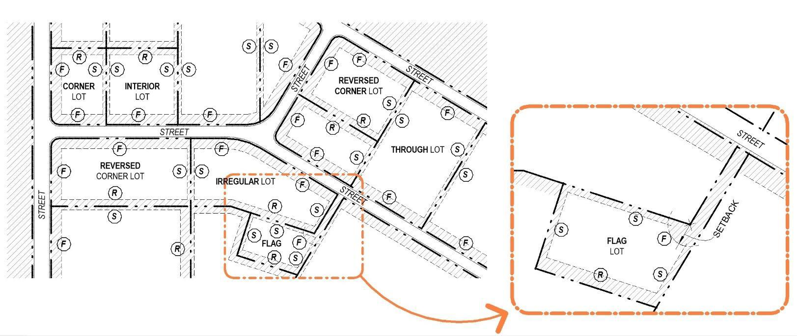

- Front, Year, and Rear Side Setbacks must comply with the requirements of the applicable Zoning District. The purpose of the above graphic is to illustrate which Lot Lines serve as Front, Rear, and Side Lot Lines for each type of Lot.

- For a Flag Lot, the Front Yard shall be determined by identifying the midpoint of the terminus of the panhandle (or the terminus of an easement outside of the panhandle) and drawing a semi-circle with a radius that is equal to the minimum setback for the applicable Zoning District.

Remainder Intentionally Left Blank

9.12 TYPES OF ENCROACHMENTS

Each Zoning District allows various types of encroachments. Refer to the Lot Area, Setback and Height Tables in each Zoning District to identify the types of permitted encroachments for said Zoning District.

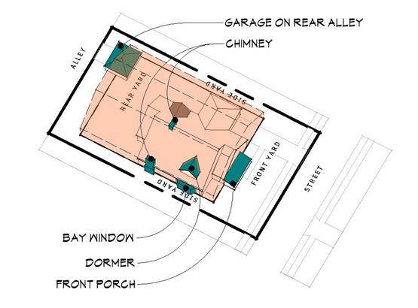

Remainder Intentionally Left Blank

9.13 RULES OF MEASUREMENT

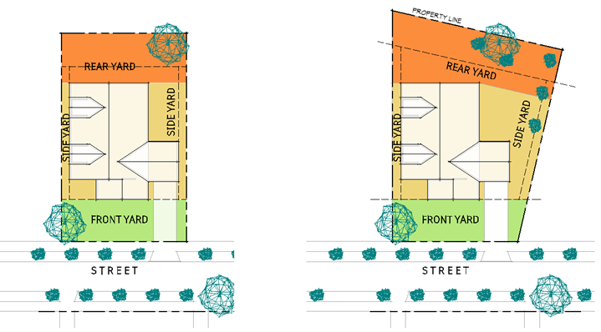
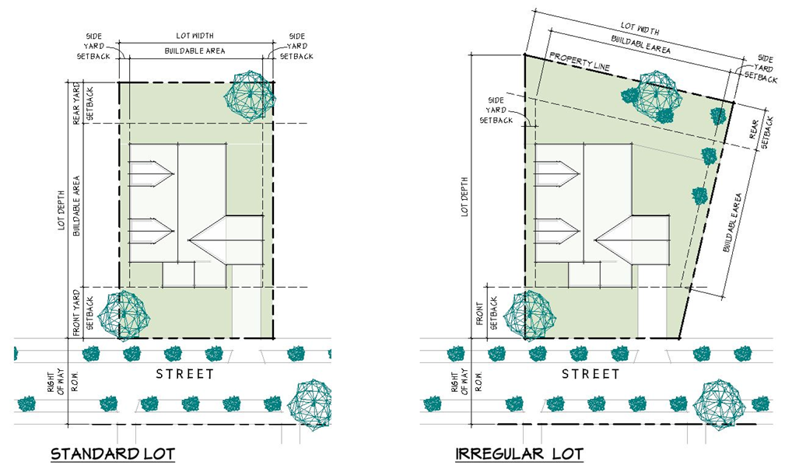
- Front Lot Line is the right-of-way line.

- Front Lot Line is the center line of the roadway.
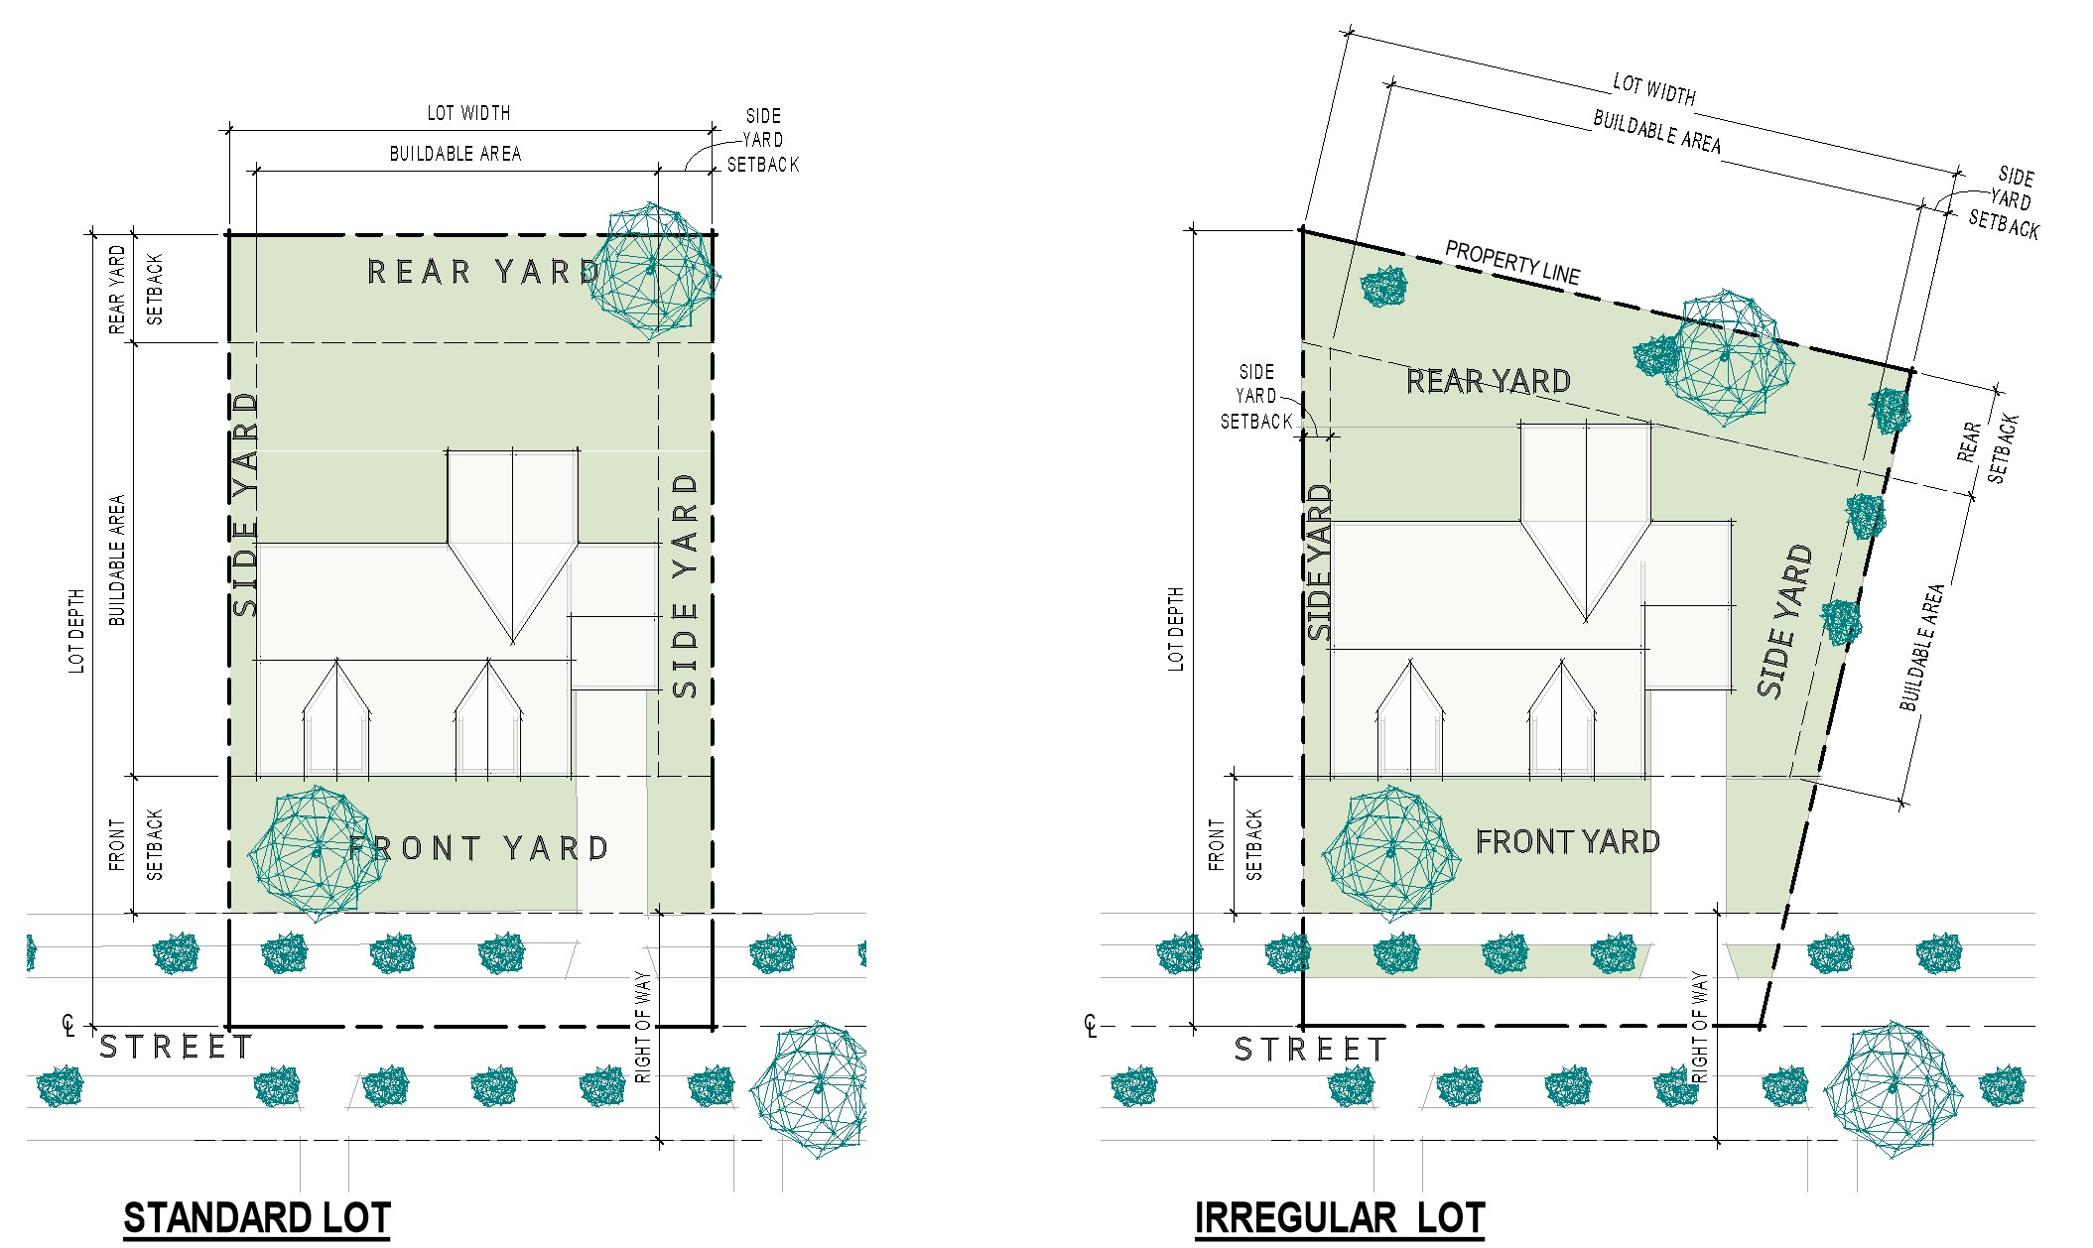
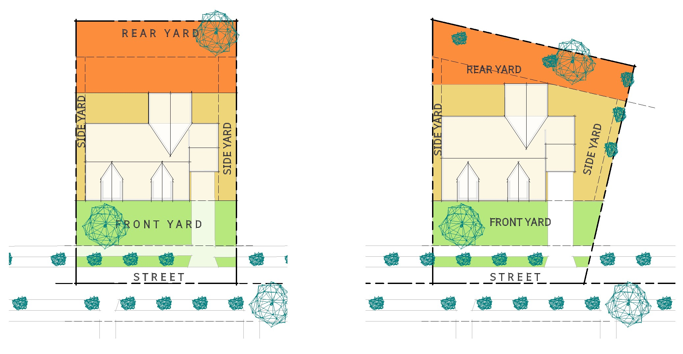

ARTICLE X
Use Tables

10.01 Identified Uses.
10.02 Use Table – Residential, Commercial, and Industrial.
10.03 Use Table – Gateway Corridor Overlay District.

10.01 IDENTIFIED USES.

- Each Zoning District includes a list of Permitted, Conditional, and Accessory Uses. Listed uses are to be defined by their customary name or identification, except as specifically defined or limited by this Code. If a use is not listed as a Permitted, Conditional, or Accessory Use in a District, it shall be considered prohibited in said District.

- Permitted Uses. A Use listed as permitted is allowed by a matter of right when designated as such in a District, provided said use complies with all applicable setback and development standards and is issued a Zoning Permit from the Zoning Inspector, or his/her designee. Such uses are designated with a “P” in each District.

- Conditional Uses. A Use listed as conditional may be allowed when designated as such in a District, provided it complies with the criteria in Section 5.02 and a Conditional Use Permit is issued by the Board of Zoning Appeals in accordance with Article V. Such uses are designated as “C” in each District.

- Accessory Use. A Use listed as accessory may be allowed when designated as such in a District, provided it is subordinate to the Permitted Use, complies with the requirements of Section 16.02, and is issued an Accessory Use Permit from the Zoning Inspector, or his/her designee. Such uses are designated with an “A” in each District.

- Development Standards. Each District has a set of development standards to which each use and structure must comply. These standards include, but are not limited to, height; Lot Width; lot size; and Front, Side, and Rear Setbacks. In addition to the development standards in each District, all uses must comply with any applicable “General Development Standards” listed in Article 16.

10.02 USE TABLE – RESIDENTIAL, COMMERCIAL, AND INDUSTRIAL

Use | A  Agriculture | PR  Preservation Residential | GB  General Business | SE  Sports and Entertainment | TI  Transitional Industrial | HI  Heavy  Industrial
Accessory Dwelling Unit (Subject to Section 16.01) | C | C
Accessory Structures (Subject to Section 16.02) | P | P | A | A | A | A
Adult Entertainment Uses (Article XVII) |  |  |  |  |  | C
Advanced Manufacturing |  |  |  |  |  | P
Agriculture | Subject to ORC 519.21 |  | Subject to ORC 519.21
Agritourism (Subject to Section 16.03) | C | C
Airports/Private Landing Strips | C
Animal Service Facilities |  |  | C |  | C | C
Assisted Living Facilities |  |  | P
Automobile Oriented Uses |  |  | C |  | P | P
Automobile Oil Change Facility (Subject to Section 16.05) |  |  | C |  | C | C
Automobile Repair |  |  | C |  | P | P
Bank, with Banking Window |  |  | C
Bank, without Banking Window |  |  | P
Bed and Breakfast Facilities (Subject to Section 16.06) | C | C
Beverage Sales, Alcoholic |  |  | P | P
Beverage Sales, Microbrewery |  |  | P
Bio-Technology Facilities |  |  |  |  |  | C
Body Art Establishments |  |  | P |  | P | P
Business, Retail Small (With Drive-Thru) |  |  | C |  | C
Business, Retail Small With Pick Up Window  (No Drive-Thru) |  |  | P
Business, Retail Small (No Drive-Thru or Pick Up Window) |  |  | P |  | P
Business, Retail Medium  (With Drive-Thru) |  |  | C |  | C
Business, Retail Medium (With Pick-Up Window, but No Drive-Thru) |  |  | P |  | P
Business, Retail Medium  (No Drive-Thru or Pick Up Window) |  |  | P
Business, Retail Large (May include Drive-Thrus and Pick Up Windows) |  |  | C
Campgrounds |  |  |  | C
Cannabis Stores | See, Section 16.08 |  | See, Section 16.08
Commercial Recreation Facilities, Small |  |  | P | P | P | P
Commercial Recreation Facilities, Large |  |  | P | P | P | P
Commercial Recreation Facilities, Outdoor (Subject to Section 16.27) |  |  | C | P | C | C
Community Gardens | P | P | P
Community Services (Subject to Section 16.11) | C | C | P | P | P | P
Contractor Office |  |  | P |  | P | P
Data Centers (Subject to Section 16.13) |  |  |  |  | C | C
Day Care Centers |  |  | P
Dwelling, One Unit | P | P
Early Childhood Learning Center |  |  | C |  | C | C
Elderly/Retirement Housing |  |  | C
Emergency and Protective Services Shelter (Subject to Section 16.23) |  |  | C |  | C | C
Equipment Repair, Small |  |  |  |  | P | P
Equipment Repair, Large |  |  |  |  | C | C
Farm Market | P | P | P | P | P | P
Flea Market | C
Flex Office – Laboratory/Research/ Development |  |  |  |  | P | P
Flex Office – Retail |  |  |  |  | P | P
Flex Office – Warehouse |  |  |  |  | P | P
Food Truck (Subject to Section 16.18) |  |  | P | P | P | P
Funeral Service Facilities |  |  | P
Governmental Services (Subject to Section 16.19) |  |  | P |  | P | P
Health Care Facilities |  |  | P
Home Day Care Family, Large (Subject to Section 16.22) | C | C
Home Day Care Family, Small | A | A
Home Occupations, Major (Subject to Section 16.20) | C | C |  |  |  | C
Home Occupations, Minor (Subject to Section 16.20) | A | A |  |  |  | A
Hotels, Boutiques |  |  | C |  | C
Junk Yards  (Subject to Licensing by County – ORC 4737) |  |  |  |  | P | P
Kennels, Agriculture | P
Kennels, Commercial (Subject to Section 16.09) |  |  | C
Landscape and Hardscape Business |  |  |  |  | P | P
Life Care Retirement Center | A | A | A
Logistics |  |  |  |  | P | P
Lumberyard (Subject to Section 16.25) |  |  |  |  | C | C
Machine Shop |  |  |  |  | P | P
Maker Space, Small (Subject to Section 16.25) | C |  | P |  | P | P
Maker Space, Large (Subject to Section 16.26) |  |  | C |  | P | P
Manufacturing |  |  |  |  | P | P
Manufactured Home, Permanently Sited | P | P
Mining and Quarrying (Subject to Article XVIII) | C
Motor Vehicle Racing Track |  |  |  | P
Motor Vehicle Dirt Racing Track |  |  |  | C
Nursing Home (Subject to Section 16.27) |  |  | C
Offices, Administration, Business Medical or Professional, Large |  |  | P
Offices, Administration, Business Medical or Professional, Small |  |  | P |  | A | A
Off-Street Parking and Garages as a Principal Use (Subject to Article XX)
Outdoor Service Facilities |  |  | C |  | C | C
Park, Neighborhood | C | C | P
Park, Community or Regional | C | C | P
Permanent Supportive Housing (Subject to Section 16.23) |  |  | C
Personal Services |  |  | P |  | A | A
Pick-Up Window |  |  | P
Places of Assembly, Large (Subject to Section 16.30) | C | C
Places of Assembly, Small (Subject to Section 16.30) | C | C
Portable Home Storage Units and Shipping Containers | See, Section 16.31 |  | See, Section 16.31
Plants for mixing and/or processing concrete and/or asphalt (Subject to Section 16.32) |  |  |  |  | C | C
Public Protection Facility | C |  | P |  | P | P
Research and Development |  |  |  |  | P | P
Residential Facility, Large (Subject to Section 16.23) | C | C | C
Residential Facility, Small | P | P | P
Residential Treatment Center (Subject to Section 16.23) |  |  | C
Restaurants (with Drive-Thru) |  |  | C
Restaurant  (with No Drive-Thru) |  |  | P
Restaurants (with No Drive-Thru or Pick Up Window) |  |  | P
School, Primary, Intermediate, or Middle (Subject to Section 16.34) | C | C | P
School, High or Technical (Subject to Section 16.34) | C | C | P
School, Post-Secondary (Subject to Section 16.34) | C | C | P
Self-Storage Facilities (Subject to Section 16.35) |  |  |  |  | C
Shooting Range-Indoor (Subject to Section 16.36) | C
Shooting Range-Outdoor (Subject to Section 16.36) | C
Short-Term Rentals (Subject to Section 16.37) | C | C
Solar Energy Systems | See, Section 16.38 |  | See, Section 16.38
Telecommunication Tower, Attached |  |  | P | P | P | P
Telecommunication Tower, Free Standing (Subject to Section 16.39) | C | C | P | P | P | P
Temporary Entertainment Use |  |  |  | C
Temporary Structures (Subject to Section 16.40) |  |  | C |  | C | C
Transitional Living Center (Subject to Section 16.23) |  |  | C
Truck and Travel Service Centers |  |  |  |  | C | C
Vehicle Charging Stations |  |  | A | A | A | A
Vehicular Sales, New and Used Cars (Subject to Section 16.41) |  |  | C |  | P
Vehicular Sales, Motorcycles (Subject to Section 16.41) |  |  | C |  | P
Vehicular Sales, Recreational Vehicles (Subject to Section 16.41) |  |  | C |  | P
Vehicular Sales, Equipment (Subject to Section 16.41) |  |  | C |  | P | P
Water and Wastewater Facilities (Subject to Section 16.43) |  |  | C |  | C | C
Wind Energy Conversion Systems (Subject to Section 16.44) |  |  | C | C | C | C

10.03 USE TABLE – GATEWAY CORRIDOR OVERLAY DISTRICT.

Use | Sub  Area A (HSC) | Sub  Area B  (SI) | Sub  Area C  (I) | Sub  Area D  (MU-L) | Sub  Area E  (MU-S)
Accessory Dwelling Unit (Subject to standards in Section 16.01) |  |  |  | P | P
Accessory Structures (Subject to standards in Section 16.02) | P | P | P | P | P
Advanced Manufacturing |  |  | P
Animal Service Facilities | P | P | P | P | P
Assisted Living Facilities | P |  |  | P | P
Automobile Oriented Uses (includes gas stations and quick lube facilities) | P | P | P
Automobile Repair | P | P
Bank, with Automobile Oriented Uses | P | P | P
Bank, without Automobile Oriented Uses | P | P | P | P | P
Bed and Breakfast Facilities |  |  |  | P | P
Bio-Technology |  |  | P
Beverage Sales, Alcoholic | P | P | P | P | P
Beverage Sales, Microbrewery | P | P | P | P | P
Business, Retail Medium | P | P | P | P | P
Business, Retail Small  (With Drive-Thrus) |  | P | P*
Business, Retail Small  (No Drive-Thrus) | P |  | P* | P | P
Business, Retail Small  (No Drive-Thrus or Pick-Up Windows) | P |  | P*
Business Wholesale |  | P | P
Commercial Recreation Facilities, Large |  | P |  | P | P
Commercial Recreation Facilities, Outdoor |  | P |  | P | P
Commercial Recreation Facilities, Small |  | P |  | P | P
Community Services | P |  |  | P | P
Contractor Office |  | P | P
Data Center (Subject to Section 16.13) |  |  | C
Day Care Centers | P | P | P | P | P
Dwelling, Multi-Family (four or more units per building) |  |  |  | P
Dwelling, Single Family |  |  |  |  | P
Dwelling, Row Houses, Townhomes (up to four units per building) |  |  |  | P | P
Dwelling, Studio, One or Two Bedroom Units |  |  |  | P
Dwelling, Duplex |  |  |  |  | P
Equipment Repair, Large |  |  | P
Equipment Repair, Small |  | P | P
Flex-Office – Retail/Office |  | P | P
Food Truck/Trailer, in accordance with Section 16.18 | P | P | P | P | P
Golf Courses and Country Clubs |  |  |  | P | P
Health Care Facilities |  | P | P | P | P
Home Day Care Family, Large |  |  |  | P | P
Home Day Care Family, Small |  |  |  | P | P
Home Occupations, Major |  |  |  | P | P
Home Occupations, Minor |  |  |  | P | P
Hotels/Motels | P | P | P | P | P
Individual Small Wind Turbine Systems in accordance with Section 16.44 | P | P | P | P
Landscape and Hardscape Businesses |  | P | P
Logistics, Being No More Than 49% of a Tracts Use |  |  | P
Lumberyard |  | P | P
Machine Shop |  | P | P
Maker Space, Large |  | P | P
Maker Space, Small |  |  | P | P | P
Manufacturing |  | P | P
Mixed Use Building |  |  | P | P | P
Nursery School |  | P | P
Nursing Home |  |  |  | P | P
Offices, Large administration, business medical or professional | P |  |  | P | P
Offices, Small administration, business medical or professional | P |  | P | P | P
Outdoor Service Facilities |  | P |  | P | P
Outdoor Seasonal Business |  | P |  | P | P
Park, Community or Regional |  | P |  | P | P
Park, Neighborhood |  | P |  | P | P
Permanently Sited Manufactured Homes (on permanent foundation) |  |  |  |  | P
Personal Services | P | P | P | P | P
Places of Assembly, Large |  |  | P | P | P
Places of Assembly, Small |  |  | P | P | P
Research and Development |  | P | P
Restaurants  (With Drive-Thru) | P | P | P
Restaurants  (No Drive-Thru) | P |  |  | P | P
Restaurants  (No Drive-Thru or Pick-Up Window) | P |  |  | P | P
Restaurants
School, High or Technical |  |  |  | P | P
School, Post Secondary |  |  |  | P | P
School, Primary, Intermediate, or Middle |  |  |  | P | P
Solar Energy Systems, Roof Mounted | P | P | P | P | P
Swimming Pool, Community |  |  |  | P | P
Temporary Structure, Construction Trailer Office, subject to Section 16.40 | P | P | P | P | P
Truck Service Centers |  |  | P**
Water, Wastewater, Transportation and Other Governmental Services | P | P | P | P
* Small Retail Business is permitted only when located within Subarea C Industrial-Highway Business designated area.

** Truck Services Centers are permitted only within the Subarea C Industrial-Highway Business designated area and are limited to one (1) on either side of State Route 37.

ARTICLE XI
Residential Districts

11.01 Agriculture (AG).
11.02 Preservation Residential (PR).

11.01 AGRICULTURE (A).

- Purpose.

- Promote, preserve, and continue to support agricultural land within the Township.
- Discourage the development of inappropriate uses in rural areas.
- Promote the efficiency of public expenditures for infrastructure and services.
- To balance growth and preservation by focusing on conserving the rural aesthetic and natural resources of the Township.
- Support sustainable infrastructure in accordance with the Comprehensive Plan.

- Target Areas.

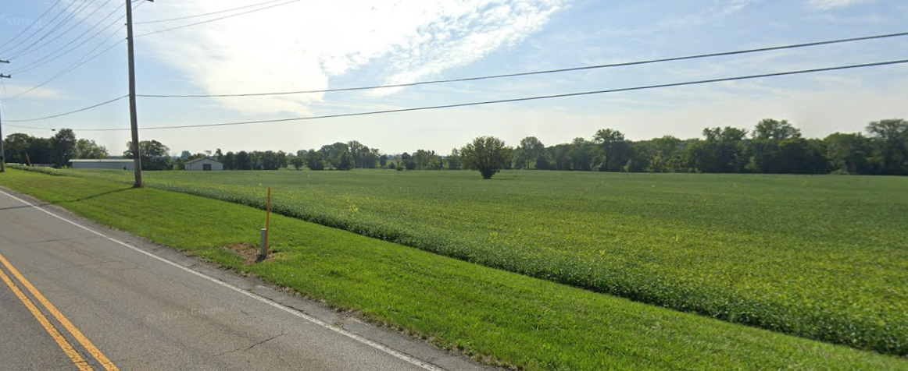

- Permitted, Conditional, and Accessory Uses.

See, Section 10.02 – Use Table – Residential, Commercial, and Industrial.

- Lot Area, Setback, Height, and Lot Coverage Requirements.

Development Standards | Agriculture
Minimum Lot Size (Acres) | 10
Maximum Density (Utilize Net Acres) | 1 dwelling unit per 10 acres
Minimum Frontage (Feet) | 300
Minimum Front Setback (Feet) | 50
Maximum Front Setback (Feet) | N/A
Minimum Side Setback (Feet) | 25
Minimum Rear Setback (Feet) | 50
Maximum Height (Feet) | 35
Maximum Lot Coverage (Percent) | N/A
Projection into required setback
Cornices, canopies, eaves (roof overhang), fireplaces-chimneys, bay windows, porch, stoop, or other similar architectural features may project into a required setback up to two (2) feet.
Exemptions from required Side and Rear Setbacks
Swimming pools; tennis courts; clotheslines; barbeque pits; playground equipment; portable or permanent dog run, house, or kennel; and similar structures customary and ancillary to the primary residential use of the property may be placed in a required minimum Side or Rear Setback, but in no case shall such uses be closer than ten (10) feet from a Side or Rear Lot Line.

- Example Lot Layout and Rendering.

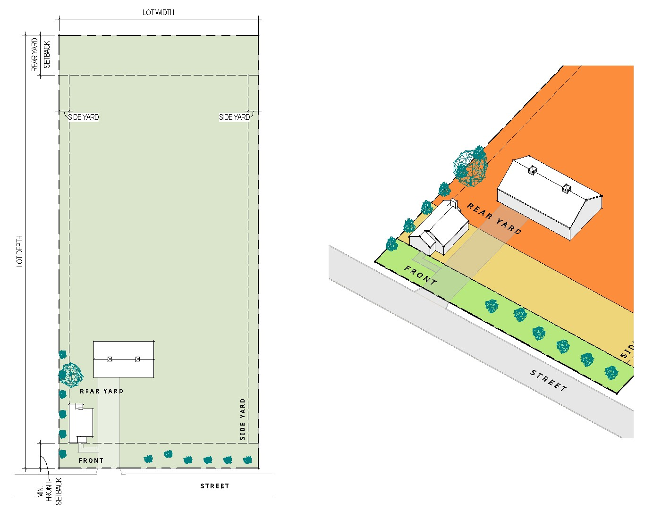

- General Development Regulations.

 | Applicable | Section Reference | Notes
Accessory Structures | Y | Section  16.02 | Detached Accessory Structures may encroach a side or rear setback but shall be no closer than fifteen (15) feet from the side or rear lot line. Accessory Structures shall also comply with all other requirements in Section 11.01(d).
Fences | Y | Section  16.17 | Fences and walls may be placed in a required minimum setback provided they comply with Section 11.01(d)
Floodplain | Y | Flood Damage Prevention Regulations for Licking County, Ohio | In the scenario that the Lot is located within the Floodplain as designated by the County, the Owner should consult with and follow the procedures listed within the Flood Damage Prevention Regulations for Licking County, Ohio.
Landscaping/Buffering | Y | Article  XIX | Plant material and berms may be placed in any required minimum setback provided they do not constitute a nuisance.
Parking | Y | Article  XX | Parking must be provided in accordance with Article XX.
Signs | Y | Article  XXI | Sign, provided they comply with Section 11.01(d), may be located within a Front Setback.

11.02 PRESERVATION RESIDENTIAL (PR)

- Purpose.

- To provide a residential district that accommodates currently existing residential areas within the Township’s rural subdivisions.
- To allow for minimal non-residential uses, such as schools and parks, that are compatible with and maintain the overall residential character of the area and provide for pedestrian connections between such uses.

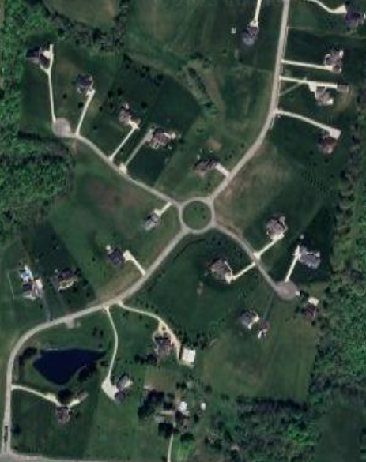
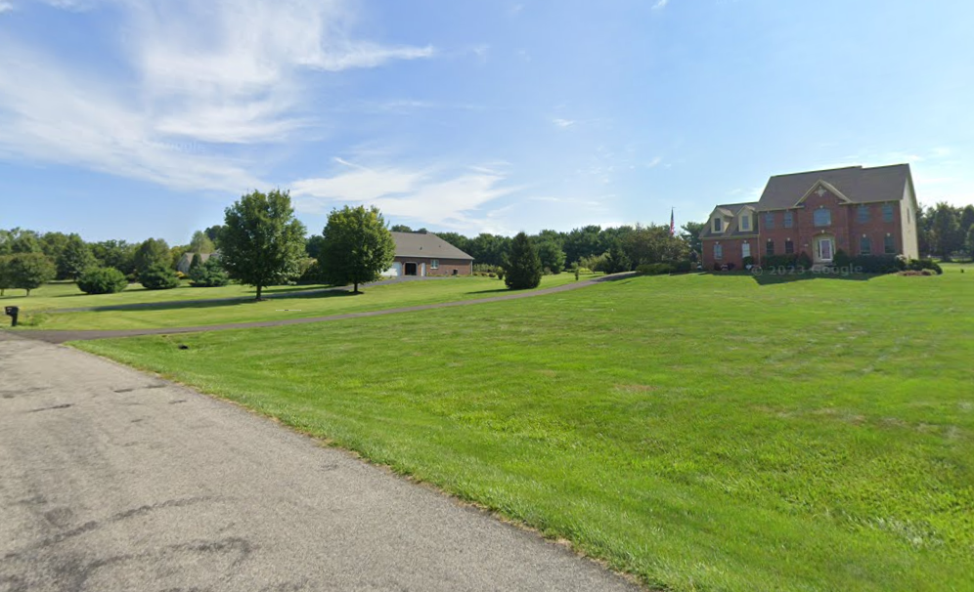
- Target Areas.
- Permitted, Conditional, and Accessory Uses.

See, Section 10.02 – Use Table – Residential, Commercial, and Industrial.

- Lot Area, Setback, Height, and Lot Coverage Requirements.

Development Standards | Preservation Residential
Minimum Lot Size (Acres) | 3
Maximum Density (Utilize Net Acres) | 1 dwelling unit per 3 acres
Minimum Frontage (Feet) | 225
Minimum Front Setback (Feet) | 50 (For All Streets)
Maximum Front Setback (Feet) | N/A
Minimum Side Setback (Feet) | 20
Minimum Rear Setback (Feet) | 50
Maximum Height (Feet) | 35
Maximum Lot Coverage (Percent) | 35
Projection into required setback
Cornices, canopies, eaves (roof overhang), fireplaces-chimneys, bay windows, porch, stoop, or other similar architectural features may project into a required setback up to two (2) feet.
Exemptions from required Side and Rear Setbacks
Swimming pools; tennis courts; clotheslines; barbeque pits; playground equipment; portable or permanent dog run, house, or kennel; and similar structures customary and ancillary to the primary residential use of the property may be placed in a required minimum side or rear setback, but in no case shall such uses be closer than ten (10) feet from a side or rear lot line.

- Example Lot Layout and Rendering.
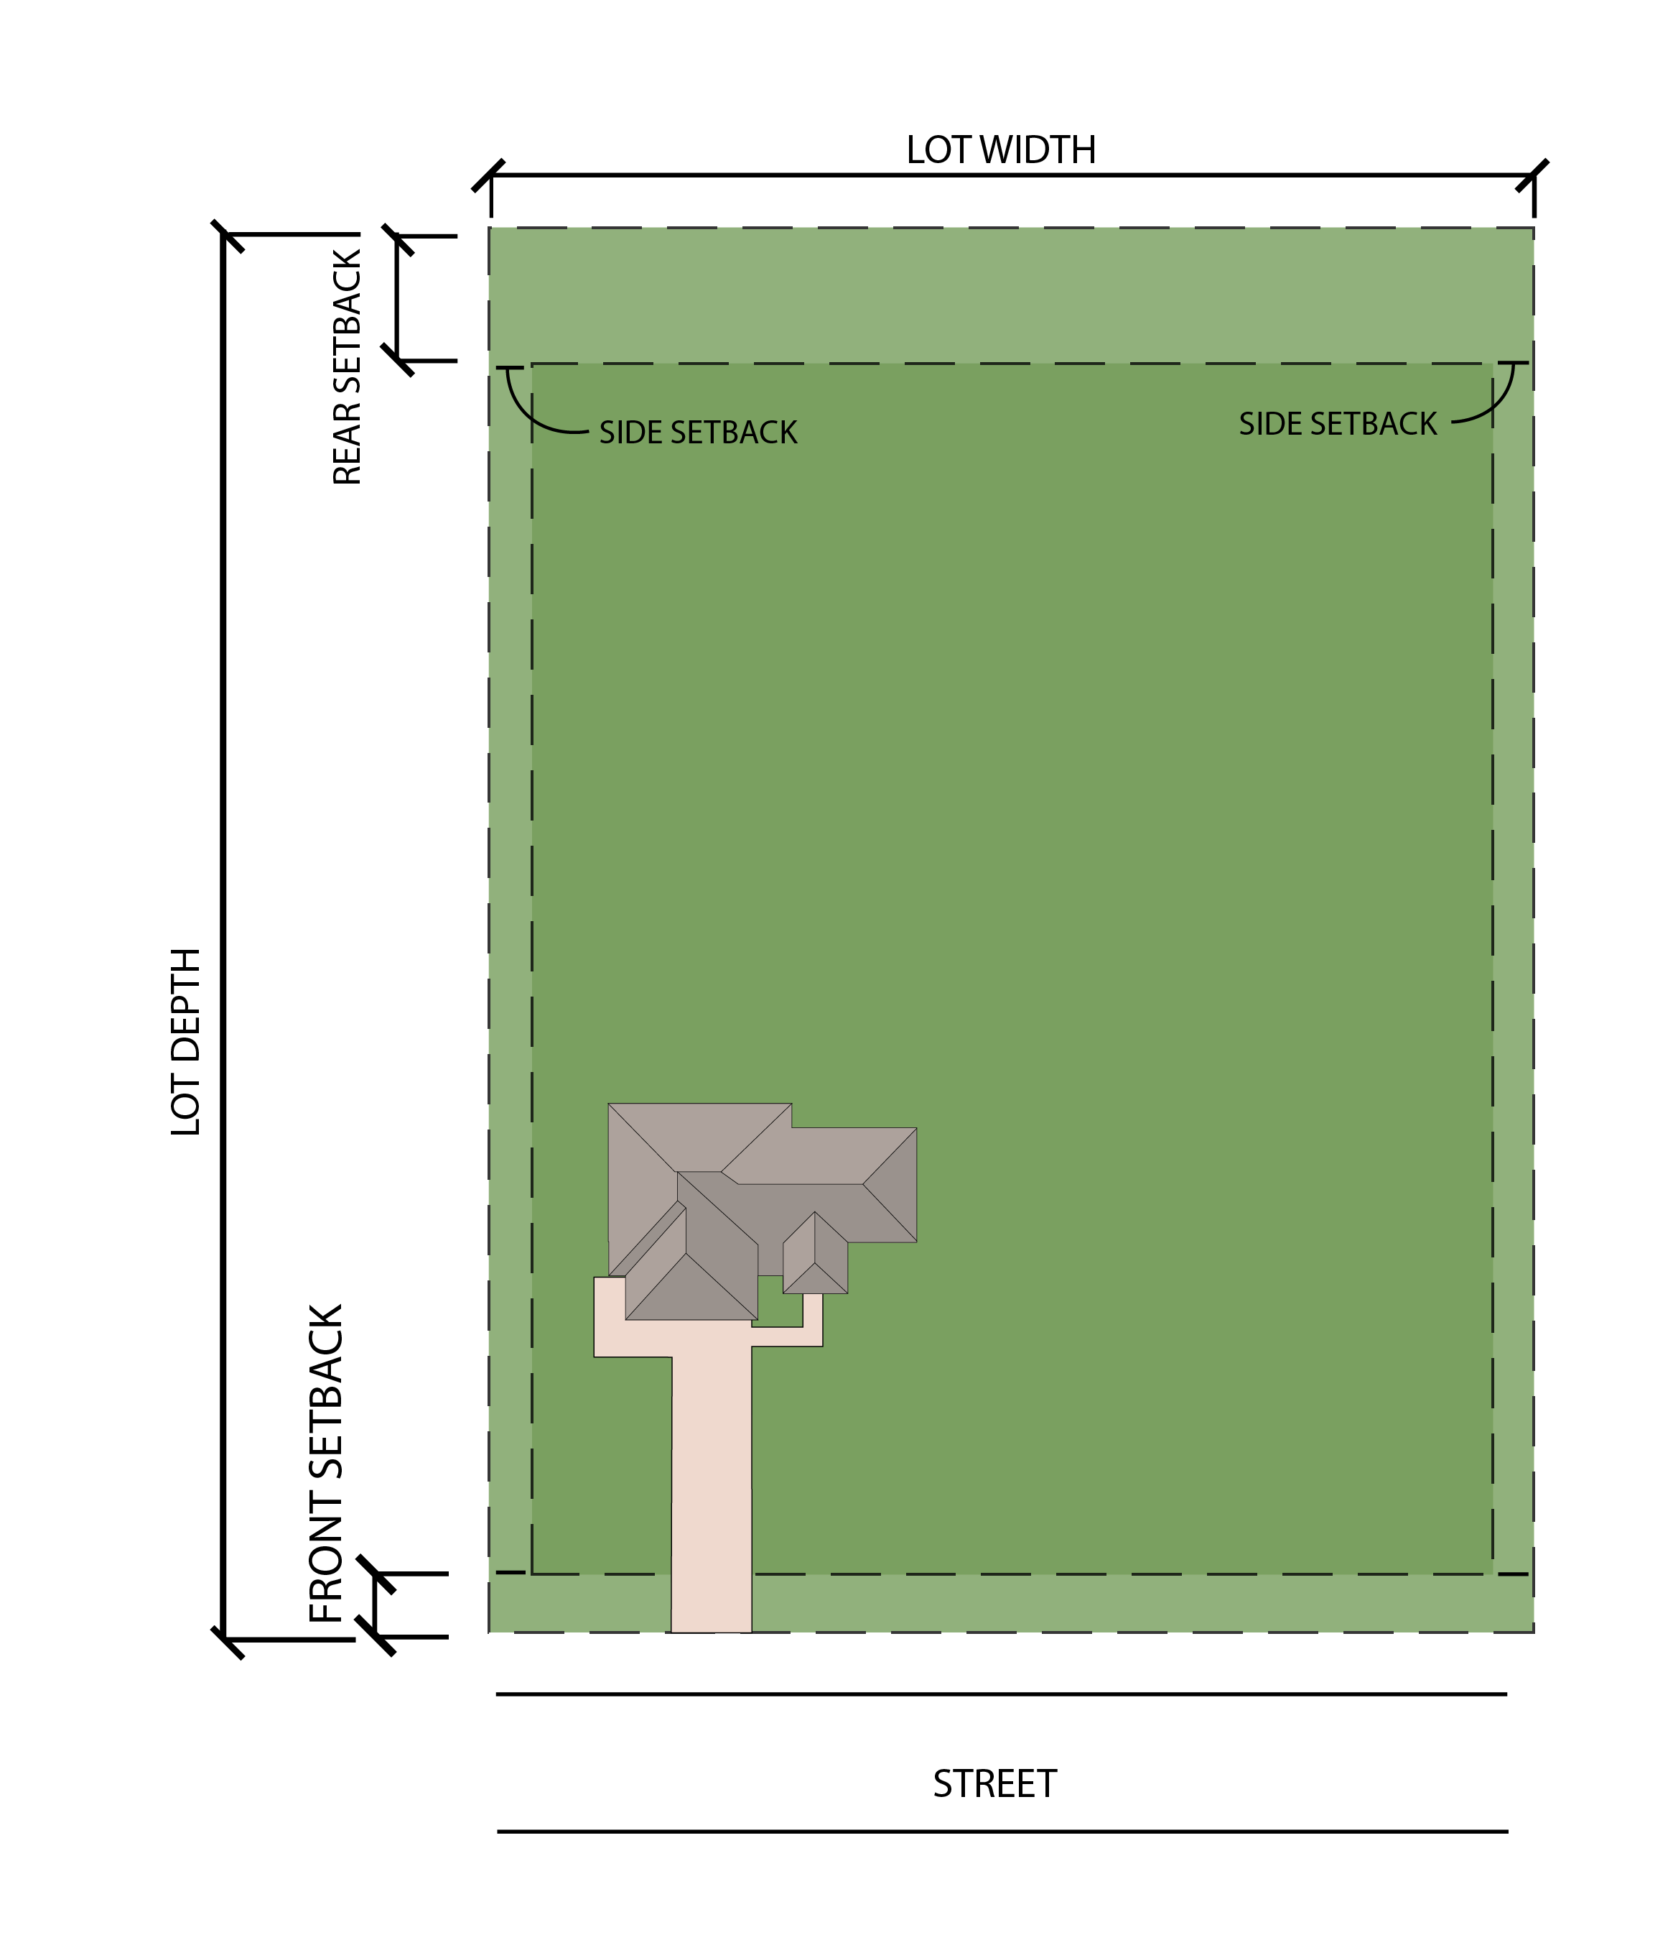

- General Development Regulations.

 | Applicable | Section Reference | Notes
Accessory Structures | Y | Section  16.02 | Detached Accessory Structures may encroach a side or rear setback but shall be no closer than fifteen (15) feet from the side or rear lot line. Accessory Structures shall also comply with all other requirements in Section 11.02(d).
Fences | Y | Section  16.17 | Fences and walls may be placed in a required minimum setback provided they comply with Section 11.02(d)
Floodplain | Y | Flood Damage Prevention Regulations for Licking County, Ohio | In the scenario that the Lot is located within the Floodplain as designated by the County, the Owner should consult with and follow the procedures listed within the Flood Damage Prevention Regulations for Licking County, Ohio.
Landscaping/Buffering | Y | Article  XIX | Plant material and berms may be placed in any required minimum setback provided they do not constitute a nuisance.
Parking | Y | Article  XX | Parking must be provided in accordance with Article XX.
Signs | Y | Article XXI | Sign, provided they comply with Section 11.02(d), may be located within a Front Setback.

ARTICLE XII
Commercial and Industrial Districts

12.01 General Business (GB).
12.02 Sports Entertainment (SE).
12.02 Transitional Industrial (TI).
12.03 Heavy Industrial (HI).

12.01 GENERAL BUSINESS (GB).

- Purpose.

- To accommodate uses that generate increased vehicle traffic.
- To create design standards that include increased setbacks and building height to allow for these more intense business uses within high growth corridors located along the eastern edge of SR 79 as found in Appendix B of the Comprehensive Plan.

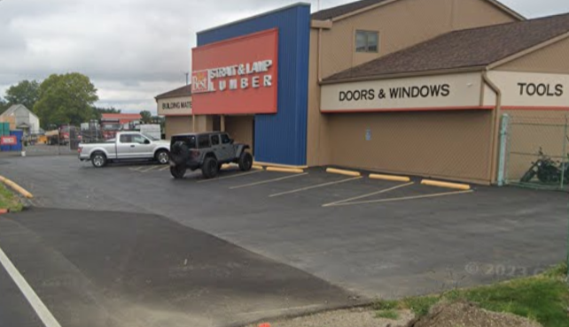
- Target Areas.

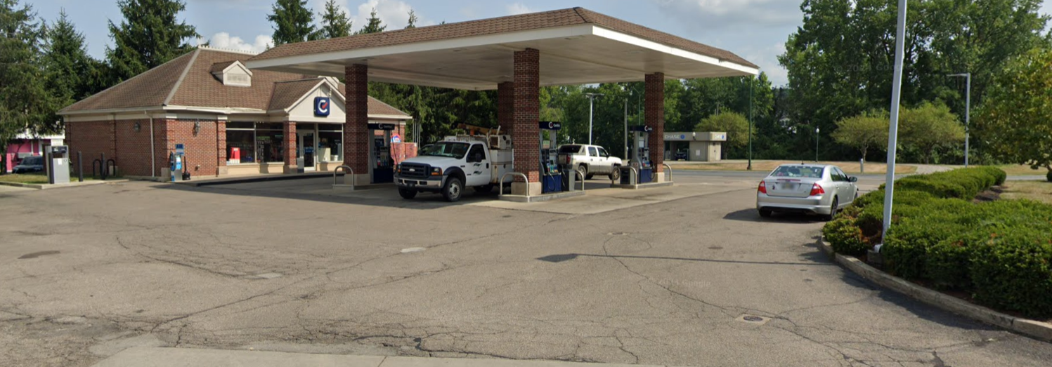

- Permitted, Conditional, and Accessory Uses.

See, Section 10.02 – Use Table – Residential, Commercial, and Industrial

- Lot Area, Setback, Height, and Lot Coverage Requirements.

Development Standards | General Business
Minimum Lot Size (Acre) | 1
Minimum Frontage (Feet) | 200
Minimum Front Setback (Feet) | 50 (Arterial and Collector Roadways)  25 (All Other Roadways)
Minimum Side Setback (Feet) | 40
Minimum Rear Setback (Feet) | 50
Maximum Height (Feet) | 35, except however, mechanical equipment and/or ventilation systems may extend up to ten feet above the height of the building. Said mechanical equipment/ventilation systems must be screened from view by parapet walls, mansard roofs, or other screening material approved by the Zoning Inspector, or their designee, provided said material has 100 percent (100%) opacity year-round.
Maximum Lot Coverage (Percent) | 75

- Example Lot Layout and Rendering.

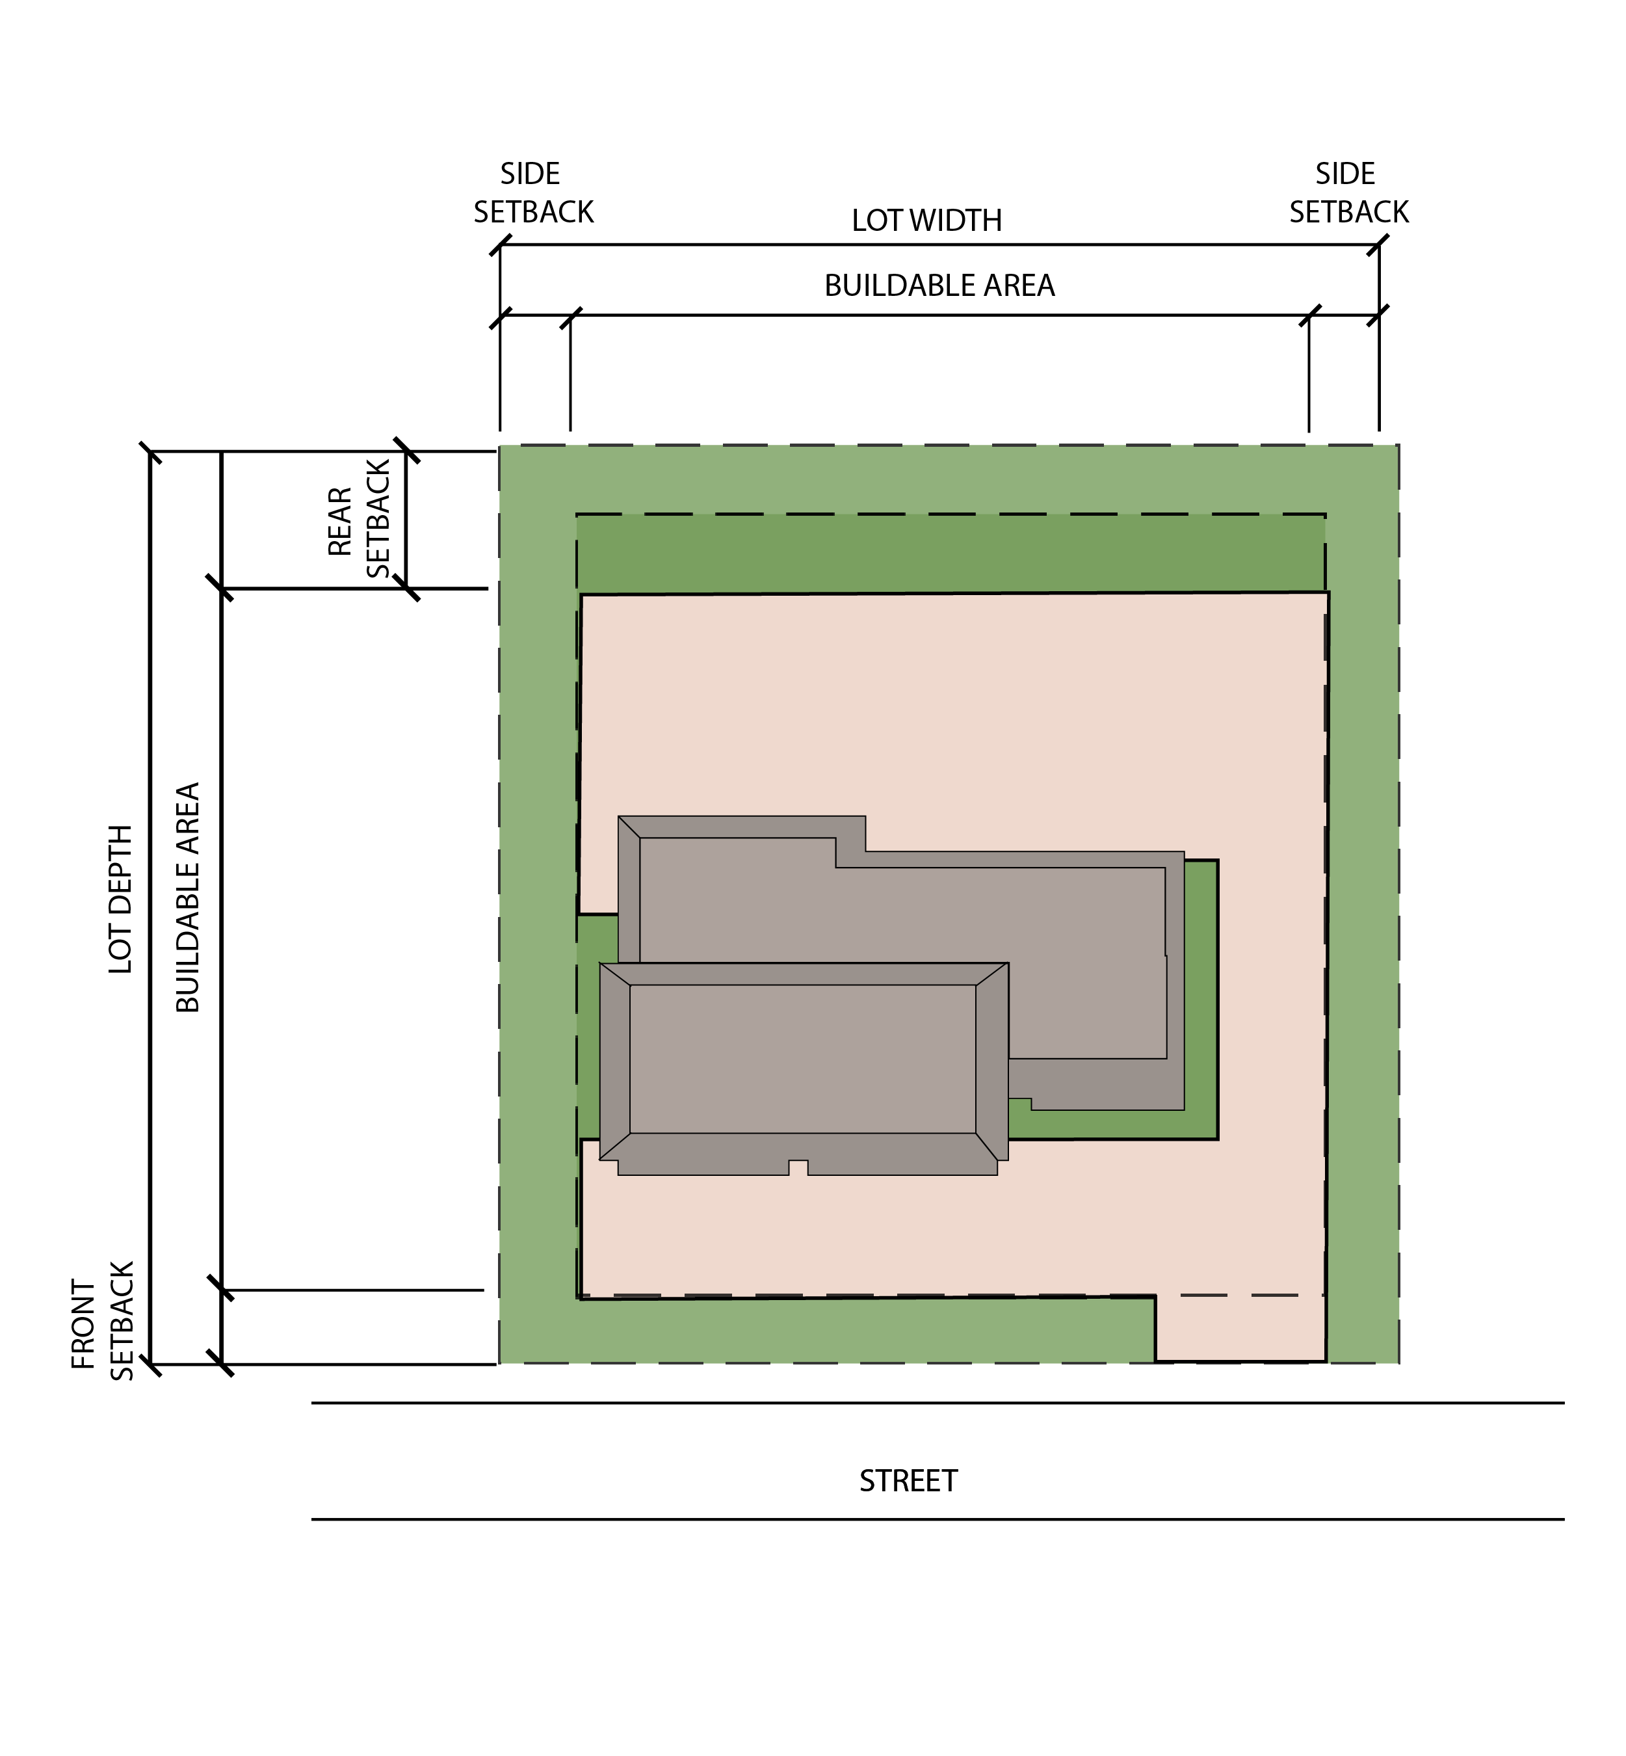

- General Development Regulations.

 | Applicable | Section Reference | Notes
Accessory Structures | Y | Section  16.02 | Detached Accessory Structures may encroach a side or rear setback but shall be no closer than fifteen (15) feet from the side or rear lot line. Accessory Structures shall also comply with all other requirements in Section 12.01(d).
Fences | Y | Section  16.17 | Fences and walls may be placed in a required minimum setback provided they comply with Section 12.01(d).
Floodplain | Y | Flood Damage Prevention Regulations for Licking County, Ohio | In the scenario that the Lot is located within the Floodplain as designated by the County, the Owner should consult with and follow the procedures listed within the Flood Damage Prevention Regulations for Licking County, Ohio.
Landscaping/Buffering | Y | Article XIX | Plant material and berms may be placed in any required minimum setback provided they do not constitute a Nuisance
Parking | Y | Article XX | Parking may be located in the front of the Building; however, loading areas must be located on either the side or rear of the Building.
Signs | Y | Article XXI | Sign, provided they comply with Section 12.01(d), may be located within a front setback.

12.02 SPORTS ENTERTAINMENT (SE).
- Purpose.

- To designate the area where large outdoor recreation and sporting facilities are located.
- To accommodate large crowds and traffic increases from the sporting or entertainment use.

- Target Areas.

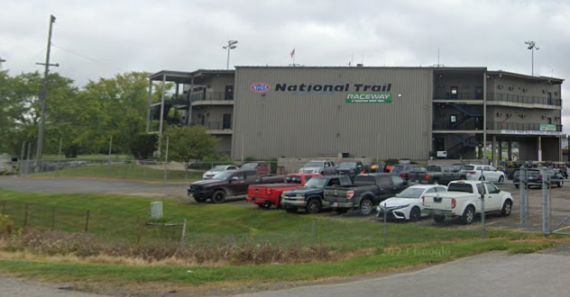

- Permitted, Conditional, and Accessory Uses.

See, Section 10.02 – Use Table – Residential, Commercial, and Industrial

- Lot Area, Setback, Height, and Lot Coverage Requirements.

Development Standards | Sports Entertainment
Minimum Lot Size, Outside Uses (Acre) | 200
Minimum Frontage, Outside Uses (Feet) | 2,000
Minimum Front Setback, Outside Uses (Feet) | 100
Minimum Side Setback, Outside Uses (Feet) | 200
Minimum Rear Setback, Outside Uses (Feet) | 200
Minimum Lot Size, Inside Uses (Acre) | 50
Minimum Frontage, Inside Uses (Feet) | 500
Minimum Front Setback, Inside Uses (Feet) | 75
Minimum Side Setback, Inside Uses (Feet) | 75
Minimum Rear Setback, Inside Uses (Feet) | 75
Maximum Height (Feet) | 35
Maximum Lot Coverage (Percent) | N/A

- General Development Regulations.

 | Applicable | Section Reference | Notes
Accessory Structures | Y | Section  16.02 | Detached Accessory Structures may encroach a side or rear setback but shall be no closer than fifteen (15) feet from the side or rear lot line. Accessory Structures shall also comply with all other requirements in Section 12.02(d).
Fences | Y | Section  16.17 | Fences and walls may be placed in a required minimum setback provided they comply with Section 12.02(d).
Floodplain Procedures | Y | Flood Damage Prevention Regulations for Licking County, Ohio | In the scenario that the Lot is located within the Floodplain as designated by the County, the Owner should consult with and follow the procedures listed within the Flood Damage Prevention Regulations for Licking County, Ohio.
Landscaping/Buffering | Y | Article XIX | Plant material and berms may be placed in any required minimum setback provided they do not constitute a nuisance.
Parking | Y | Article XX | Parking must be provided in accordance with Article XX.
Signs | Y | Article XXI | Sign, provided they comply with Section 12.02(d), may be located within a front setback.

12.03 TRANSITIONAL INDUSTRIAL (TI)
- Purpose.

- To serve commercial and industrial business that create a transition from areas dedicated to rural uses to more intense industrial uses.
- To increase aesthetically pleasing borders between residential and industrial uses.

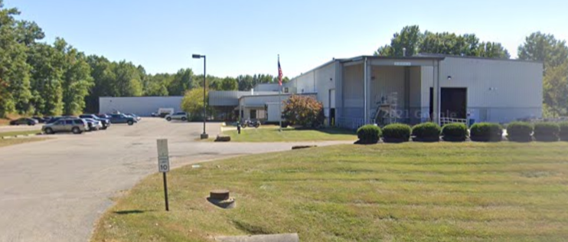
- Target Areas.

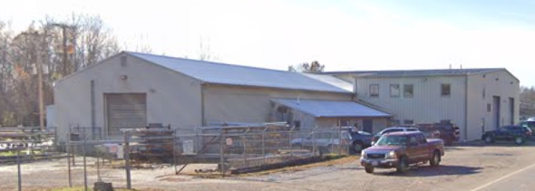

- Permitted, Conditional, and Accessory Uses.

See, Section 10.02 – Use Table – Residential, Commercial, and Industrial

- Lot Area, Setback, Height, and Lot Coverage Requirements.

Development Standards | Transitional Industrial
Minimum Lot Size (Acres) | 2
Minimum Frontage (Feet) | 200
Minimum Front Setback (Feet) | 50
Minimum Side Setback (Feet) | 40 – when a side or rear lot line abuts an existing residential use or District that permits one-unit dwellings, then a buffer shall be provided in accordance with Section 19.08.
Minimum Rear Setback (Feet) | 50, except however, when a side or rear lot line abuts an existing residential use or District that permits one-unit dwellings, then a buffer shall be provided in accordance with Section 19.08.
Maximum Height (Feet) | 35, except however, mechanical equipment and/or ventilation systems may extend up to ten (10) feet above the height of the building. Said mechanical equipment/ ventilation systems must be screened from view by parapet walls, mansard roofs, or other screening material approved by the Zoning Inspector, or their designee, provided said material has 100 percent opacity year-round.  65 maximum height for towers, spires, and other similar structures that are secondary to the primary structure.
Maximum Lot Coverage (Percent) | 75

- Example Lot Layout and Rendering.
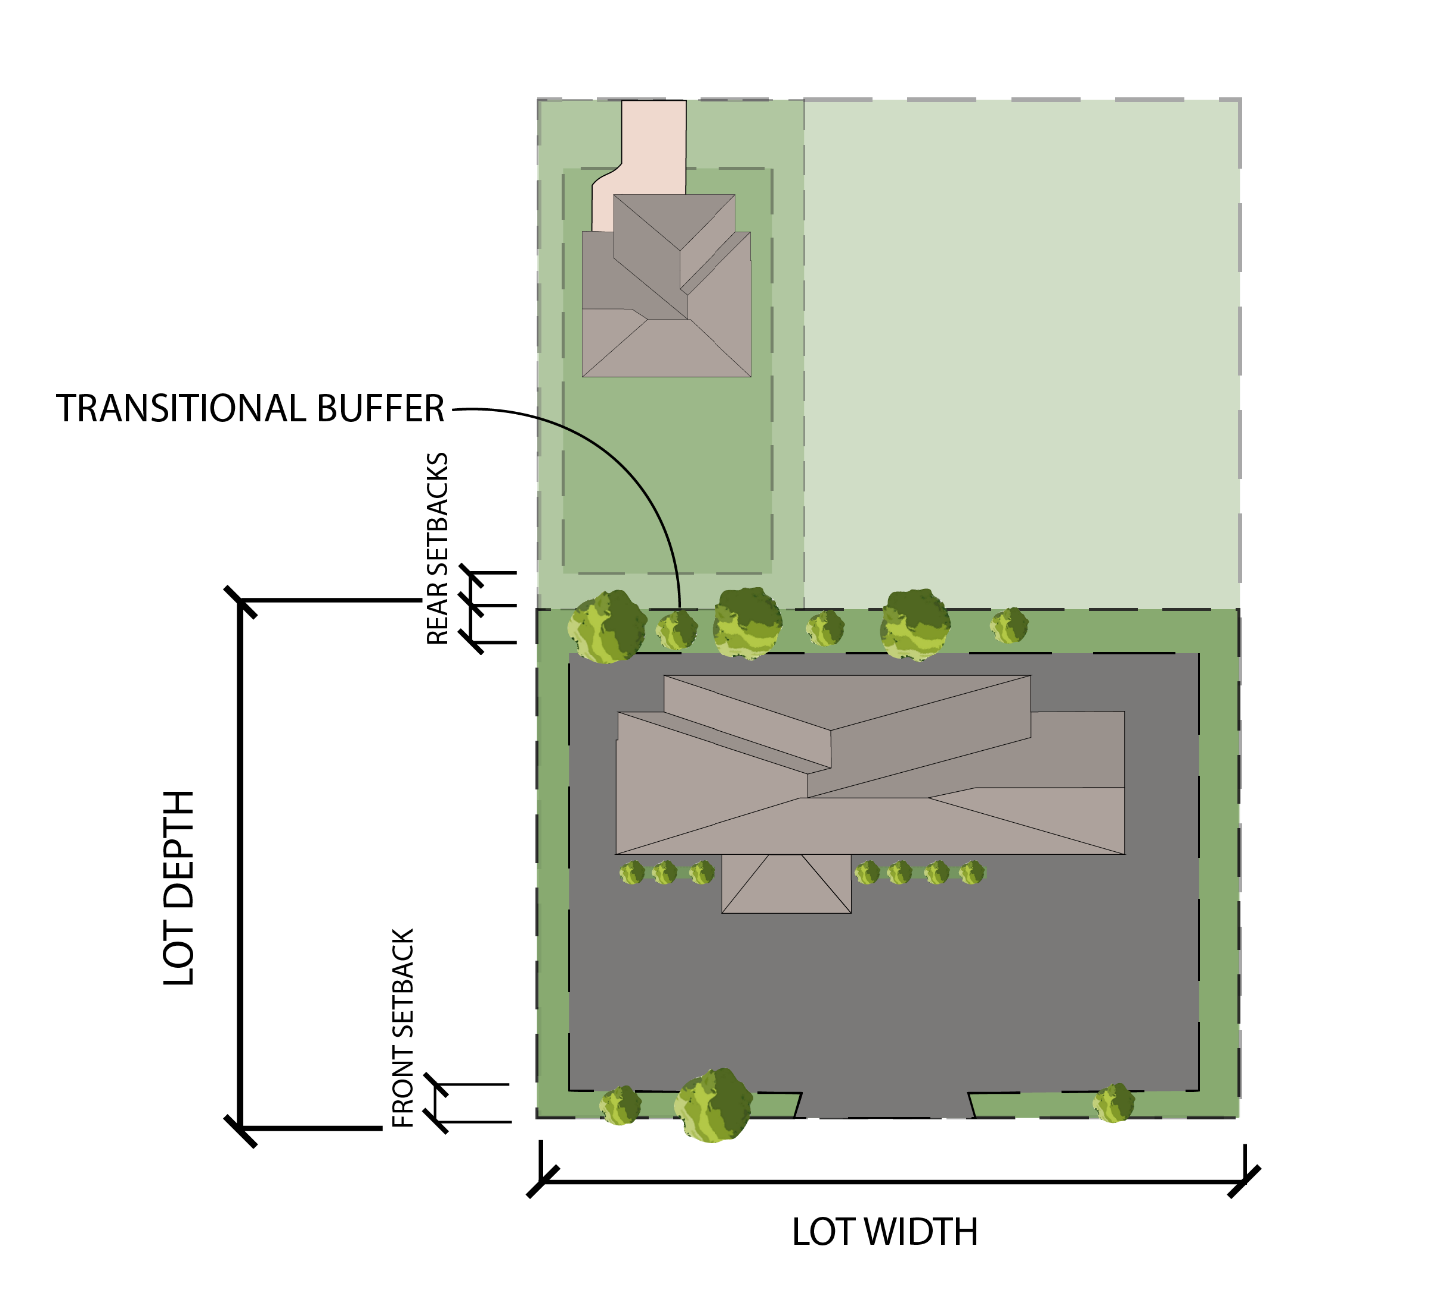

- General Development Regulations.

 | Applicable | Section Reference | Notes
Accessory Structures | Y | Section  16.02 | Detached Accessory Structures may encroach a side or rear setback but shall be no closer than fifteen (15) feet from the side or rear lot line. Accessory Structures shall also comply with all other requirements in Section 12.03(d).
Fences | Y | Section  16.17 | Fences and walls may be placed in a required minimum setback provided they comply with Section 12.03(d).
Floodplain | Y | Flood Damage Prevention Regulations for Licking County, Ohio | In the scenario that the Lot is located within the Floodplain as designated by the County, the Owner should consult with and follow the procedures listed within the Flood Damage Prevention Regulations for Licking County, Ohio.
Landscaping/Buffering | Y | Article  XIX | Plant material and berms may be placed in any required minimum setback provided they do not constitute a nuisance.
Parking | Y | Article XX | Limited – Parking is permitted in front of a principal building, but it is encouraged to be placed to the side or rear of the principal building. Parking may encroach a front, side or rear setback provided the parking is no closer than five (5) feet from said lot line. However, when adjacent to an area zoned for Residential uses, it must follow the procedures found in Section 19.08.
Signs | Y | Article XXI | Sign, provided they comply with Section 12.03(d), may be located within a front setback.

12.04 HEAVY INDUSTRIAL (HI).
- Purpose.

- To broaden the economic development opportunities of the Township by creating development standards that will promote innovation and employment opportunities where water and sewer connections are readily available.
- To locate industrial areas east of SR 79.

- Target Areas.
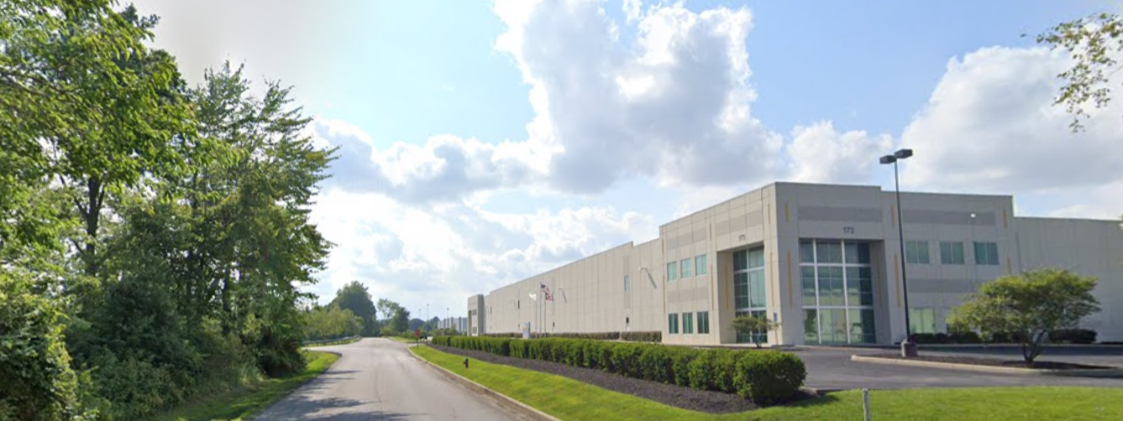
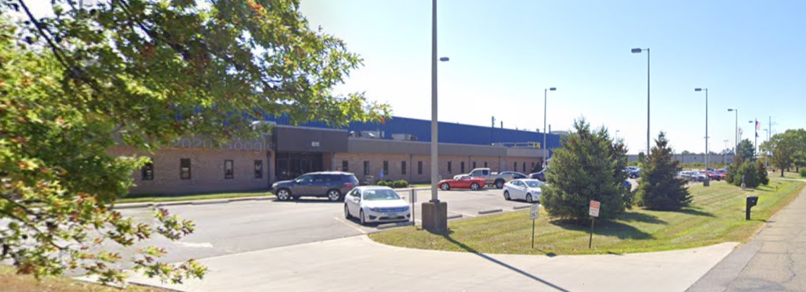

- Permitted, Conditional, and Accessory Uses.

See, Section 10.02 – Use Table – Residential, Commercial, and Industrial.

- Lot Area, Setback, Height, and Lot Coverage Requirements.

Development Standards | Industrial
Minimum Lot Size (Acres) | 2
Minimum Frontage (Feet) | 200
Minimum Front Setback (Feet) | 50
Minimum Side Setback (Feet) | 50
Minimum Rear Setback (Feet) | 50
Maximum Height (Feet) | 60, except however, mechanical equipment and/or ventilation systems may extend up to ten (10) feet above the height of the building. Said mechanical equipment/ ventilation systems must be screened from view by parapet walls, mansard roofs, or other screening material approved by the Zoning Inspector, or their designee, provided said material has 100 percent opacity year-round  80 maximum height for towers, spires, and other similar structures that are secondary to the primary structure.
Maximum Lot Coverage (Percent) | 75

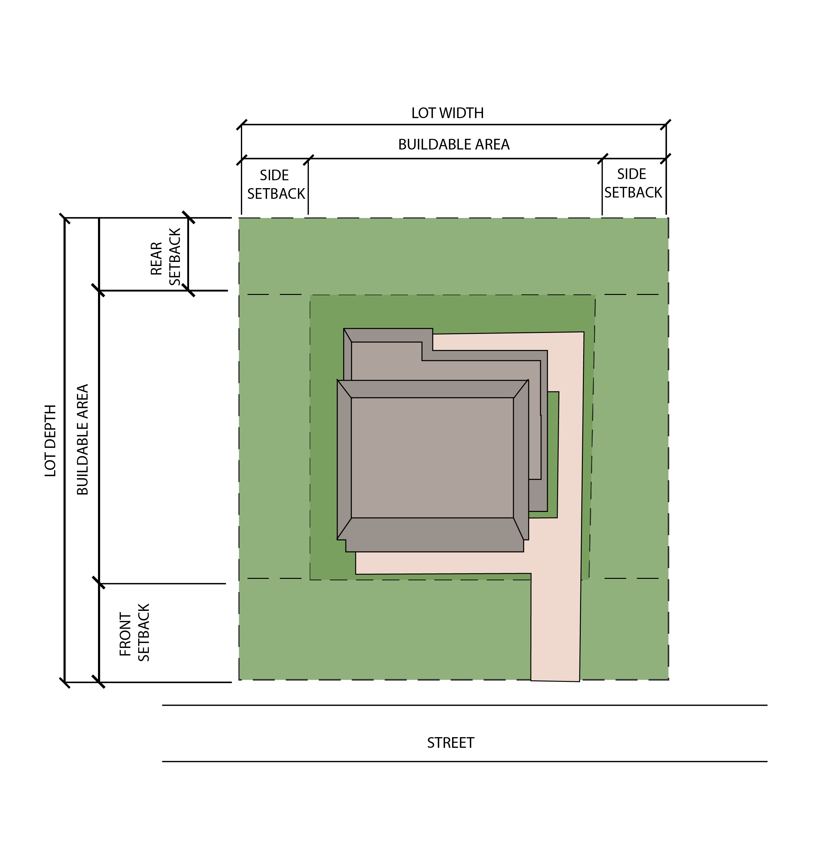
- Example Lot Layout and Rendering.

- General Development Regulations.

 | Applicable | Section Reference | Notes
Accessory Structures | Y | Section  16.02 | Detached Accessory Structures may encroach a side or rear setback but shall be no closer than fifteen (15) feet from the side or rear lot line. Accessory Structures shall also comply with all other requirements in Section 12.04(d).
Fences | Y | Section  16.17 | Fences and walls may be placed in a required minimum setback provided they comply with Section 12.04(d).
Floodplain | Y | Flood Damage Prevention Regulations for Licking County, Ohio | In the scenario that the Lot is located within the Floodplain as designated by the County, the Owner should consult with and follow the procedures listed within the Flood Damage Prevention Regulations for Licking County, Ohio.
Landscaping/Buffering | Y | Article XIX | Plant material and berms may be placed in any required minimum setback provided they do not constitute a nuisance.
Parking | Y | Article XX | Limited – Parking is permitted in front of a principal building, but it is encouraged to be placed to the side or rear of the principal building. Parking may encroach a front, side or rear setback provided the parking is no closer than five (5) feet from said lot line. However, when adjacent to an area zoned for Residential uses, it must follow the procedures found in Section 19.08.
Signs | Y | Article XXI | Sign, provided they comply with Section 12.04(d), may be located within a front setback.

ARTICLE XIII
Airport Hazard Zone Overlay District (AHZ)

13.01 Purpose
13.02 Applicable Lands

13.03 Permit Requirements
13.04 Enforcement

13.01 PURPOSE

It is the purpose of this Article to promote the public health, safety, and general welfare by minimizing the hazards to life and property. The AHZ District is an area in which, due to the approach and takeoff of aircraft from the Newark-Heath Airport, the height of structures and objects may pose a hazard to both those utilizing the airport and to the property owner. Therefore, this article prioritizes the minimization of these hazards by ensuring structures and objects do not pose a hazard to both those utilizing the Newark-Heath Airport and the surrounding property owners.

13.02 APPLICABLE LANDS

The AHZ District shall apply to all lands within the identified Airport Hazard Zones as prescribed by ORC 4563 and the Newark-Heath Airport Airspace Zoning Resolution, which are depicted on the Official Zoning Map.

13.03 PERMIT REQUIREMENTS

No structure or object located in an identified AHZ District, as identified on the Official Zoning Map shall be erected until a permit or letter stating "No Permit Required" is received from the Licking County Planning Commission.

13.04 ENFORCEMENT

It shall be the duty of the Zoning Inspector to ensure that all structures and objects comply with the height requirements of the Newark-Heath Airport Airspace Zoning Resolution. This shall be determined by the applicant obtaining a Newark-Heath Airport Airspace Zoning Permit or a letter stating that no permit is required from the Licking County Planning Commission and submitting a copy to the Zoning Inspector prior to any Zoning Permit being issued. Should a permit not be issued by the Licking County Planning Commission, the Zoning Inspector shall not approve any zoning permit for any proposed structure or object of natural growth, as said structure shall be considered in violation of this section.

ARTICLE XIV
Gateway Corridor Overlay District (GCO)

14.01 Purpose.
14.02 Overlay Established.
14.03 Subareas.
14.04 Procedure.
14.05 Lot Area, Setback, Height, and Lot Coverage Requirements.
14.06 Mixed Use Subarea Requirements.
14.07 General Development Regulations.

14.01 PURPOSE.

The Gateway Corridor Overlay District (“GCO”) is created pursuant to Section 519.021(C) of the Ohio Revised Code to further the purpose of promoting the general welfare, encouraging the efficient use of land and resources, promoting public and utility services, and encouraging innovation in the planning and building of appropriate types of retail, office, and commercial development. The overlay encourages flexibility of design to promote and accommodate environmentally sensitive and efficient use of the land, thereby allowing for a unified development that:

- Encourages unified development projects that exhibit creative planning and design in ways that cannot be achieved through a standard zoning district yet are imaginative in architectural design and are consistent with the Township Comprehensive Plan;
- Preserves unique or sensitive natural resources by integrating open space within developments.
- Plans the appropriate amount of infrastructure, including paved surfaces and utility easements necessary for development.
- Reduces erosion and sedimentation by minimizing land disturbance.
- Provides an opportunity for an appropriate mix of uses.
- Enables an extensive review of design characteristics to ensure that projects are properly integrated into surroundings and are compatible with adjacent development.
- Assures compatibility between proposed land uses through appropriate development controls.
- Preserves the streetscape along the roadways, maintaining the character and promoting safe pedestrian movement.
- Enhances the welfare and economy of Union Township by making available a variety of employment opportunities, providers of goods and services, as well as providing a variety of housing options for the Township residents.

For purposes of this overlay, certain words have been defined in Article II.

14.02 OVERLAY ESTABLISHED.

The GCO encompasses and includes all areas within the crosshatched area of the Zoning Map. The zoning regulations and districts in existence at the time of the effective date of the GCO rezoning shall continue to apply to all property within the GCO, unless the Trustees, in accordance with Section 14.04, approve an application submitted by a property owner and/or their agent (“the Applicant”), to subject their property to the provisions of the GCO. Such an application shall be made in accordance with the provisions of this Article and all other applicable Articles of this Code.

14.03 SUBAREAS

The following subareas are hereby established as listed below and defined as found on the Zoning Map.

- Subarea A – Hotels/Service Commercial (HSC)

- Subarea B – Service Industrial (SI)

- Subarea C – Industrial (I)

- Subarea D – Mixed Use (MU – Large)

- Subarea E – Mixed Use (MU – Small)

14.04 PROCEDURE.

All applications to submit property to the GCO regulations shall follow the procedures outlined below:

- Preapplication Meeting:

  - The applicant shall engage in informal consultations with staff from the Township. Such consultations may also include and are strongly encouraged with the Licking County Planning Commission, the Licking County Engineer, one or two representatives from the Township Zoning Commission, and other departments prior to submission of an application for approval of a Development Plan. No statement or action by Township or County officials in the course of these informal consultations shall be construed to be a waiver of any legal obligation of the applicant or of any procedure of formal approval required by the Township or County statutes or rules. Ohio’s Open Meetings Laws (Section 121.22 of the Ohio Revised Code) is required to be observed at all meetings involving a quorum of members of the Zoning Commission or Trustees.

  - The application should provide a conceptual layout of the proposed development to allow discussion of the existing features of the site, environmental limitations of the site, and any utility and transportation-related matters.

- GCO Development Plan Schedule:

  - Each year the Union Township Board of Trustees shall adopt a GCO Development Plan schedule, which shall include monthly submittal deadlines for GCO applications. The submittal deadline immediately following the submission of a completed application, as determined by the Zoning Inspector, shall be considered the “submittal date” of said application.
  - Each year the Zoning Commission shall adopt a GCO Work Session Schedule that includes one work session per month within fourteen days of each month’s submittal deadline established by the Board of Trustees. The purpose of the monthly work sessions is to review any proposed GCO applications including associated development plans and to provide informal feedback to the Board of Trustees prior to the required Trustee Public Hearing.

- Application and Development Plan:

  - The applicant shall prepare and submit a formal application and Development Plan, with a minimum of five (5) hard copies, along with an electronic copy and any and all applicable fees to the Union Township Zoning Inspector. The application shall be signed by the applicant and all owners of the property. The Trustees may request that any County agency and/or any committee of the Licking County Planning Commission submit comments for consideration at the meeting.

  - The application shall include a Development Plan and be accompanied by the following supporting information and documentation in text and map form:

    - A survey plat and legal description signed by a registered Ohio surveyor showing the size and location of the Tract to be developed.
    - A grading plan drawn to scale of 1” = 100’, or to another scale acceptable to the Zoning Inspector, showing all information pertaining to surface drainage for the Tract.
    - An explanation of the method/structure and proposed documentation and instruments to be used in order to perpetually own, maintain and preserve the required open space. The location, size, and proposed use(s) of all open space areas shall be detailed.

Remainder Intentionally Left Blank
- Development Plan Contents: The Development Plan must be drawn to a scale of at least 1” = 100’, or to another scale acceptable to the Zoning Inspector, and include in text and map form the following proposed features:

  - Proposed name of the development and its location.

  - Names and addresses of the applicant, owners, and developers.

  - Date and north arrow.

  - A list, description and location of the precise uses proposed for the development and phases for construction, if any. The list of uses shall be defined by their customary name or identification and must be allowed as permitted uses for the applicable subarea. Any listed uses may be limited to specific areas delineated in the Development Plan. If the proposed timetable for development includes constructing the property in phases, all phases to be developed after the first phase shall be fully described in textual form in a manner calculated to give Township officials definitive guidelines for approval of future phases.

  - Boundary lines of the proposed development and the total acreage of the proposed project.

  - The adjoining lines of adjacent Tracts, Parcels or Lots.

  - Layout, numbering, and dimensions of Lots, if more than one.

  - Labels for the existing zoning districts for the Tract and adjacent Parcels.

  - Existing deed restriction for the Tract to be developed, if applicable.

  - Sight Line Diagram for adjacent residential districts.

  - Locations, widths, and names of all existing and proposed public streets or other public rights-of-way, railroad and utility rights-of-way or easements, parks and other public open spaces, and section and corporation lines within the Tract.

  - Existing sewers, water mains, culverts, and other underground facilities within the Tract, adjacent to the Tract or that will be used or are proposed to be used in developing the Tract, indicating pipe sizing, grades, and locations.

  - Existing ground configuration, drainage channels, wooded areas, watercourses, and other significant physical features within the Tract. An exhibit demonstrating environmentally sensitive areas such as the 100-year floodplain, wetlands, and slopes greater than 20 percent.

  - Any stream or wetland delineations and mitigation setbacks required by the Army Corps of Engineers, Ohio Environmental Protection Agency, and Licking County Planning Commission including the Flood Damage Prevention Regulations.

  - Parcels of land intended to be dedicated or temporarily reserved for public use or reserved by deed covenant with the condition proposed for such covenant, and for the dedications.

  - The proposed provisions for water, fire hydrants, sanitary sewer, all underground utilities, and surface drainage with engineering feasibility studies or other evidence of reasonableness. Preliminary water, sanitary sewer, and storm sewer line sizes and location, detention basins and drainage structures shall be drawn. Detailed engineering is not required.

  - A copy of letters from the following entities:
    - County Engineer or roadway maintaining authority stating that the proposed access and sight distance is adequate.
    - Water and Sewer District stating that central water and sanitary sewers are available and have sufficient capacity to serve the proposed land uses.

  - Proposed street grades and preliminary sewer size slope.

  - Building setback lines with dimensions.

  - Layout, location, dimensions of any existing and proposed structures. Any existing structures to be demolished when developing the Tract must be labeled as “to be removed”.

  - Building locations depicting the bulk, height, and spatial relationships of building masses with adjacent development.

  - Preliminary drawings for buildings to be constructed, including preliminary floor plans, exterior elevations, and sections.

  - Color renderings of proposed and existing Structures (except those that are “to be removed”), complete with a listing of all colors referenced by the Pantone Color Reference System (latest edition) or if Pantone is not available, the manufacturer’s reference/serial number with samples and materials to be used.

  - Intended measures to screen rooftop mechanical equipment, production areas, service areas, storage areas, trash containers, and loading zones from view.

  - Detailed Parking and Loading Plan showing layout, location and design of parking and loading areas, number of parking and loading spaces, traffic circulation, curb cuts, pedestrian walks, and lane improvements on existing public roads.

  - Accommodations and access for emergency and fire-fighting apparatus.

  - A detailed Signage Plan showing the location, type, dimensions, and features of all signage.

  - A detailed Exterior Lighting Plan that include a photometric plan showing:
    - The proposed intensity levels of the lighting throughout the site indicating footcandle measurements;
    - The lighting levels for the proposed site and an area extending a minimum of 30 feet onto adjacent properties;
    - The locations of each of the proposed lighting fixtures (wall mounted and pole);
    - The minimum, maximum, and average intensity/illumination for the site;
    - Details of all proposed outdoor lighting fixtures indicating manufacturer, model, and style of the fixture.
    - A graphic representation of the fixture is required.
    - The fixture lamp type (i.e., low pressure sodium, metal halide, etc.) shall be indicated on the proposed plans;
    - The proposed height of the lighting fixtures; and
    - The hours of use of the lighting fixtures.

  - A Landscape Plan which depicts and identifies all proposed landscaping features. The Landscape Plan shall identify the caliber, height, and numbers of each plant, shrub, or tree, its name, its size at planning and rendering(s) of how that section of the development would look in elevation.

  - Intended green infrastructure measures described and shown such as the use of pervious pavement, green roofs, or rain gardens.

  - A letter stating that all necessary restrictive covenants, to ensure the perpetual maintenance of the required open space, will be executed. Executed covenants shall be submitted prior to the Zoning Inspector issuing a Zoning Permit for construction.

  - A letter stating that all necessary agreements will be executed to ensure access to and maintenance of any proposed shared parking. Executed agreements shall be submitted prior to the Zoning Inspector issuing a Zoning Permit for construction.

  - The ability of the applicant to carry forth this plan by control of the land and the engineering feasibility of the plan.

  - The applicant may request a divergence from the development standards set forth in Section 14.07(b). An applicant making such a request shall specifically and separately list each requested divergence and the justification therefore on the Development Plan submittals, with a request that the proposed divergence be approved as part of and as shown on the Development Plan. Unless specifically supplemented by the standards contained in the Development Plan, the development shall comply with the requirements contained in Section 14.07. A request to approve a use that is not listed as a permitted use in the Subarea shall not be considered a divergence and shall follow the statutory rezoning process to determine if such use should be added to the Subarea text.

  - Any other information, as may be required by the Trustees, in order to determine compliance with this Zoning Code.

  - All drawings that are a part of the Development Plan shall respectively bear the seals of the preparing architect, landscape architect, and/or professional engineer. The respective professional attaching his or her seal to the drawings must be licensed to practice in the state of Ohio.

- Zoning Inspector: After receipt of completed application materials and required fees, the Zoning Inspector shall forward said materials to both the Zoning Commission and Trustees for further action under this Article, including, but not limited to, this Section.

- Zoning Commission:

  - The Zoning Commission may review said application materials at its next Work Session immediately following the submittal date of said application and at no other or additional Work Session(s). During the Work Session, the Zoning Commission may provide informal feedback to the applicant and the Zoning Inspector. The Zoning Inspector may provide a written report to the Board of Trustees that includes the informal feedback received from the Zoning Commission during its informal Work Session.

  - The Zoning Commission informal feedback during this Work Session is advisory to the applicant and Zoning Inspector and is non-binding upon the applicant, Zoning Inspector, and Board of Trustees. No statement or action by the Zoning Commission, or any of its members, in the course of a Work Session shall be construed to be a waiver of any obligation of the applicant or of any procedure or approval required under this Section or any other applicable Township, County, or State statutes or rules. Ohio’s Open Meetings Laws (Section 121.22 of the Ohio Revised Code) is required to be observed at Zoning Commission Work Sessions. Failure of the Zoning Commission to obtain a quorum to open and conduct said Work Session shall not delay the review of said application by the Board of Trustees.

  - The Zoning Commission shall give the applicant and all owners of property within, contiguous to, and directly across the street from the area subject to the Application written notice of the Work Session at least ten (10) days before the date of the Zoning Commission Work Session.

  - Notice shall be sent by regular, first-class mail to the addresses of those owners as they appear on the County Auditor’s then current tax list. The failure of delivery of that notice shall not invalidate any action taken by the Township on the Application.

- Board of Trustees Action: The Trustees shall schedule and hold a public hearing within forty-five (45) days after the “submittal date” of said application and shall give the applicant along with any adjoining property owner(s) written notice of the hearing at least ten (10) days before the date of the hearing. Notice shall be sent by regular mail. The Trustees may take into consideration any comments received from the Zoning Inspector, including any provided from the Zoning Commission Work Session. The Trustees shall render a decision on the Application and Development Plan within thirty (30) days after the conclusion of the hearing. Failure of the Zoning Commission to provide informal feedback or of the Zoning Inspector to provide a written report shall not delay the review of said application by the Board of Trustees.

- Condition of Approval: Unless otherwise excluded by resolution approved by the Trustees, no real property shall be included in an Application and Development Plan unless such property is located in a joint economic development district created under Section 715.72 of the Ohio Revised Code and in which the Township is a contracting party (a “JEDD”). No Application and Development Plan shall be approved unless this condition is met at the time of filing the complete Application. In the event that a JEDD is not yet in existence at the time of filing of an Application, an Applicant shall include as part of the development text contained in the Development Plan a requirement that the Applicant shall affirmatively take all steps necessary to assist in the creation of a new JEDD in which Union Township is a contracting party by agreeing to add all real property put to a commercial or mixed use in a new JEDD. In the course of assisting in the creation of this new JEDD, the Applicant shall be required to obtain an executed petition or petitions that fulfill the statutory requirements of R.C. 715.72(J) from the owner(s) of record, and the owner(s) of any businesses operating thereon, for any property included in the Application and Development Plan that is put to a commercial or mixed use, to effectuate and acknowledge said property owner(s) and business owner(s) consent and subjection to the JEDD. No permits or Certificates of Zoning Compliance shall be issued by the Zoning Department until such time that all real property put to a commercial or mixed use that is part of an Application has joined a JEDD as required herein.

- Basis of Approval: In determining whether or not to approve an Application and Development Plan, the reviewing authorities shall consider the following:

  - If the proposed Development Plan is consistent with the purpose, criteria, intent, and standards of this Article and Zoning Code, and/or that proposed divergences provide the benefits, improved arrangement and design of the proposed development and justify the deviation from the development standards or requirements of the Zoning Resolution.

  - If the proposed Development Plan meets the design features and development standards required in this Article and Zoning Code or otherwise are listed and approved as divergences.

  - If the proposed development will be adequately served by essential public facilities and services including, without limitation, roads, sidewalks, and multi-use paths, police and fire protection, drainage structures, potable water and centralized sanitary sewers or other approved sewage disposal systems.

  - If the proposed development can be made accessible through existing Township roadways or roadways and lane improvements actually being constructed and opened prior to the opening of the uses in the Development Plan without creating unreasonable traffic congestion in the immediate vicinity of the proposed development or elsewhere in the Township.

  - Whether an adequate funding source for the construction and long-term maintenance of the required open space and community improvements has been provided.

  - Such other considerations which promote public health, safety, and welfare may be deemed relevant by the Board of Trustees.

In approving the Application and Development Plan, the Board of Trustees may impose such conditions, safeguards and restrictions deemed necessary in order to carry out the purpose and intent of the GCO.

- Effect of Approval: The Board of Trustees action on a proposed Development Plan under this Article shall not be considered to be an amendment to the Township Zoning Resolution for purposes of Section 519.12 of the Revised Code, but is subject to appeal pursuant to Chapter 2506 of the Ohio Revised Code. If the Trustees determine that an Application and a proposed Development Plan complies with the requirements of this Article, including any approved divergences, and approve said application, upon such approval the Zoning Map shall be changed so that any other zoning district that applied to the Tract that is subject to the Application no longer applies to that Tract. The removal of the prior zoning district from the Zoning Map is a ministerial act and shall not be considered to be an amendment to the Township Zoning Resolution for the purposes of Section 519.12 of the Ohio Revised Code.

- Plat: The Development Plan as approved by the Board of Trustees shall be the subject of a subdivision plat to be approved by the Licking County Planning Commission, only if required by the Ohio Revised Code or the Licking County Planning Commission. When the land will be developed in phases, plats for all phases shall be submitted in accordance with the timetable in the approved Development Plan. If a plat is required by applicable law, no use shall be established or changed, and no structure shall be constructed or altered until the required subdivision plat has been prepared and recorded in accordance with the Subdivision Regulations for Licking County, Ohio, and this Zoning Resolution. The subdivision plan and plat shall be in accordance with the approved Development Plan. No zoning certificate shall be issued for any structure in any portion of the GCO for which a plat is required until such plat for that portion has been approved by the applicable platting authorities and recorded with the Licking County Recorder in accordance with the approved Development Plan and the Subdivision Regulations of Licking County, Ohio.

- Development Plan Approval Period: The approval of the Development Plan shall be effective for a period of five (5) years in order to allow for the preparation and recording of a subdivision plat (if required under applicable law) and the Commencement of Construction following the issuance of a zoning permit. If no plat has been recorded within this approval period (or if platting is not required, if construction has not commenced), the Development Plan shall expire. Upon the expiration of the Development Plan, no use shall be established or changed, and no building, structure or improvement shall be constructed until either an extension has been approved in accordance with Section 14.04 or an application accompanied by a new Development Plan has been filed with and approved by the Township using the same procedures and criteria as established for the approval of the initial Development Plan.

- Extension of Time: An extension of the time limit for either recording the approved subdivision plat or the Commencement of Construction may be granted by the Trustees upon application of the owner(s), provided the Trustees determines that such an extension is not in conflict with the public interest, that there is a legitimate purpose and necessity for such extension, and that the applicant shows evidence of reasonable effort toward the accomplishment of the recordation of the plat and the completion of the development of the project. The length of time permitted for an extension shall be determined based upon the application submitted and at the discretion of the Trustees. A request for an extension shall be filed prior to the expiration of the established approval period.

- Amendment of an Approved Development Plan: After a Development Plan has been approved by the Board of Trustees, no changes to said plan shall be permitted without approval as set forth below:

  - Minor Amendments: Within 30 days of the submittal of a written application specifically detailing the changes requested along with a revised Development Plan, the Zoning Inspector may administratively approve a minor amendment. Minor amendments are limited to the following:

    - An encroachment of five (5) feet or less into a Side or Rear Setback as shown on the approved development plan, provided such setback abuts property having the same or similar use, as determined by the Zoning Inspector. (Changes to the Right-of-Way setbacks have more impact to utilities and the overall design intent of this Article and shall be considered a major amendment.)
    - An increase of no more than five (5) percent of the lot coverage provided on the approved development plan.
    - An increase of no more than five (5) feet in the maximum building height as shown on the approved development plan.
    - Like for like adjustments to specified building materials.

Anyone aggrieved by the Zoning Inspector’s decision on a proposed minor amendment, may appeal said decision to the Board of Trustees within 30 days of said decision by the Zoning Inspector. The Board of Trustees shall hear said appeal within 30 days of receiving the appeal. The Board of Trustee’s action is final and is subject to appeal through Chapter 2506 of the Ohio Revised Code.

  - Major Amendment:

    - All other proposed amendments, other than the four (4) identified in Section 14.04(m)(1) above, shall be considered major amendments and must be approved by the Board of Trustees after a public hearing.

    - The Board of Trustees shall schedule and hold a public hearing within 30 days of receiving an application for a major amendment and provide notice of the public hearing where said modification will be considered. The purpose of the public hearing is to determine whether the owner(s) has made reasonable and diligent efforts toward the accomplishment of the original Development Plan, and that such amendment is consistent with the intent of this Section. Notice shall be provided to the applicant and all owners within, contiguous to, and directly across the street from the property for which the amendment is proposed. Said notice shall be given by regular first-class mail sent no less than 10 days prior to the public hearing. The notice shall be mailed to the addresses of those owners as they appear on the County Auditor’s current tax list. The failure of delivery of said notice shall not invalidate any action the Board of Trustees may take on the request. The Board of Trustees shall render a decision on the proposed amendment at the conclusion of the public hearing. The decision of the Township Trustees on the amendment is administrative in nature and is subject to appeal in accordance with Chapter 2506 of the Ohio Revised Code.

  - Any minor or major modification that is approved shall apply only to the proposed Development Plan for which the amendment application has been submitted and shall not apply to the entire GCO.

  - A request to approve a use that is not listed as a permitted use in the Subarea, and that is not otherwise permitted in this overlay shall not be considered an amendment and shall follow the statutory rezoning process to determine if such use should be added to the Subarea text.

- Fee: A fee as established by the Schedule of Zoning Fees shall accompany an application requesting approval of the Development Plan. In addition, the applicant shall also be responsible for all reasonable and necessary expenses incurred by the Township in using professional consulting services to review the Development Plan. These expenses may include, without limitation, costs for professional consultants such as architects, legal, landscape architects, planners and engineers utilized by the Township in connection with reviewing the Development Plan and related application materials. As soon as reasonably practicable following the submission of an application for approval of a Development Plan, the Zoning Commission Chair and Zoning Inspector shall decide if it needs a professional consultant(s) to assist it in reviewing the application. If the Zoning Commission Chair and Zoning Inspector decides it needs professional consulting services, it shall designate the person(s) to be consulted and make an initial estimate of the expenses anticipated to be incurred in reviewing the application materials. The Zoning Inspector shall provide the applicant with notice of its initial estimate of such expenses. This initial estimate will be reviewed, and may be revised, from time to time during the review process, and, if such review results in an increase in the estimated professional consulting fees and charges which will be incurred in the Township’s review of the application materials, the Zoning Inspector shall send the applicant written notice of the revised estimate of fees and charges. Within 14 days of the date of the notice of the initial estimate of fees and charges (and, if applicable, within 14 days of the date of the notice of any revised estimate), the applicant shall deposit in the office of the Fiscal Officer, an amount equal to the estimated cost of the Township’s expenses. In making the estimate of the professional consulting fees and charges anticipated to be incurred, the Zoning Commission Chair and Zoning Inspector shall consider the reasonable commercial rates of qualified professionals and reasonable estimates of time to complete the review. Any unused portion of the estimated amount received to cover the professional consulting fees and charges shall be returned to the applicant as soon as practicable following the final disposition of the application, along with a summary of the fees and charges expended for such services.

14.05 LOT AREA, SETBACK, HEIGHT, AND LOT COVERAGE REQUIREMENTS.

Development Standard
Use | Subarea A (HSC) | Subarea B (SI) | Subarea C (I) | Subarea D  (MU-L) | Subarea E  (MU-S)
Minimum Tract Size | 25 AC | 25 AC | 25 AC | See, Section 14.06 | See, Section 14.06
Minimum Lot Size | 1 AC | 1 AC | 1 AC | See, Section 14.06 | See, Section 14.06
Minimum Lot Width | ½ the lot depth | ½ the lot depth | ½ the lot depth | See, Section 14.06 | See, Section 14.06
Minimum Building and Parking Setback from S.R. 37 and U.S 40 | 100 | 200 | 200 | See, Section 14.06 | See, Section 14.06
Minimum Building Setback from Collector Road Right-of-Way Line* | 100 | 100 | 100 | See, Section 14.06 | See, Section 14.06
Maximum Building Setback from Collector Road Right-of-Way Line* | N/A | N/A | N/A | See, Section 14.06 | See, Section 14.06
Minimum Building Setback from Local Road Right-of-Way Line* | 60 | 60 | 60 | See, Section 14.06 | See, Section 14.06
Minimum Building Setback from Canal Road Right-of-Way Line | NA | 200 | 200 | See, Section 14.06 | See, Section 14.06
Maximum Building Setback from Local Road Right-of-Way Line | N/A | N/A | N/A | See, Section 14.06 | See, Section 14.06
Minimum Rear Building Setback* | 60** | 25** | 25** | See, Section 14.06 | See, Section 14.06
Minimum Side Building Setback* | 60** | 25** | 25** | See, Section 14.06 | See, Section 14.06
Maximum Building Height† | 80 | 45 | 60‡ | See, Section 14.06 | See, Section 14.06
Maximum Lot Coverage | 80 | 80 | 80 | See, Section 14.06 | See, Section 14.06
*Parking may encroach the front setback in subareas A – C in accordance with Section 14.07(d).
**When a property abuts a mixed use subarea (subarea D or E) or abuts an existing structure being utilized for residential purposes, the building and parking setback shall be increased to 200 feet. This includes abutting properties within the Gateway Corridor Overlay District that have not yet following the Gateway Corridor Overlay zoning, are following the underlying zoning and contain an existing single-family structure.
†Mechanical and HVAC units may extend above the maximum building height by 10 feet provided such units are screened in accordance with Section 14.07(c). This applies to all uses.
‡ Unless otherwise approved by the Union Board of Trustees in accordance with Section 14.04.

14.06 MIXED USE SUBAREA REQUIREMENTS.

- MIXED USE SUBAREAS (Subareas D and E): Subareas D and E shall comply with the following use and development standards, in addition to the General Development Standards in Section 14.07.

- Permitted Uses: See, Section 10.03 Use Table – Gateway Corridor Overlay District.

- Minimum Tract Size per development plan : Twenty-five (25) acres

- Ownership: Any land area proposed for development shall be in one ownership or shall be subject to a joint application filed by every owner of the land area proposed for development, under single direction, using one overall plan and complying with all requirements of the Mixed-Use Subarea D or E.

- Open Space: There shall be a minimum of 30 percent of gross Tract acreage reserved as open space for parks, playgrounds, schools, and other public areas within a proposed Mixed-Use Development Plan.

  - The location of all dwelling units shall be accessible to some type of usable green space, as determined by the Board of Trustees. The developer shall provide a written explanation describing the open space design/use (i.e. active open space for parks, playgrounds; natural areas with walking trails; or community-based services such schools or recreation facilities) and the long term maintenance plans for the open space.

  - Green spaces such as parks are recommended to be located near the middle of the development, and shall be easily and conveniently accessible by sidewalk or paved trail from all dwelling units and non-residential buildings in the development. Detention basins and other stormwater areas, except for permanent wet ponds, may not be located in central open space areas used to meet the minimum amount of required central open space.

  - When streets abut the Green Space, the front façade of the buildings on the opposite side of the street shall face the Green Space rather than the rear building elevations, stormwater basins, or parking lots.

  - All open space shall be permanently deed restricted from future subdivision and development.

- Residential Density and Unit Sizes

  - The maximum density of any portion of a Tract devoted to single-family or duplex dwellings shall be limited to two (2) dwelling units per gross acre
.
  - The maximum density of any portion of a Tract devoted to Townhome or Multi-Family Buildings shall not exceed 12 dwelling units per gross acre in Subarea D and eight (8) dwelling units per gross acre in Subarea E.

  - The density requirements outlined in this Section do not apply to dwelling units in Multi-Use Buildings. The number of units permitted within Multi-Use Buildings shall be determined by the Floor Area Ratio requirements in Section 14.06(f)(5).

  - The overall average gross density of all types of dwelling units within entire Mixed-Use Subarea D and E shall not exceed an average of two (2) dwelling units per gross acre per the Union Township Comprehensive Plan. Once this overall average gross density is achieved in each Subarea (D and E), then no additional dwelling units shall be permitted in said Subarea.

  - The following minimum unit sizes shall apply to all Mixed-Use Buildings and Multi-Family Buildings.

Unit Type | Minimum Unit Size (Sq. Ft.)
Studio/One Bedroom | 600
Two Bedroom | 950
Three Bedroom | 1,000

  - No more than 35 percent of the multi-family units within an approved development plan shall be studio or one-bedroom units.

Remainder Intentionally Left Blank

- Mixed Use Buildings – Maximum Floor Area Ratio.

Example Building Uses
 | Use | Number of Dwelling Units | SF
First Floor Use | Restaurant/ Ice Cream/Coffee | N/A | 2,178
First Floor Use | Retail | N/A | 6,212
First Floor Use | Office | N/A | 2,300
Upper Floors | Studio (600 SF) | 11 | 6,600
Upper Floors | Two Bedroom (950 SF) | 11 | 10,450
Upper Floors | Three Bedrooms (1,000 SF) | 9 | 9,900
Upper Floors | Hallways/Elevator/ Back of House | N/A | 5,920
 | Total Square Footage |  | 43,560
Mixed-Use Buildings shall have a maximum Floor Area Ratio of 0.5 Residential uses may only be permitted on the upper floors of a Mixed-Use building and each unit must be a minimum of 600 square feet.

Example Subarea D:
Example
Site and Building Footprint
Lot Size (Acres) | 2.00
Max. Floor Area Ratio | 0.50
Total Building Size Permitted (SF) | 43,560
# of Floors | 4
Total SF Per Floor | 10,980

- General Layout Requirements:

  - In general, mixed-use developments are planned for areas located along Arterial or Collector Roads and around a Central Park area. Existing mixed use or multi family zonings shall not be required to meet this general goal.

  - Streets shall be interconnected with other streets within the Mixed-Use subarea and shall also with the connectivity requirements in Section 14.07(f).

  - The use of cul-de-sacs should be minimized within the Mixed-Use subareas. When the use of a cul-de-sac is necessary, then its length shall not exceed 400 feet.

  - Sidewalks shall extend from the multi-use paths and/or sidewalks required in Section 14.07(f) to the front building entrances, parking areas, Central Green Space areas, and any other area that generates pedestrian activities.

- Lot Area, Setback, Height, and Lot Coverage Requirements for Mixed Use Subareas:

Subareas D and E | Commercial – Office  (including Mixed Use Buildings) | Townhomes | Multi-Family Buildings | Single-Family Dwellings
Minimum Lot Size | 10,000 sq. ft. | 2,400 sq. ft. per dwelling unit | 10,000 sq. ft. per building | 7,500 sq. ft.
Minimum Lot Width | 70 feet | 24 feet per interior unit and 45 feet per end unit | 100 feet | 60 feet
Minimum Building and Parking Setback from SR 37 or US 40 right-of-way line* | 200 feet | 200 feet | 200 feet | 200 feet
Building and Parking Setback from Collector Road future right-of-way line* | Maximum 40 feet | Max. 40 feet | Maximum 40 feet | 25 feet
Building and Parking Setback from Local Road future right-of-way Line* | Maximum 30 feet | Maximum 30 feet | Maximum 30 feet | Minimum 25 feet
Minimum Side Setback | 15 feet** | 12 feet** | 15 feet** | 5 feet
Minimum Rear Setback | 25 feet** | 25 feet** | 25 feet** | 25 feet
Tract Boundary Setback when abutting a single-family residential area | 100 feet | 100 feet | 100 feet | N/A
Maximum Lot Coverage | 70 percent | 70 percent | 70 percent | 35 percent
Maximum Building Height*** (Subarea D) | 45 feet | 45 feet | 45 feet | 35 feet
Maximum Building Height*** (Subarea E) | N/A | 35 feet | 35 feet | 35 feet
Min. Distance Between Buildings on Same Lot | 20 feet | 12 feet | 20 feet | N/A
* In no case, shall a parking lot encroach into the minimum setback from the right-of-way. The setback from the right-of-way should be landscaped and may include the required multi-use path or sidewalk, fences, or a development entry features or sign that meets the requirements of this Article.
**Parking may encroach into a side or rear setback, but in no case shall parking be located closer than five feet from the internal lot line, except in cases where the Board of Board of Trustees determines that parking lots need to straddle internal lot lines in order to comply with the connectivity requirements of Section 14.07(d). In such cases, appropriate cross access easements must be established.
***Rooftop mechanical units, antennas, etc., may extend an additional 10 feet above the building.

- Building Design and Materials: The design and materials for all uses in the Mixed-Use subareas uses must comply with the requirements in Section 14.07(b).

14.07 GENERAL DEVELOPMENT STANDARDS.

- The general development standards of the GCO shall apply to all new developments, redevelopments, additions, accessory structures, and major site modifications for all uses including, but not limited to, commercial, office, industrial, institutional, religious, governmental, mixed use, and multi-family residential. These general development standards ensure consistency and quality throughout the GCO and each Parcel’s development.

- Architectural Requirements. Buildings in all subareas shall be designed to be seen from 360 degrees and have the same caliber of finish on all elevations. Building additions and accessory structures, whether attached or detached, shall be of similar design, materials, and construction to that of the existing or principal structure. The following standards shall also apply to structures for the following uses:
  - Subareas B and C.
    - Building Scale. The scale of each building shall be aided through the use of articulated building elements such as recesses, offsets, canopies, or other such elements to break up the building mass. Long expanses of exterior walls and any building façade visible from a public right-of-way shall be broken up with architectural design elements, landscaping, or a combination thereof, including but not limited to access bands, texture changes, fenestrations or painted bands or patterns.
    - The Building shall appear to be constructed of one or more of the following materials: Pre-cast concrete, cast stone, wall panel systems, brick, glazed brick, integrally colored, painted, or stained split fact concrete masonry units or brick. No Building shall appear to be constructed from standard concrete masonry unit (cinder block). EIFS may be utilized as an accent provided it is utilized at eight (8) feet above the finished grade or higher. Pre-engineered metal and pole buildings shall be prohibited.
    - Canopies. All exterior canopies and entrance features, including loading dock canopies, on a single building shall be a consistent color scheme.
    - The main building entrance shall incorporate a sufficient amount of glass curtainwall to provide an appropriate scale to the overall building. One color/finish of aluminum curtainwall or window opening framing will be permitted per building. One (1) primary exterior glass color will be permitted per building. Colored spandrel glass may be used as an accent or to conceal interior framing or ductwork. All other colored glass shall be prohibited.
    - Use of Color. Earth tones, muted hues, and natural tones are permitted as a structure’s base color. Brighter hues are permitted only as an accent feature on building elements such as awnings, doors and trim. A mixed color palette on a single building should be carefully selected so all colors harmonize with each other.
    - Roofs. Flat roofs are permitted and shall be designed and constructed with positive drainage so as to prevent water ponding and to shed water in a reasonable time. The slope shall be the minimum recommended by the manufacturer of the proposed roofing systems to achieve proper drainage.
    - Overhead doors and seals. All overhead doors within a building shall be a single color. No exterior graphics will be permitted on the exterior face of the overhead doors. All dock seals shall be black.
    - For Buildings with Drive-Thrus. A Drive-Thru, if deemed appropriate for the site, shall be designed as an integral part of the structure it serves. Features incorporated with a Drive-Thru including, but not limited to, canopies, awning, and support posts shall match the materials and color scheme of the building they are serving. Drive-thru features shall not have any pickup windows, ordering areas, signage, or other related items located on the front elevation of a building or located between the building and a street right-of-way.

  - Subareas A, D, and E.
    - Blank walls shall not be permitted. There shall be a minimum of three (3) design elements for every 100 feet of elevation width for an elevation facing a public Right of Way and a minimum of two (2) design elements for every hundred (100) feet of elevation for each side and rear elevation that does not front on a public right-of-way. Typical design elements are as follows:
- A door of at least 28 square feet in area with an awning, window, faux window or other feature subject to approval by the Board of Trustees, as applicable;
- A window of at least six (6) square feet in area. Windows closer than 10 feet shall be considered as one (1) element. A set of adjacent windows, such as double or bay windows, shall be considered one element;

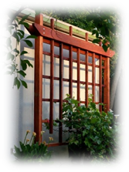
- Portico;
- Dormers;
- Projecting canopy;
- Masonry water table;
- Trellis containing plantings;
- A gabled vent of at least four (4) square feet in area;
- Patio, deck, or similar feature; or
- A similar significant permanent architectural feature consistent with the style of the building upon approval of the Board of Trustees as applicable.
    - All elevations shall have similar style, materials, colors, and details.
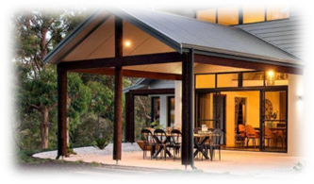
    - Façade Appearance. A building frontage that exceeds a width of 50 feet shall incorporate sectioning and offset of the wall plane to inhibit a large expanse of blank wall and add interest to the façade. Such offsets may be met through the use of bay windows, porches, porticos, building extensions, gables, dormers, or other architectural treatments.
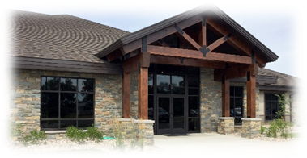
    - Materials. All exterior elevations shall be comprised of eighty (80) percent wood, fiber cement, and native or cultured stone. Foundations must be clad with the same natural material utilized on the building to blend with the overall architecture of the structure. No Building shall appear to have exposed cement block or split face block foundations. The appearance of natural materials such as brick may be utilized as an accent material provided it does not exceed twenty (20) percent of the gross exterior building wall square footage. Vinyl and/or aluminum shall be prohibited except when used for trim details such as downspouts, soffits, gutters and shutters. The use of black, gold, green, silver, opaque or any other reflective or colored glass on a building is prohibited. The appearance of frosted glass may be permitted in some cases, subject to review.
    - Accent Materials. Fiber cement, E.I.F.S., and like materials may be used as accents provided the total square footage of accent material does not exceed twenty (20) percent of the gross exterior building wall square footage. Other natural materials may also be incorporated into the building’s exterior design. Vinyl and/or aluminum shall be prohibited except when used for trim details such as downspouts, soffits, gutters, and shutters.
    - Roofing. All single-story buildings shall have a minimum 4:12 pitched roof. Multi-story buildings may be permitted to have flat roofs. When pitched roofs are utilized, they shall be constructed of dimensional shingles, standing seam metal, slate, or simulated slate.
    - In-Line Retail Exemption. Side or rear elevations of an in-line retail development may be exempt from the building design standards of the GCO if such elevations are not visible to customer traffic, a public right-of-way, or if a future phase of the in-line retail development is forthcoming adjacent to the elevation. Such exempt elevations shall use materials complimentary to the primary elevation and be screened by landscaping, mounding fencing, or a combination thereof, as deemed appropriate.
    - For buildings with Drive-Thrus. A Drive-Thru, if deemed appropriate for the site, shall be designed as an integral part of the structure it serves. Features incorporated with a drive-thru including, but not limited to, canopies, awning, and support posts shall match the materials and color scheme of the building they are serving. Drive-thru features shall not have any pickup windows, ordering areas, signage, or other related items located on the front elevation of a building or located between the building and a street right-of-way.

- Landscaping: Buffering, Landscaping, Open Space and Screening.
  - The following Requirements Apply to All Subareas:
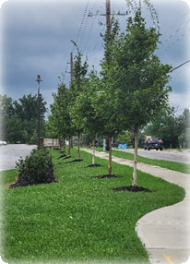
    - Grass (seed or sod), shrubs, trees, garden planting areas or other appropriate landscaping materials shall be planted in all exterior areas. Other groundcover such as ivy, may be planted in exterior areas which are not occupied by required landscaping material or required for drainage.
    - All trees required by these GCO Development Standards, Example: Street Trees or other applicable standard, shall meet the following minimum tree sizes at the time of planting:
      - Deciduous Tree: two (2)-inch caliper
      - Coniferous Tree: five (5)-feet in height
      - Shrubs and Hedges: Three (3)-feet in height
    - The following types of trees shall be prohibited:
      - Callery Pear (Pryus calleryana – any cultivar)
      - Tree of Heaven/Ailanthus – (Ailanthus altissima)
      - White Mulberry – (Morus alba)
      - Russian Olive – (Elaeagnus angustifolia)
      - Autumn Olive – (Elaeagnus umbellate)
    - All plants shall meet or exceed American Standards for nursery stock as set forth by the American Association of Nurserymen.
    - All trees and landscaping shall be well maintained. Dead trees, shrubs and other landscaping material shall be promptly removed and, when required, shall be replaced within six (6) months.
    - Tree Preservation. Reasonable and good faith efforts will be made to preserve existing trees. Consideration shall be given to laying out service roads, lots, structures, and parking areas to avoid the unnecessary destruction of wooded areas and individual trees. Additionally, standard tree preservation practices must be used to preserve and protect trees during all phases of construction, including the installation of snow fencing at the drip line.

  - In addition to the above standards, the following regulations shall apply:
    - Parking Lot Screening. Any surface parking areas adjacent to an existing or planned public right-of-way shall be screened from the respective right-of-way with a minimum of a 36-inch continuous planting hedge and tree combination. The height shall be measured from the adjacent parking area.
    - Parking Island Landscaping. All parking islands required in Section 14.07(d) shall have a minimum of one shade tree with a minimum of two (2) inches in caliper and include a minimum of fifty (50) square feet of other plant material. The remaining area of the landscaped island shall be covered with stone or planted with grass. The use of mulch shall be prohibited within the landscaped islands.
    - Right-of-Way – Setback Landscape Zone. Throughout the Setback area along an existing or planned public Right-of-Way, there shall be a landscape zone that complies with the following:
      - S.R. 37 and U.S. 40 Right-of-Way Landscape Zone shall have a:
        - Minimum of 40 ft in depth; and
        - Three (3) foot mound; and
        - A cluster of the following trees at 100-foot intervals for the entire frontage that includes a minimum of three (3) coniferous trees and two (2) deciduous trees.
      - Collector and Local Road Setback Landscape Zones shall be a minimum of ten (10) feet in depth and contain deciduous trees every thirty (30) feet for the entire frontage.

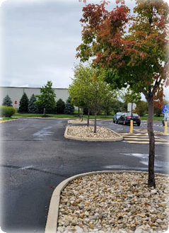
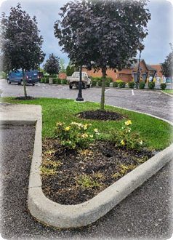
    - Screening Between Uses. A continuous planting hedge and tree combination to provide screening between non-residential and residential uses shall be installed. The required planting hedge and tree combination shall be a minimum of five (5) feet in height at the time of installation. Mounding may be used to achieve the required height and fencing may be incorporated to provide additional screening. Mounding and fencing can only be utilized in addition to and not in lieu of the planting hedge and tree combination.

  - The following regulations shall apply to any development along Canal Road.
    - Existing tree lines must be preserved, and a 200 foot woodland buffer must be established from the property line closest Canal Road. This buffer shall account for a percentage of the required thirty (30) percent open space for a mixed-use development.
      - A 200-foot woodland buffer, when required, shall consist of a minimum of 40 feet in width of native vegetation and trees and shall mimic the natural condition of a forest edge for the purpose of greatly reducing noise pollution and visual impacts of the development from Canal Road. This 40-foot area shall comply with the requirements in Table 14.07(c) below.
      - The image below shows the ideal woodland buffer where grasses, sedges, and perennials give way to woody shrubs, before finally transitioning to small flowering trees and young canopy trees.

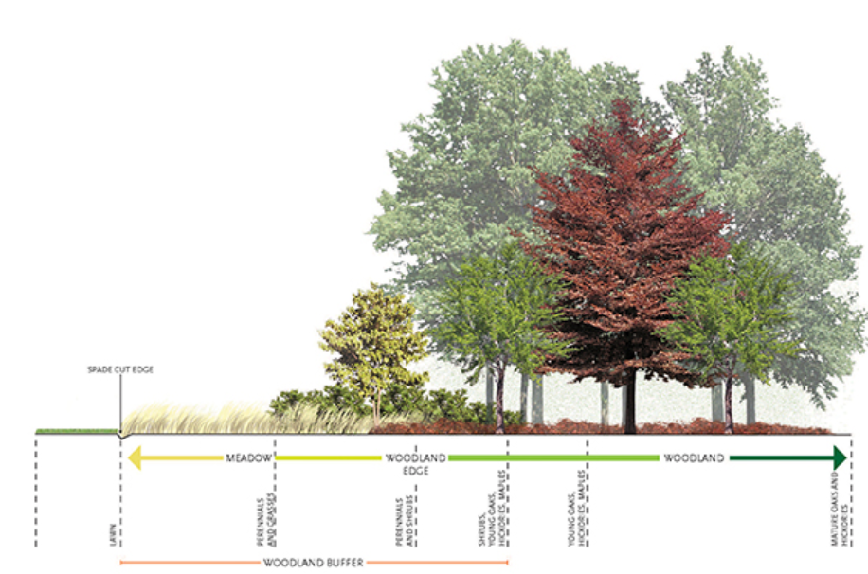

Table 14.07(c) Woodland Buffer
Woodland Buffer Along Major Thoroughfare
 | Min. # of trees and shrubs per 100 lineal feet of frontage or fraction thereof shall include the following:
Minimum Buffer Width (Feet) | Min. # of Large Trees | Min. # of Small Trees | Min. # of Shrubs
40 | 4 | 10 | 33

      - All trees required by these regulations, or other applicable standards, shall be live plants and meet the following minimum tree sizes at the time of planting listed in this Section.
      - Trees and shrubs listed in this Section under the prohibited tree list shall be prohibited as well as any other invasive or undesirable species as listed by the Ohio Department of Natural Resources.
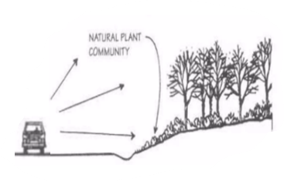
      - Additionally, low maintenance ground covers shall be used for earth berms, when earth berms are determined as necessary along an existing roadway. Long-term self-maintaining natural plant communities can be used as low maintenance ground covers for earth berms. Berms shall be discouraged, but when necessary, shall be constructed with a 3:1 slope.

  - The following Requirements Apply to All Subareas.
    - Mechanical Equipment. All external mechanical equipment shall be screened from adjacent existing or planned public rights-of-way with materials that are similar to or the same as those used on the adjacent building façade, or with landscaping. This requirement shall include rooftop equipment and ground mounted mechanical equipment.
    - Service Areas, Production areas, Service areas, Storage Areas, Trash Containers, and Loading Zones. Production areas, service areas, storage areas, trash containers and loading zones shall be located at the rear or the side of the building, except however, these areas are prohibited along a side of a building facing an existing or proposed single-family residential use. These areas shall be effectively screened from all adjacent property lines, existing or planned public rights-of-way and private streets.
    - Production areas, service areas, and loading zones: Screening of such areas shall consist of either landscaping or walls accented with landscaping materials. Screening consisting of walls shall utilize the same or similar materials as those used on the principals building.
    - Trash containers and storage areas: Trash containers and storage areas shall be screened on three sides with a solid wall or fence that is a minimum of one foot taller than the trash container or the material within the storage area to be screened. Said wall or fence must be constructed with the same or similar materials as those used on the principal building and must be accented with landscaping. So that the trash container or storage area can be accessed, a solid, decorative gate of the same height as the wall/fence shall be utilized as screening on the fourth side of said trash container or storage area.
    - The use of green infrastructure is encouraged where applicable and may include the use of pervious pavements, green roofs, or rain gardens as approved by the Township Board of Trustees.
    - All mechanical equipment, trash containers, and storage areas must comply with the floodplain regulations of the Licking County Planning Commission including the Flood Damage Prevention Regulations.

- Parking. Parking lot areas shall be designed and constructed to minimize the visual impact of the parking area, minimize production of excess heat, and prohibit any adverse effects on drainage. Appropriately sized landscaped areas shall be provided within each parking lot area allowing for a variety of shade trees to be planted. In order to accomplish these goals, all off-street parking lot areas shall be designed and constructed using the “Parking Bay” concept, which consists of parking spaces grouped together, with each Parking Bay separated by landscaped tree islands as further defined in the following sections.

  - Parking Lot Location. All parking lots shall be located behind or to the side of the principal building, except as otherwise provided for herein.
    - Parking lots, when possible, should be located to the side or rear of the principal building. In all subareas, except in Subarea E and F, parking may encroach a right-of-way setback line, but in no case shall parking be less than 20 feet from the road right-of-way line. No parking shall be permitted in the required 200-foot minimum setback along S.R. 37 and U.S. 40.
    - Parking lots may encroach into a required internal Side or Rear Setback but in no case shall the parking be closer than five (5) feet to internal lot lines, except in cases where the Board of Trustees determines that parking lots need to straddle internal lot lines in order to comply with the connectivity requirements of Section 14.07(f). In such cases, appropriate cross access easements must be established. In no case shall a parking lot be permitted closer than 100 feet from a Side or Rear Lot Line, if such lot line abuts an existing or proposed single family residential use.
    - Parking lots and garages are encouraged to be located underneath buildings to mitigate floodplain disturbance and flooding events.

  - Parking Bays. No Parking Bay shall contain more than 24 parking spaces, with a maximum of 12 spaces in a single row in Subarea A, D, and E. In Subareas B and C, no Parking Bay shall contain more than 48 parking spaces, with a maximum of 24 spaces in a single row.
    - Parking Lot Islands. Each landscape island in a single loaded parking stall design shall have a minimum area of 162 square feet with a minimum width of nine (9) feet. Each landscape island in a double loaded parking stall design shall have a minimum of 324 square feet with a minimum width of nine (9) feet.
    - Parking Lot Screening. All parking lots shall be screened in accordance with Section 14.07(c).
    - Number of Parking Spaces. Every Development Plan within the GCO shall include a detailed Parking and Loading Space Plan, which shall comply with these general requirements as well as any specific parking requirements within the applicable subarea standards. Due to the unique nature of the GCO, parking requirements for all development within the GCO are being established to encourage efficient use of parking areas by establishing a maximum number of spaces required and permitting sensible shared parking to reduce Impervious Surfaces and increase green space. The Total Number of Required Parking Spaces shall be calculated for each separate use within the proposed Development Plan. In no case shall the total number of parking spaces for a particular use be less than the Minimum nor more than the Maximum Number of Required Parking Spaces for said use based upon the below chart. When calculating the required number of spaces, fractional numbers shall be increased to the next whole number.

Table 14.07(d)(1) - Parking
USE | MINIMUM NUMBER OF REQUIRED PARKING SPACES | MAXIMUM NUMBER OF REQUIRED PARKING SPACES
General Retail ‐ Personal Services | 1 space per 265 square feet | 1 space per 225 square feet
Restaurants, Bars, Coffee, and Ice Cream Shops | 1 space per 100 square feet | 1 space per 75 square feet
Library | 1 space per 250 square feet | 1 space per 200 square feet
Movie Theater | .25 spaces per seat | .3 spaces per seat
Hospital/Nursing Home/Hospice | 1 space for every bed plus 1 space for each employee on  largest shift | 1 space for every bed, 4 spaces for every 1,000 square feet of inpatient treatment area, and 5 parking spaces for every 1,000 square feet of outpatient  treatment area
Professional Offices ‐ Open Floor Plan | 1 space per square 175 feet | 1 space per 150 square feet
Professional Offices ‐  Traditional Floor Plan | 1 space per 300 square feet | 1 space per 250 square feet
Medical Office | 1 per 225 square feet | 1 space per 200 square feet
Flex/Advanced Manufacturing | 2 spaces per 1,000 square feet | 2.5 spaces per 1,000 square feet
Warehouses | 1 space per employee on largest shift | 1.5 space per employee on largest shift plus 1 space per vehicle stored on site
Daycare | 1 space for every 7 children and 1 space for each employee on  the largest shift | 1 space for every 5 children and 1 space for each employee on  the largest shift
Assisted Living Facilities | 1 space for every 2.5 Dwelling Units plus 1 space for every 2 employees | 1 space for 2 Dwelling Units  plus 1 space for every 2 employees on largest shift
Independent Senior Living Facilities | .85 spaces per Dwelling Unit | 1 space per Dwelling Unit
Multi‐Family Dwelling Units, Townhomes | 1 Space per Dwelling Unit | 3 spaces per Dwelling Unit
Recreational Uses
Mini‐Golf, Batting Cage | 1 per tee or cage | 1.5 per tee or cage
Bowling Alley | 3 per lane | 4 per lane
Recreation/Fitness Centers | 7 spaces per 1,000 square feet | 8 spaces per 1,000 square feet
Outdoor recreation fields | 50 per field | 75 per field
Ice or Skating Rink | 1 per 200 square feet | 1 per 150 square feet
*Utilize gross square footage whenever there is a reference to square feet

    - Handicap accessible parking spaces shall be provided in accordance with the American with Disability Act requirements.
    - All parking spaces shall be a minimum of nine (9) feet in width and 18 feet in length measured rectangularly and shall be served by aisleways of a minimum of 24 feet in width to permit easy and smooth access to all spaces.
    - All common areas and adjacent driveways shall be paved with asphalt material or cement and parking spaces shall be striped. Green or pervious pavers/pavement may be approved by the Board of Trustees provided they meet the requirements of the Fire Department and mechanisms for long term maintenance are provided. The use of gravel for parking lots shall be prohibited.
    - Mixed-Use Development Parking. When a mix of uses creates staggered peak periods of parking (see, Table 14.07(d)(2) below), the total parking requirements for the uses in a Development Plan may be reduced up to fifteen (15) percent below the Total Minimum Parking Requirements for all uses, provided a shared Parking Plan is approved by the Board of Trustees during Development Plan approval. The shared parking plan must be based upon the number of originally required spaces for differed uses or facilities sharing the same parking area and documentation that the required parking needed for different uses at different days and times generally based upon Table 14.07(d)(2) below. Parking spaces included in the shared parking plan must be distributed in a manner that provides parking spaces within a reasonable distance from all proposed uses as determined by the Board of Trustees during Development Plan approval. Shared parking must remain under common ownership providing access to all users of the shared parking. If common ownership is not proposed, the Board of Trustees may require documentation of shared access agreements to be provided.

Table 14.07(d)(2) – Peak Parking Periods
Weekday Peaks | Evening Peaks | Weekend Peaks
Banks | Bars | Retails Uses
Professional Offices | Ice Cream Shops | Movie Theaters
Medical Offices | Restaurants
Library | Movie Theaters
Daycare
Coffee Shops

    - Loading Spaces.
      - All loading spaces must be located to the side or rear of the principal structure and screened in accordance with Section 14.07(c) and are prohibited within any Right-of-Way Setback.
      - A loading space shall consist of a rectangular area adequate for loading and unloading and be accessible from a maneuvering area.
      - All loading spaces and maneuvering areas shall be located on the same Lot as the use they are intended to serve.
      - A required loading space shall have a clearance height of not less than 15 feet and shall have minimum dimensions of not less than 12 feet in width and 50 feet in length, exclusive of any driveway, aisle, or other circulation area.
      - The number of off-street loading spaces required for various types of uses shall be no less than as set forth in the following:
      - Subareas B and C. Each use in this subarea shall provide loading spaces based on gross floor area as follows:
        - Under 10,000 square feet = None.
        - 10,000 square feet or more but less than 75,000 square feet = One space.
        - 75,000 square feet or more but less than 150,000 square feet = Two spaces.
        - 150,000 square feet or more but less than 300,000 square feet = Three spaces
        - Over 300,000 square feet = One space for each 100,000 square feet or portion thereof.
        - The loading space requirements for buildings with multiple uses or tenants shall be determined based on the aggregate total of gross floor area of all uses or tenants.
      - Subareas A, D, and E. Each use in this subarea shall provide loading spaces based on gross floor area as follows:
        - Less than 5,000 square feet = None
        - 5,000 square feet - 250,000 square feet = One space
        - Over 250,000 square feet = One space for each 250,000 square feet or portion thereof.

- Drive-Thru Stacking Requirements.
  - Developments providing an order and drive-thru service, pick up window, or other automobile-oriented use on the site shall be designed so that vehicles do not interfere with the parking and movement of other vehicles. Stacking lanes shall be provided to achieve this in accordance with the Stacking Requirements table below.

Table 14.07(e) – Drive-Thru Stacking
Activity | Minimum Stacking Spaces (per lane) | Measured From and Including
Banks and ATMs | 3 | Teller/Window or ATM machine
Restaurant, Coffee Shop, or other similar use | 8 | First pick up window
Full Service Car Wash* | 20 | Entrance of tunnel
Self Service – Automated Car Wash | 4 | Washing Bay
Fuel/Gasoline Pump Island | 1 (at each end of the outermost gas pump island) | Pump Island

  - Design and Layout:
    - Pump spaces can count toward the stacking space requirement.
    - Stacking spaces shall be a minimum of nine (9) feet by twenty (20) feet in size.
    - Stacking spaces may not impede on- or off-site traffic movements or movements in or out of off-street parking spaces. There shall be a separate drive aisle allowing ingress and egress of vehicles that are not waiting in the Drive-Thru lanes.
    - Stacking spaces shall be separated from other internal driveways by surface markings or raised medians.
    - These stacking space requirements shall be in addition to the off-street parking space requirements.
    - When adjacent to residential uses, stacking spaces shall be required to be located on sides of the lot opposite the adjacent residential use.

- Access, Connectivity, and Visibility.

  - All access points shall be limited to those locations approved by the permitting authority (state, county, or township as applicable). On township roads, the minimum spacing between driveways shall be determined by the Licking County Access Management Regulations.

  - Visibility at intersections shall comply with Section 16.42 of this Code.

  - The internal circulation of a parking area shall comply with the Article XX of this Code.

  - The overall design within the Development Plan must provide for vehicular connectivity between properties within the Development Plan as well as future connections to adjacent properties outside of the Development Plan boundaries. This requirement could be achieved through access roads (at the rear of the property or running parallel to an existing/proposed public road) and/or through the use of cross access easements between parking lots. The Board of Trustees may rely upon recommendations from the Licking County Engineer or other consulting engineers to determine that the proposed method for providing connectivity is the most suitable in each particular development.

  - If access roads are utilized to comply with this connectivity requirement, there shall be a minimum distance of 200 feet between intersections. A greater distance may be required upon recommendation by the Licking County Access Management Regulations or a consulting engineer to avoid safety concerns.

  - Multi-Use Path and Sidewalks. All Collector and Local Roads in all subareas shall have a 10-foot multi use path along each side of the road (within a 15-foot MUP easement). All local roads shall have a five (5)-foot sidewalk on both sides of the road within a 10 feet sidewalk easement which must be located outside of the right-of-way. Curb ramps and crosswalks shall be installed per the American Disability Act requirements. Multi-use paths and sidewalks shall be constructed immediately outside the road right-of-way within a 15-foot MUP easement, or 10-foot sidewalk easement designated for such public use.

  - Sidewalks shall connect to the building entrances and to existing sidewalks on adjacent abutting Tracts and to nearby pedestrian destination points including any transit stops.

- Lighting.

  - All Exterior Lighting shall comply with these standards unless specifically exempted.

  - Exemptions:
    - All exterior lighting fixtures producing light directly by the combustion of fossil fuels, such as kerosene lanterns or gas lamps are exempt from the requirements of this section.
    - Holiday lighting shall be exempt from the requirements of this section.
    - All temporary emergency lighting needed by the police, Fire Department, other emergency service vehicles, and public service vehicles, as well as all vehicular luminaries, shall be exempt from the requirements of this section including flashing or blinking lights.
    - Street lights shall be exempt from the provisions of this section.

  - Prohibited Lighting. Search lights, beacons, laser source lights, or any similar high-intensity or flashing lights are prohibited, except in emergencies by police and/or Fire Department personnel.

  - Types of Fixtures: All light fixtures shall be full cut-off type fixtures except for decorative light fixtures.

  - Fixture Height:
    - The fixture height in parking lots shall not exceed twenty (20) feet.
    - Lighting located under canopies shall be flush mounted or recessed within the canopy.
    - Fixture height shall be measured from the finished grade to the topmost point of the fixture.

  - Kelvin Levels. The color temperature for each light shall not exceed 4,000K.

  - Exterior lighting shall be designed and located to have the following maximum illumination levels. The levels shall be measured at the finished grade at the Lot Line as demonstrated by a lighting plan:
    - The maximum illumination at a Lot Line that abuts a lot zoned for single family or multi-family uses shall be 0.4 foot-candles.
    - The maximum illumination at a Lot Line that abuts any other use shall be one (1) foot-candles.
    - The maximum illumination at a Lot Line for properties used for outdoor sports and recreation shall be reviewed for compliance with regard to the intent of these guidelines to minimize the impact of light trespass and glare on all surrounding properties and public rights-of-way.
    - The illumination across any property shall be designed so as to not create excessively dark spots that may create safety issues.

  - This subsection applies to any development that abuts a property zoned for single family residential purposes (including abutting properties within the GCO that are not yet utilizing the GCO zoning and contain an existing single-family residence:
  - All non–essential outdoor lighting fixtures for non-residential uses, including lighting for parking areas, signs, displays and aesthetic lighting shall be turned off after business hours.

  - Only lighting needed for safety or security may remain lit after close of business, in which case the lighting shall be reduced to the minimum level necessary.

  - Automatic shut-off fixtures, auto-dimming to adjust lighting based on ambient lighting and the use of as little lighting as necessary without creating safety issues is encouraged.

- Signs. All signs in the GCO shall comply with the requirements of Article XXI of this Code.

- Utilities, Water and Drainage.

  - All developments shall be served by central water and sewer systems.

  - Dry detention basins are prohibited in all subareas.

  - All stormwater basins shall be wet basins and aeration devices may be required. Bioretention basins, or rain gardens, may be used only when approved by the Board of Trustees.

  - All stormwater requirements must also comply with the Ohio Department of Natural Resources Rainwater and Land Development Handbook, the Licking County Subdivision Regulations, the Licking County Soil Erosion and Stormwater Regulations, and any applicable requirements of the Licking County Engineer.

  - A comprehensive regional stormwater plan for each sub area is encouraged.

- Accessory Structures.

  - In all Subareas, Accessory Structures for all uses, except for those on individual lots or parcels shall be identified on and constructed in accordance with an approved Development Plan.

  - Accessory Structures must comply with the architectural requirements in Section 14.07(b) and all Setback requirements in this overlay. All Accessory Structures shall be located behind the front plane of the Principal Building. Sheds in all zoning districts that are 100 square feet or less are exempt from these requirements.
Table 14.07(j) – Accessory Structure Requirements.
Maximum Height (Feet) | 25
Total Maximum Square Footage of Accessory Structures | 2,400
Minimum Distance from Principal Building or any other Accessory Structure (Feet) | 5
Minimum Setback from Rear and Side Lot Line (Feet) | 15 (Residential Use)  40 (Commercial Use)

- Fences. Fences shall be permitted if they comply with the following regulations:

  - Industrial Uses. The following types of Fences are permitted provided they are located behind the front building line, outside of the right-of-way and do not exceed eight (8) feet in height:
    - Chain Link provided they are painted black or have a black vinyl coating;
    - Privacy Fences.

  - All Uses (Except Industrial). The following types of fences are permitted provided they are less than four (4) feet in height and located behind the front façade of a single-family structure.
    - Brick or stone walls
    - Wrought Iron
    - Brick or stone columns with wrought iron fence in between
    - Accent Fence
    - Chain Link provided they are painted black or have a black vinyl coating.

  - On non-single-family lots, these fences may encroach in front of the front building façade provided these fences do not fully enclose an area are utilized for decorative purposes to enhance the entry to an overall development. These fences shall not interfere with sight distance. Fences are prohibited within the right-of-way.

  - The following fences are permitted only when providing the required screening per Section 14.07(c) and they do not exceed five (5) feet in height:
    - Privacy Fences

  - The following types of Fences are permitted to fully enclose a patio or other similar feature immediately adjacent to a building provided they do not exceed six (6) feet in height.
    - Any type of Fence permitted in Section 14.07(k)(2).
    - Privacy Fence

  - The following materials are considered non-suitable materials and are prohibited for all fences in the GCO:
    - Barbed wire
    - Electrically charged wire
    - Temporary snow fence (unless used temporarily when a site is actively under construction)
    - Solid concrete block
    - Pallets
    - Prongs, spikes, or other sharped edged materials.

- Home Occupations. Home Occupations, when permitted, shall comply with the following requirements:

  - A Home Occupation shall be conducted entirely within a dwelling unit and shall be clearly subordinate to the use of the dwelling unit. Home Occupations shall not be conducted within Accessory Structures, such as garages or sheds.

  - The appearance of the dwelling unit in which a Home Occupation is conducted shall not be altered or the occupation within the dwelling shall not be conducted in a manner which would cause the premises to differ from its surrounding character either by colors, materials, construction, or lighting.

  - The Home Occupation shall not generate traffic greater in volume than normal for the subarea.

  - The Home Occupation shall not involve delivery trucks other than normal parcel delivery services.

  - No equipment or processes shall be used in a Home Occupation which creates noise, vibration, glare, fumes, odors, or electrical interference detectable to the normal senses on the lot. No equipment or processes shall be used which creates visual, audible, or electrical interference in any radio or television receiver or computer terminal off the premises or causes fluctuations in voltage off the premises.

  - The Home Occupation shall not occupy more than twenty (20) percent of the livable floor area of the dwelling unit.

  - No person shall operate or be employed by a Home Occupation unless the person is a resident of the dwelling unit in which the Home Occupation is conducted.

- Noise. There shall be quiet hours between the hours of 10:00 p.m. and 6 a.m. every day of the week.

ARTICLE XV
Planned Unit Development (PUD)

15.01 Authority and Purpose
15.02 General Requirements
15.03 Site Review
15.04 Procedure for Approval – Pre-Development Plan
15.05 Procedure for Approval – Final Development Plan
15.06 Text Standards and Guidelines

15.07 Submission Requirements
15.08 Pre-Development Plan Contents
15.09 Final Development Plan Contents
15.10 Expiration of Approval
15.11 Extension of Time or Modification of a Pre-Development Plan or Final Development Plan

15.01 AUTHORITY AND PURPOSE

- ORC 519.21(B) authorizes townships to establish and regulate PUDs, which require both a Zoning Text Amendment and Zoning Map Amendment applicable solely to the adopted PUD District. The approval and amendments are subject to referendum pursuant to ORC 519.12.

- The intent of the PUD, Planned Unit Development District, is to create flexible design criteria that the traditional zoning districts may not include. These regulations are based upon the premise that the ultimate quality of the built environment is determined not by the compatibility of uses, but how uses are appropriately integrated together through character type and design standards. This District is intended for large scale developments and aims to:
  - Provide an opportunity for a mix of land uses otherwise not permitted within the standard zoning district classifications.
  - Allow the creation of development standards that respect the unique characteristics, natural quality, beauty of the immediate vicinity, and protect the community's natural resources by avoiding development on, and destruction of, sensitive environmental areas.
  - Enable greater review of design characteristics to ensure the development project is appropriately integrated into its surroundings.
  - Pursue the housing and economic development goals of the Township.
  - Encourage innovative architecture.
  - Establish objective criteria for development plan review that ensure conformity to community and development standards and allow for consistent treatment throughout.
  - Support the proper relationships between buildings, developments and structures and the land.
  - Encourage a more efficient land–use pattern by reducing the amount of public infrastructure, creating usable open space, preserving existing natural features, and providing for various building styles, types, and uses.

15.02 GENERAL REQUIREMENTS

- Project Location. A PUD may be located in any area of the Township where the applicant can demonstrate that the proposal will meet the objectives of this Article and the Township's Comprehensive Plan.

- Project Area. The minimum gross project area shall be twenty (20) contiguous acres in size. Smaller parcels may be considered if contiguous to an existing PUD and/or in conjunction with another proposed PUD. However, said development shall meet all requirements within this Article within the gross project area of the proposed development. A development shall not rely on another development for open space, setbacks, buffers, etc.

15.03 SITE REVIEW

- Prior to any formal application, the developer shall schedule an informal on-site walkabout and review of the proposed project. The purpose of such review shall be to identify areas for conservation, identify areas where buffering of adjoining parcels may be needed, discuss general layout concepts, and familiarize the township and those involved in the project with the site prior to any formal submittal. No binding decisions or votes are made during this review, it is merely to provide open dialogue between the applicant and the township to establish general concepts prior to formal application. Upon completion of the on-site review, the developer may make a formal Pre-development Plan application based upon comments from the PUD site review.

- This is an official public meeting pursuant to the Ohio Revised Code and Ohio Sunshine Law, therefore notice of such hearing shall be given by the Union Township Zoning Commission by at least one publication in one or more newspapers of general circulation of the Township at least ten (10) days before the date of said meeting.

15.04 PROCEDURE FOR APPROVAL – PRE-DEVELOPMENT PLAN

To establish a PUD at the election of a property owner, the following process shall be followed:

- Pre-Submissions Conference. A pre-submission conference is strongly recommended prior to submitting the PUD text for consideration and review. The purpose of the pre-submission conference shall be to introduce the Township Zoning Commission to the proposed project, give the Zoning Commission a preliminary review period, and allow the Township to present some preliminary concerns and suggestions that the developer may not have considered so that the developer may have an opportunity to make changes prior to the official submittal when the Township will be required to make an official decision of approval, approval with modifications, or denial of the proposal. This is an informal process. The Zoning Commission shall take no official action during these meetings, nor shall any binding decisions be made. The developer may request more than one pre-submission conference to resolve as many issues as possible prior to the official submittal. Said meeting is a public meeting and subject to notification requirements as outlined in Section 4.09, or may be held during a regularly scheduled meeting in which notice has been previously given and the agenda is prepared prior to the meeting stating it will be discussed, or is amended at the beginning of the meeting to reflect the issue being discussed.

- Submission of Text and Map Amendments. Both a text and map amendment are required for the PUD process. Therefore, the Applicant shall submit the PUD Text and Zoning Map for consideration and review. This step shall follow the procedures outlined in Article VII – Amendment of this Code, and is subject to referendum. Submit application to amend the Official Zoning Map.

- Pre-Development Plan Review Procedures. The application, including all submission requirements for preliminary development plans in accordance with Section 15.08, shall be reviewed and distributed according to the procedures herein.

- Zoning Inspector Review and Transmittal to the Zoning Commission.

  - After determining that an application is complete in accordance with Section 15.08, the Zoning Inspector, or designee, shall forward the application to the appropriate Township departments and, if determined necessary, professional consultants for review and comment. The Zoning Inspector, or designee, shall schedule a public hearing of the preliminary plan by the Zoning Commission no less than twenty (20) days and no more than forty (40) days from the date the application is deemed complete and notify all adjacent property owners in accordance with Section 4.09.
  - L.C.P.C. Sketch Plan Application Submittal Requirement. Simultaneously with the submittal of the Pre-Development Plan Application to the Zoning Commission, the property owner shall submit a Sketch Plan Application to the Licking County Planning Commission (L.C.P.C.), according to the Licking County Subdivision Regulations.

- Action by Zoning Commission. Within thirty (30) days of the conclusion of its public hearing, the Zoning Commission shall recommend to the Township Trustees one of the following:
  - That the Pre-Development Plan, development text, and its supporting documentation be approved as submitted;
  - That the Pre-Development Plan, development text, and its supporting documentation be approved with specific conditions set forth by the Planning Commission; or
  - That the Pre-Development Plan be disapproved.

- Transmission to Township Trustees. The Zoning Commission shall transmit the zoning amendment application and the Pre-Development Plan in the form of a resolution along with all appropriate documentation, including their recommendation to the Township Trustees.

- Review and Action by Township Trustees. Within thirty (30) days of receiving the Zoning Commission's recommendation, the Township Trustees shall conduct a public hearing , in accordance with Township procedures and public notice provisions set forth in Section 4.09. In reviewing the resolution(s), the Township Trustees shall consider the approval criteria set forth in Section 15.06.

- Approval of the Pre-Development Plan. Adoption of the resolution shall constitute a rezoning of the property included in the Pre-Development Plan to a PUD, and the Pre-Development Plan and associated commitments become binding on the applicant. The Zoning Map shall be amended to reflect the zoning changes. In the event Township Trustees approve the Pre-Development Plan with modifications, the applicant shall incorporate such modifications into the appropriate documents and file the revised Pre-Development Plan with the Zoning Inspector, or designee. No Final Development Plan application will be processed until the revised Pre-Development Plan is submitted and approved.
  - An application shall only be approved by the Union Township Zoning Commission and Township Trustees if:
    - The proposed use complies with the PUD text;
    - The proposed design standards and elements are in compliance with the PUD text;
    - The proposed development is in compliance with the Comprehensive Plan;
    - The proposed development will be adequately served by public utilities, such as but not limited to roads, walkways/pathways, police protection, fire protection, schools, drainage structures, water and wastewater facilities, etc.;
    - The proposed development is in keeping with the existing land use character and physical development potential of the area;
    - The proposed development promotes efficient use of land and resources, promoting greater efficiency in providing public and utility services, and innovation in the planning of the development and the buildings within the development;
    - The proposed development promotes public health, safety, and general welfare;
    - In approving the application for Pre-Development Plan, the Zoning Commission/Board of Trustees may impose such conditions, safeguards and restrictions in order to carry out the purpose and intent of this district and provide for public health, safety, and general welfare.

- Significance of Approve Pre-Development Plan. Approval or approval with recommended modifications of the Pre-Development Plan by the Township Trustees shall:
  - Establish the development framework for the project, including the general location of open space, use areas, densities, unit types, recreational facilities, and street alignments;
  - Permit the applicant to proceed with detailed drafting of the Final Development Plan; and
  - Authorize the applicant to apply for all other required regulatory approvals for the project or subsequent phases thereof.

15.05 PROCEDURE FOR APPROVAL – FINAL DEVELOPMENT PLAN

- Final Development Plan Submittal. After approval of the Pre-Development Plan Application, the property owner shall submit the Final Development Plan Application to the Township.
  - L.C.P.C. Preliminary Plan Application Submittal Requirement. Simultaneously with the submittal of the Final Development Plan Application to the Township, the property owner shall submit a Preliminary Plan Application to the Licking County Planning Commission, according to the Licking County Subdivision Regulations.

- L.C.P.C. Final Plat Application Submittal Requirement. After approval of the Final Development Plan Application by the Township Trustees and the Pre-Development Plan Application by the Licking County Planning Commission, the property owner shall submit the Final Plat Application to the Licking County Planning Commission in accordance with the Licking County Subdivision Regulations.

- Modifications To Require Re-Submission of Pre-Development or Final Development Plans. At any point in the review process where the Licking County Planning Commission, Licking County Engineers Office, Licking County Health Department, Licking County Board of Commissioners, or other government body with jurisdiction shall require a substantial change in the plans, the property owner/developer shall be required to resubmit and obtain approvals from the Township for the step (i.e. Pre-Development Plan or Final Development Plan) for which the change occurred.
  - Modifications deemed as minor may include the following changes:
    - Minor adjustments in Lot Lines provided no additional lots are created and required setbacks are maintained;
    - Minor adjustments in the location of and layout of parking lots provided the perimeter setbacks, yards and buffers are maintained;
    - Minor adjustments in building footprints up to ten (10) percent in total floor area of the originally approved building, building height(s) or floor plans, that do not alter the character or intensity of the use;
    - Substitution of landscaping materials specified in the landscape plan with comparable materials of an equal or greater size;
    - Redesigning and/or relocating stormwater management facilities provided that general character and stormwater capacities are maintained and approved by the County Engineer.
    - Redesigning and/or relocating landscape mounds, provided that the same level and quality of screening is maintained;
    - Minor modifications to the sign face, landscaping and lighting, provided the other sign requirements of the final development plan are maintained;
    - Minor changes in building material or colors that are similar to and have the same general appearance comparable to or of a higher quality as the material approved on the final development plan;
    - Changes required by outside agencies such as the county, state, or federal departments; or
    - Other minor modifications deemed by the Zoning Inspector that do not alter the basic design or any specific conditions imposed as part of the original approval.

- Appeals. Steps outlined in this section are not subject to referendum or a Variance, but are subject to Appeal as outlined in Article IV, Section 4.03 – Appeals of This Code. Based upon ORC 2506, an aggrieved party may make application for administrative appeal to the Licking County Court of Common Pleas upon final review and decision made with regard to the Final Development Plan.

15.06 TEXT STANDARDS AND GUIDELINES

- Preface. The standards and guidelines listed within this section shall be the minimum to guide the developer and township official(s) in developing and reviewing the PUD text. It should be noted that these standards and guidelines are not all encompassing, and unexpected or optional standards and techniques exist. These issues shall be considered and negotiated between the developer and the township officials. Such deviations and/or considerations shall only be considered if:
  - They promote public health, safety, and general welfare;
  - They will not detriment any adjoining property, including the Township’s nuisance guidelines adopted by separate resolution.
  - They will create a well-designed, environmentally sensitive development, which is conservative of riparian corridors, wetlands, large/mature wooded areas, wildlife habitats and other scenic and environmental sensitive areas;
  - They will create a quantity and quality interconnected network of open space that abuts and is accessible to each proposed lot within said development;
  - They will promote exemplary use of access management and road design to minimize the affects of the increased traffic from the proposed development;
  - They will promote and maintain the rural character, aesthetics, and appeal of the township.

- General Outline of Required Elements of the PUD Text. The following list represents the required elements contained within the PUD application:

  - Lot Area Requirements
  - Lot Width Requirements
  - Structure Bulk Requirements
  - Structure Height Requirements
  - Structure Setback Requirements
  - Buffer Requirements
  - Open Space Requirements
  - Access Management
  - Recreational Facilities – Both active and passive
  - Environmental Preservation – Specify in quantity, the type and how it is to be preserved.
  - Sanitary Sewer and Water Disposal Systems
  - Storm Water Management
  - Deed Restrictions and Restrictive Covenants

- Specific Requirements of the PUD Text.

  - Density. The density shall be based upon the goals of the Comprehensive Plan in conjunction and shall be specifically defined within the PUD text. This may be decreased or increased through negotiations between the Township and the developer as well as upon the Township's determination that the proposed site is unable to sustain said density based upon ground water availability and its ability to support on-site wastewater systems. The Township shall rely on reports and documentation from but not limited to the Ohio Department of Natural Resources, the Ohio Environmental Protection Agency, the Licking County Health Department and any engineering firm from which the Township has sought professional services.
  - Net Developable Area. The net developable area shall be determined by the following formula:

GROSS PROJECT AREA FORMULA
LESS: | Fifteen (15) percent of the PUD's gross acreage for streets and utilities; and jurisdiction wetlands, as defined by the U.S. Army Corps of Engineers
LESS: | Areas within the 100-year floodplain as shown on FEMA Flood Insurance Rate Maps, and/or those areas not studied by FEMA but identified as 100-year floodplain through the Licking County Subdivision Regulations;
LESS: | Slopes fifteen (15) percent or greater;
LESS: | Existing utility easements and/or rights-of-way;
LESS: | Required Open Space (See, Section 15.06(4) below)
TO EQUAL: | NET DEVELOPABLE AREA

  - Exclusions from Building Sites/Lots. No portion of a building site/lot shall be located within any area identified as a 100-year floodplain, jurisdictional wetland, having slopes of fifteen (15) percent or greater or easements for utilities or access which do not serve the lot itself.
  - Required Open Space. A minimum of fifty (50) percent of the gross site area shall be set aside as open space and shall remain undeveloped land in perpetuity for the enjoyment of the residents of the Township.
    - Areas Not Permitted to Count Towards Open Space:
      - Open Space shall not be areas of individual fee simple lots conveyed to homeowners;
      - Private roads and public roads rights-of-way;
      - Parking areas, access drives (small strips of land to allow access to open space), and driveways;
      - Other small fragmented or isolated areas that have a dimension of less than one hundred (100) feet in any direction.

    - Permitted Uses of Required Open Space:
      - Preserved in a natural state;
      - Utilized for agriculture when authorized in a conservation easement and/or the association's covenants and restrictions;
      - Sewage service and/or water supply facilities may be located partially or entirely within the required open space areas. Where such facilities are so located, easements satisfactory to the Licking County Health Department shall be established to require and enable maintenance of such facilities by the appropriate parties.
      - A portion of the required open space may be used for active recreation. Said active recreation facilities shall not be located in or disturb any wooded areas; the areas of the subdivision dedicated as public right-of-way for streets and utilities; Jurisdictional Wetlands as defined by U.S. Army Corps of Engineers; areas within the 100-year floodplain as shown on FEMA Flood Insurance Rate Maps, and/or those areas not studied by FEMA but identified as 100-year floodplain through the Licking County Subdivision Regulations; areas with slopes fifteen (15) percent or greater and any existing utility easements and/or rights-of-way; and any area of natural habitat for an endangered, threatened, or special concern species as identified by the Ohio Department of Natural Resources.
    - Ownership of Required Open Space. Required open space land may be owned by one of the following entities, provided the land is permanently and irrevocably dedicated as open space:
- Homeowners Associations
- Public conservation organizations
- Land trusts
- Township Board of Trustees (upon willingness and passage of a resolution by the Township Board of Trustees to accept the land).
- Third parties if protected by an open space easement, which permanently and irrevocably transfers the development rights to one of the above-mentioned entities.
- New Community Authorities (NCAs)
    - Open Space shall:
      - Be sufficiently aggregated with adjacent areas dedicated to Open Space to create large, contiguous, and useable areas of planned Open Space.
      - Conserve significant natural features within the PUD to the extent practicable.
      - Provide a scenic natural environment along existing public streets characterized by large setbacks that enable the preservation of natural features.
      - Be easily accessible to residents of the PUD.

  - Lot Area. The minimum Lot Area for individual lots within the PUD shall be determined as follows:
    - Lots should be clustered along the edges of the conservation (open space) areas and arranged to maximize homeowners’ views of open space areas and access to public amenities.
    - Every lot shall be of appropriate size to meet the requirements of the Licking County Health Department or Ohio Environmental Protection Agency (OEPA) for on-site water and wastewater or other approving authority at the time of the improvements to support a water and wastewater system. This requirement may be waived if the wastewater systems are located within the common areas with appropriate easements and approved by the Ohio Environmental Protection Agency and Licking County Health Department.
    - Every lot shall be of appropriate size to accommodate the proposed dwelling bulks, yard setbacks, and lot coverage requirements.
    - Every lot shall be of appropriate size to be supported by a natural aquifer for well water, unless said site is served by central water and sewer.
  - Lot Width. The proposed lot width shall be of sufficient size to meet the proposed structure bulks, yard setbacks, septic and well setbacks and locations. Every lot shall not exceed a 3:1 depth to width ratio. The width shall be measured along the edge of the road right-of-way line for any existing or proposed roadway, and the depth shall be measured from the building front yard setback line for any existing or proposed lots. (Example: A proposed lot has 100’ of width at the road right-of-way line and a front yard setback of 50.’ In this case, the 3:1 ratio would allow for the 100’ width lot to have a depth of 350.’)
  - Setbacks.
    - Perimeter Setbacks.
      - The setback from existing public road right-of-way shall take into consideration the average setbacks of existing homes, whether the front of the main structure or the rear will be facing the roadway, and whether there is substantial natural vegetation located along the street to provide a visual buffer (75% opacity) of the structure on a year-round basis.
      - The setback from perimeter lot lines, which should serve the same function as the rear yard setback for the standard subdivision, shall be set. Said setbacks shall take into consideration adjoining zoning classifications and land use. Greater setbacks shall be expected for differing uses (ex. residential being developed next to a commercial zoned property).
    - Internal Setbacks. Every lot shall specify the following setbacks:
• Front Yard
• Side Yard
• Rear Yard
• Said setbacks shall be for any structure developed on said site.
    - Setbacks Generally. Said setbacks shall take into consideration concepts of providing adequate buffers from unlike and dissimilar uses; providing adequate area for future property owners to utilize said lot; providing adequate buffering from adjoining properties so that noise, glare, and other nuisances from adjoining properties are minimized if not eliminated; and providing adequate setbacks to prevent the spread of, or damage from a structure fire (unless fire suppression systems are used) in the event one should occur.
  - Waste and Wastewater.
    - Every lot shall meet the requirements of the Licking County Health Department or Ohio Environmental Protection Agency (OEPA) or other approving authority at the time for on-site septic and well.
    - Off-site septic wastewater systems may be utilized within the required open space with appropriate easements if they are approved by the Licking County Heath Department and/or OEPA Proposals with such systems shall have a water and wastewater management plan, including maintenance, inspections and funding for repairs developed and stated in the Homeowners Association Agreement. Said management plan shall be reviewed and approved by the Licking County Health Department.
  - Fire Protection. The PUD Text shall specify how fire protection will be provided to the residents and structures developed on the site. In the event public sewer and water service is available, this shall be in the form of fire hydrants and the design and layout thereof. In the event public sewer and water is not available, this shall be in the form of dry hydrants and the placement and design thereof. Any development which has or develops a pooled body of water (pond, lake, detention pond and the like) shall be required to establish a dry hydrant within said development to provide for the public safety of those within said development. Where pooled water (pond, lake, detention pond and the like) exist in multiples and are in various locations throughout the development (i.e. not clustered), multiple dry hydrants shall be required by the township, especially if the development is of significant size. The design of a dry hydrant shall be approved by the local fire district and the Licking County Soil and Water Conservation District. Testing prior to acceptance of the final plat by Licking County shall be required to ensure the dry hydrants function properly. The Township shall provide notice of this requirement at the Licking County Technical Review Committee Meeting and request it be a condition of approval for the final plat.

- Design Features Required of the PUD. The development plan shall incorporate the following standards:
  - Open space shall be distributed throughout the development as part of a unified open space system. To the greatest extent possible every lot shall abut open space, and linkages to open space within the development and to open space outside the development shall be made. Said system shall serve to unify the development visually and functionally, and buffer surrounding land uses while preserving environmentally significant resources, habitats and vistas.
  - Woodlots greater than one (1) acre, tree rows, greenspaces, and other notable site characteristics shall be preserved, protected, and replaced in compliance with the requirements set forth in Article XIX – Landscaping.
  - A riparian buffer shall be provided along the entire length and on both sides of a river or perennial stream channel. Walkways may be located within riparian buffers when the Board of Zoning Appeals determines that such will create minimal change to the riparian buffer.
  - No buildings shall be constructed within any area identified as a 100-year floodplain or wetlands.
  - No cut/fill operations shall occur in any area identified as a 100-year floodplain or wetlands.
  - No storm drainage structures such as retention or detention ponds shall be designed or located within any area identified as a 100-year floodplain or wetlands.
  - Passive recreation facilities such as walking paths and bike trails shall be encouraged within the open space throughout the development. Said trails shall provide an interconnected network of paths throughout the development and to adjoining existing networks should they exist.
  - Moderate to thick coverage by trees and natural undergrowth is desirable to most intended functions of the open space. Where such foliage exists naturally, it should be retained. Where adequate foliage does not exist, the township shall require establishment of such tree cover or other foliage as necessary to achieve the purpose of the open space and the buffer of adjacent uses.
  - Scenic areas and views shall be preserved to the maximum extent possible, including views from the adjacent road.
  - Open spaces may be used for the natural disposal of storm drainage. No features should be designed which are likely to cause erosion or flooding of the proposed or existing houses.
  - Improvements within the PUD shall conform to the Licking County Subdivision Regulations, in addition to this Code. In instances of conflict, the stricter standard shall apply.
  - Wetlands, steep slopes (15% or greater), forests, 100-year floodplains, ravines and noted wildlife habitat shall be preserved.
  - Landscaping shall be designed to complement the surrounding natural environment and rural character of Union Township, in addition to providing both visual and acoustic buffering. It is strongly encouraged that the developer work with a landscape architect in the designs of landscaped areas.
  - Streetscapes shall be encouraged to create visually appealing roadways that are pedestrian friendly and promote traffic calming and overall safety. This may include but is not limited to street trees, varied pavement material at intersections or mid-block crossings, roundabouts, bike lanes, sidewalks, speed islands, boulevard designs, etc.
  - The use of cul-de-sacs and dead-end roadways shall be discouraged, and the use of an interconnected network (loop roads, grid, square, etc.) of roadways shall be encouraged. This allows the local government to provide such services as snow removal, emergency and fire protection more efficiently without concern of being able to maneuver large emergency and snow removal equipment down and turn around in a no-outlet roadway. Additionally, it provides for safety of the residents along said roadway, as they have multiple points of ingress and egress in the event that a roadway becomes blocked or under repair. Cul-de-sacs shall only be considered when due to reasons of topography, environmentally sensitive areas, and/or other environmental concerns. The establishment of through streets is not environmentally feasible.
  - If Dwellings are planned to be placed in an area adjacent to open fields, the Dwellings should generally be located along the edges of these open fields as seen from existing Public Road Rights-of-Way, rather than in the center of the field to reduce visual impact and preserve the rural viewshed from the Street. (Note: This may require varied setbacks for certain lots to encourage homes to be located in such locations.)
  - Retain or replant any disturbed areas of vegetation adjacent to wetlands and/or surface waters.
  - Avoid new construction on prominent hilltops and ridges.
  - Preserve historic or archaeological sites (i.e. earthworks, burial grounds). Additionally, adequate buffering shall be provided to protect such sites.
  - Access to individual lots shall be from internal roads and not from existing state, county, or township roads.
  - Buffers shall be established along the perimeter of the development to shield adjoining properties from the effects of the development. Said buffers shall be of sufficient size to limit if not eliminate (preferable) the effects of noise, glare, dust, and other nuisances. Said buffers shall provide 100% opacity if abutting a multifamily, commercial or industrial zoned or use property, and 75% opacity if abutting a single family zoned or use property. Developments adjoining agricultural lands shall consider the type of agricultural use occurring. Many agricultural uses require significant setbacks from residential uses. For example, livestock uses require 300' to 1,000' setbacks from wellheads due to potential animal waste infiltration hazards. Row crops may require 100' or greater setback from wellheads depending on the chemicals used (this is determined by warning labels on the products). It is encouraged that the developer contact the adjoining land owners to determine the agricultural practices and potential chemicals they may use and the recommended distances they may need to be from residential developments and wellheads.
  - It shall be the property owner’s responsibility to prove that the proposed PUD text regulations are sufficient to uphold the requirements and intent of this Code and promote public health, safety, convenience, comfort, prosperity and general welfare. In the event that any or all township officials are in disagreement that a proposal will uphold these regulations, the intent of these regulations, and/or promote public health, safety and general welfare, the property owner and/or township shall have the right to obtain and bring forth supporting evidence in support or opposition to the proposal.

15.07 SUBMISSION REQUIREMENTS

For any plan submission, the following shall be submitted as part of the application:

- Application Form. Application form as provided by Union Township;
  - Name of the development;
  - Location of the development;
  - Name, mailing address, phone number, e-mail address, and fax number of applicant;
  - Name, mailing address, phone number, e-mail address and fax number of registered surveyor, registered civil engineer, and/or landscape architect assisting in the preparation of the predevelopment plan;
  - Name, mailing address, phone number, e-mail address, and fax number of current property owner;
  - Name, mailing address, phone number, e-mail address, and fax number of primary contact;
  - Any other information as deemed necessary and appropriate by the township.

- Application Contents. The PUD development plan and application shall include the following:
  - Plans drawn to a scale of 1” = 100’ as required in Section 15.04 – PUD Pre-Development Plan or Section 15.05 – PUD Final Development Plan.
  - Number of Copies. The applicant shall submit eight (8) copies of a PUD Development Plan and text to the Township Zoning Inspector along with the required application fee.
  - Fees. The applicant shall submit a fee, by certified check, according to the Union Township Zoning Fee Schedule. If the township expends more funds than the established fee, the applicant will be billed by Union Township for any additional expenses. No zoning permits will be issued until the additional fee has been paid in full. All fees must be submitted at the time of application and in order for an application to be considered complete. Fees are not refundable.
  - Additional Fees Such expenses may include items such as the cost of professional services, including legal fees and the fees of other professionals, such as geologists, landscape architects, planners, engineers, environmental scientists, and architects; incurred in connection with reviewing the plans and prepared reports, the publication and mailing of public notices in connection therewith, and any other reasonable expenses attributable to the review of the plans.
  - Requirement of any Plan Submission. All plans submitted shall be in compliance with the adopted PUD Text for said development and the Code.

15.08 PRE-DEVELOPMENT PLAN CONTENTS

- Application Contents. The following application materials, in addition to those specified in Section 15.07 must be submitted at the time of submittal:

  - Legal description of property to be developed.
  - Copy of recorded property deed(s).
  - Present use(s).
  - Written statement that offers a conceptual overview of the proposed development. This statement shall include a description of the nature of the proposed development, proposed land uses, including specific types (e.g. two-family dwellings, local businesses, recreational facilities, etc.), and the clientele for which it is to serve (e.g. public, residents only, etc.)
  - Description of proposed provisions for utilities, including water, sewage disposal, power, cable and telephone service. A list of all utility companies to serve the proposed development, including contact persons, mailing addresses and telephone numbers shall also accompany the application.
  - A statement describing the proposed ownership and maintenance of open spaces, parking areas, and any amenities shown to be a part of the development.
  - Evidence that the applicant has sufficient control over the land in question, and the financial capability to begin the project within one year and complete the project in accordance with the applicant’s proposed timetable.
  - An estimated timetable for project completion.
  - Should the applicant propose any type of phasing of the development, a description and graphic representation of how this is to be accomplished shall be provided.
  - The names and mailing addresses of all owners of property that have any portion of which within five hundred (500) feet of the boundary of the subject property. These names and addresses shall be submitted on mailing labels, and two sets of these labels shall be provided. This information shall be obtained from the County Auditor’s current tax list or the Treasurer’s mailing list, and to such other list or lists that may be specified by the Board of Township Trustees.
  - Certification that all information in the application is true and correct.
  - The specific description of principal Permitted, Conditional, and Accessory Uses to be allowed in each area of the development.
  - A specific description of all other proposed requirements that would differ from the typical zoning regulations of Union Township.
  - Any proposed deed restrictions and conservation easements.
  - Any other information determined necessary by the Union Township Officials.

- Plan Drawing. The following information shall be submitted and shown on drawings of the site:
  - A vicinity map showing the general relationship of the proposed development to the surrounding areas, with access roads referenced to the intersection of the nearest State Routes. Reference distances shall be shown in feet if less than 1,000 feet, and in miles or tenths of a mile if greater than 1,000 feet.
  - A table showing the amount of gross acreage to be dedicated to each type of proposed land use, density for each type of proposed use, and the amount of land as a percent of the whole devoted to each land use.
  - Location, type, and density of residential development.
  - Conceptual drainage plan.
  - Natural features (wetlands, major wooded area, streams, 100-year floodplain, area of habitat for endangered, threatened, or special consideration species, etc.).
  - Location and type of undeveloped land.
  - Buffers between land uses and activities.
  - Proposed street system layout/circulation pattern.
  - Proposed pedestrian circulation system.
  - Any existing buildings or potential environmental hazards (underground storage tanks, former industrial dumpsite, etc.).
  - Proposed driveways.
  - Any proposed off-site improvements (e.g. deceleration lanes, stoplight, road widening, intersection improvements, etc.).
  - Overlay maps showing topography (derived from a field survey or aerial photography), and soil types obtained from the Licking County Soil and Water Conservation District.

15.09 FINAL DEVELOPMENT PLAN CONTENTS

- Application Contents. The following application materials, in addition to those specified in Sections 15.07 and 15.08, must be submitted at the time of submittal:

  - A survey of the proposed development site, showing dimensions and bearings of the property lines, area in acres, topography, and existing features of the development site, including major wooded areas, streets, easements, utility lines, and land uses.
  - The location and dimensions of all lots, setbacks, and building envelopes, as well as those of any primary and secondary leaching field area.
  - Engineering drawings and plans of sewer and water facilities, as well as street and drainage systems.
  - Landscaping plan for all buffers and other common areas.
  - Architectural guidelines to apply throughout the development.
  - The proposed names of all interior streets proposed for the development.
  - Layout and dimensions of all parking and loading areas, along with an indication of what they are to be built to serve.
  - A layout designating all undeveloped land, including green space, conservation areas and wetlands. A plan for maintenance and administration of such undeveloped space.
  - Layout and dimensions of all fire protection devices (i.e. fire hydrants or dry hydrants) on the site plan. In addition, detailed drawings of the design of such device shall be submitted.
  - The Union Township Officials, at their option, may require additional information such as maps, data, or studies (e.g. environmental impact statements, traffic impact analyses, etc.).

15.10 EXPIRATION OF APPROVAL

- Pre-Development Plan. Approval of a Pre-Development Plan shall be valid for twelve (12) months. If the property owner has not filed a Final Development Plan Application within twelve (12) months of the Pre-Development Application, said property owner shall be required to resubmit a complete Pre-Development Application, along with associated materials and fees.

- Final Development Plan. Approval of a Final Development Plan shall be valid for a period of twenty-four (24) months. If a PUD has not commenced construction and filed Final Plat (according to the requirements of the Licking County Subdivision Regulations) within twenty-four (24) months from the date of approval, said approval shall expire.

15.11 EXTENSION OF TIME OR MODIFICATION OF A PRE-DEVELOPMENT PLAN OR FINAL DEVELOPMENT PLAN

- Extension of Time. A one-time request for an extension of time for a Pre-Development Plan or Final Development Plan may be granted by the Zoning Commission/Board of Trustees for a period up to twelve (12) months. Such an extension shall require a quasi-judicial public hearing as specified in this Article. The applicant shall show substantial cause as to why the development has not been completed within the time frame allowed. Upon the expiration of the extension of time, the Pre-Development Plan or Final Development Plan shall be expired and considered null and void. The applicant shall be required to restart the process with all new complete applications.
  - Substantial cause may include:
    - Extreme weather conditions.
    - Physical issues encountered on-site that require reengineering.
  - Timing of Request. Said request for an extension of time shall be submitted at least sixty (60) days prior to the expiration date of the plan and no more than ninety (90) days prior to the expiration date of the plan.
  - Submittal. All requests for an extension shall be submitted in writing starting the date of the request, the project name, step for which the extension is being requested (predevelopment plan or final development plan), expiration date of the plan, and a justification based upon substantial change as defined above in Section 15.11(a)(1).

- Modification of the Pre-Development Plan or Final Development Plan.
  - Minor changes shall not require a formal request to modify the Pre-Development Plan or Final Development Plan. A minor request shall be classified as any:
    - Changes to road names.
    - Development name.
    - Information within an application such as phone numbers, addresses, and the like.
  - Any substantial change to the Pre-Development or Final Development Plan shall require a formal request for modification, and shall follow the procedures outlined in this Article. Such changes shall only be considered when they are within lawful limits of the approved PUD text. Any change that is proposed and not in compliance with the PUD text would require an approved amendment to the PUD text prior to a change to the plan being approved. A substantial change shall include but not be limited to the following:
    - A change of use;
    - An increase in density;
    - Any change in setback, dwelling bulk, or structure height;
    - A change in lot configurations;
    - A reduction in approved open space;
    - Any substantial change that may place the PUD in substantial violation of the approved PUD text.

ARTICLE XVI
General Development Standards

16.01 Accessory Dwelling Units
16.02 Accessory Uses and Structures
16.03 Agritourism
16.04 Airports/Private Landing Strips
16.05 Automobile-Oriented Uses and Automobile Oil Changing Facilities
16.06 Bed and Breakfast Facilities
16.07 Campgrounds
16.08 Cannabis Stores
16.09 Commercial Kennels
16.10 Community Gardens
16.11 Community Services
16.12 Community Swimming Pools
16.13 Data Centers
16.14 Drive-Thru Facilities
16.15 Early Childhood Learning Center
16.16 Elderly/Retirement Housing
16.17 Fences and Walls
16.18 Food Trucks
16.19 Governmental Services
16.20 Home Occupations
16.21 Large Equipment Repair Facilities
16.22 Large Home Day Care Facilities
16.23 Large Residential Facilities, Emergency and Protective Shelters, Transitional Living Centers, and Permanent Supportive Housing
16.24 Lighting
16.25 Lumberyards
16.26 Maker Spaces
16.27 Nursing Homes
16.28 Outdoor Commercial Recreation Facilities
16.29 Outdoor Service Facilities
16.30 Places of Assembly
16.31 Portable Home Storage Units and Shipping Containers
16.32 Plants for Mixing and/or Processing Concrete and/or Asphalt
16.33 Recreational Vehicles
16.34 Schools
16.35 Self-Service Storage Facility
16.36 Shooting Ranges
16.37 Short-Term Rentals
16.38 Solar Energy Systems
16.39 Telecommunication Towers
16.40 Temporary Structures
16.41 Vehicular Sales
16.42 Visibility at Intersections
16.43 Waste and Wastewater Facilities
16.44 Wind Energy Systems

16.01 ACESSORY DWELLING UNITS

- Purpose. The purpose of the Accessory Dwelling Unit (ADU) regulations is to respond to changes in housing needs and increasing housing costs, while simultaneously respecting the curb appeal and scale of the dwelling units within the surrounding residential area; to increase affordable housing options to vulnerable populations such as the elderly and persons with disabilities; to support more efficient use of the existing housing stock and associated infrastructure; and to reduce the carbon footprint by allowing smaller dwelling units. A Detached ADU cannot be used to establish the reasoning for splitting a Lot.

- Applicability. The standards apply to any Residential District where ADUs are listed as an Accessory Use in Section 10.02. If the Ohio Revised Code (ORC) is amended to contradict with any portion of the standards in this section, then said standard(s) shall become null and void. All other standards in this section that are consistent with state law shall remain in full force and effect.
  - Number. Only one (1) ADU shall be permitted on a single, residentially zoned lot.
  - Density. ADUs do not count toward the density calculations for the District in which they are located.
  - General ADU Design Standards. All ADUs shall comply with the following general ADU design standards:
    - An ADU may be no larger than one thousand (1,000) square feet or the size of the primary dwelling unit, whichever is less.
    - ADU's shall be limited to residential uses including a Minor Home Occupation and shall not be utilized for any other purpose. Regular Accessory Structures, including Pool Houses, cannot be used as an ADU.
    - No additional parking is required for the ADU.
    - For ADU's located on the second floor of a Dwelling or structure, exterior stairs are prohibited.
    - All ADU's must be attached to a permanent foundation. No ADU may be portable or on wheels.
    - The applicant signs and records a restrictive covenant with County Deeds and Records stating that the ADU allowed under this section will not be used for Short-Term Rental.
  - Detached ADUs. In addition to the general ADU design standards, Detached ADUs must comply with the following requirements:
    - A Detached ADU shall not exceed twenty-five (25) feet in height.
    - The ground coverage of the Detached ADU shall not exceed the ground coverage of the primary dwelling unit.
    - All Detached ADUs shall be located at or behind the front plane of the primary dwelling.
    - All Detached ADUs shall comply with the minimum setback requirements of the applicable Zoning District.
    - A sewage system must be approved by the Health Department. Dependent upon Health Department approval, it is encouraged to connect a Detached ADU to the existing sewage system. If the existing sewage system would not comply with Health Department policy, an independent sewage system must serve the Detached ADU with Health Department approval.
    - All Detached ADUs that are new construction shall comply with the following requirements:
      - Be setback a minimum of five (5) feet from the primary dwelling.
      - The exterior finish materials must visually match in type, size, and placement to the exterior finish materials of the primary dwelling or existing structure on the property.
      - The roof pitch must be the same as the predominant roof pitch of the primary dwelling or existing structure on the property.
  - Accessory Suites (Attached) ADUs. In addition to the general ADU design standards, Attached ADUs must comply with all of the following requirements:
    - No new entrances into the primary dwelling shall be created for the Attached ADU.
    - Any required fire escapes for access to an upper-level Accessory Suite ADU shall not be located along the front façade of the primary dwelling.

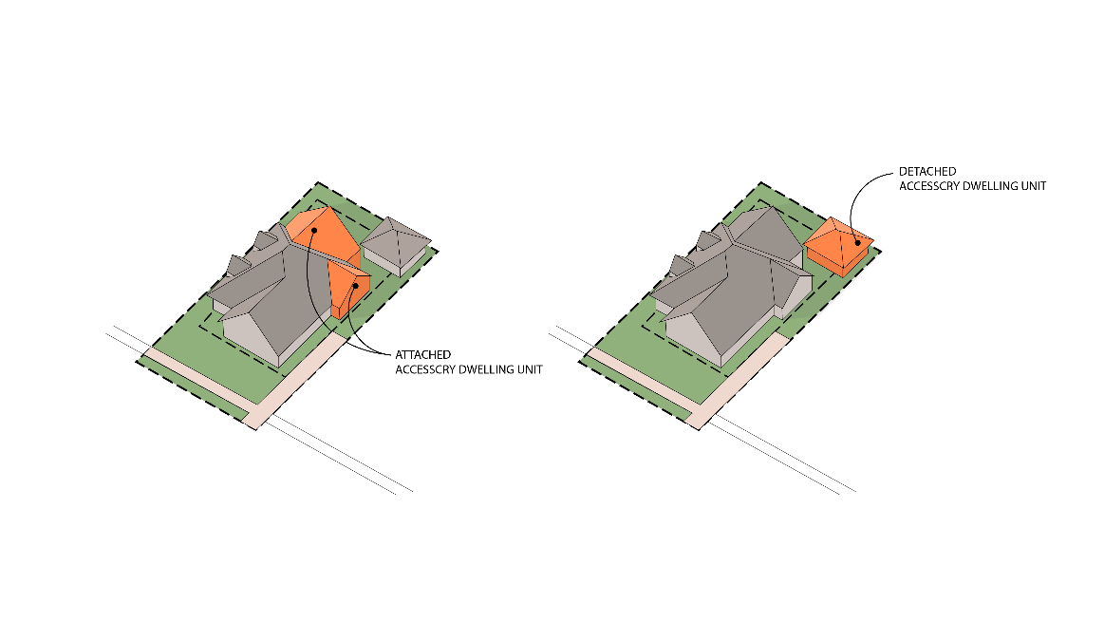

16.02 ACCESSORY USES AND STRUCTURES

- Applicability. These standards shall apply to all Accessory Structures, except Private Swimming Pools. Sheds in all Zoning Districts that are 100 square feet or less are exempt from these requirements. Accessory Structures shall be located behind the front plane of the Principal Building and must meet all other Setbacks.

- Location.
  - All Accessory Structures shall be located to the side or rear of the Principal Structure. In no case, shall an Accessory Structure be located closer than fifteen (15) feet from a Side or Rear Lot Line than the Principal Building.
  - Accessory Structures may encroach a required Side or Rear Setback, but in no case, shall an Accessory Structure be located closer than fifteen (15) feet from a Side or Rear Lot Line in a Residential District and forty (40) feet from a Side or Rear Lot Line in a Commercial District.
  - An Accessory Structure shall not be located closer than five (5) feet from the Principal Building or any other Accessory Structure.

- Height. Accessory Structures shall not exceed twenty-five (25) feet in height.

- Size. The cumulative area of Accessory Structures shall not exceed 2,400 square feet.

16.03 AGRITOURISM

- Purpose. It is the purpose of this Resolution to regulate Agritourism under the limitations of ORC §§ 303.21(C)(4) and 519.21(C)(4) in order to promote the health, safety, and general welfare for the citizens of the Township.

- Applicability and Conditional Approval. The Board of Zoning Appeals shall issue a Conditional Use permit when a proposed Agritourism use, as defined in Article II, complies with all of the conditions listed below:
  - Any structure used primarily for the purposes of Agritourism shall be limited by the standards set forth in Section 16.02 - Accessory Uses and Structures.
  - Parking complies with the regulations set forth in Article XX.
  - The corresponding Districts Setback requirements are met.
  - Proper ingress and egress are provided in accordance with this Code and any requirements by the relevant Fire Department. The ingress and egress plans shall be included with the Conditional Use Application.

16.04 AIRPORTS AND PRIVATE LANDINGS STRIPS

When Airports and Private Landings Strips are listed as a Conditional Use in a District, they shall be subject to the Nuisance regulations of this Code as well as any additional Federal Aviation Administration (FAA) regulations.

16.05 AUTOMOBILE-ORIENTED USES AND AUTOMOBILE OIL CHANGE FACILITIES

- Applicability. The following standards shall apply to Automobile-Oriented Uses and Automobile Oil Change Facilities, as defined in Article II:
  - All lubrication equipment, automobile wash equipment, hoists, and pits shall be enclosed entirely within a building.
  - The storage, sale, or rental of new or used cars, trucks, trailers, and any other vehicles on the premises is prohibited.
  - All driveways, parking areas, loading zones, and storage units shall be paved with impervious materials such as asphalt or concrete.
  - All Landscaping and Parking complies with Articles XIX and XX, respectively.

16.06 BED AND BREAKFAST FACILITIES

- Purpose. The purpose of this section is to adapt to accommodate interests in using Residential Buildings as Bed and Breakfast Facilities while also protecting residential neighborhoods from disruption that could result from traditional Bed and Breakfast Facilities, as defined in Article II, to create a convenient, safe, and harmonious environment in which Bed and Breakfast Facilities can be permitted and consistent with neighborhood tranquility.

- Applicability. Bed and Breakfast Facilities are considered Conditional Uses in Residential Districts. If the Ohio Revised Code (ORC) is amended to contradict with any portion of the standards of this section, then said contradicting standards shall become null and void. All other standards in this section that are consistent with state law shall remain in full force and effect.

- Requirements. Prior to issuing a Conditional Use Permit, the BZA must determine that the specific criteria for Conditional Uses in Article V are met in addition to the following regulations:
  - Bed and Breakfast Facilities shall be wholly within the principal structure. A Bed and Breakfast Facility is prohibited in Accessory Structures.
  - The principal or accessory residential structure, in which the Short-Term Rental is conducted, shall maintain the appearance of a Single-Family Dwelling Unit and be compatible with surrounding residences, in size and scale.
  - The Bed and Breakfast Facility establishment shall be operated by the occupant or owner of the premises, and the owner shall live full-time on the premises.
  - Exterior Signs shall be limited to a single nameplate not more than twelve (12) square feet in size. No Signs shall be internally illuminated.
  - Bed and Breakfast Facilities cannot be used for commercial uses such as parties, banquets, weddings, receptions, meetings, or advertising activities.
  - The applicant must submit proof of compliance with all applicable building and fire codes.
  - Adequate Off-Street Parking shall be provided as determined by the Board of Zoning Appeals. Off-Street Parking shall not be allowed in the Front Yard.
  - There shall be a limit of one (1) Bed and Breakfast Facility per Dwelling Unit on a parcel.
  - The Zoning Inspector may revoke the Conditional Use Permit if the property is delinquent in filing or payment of any Licking County or Union Township tax.
  - The bed tax applying to Bed and Breakfast Facilities shall be the same as that for Hotels and Motels.

16.07 CAMPGROUNDS

- Purpose. It is the purpose of this Resolution to regulate the establishment of Campgrounds as defined in Article II.

- Applicability. Campgrounds are regulated under Chapter 3729 of the Ohio Revised Code, which includes health department, fire safety, and siting location approval prior to the issuance of a Conditional Use Permit.

16.08 CANNABIS STORES

- Purpose. It is the purpose of this Resolution to regulate businesses that sell cannabis products in order to promote the health, safety, and general welfare for the citizens of the Township.

- Applicability. Cannabis Stores are prohibited within the Township in accordance with Ohio law and governed by R.C. 3780.25 and Township Resolution 2024-17.

16.09 COMMERCIAL KENNELS

- Purpose. The purpose of this section is to provide regulatory information regarding Commercial Kennels, as defined in Article II, designed only for the boarding of animals. The purpose for these requirements is to reduce noise levels from barking dogs to comply with the Township’s nuisance regulations adopted by separate resolution.

- General.
  - Indoor Commercial Kennels. Indoor Commercial Kennels with access to outdoor runs shall have solid doors between indoor and outdoor areas that are closed between the hours of 8:00 p.m. and 8:00 a.m. and all other non-business hours. All Commercial Kennels shall be contained within the principal structure and shall be separated from the exterior of the building by a solid wall and door.
  - Outdoor Commercial Kennels. Outdoor Commercial Kennels that are located only outdoors are prohibited.
  - Outdoor Runs. All outdoor runs shall be closed between the hours of 8:00 p.m. and 8:00 a.m. and all other non-business hours. All animals shall be housed inside the principal structure during these hours.
    - All outdoor runs shall be separated by a solid eight (8) foot wall, so as an animal in one outdoor run does not see an animal in another. The purpose of this requirement is to reduce the tendency of animals to bark or fight with other animals in adjoining runs.
    - All outdoor runs shall be located behind the principal structure and shall be maintained at least three hundred (300) feet from adjacent Lot Lines.
  - Perimeter Fencing. A six (6) foot tall perimeter fence shall be constructed to prevent any animal being picked up or dropped off that may get away from its handler and escape the premises, run into the public roadway, or onto adjoining properties. Said fence shall be constructed of solid, durable materials. Chain link fence with materials woven into the fencing are not permitted. The Board of Zoning Appeals may determine the area for the perimeter fencing based upon the area of use. Said perimeter fencing shall encompass all parking and loading areas, areas between structures, outdoor runs, and other areas where animals may be outside, either restrained or unrestrained.
  - Waste Disposal. The disposal of waste shall be in compliance with applicable State of Ohio Laws. No such waste shall be detectable by odor or visually seen from any adjoining lot of record. Proper measures shall be taken to ensure such waste does not affect any well water of adjoining lots of record and any surface water (i.e. streams, ponds, lakes, drainage channels, etc.).

16.10 COMMUNITY GARDENS

When Community Gardens are listed as a Permitted Use in a District, they shall be prohibited within the right-of-way and required Front Setback. Any shed, storage container, or similar structure within a Community Garden shall be considered an Accessory Structure and shall comply with the requirements of Section 16.02.

16.11 COMMUNITY SERVICES

- Purpose. It is the purpose of this Resolution to regulate Community Services, as defined in Article II, in order to promote the health, safety, and general welfare for the citizens of the Township.

- Applicability. Community Services shall be conditionally approved following the assessment of the required site plan as found in Article V - Conditional Use Permits – and the following conditions:
  - All buildings and structures shall be setback a minimum of fifty (50) feet from the front and rear lot lines and twenty-five (25) feet from the side lot lines. Except, however, that all buildings and structures shall be setback a minimum one hundred (100) feet from any lot line abutting an A or PR District.
  - Any outdoor activities, including music, loudspeakers, or other sound emitting devices that are not located within a fully enclosed building shall be located a minimum of 200 feet from any lot line abutting an A or PR District and must be transmitting sound inwards towards the property.
  - Sufficient evidence shall be provided that all off-street parking spaces have been provided in accordance with Article XX and that any on-street parking will be prohibited.

16.12 COMMUNITY SWIMMING POOLS

- Applicability. Community Swimming Pools, where permitted, shall comply with the following conditions and requirements:
  - The Community Swimming Pool is intended solely for the enjoyment of the members and the families and guests of members of the association or club under whose ownership or jurisdiction the Community Swimming Pool is operated.
  - The Community Swimming Pool and Accessory Structures thereto, including the areas used by the bathers, shall not be closer than fifty (50) feet to any Lot Line.
  - The Community Swimming Pool and all of the areas used by the bathers shall be walled or fenced to prevent uncontrolled access by children from the thoroughfare or adjacent properties.

16.13 DATA CENTERS

- Intent. The intent of this section is to regulate the placement and construction of Data Centers as a Conditional Use.

- Conditions. Along with the requirements of Article V – Conditional Use Permits – the Board of Zoning Appeals shall issue a Conditional Use permit when a proposed Data Center complies with all of the conditions listed below.
  - No building shall exceed sixty (60) feet in height.
  - All exhaust systems and mechanicals must be less than ninety (90) feet in height.
  - Sound emitted from a Data Center cannot exceed eighty-five (85) decibels (e.g., the sound of a lawn mower or garbage disposal) at the property line.
  - All Data Centers must connect into central water and sewer services.
  - Data Centers shall be required to adhere to all requirements in Article XIX - Landscaping – in addition to the requirements of this Section.
  - Data Centers shall maintain a minimum setback of two hundred (200) feet from any property line abutting a parcel zoned or used for residential purposes at the time of application. The Board of Zoning Appeals may require an increased setback upon a finding that site-specific conditions, including building height, equipment placement, topography, or lighting design, warrant additional separation to ensure compatibility with adjacent residential uses.
  - No principal building, generator, mechanical equipment yard, loading area, fuel storage, or parking area shall be located within the required setback.
  - The required setback area shall be maintained as a landscaped buffer and shall include, at a minimum, a combination of berming, evergreen plantings, and/or opaque fencing designed to mitigate noise, Light Trespass, and visual impacts.
  - A continuous 6-foot-tall hedgerow planted atop an 8-foot-tall earth berm or mound shall be required at the time of planting.
  - The hedgerow must have a minimum winter opacity of fifty (50) percent and a minimum summer opacity of seventy (70) percent.
  - Berms or mounds shall be constructed with a 3:1 foot slope.
  - Low-maintenance ground covers shall be utilized for earth berms and mounds.
  - Dead trees, shrubs and other landscaping material shall be promptly removed and shall be replaced within six (6) months

16.14 DRIVE-THRU FACILITIES

- Purpose. It is the purpose of this Resolution to regulate uses that involve Drive-Thrus, as defined in Article II, in order to promote the health, safety, and general welfare for the citizens of the Township.

- Applicability. For purposes of this section, Drive-Thru Facilities shall mean the following uses: Bank with Banking Window; Small Retail Business (with Drive-Thru); Medium Retail Business (with Drive-Thru), Large Retail Business (with Drive-Thru), and Restaurants (with Drive-Thru). These uses shall be conditionally approved following the assessment of the required site plan as found in Article V - Conditional Use Permits – in addition to applicable Drive-Thru Stacking Requirements as follows:
  - Drive-Thrus are considered Automobile Oriented Uses and require a Conditional Use permit from the Board of Zoning Appeals.
  - The following criteria shall be utilized by the Board of Zoning Appeals when approving a Conditional Use permit for a Drive-Thru.

Drive-Thru Stacking Requirements
Activity | Minimum Stacking Spaces (per lane) | Measured From and Including
Banks and ATMS | 3 | Teller/Window or ATM machine
Restaurant, Coffee Shop, or Other Similar Use | 8 | First Pick-Up Window
Full Service Car Wash* | 20 | Entrance of tunnel
Self Service – Automated Car Wash* | 4 | Washing bay
Fuel/Gasoline Pump Island | 1 | Pump island
Other – Not Specified | As determined by the Board of Zoning Appeals
*Board of Zoning Appeals shall also ensure adequate spaces are provided at the end of the tunnel or wash bay for the drying and vacuuming of vehicles.

  - Design and Layout.
    - Pump spaces can count toward the stacking space requirement.
    - Stacking spaces shall be a minimum of nine (9) feet by twenty (20) feet in size.
    - Stacking spaces may not impede on-or-off-site traffic movements or movements in or out of Off-Street Parking Spaces. There shall be a separate drive aisle allowing ingress and egress of vehicles that are not waiting in the Drive-Thru lanes.
    - Stacking spaces shall be separated from other internal driveways by surface markings or raised medians.
    - These stacking space requirements shall be in addition to the Off-Street Parking Space requirements in Article XX.
    - When adjacent to the AG or PR Districts, stacking spaces shall be required to be located on the sides of the Lot opposite the adjacent residential use.

16.15 EARLY CHILDHOOD LEARNING CENTER

- Purpose. It is the purpose of this Resolution to regulate uses that involve Early Childhood Learning Center, as defined in Article II, in order to promote the health, safety, and general welfare for the citizens of the Township. Given the size and intensity of these Uses, it is important to provide development standards for these Uses when located in certain areas of the Township to ensure that these Uses are designed in a manner that integrates them into the overall character of their surrounding area.

- Applicability. Early Childhood Learning Centers shall be conditionally approved following the assessment of the required site plan as found in Article V - Conditional Use Permits – and these following conditions:
  - The site and structure shall meet the applicable state code requirements, including licensing requirements.
  - Early Childhood Learning Centers shall not provide overnight accommodations.
  - A drop-off/pick-up location that will not impede traffic on the site shall be provided to ensure the safety of the adults and/or children. This location shall contain a minimum spot requirement of one (1) space for every seven (7) children and comply with regulations as found in Article XX – Parking and Off-Street Loading Requirements.
  - Outside areas for activities shall be fenced for the protection of the adults and/or children. The fence should be at a minimum four (4) feet in height; made from composite, metal, or wooden materials; and design shall be approved by the Board of Zoning Appeals. Outside areas shall be located at least three hundred (300) feet away from adjacently zoned residential Lot Lines.
  - Early Childhood Learning Centers shall not be located in residential Buildings.

16.16 ELDERLY/RETIREMENT HOUSING

- Purpose. It is the purpose of this Resolution to regulate uses that involve Elderly/Retirement Housing, as defined in Article II, in order to promote the health, safety, and general welfare for the citizens of the Township. Given the size and intensity of these Uses, it is important to provide development standards for these Uses when located in certain areas of the Township to ensure that these Uses are designed in a manner that integrates them into the overall character of their surrounding area.
- Applicability. Elderly/Retirement Housing shall be conditionally approved following the assessment of the required site plan as found in Article V - Conditional Use Permits – and these following conditions:
  - The site and structure shall meet the applicable state code requirements, including licensing requirements.
  - The site plan shall indicate parking and the emergency entrances and exits and appropriate safety elements.
  - Ambulance and delivery areas are to be obscured from all residential property view with a solid, ornamental masonry wall at least six (6) feet in height to a maximum of eight (8) feet in height.
  - Outside areas for activities shall be property fenced for the protection and care of the residents of the facility. Fencing height and design shall be approved by the Board of Zoning Appeals.

16.17 FENCES AND WALLS

Fences do not require a permit for construction. No fence shall be permitted within the right-of-way and must comply with the Visibility at Intersection requirements in Section 16.42. Fences or walls containing barbed wire or charged with electrical current are prohibited unless such fences or walls are located in the A or PR Districts and solely used for the enclosure of livestock.

16.18 FOOD TRUCKS

- Purpose. The intent of these regulations is to create an entrepreneurial opportunity for the food industry by providing creative opportunities outside of the traditional brick and mortar restaurants while controlling potential impacts such as traffic, food safety, and compatibility with the surrounding areas. These regulations have been crafted to ensure that Food Trucks are properly integrated into the overall existing or future streetscape designs of the Township. It is further the purpose of these regulations to limit the time frame for Food Trucks to allow ample time for business incubation but also discourage them from becoming permanent fixtures.

- Applications and Permits.
  - No one can operate or assist in the operation of a Food Truck in the Township without a Township Food Truck Permit, and applicable health license(s) issued in accordance with the Ohio Revised Code, the Ohio Administrative Code, and the Township Codes. The Food Truck may be subject to a fire inspection by the applicable Fire District. A copy of any required health license(s) or fire district inspection reports shall be submitted with the application for a zoning permit.
  - Individuals or organizations shall be permitted to operate a Food Truck on private property within the unincorporated limits of the Township after meeting the permit and fee requirements of this section, unless otherwise exempted by this section.
  - These regulations do not apply to Food Trucks operating within the right-of-way. Operations of a Food Truck within the public right-of-way permit is prohibited, unless the Township has issued a right-of-way permit for said Food Truck.
  - If a Food Truck proposed on private property complies with all standards in Section 16.18(c), a Food Truck Permit may be issued for up to thirty (30) consecutive days on a property. No more than one (1) Food Truck may operate on a single parcel at a time.

- Standards. The following standards shall apply to all Food Trucks on private property:
  - Maximum of one (1) Food Truck on lots less than one (1) acre, and maximum of two (2) Food Trucks on Lots greater than one (1) acre.
  - Food Trucks shall be located at least five (5) feet from the edge of any driveway, public sidewalk, exit or emergency access/exit way, or emergency call box, and must not be located within any area of the lot that impedes, endangers, or interferes with pedestrian or vehicular traffic. Food Trucks must be located a minimum distance of twenty-five (25) feet in all directions from fire hydrants.
  - Food Trucks shall be located at least two-hundred fifty (250) feet from any school unless with the school's written permission.
  - Food Trucks and associated seating must not occupy parking spaces without the business owners' written permission. The minimum required parking spaces shall be maintained at all times and all required handicap accessible parking spaces shall not be utilized for the Food Truck or seating.
  - Associated seating areas are only permitted on lots greater than one (1) acre and said seating must be removed from all permitted locations during impermissible hours of operation and must not be stored, parked, or left overnight on private and/or any public street or sidewalk.
  - Food Truck vendors are responsible for the proper disposal of waste and trash associated with the operation. Township trash receptacles shall not be used for this purpose. Vendors must remove all waste and trash from their approved location at the end of each day or as needed to maintain the health and safety of the public. The vendor must keep all areas within five (5) feet of the truck and associated seating area clean of grease, trash, paper, cups, or cans associated with the vending operations.
  - Food Truck vendors must provide at least one garbage can for customers within reasonable distance from the Food Truck if none are available.
  - No liquid waste or grease is to be disposed of in tree pits, storm drains, or onto the sidewalks, streets, or other public spaces. Under no circumstances can grease be released or disposed of into any centralized sanitary sewer system.
  - The Food Truck shall have access to water (through a water tank, a central water line connection, etc.) and electricity (through a generator, a utility line connection, etc.). These services shall be located in a manner that does not create a safety hazard to employees, patrons, or pedestrians.
  - Food Trucks shall be lit with existing and available site lighting. No additional exterior lighting shall be permitted. Lighting inside the Food Truck for the purpose of inside food preparation and menu illumination may be permitted. There shall be no light trespassing or additional glare onto adjacent properties. Flashing lights shall be prohibited.
  - Food Trucks are not allowed to park in a way that would impair sight visibility at intersections or impede cars from entering or exiting an existing lot.
  - The selling of alcoholic products is prohibited.
  - No Signs shall be permitted except as follows:
    - Signs directly painted or applied directly onto the Food Truck.
    - One (1) small Temporary Sign that does not exceed eight (8) square feet.
  - When a Food Truck is proposed to be located within one-hundred-and-fifty (150) feet of an existing One-Unit Dwelling, operations of said Food Truck shall be limited to 6 a.m. – 9 p.m. Sunday through Thursday and 7 a.m. – 11 p.m. Friday and Saturday.
  - An operator, or their designee, must be present at all times except in cases of an emergency.

- Exemptions.
  - No Food Truck Permit shall be required for any unit that operates exclusively as a subset of a Township approved special event, within the approved areas and time frames.
  - If a Food Truck is located on a property for less than eight (8) hours, no permit shall be required.
  - Due to the unique characteristics of the SE District, the Food Truck regulations do not apply; however, the Food Truck must still pass applicable Fire Department and Health Department regulations.
  - The Township may increase the maximum number of Food Trucks allowed for one (1) lot for Township approved special events.

16.19 GOVERNMENTAL SERVICES

- Purpose. It is the purpose of this Resolution to regulate Governmental Services, as defined in Article II, in order to promote the health, safety, and general welfare for the citizens of the Township.

- Applicability. Governmental Services shall be conditionally approved following the assessment of the required site plan as found in Article V - Conditional Use Permits – and the following conditions:
  - Such uses should be located on an Arterial or Collector Street or have direct access to such a street without going through a residential neighborhood.
  - All permanent buildings shall be constructed and designed so as to be harmonious with the setback and building design of existing uses in the neighborhood.
  - Screening and plantings are required to buffer the outdoor storage of vehicles or materials as well as any secondary structures from adjacent residential uses.

16.20 HOME OCCUPATIONS

- A Home Occupation shall be conducted entirely within a Dwelling Unit and shall be clearly subordinate and secondary to the use of the Dwelling Unit. Minor Home Occupations shall not be conducted within Accessory Structures, such as garages or sheds.

- The following regulations apply to all Home Occupations:
  - The appearance of the Dwelling Unit in which a Home Occupation is conducted shall not be altered or the occupation within the dwelling shall not be conducted in a manner which would cause the premises to differ from its surrounding character either by colors, materials, construction, or lighting.
  - The Home Occupation shall not generate traffic greater in volume for the subarea.
  - The Home Occupation shall not involve delivery trucks other than normal parcel delivery services.
  - No equipment or processes shall be used in a Home Occupation which creates noise, vibration, glare, fumes, odors, or electrical interference detectable to the normal senses on the lot. No equipment or processes shall be used which creates visual, audible, or electrical interference in any radio or television receiver or computer terminal off the premises or causes fluctuations in voltage off the premises.

- The following regulations apply to Minor Home Occupations:
  - There shall be no other people working in the Minor Home Occupation other than a person or person(s) who are residents of the Dwelling Unit in which the Home Occupation is conducted.
  - There shall be no signs associated with the Minor Home Occupation.
  - Not to occupy more than twenty (20) percent of the livable floor area of the Dwelling Unit.
  - No Zoning Permits are associated with Minor Home Occupations.
  - Home Occupations shall not be conducted within Accessory Structures, such as garages or sheds.

- The following regulations apply to Major Home Occupations:
  - Up to two (2) other persons who are not residents of the dwelling that work in the Major Home Occupation.
  - May exceed up to twenty (20) percent of the livable floor area of the Dwelling Unit, but in no case shall it exceed forty (40) percent.
  - One Ground-Mounted Sign is permitted that does not exceed six (6) square feet per sign face and has a maximum height of twelve (12) feet. Ground Signs shall not be more than six (6) feet in height relating to Section 21.07.
  - Major Home Occupations may be conducted in Accessory Structures, such as garages or sheds, in the A and PR Districts; however, a newly constructed Accessory Structure, if associated with the Major Home Occupation, will be considered a Conditional Use and must receive a Conditional Use Permit for construction.
  - Major Home Occupations, if located in an Accessory Structure, must be located 1,000 feet away from a Dwelling Unit on any adjoining Lots.
  - A Conditional Use Permit is required for approval of a Major Home Occupation.

16.21 LARGE EQUIPMENT REPAIR FACILITIES

- Purpose. It is the purpose of this Resolution to regulate Large Equipment Repair Facilities, as defined in Article II, in order to promote the health, safety, and general welfare for the citizens of the Township.

- Applicability. Large Equipment Repair Facilities shall be conditionally approved within the Districts wherein they require conditional approval following the assessment of the required site plan as found in Article V - Conditional Use Permits – and the following conditions:
  - Such uses shall be conducted a minimum of one hundred (100) feet from any residential district boundary and said operations will not be materially injurious or offensive to the occupants of adjacent premises or community by reason of the emission or creation of noise, vibration, electrical or other types of interference, materials, odors, fire, explosive hazards, glare or heat.
  - Sufficient landscaping around the perimeter of the site shall be provided to reduce any potential noise, visual, and environmental impacts associated with the proposed use. The landscaping shall include hardy evergreen shrubbery and shall be placed in a manner that creates a visual buffer from the adjacent parcels. In no case shall the landscaping be less than that required in Article XIX.
  - The proposed site shall have adequate ingress/egress for the type of vehicles utilized for transporting such materials, goods, or products, and proper on-site circulation shall be provided within the development, including appropriate loading/unloading areas.

16.22 LARGE HOME DAY CARE FACILITIES

- Purpose. It is the purpose of this Resolution to regulate Large Home Day Care Facilities, as defined in Article II, in order to promote the health, safety, and general welfare for the citizens of the Township.

- Applicability. Large Home Day Care Facilities shall be conditionally approved within the Districts wherein they require conditional approval following the assessment of the required site plan as found in Article V - Conditional Use Permits – and the following conditions:
  - The site and structure shall meet the applicable state code requirements, including licensing requirements.
  - Day care centers shall not provide overnight accommodations.
  - A drop-off/pick-up location that will not impede traffic on the site shall be provided to ensure the safety of the adults and/or children. This location shall be limited to the home's driveway or a designated area approved by the Board of Zoning Appeals.
  - Outside areas for activities shall be fenced for the protection of the adults and/or children. Fencing height and design shall be approved by the Board of Zoning Appeals.

16.23 LARGE RESIDENTIAL FACILITIES, EMERGENCY AND PROTECTIVE SHELTERS, TRANSITIONAL LIVING CENTERS, AND PERMANENT SUPPORTIVE HOUSING.

- Purpose. It is the purpose of this Resolution is to regulate rehabilitation centers, as defined below, in order to promote the health, safety, and general welfare of the citizens of the Township.

- Applicability. The regulations under this Resolution apply to the Districts where the following Drug Rehabilitation Centers are located:
  - Small Residential Facilities may only be located as a Permitted Use in all Residential and Commercial Districts.
  - Emergency and Protective Shelters, Large Residential Facilities, and Transitional Living Centers may only be located as a Conditional Use in the Gateway Corridor Overlay and GB Districts.
  - Permanent Supportive Housing may only be located as a Conditional Use in the Gateway Corridor Overlay and GB Districts.

- Development Standards: Emergency and Protective Shelters, Permanent Supportive Housing, Large Residential Facilities, Residential Treatment Facilities, and Transitional Living Centers are a Conditional Use within their respective Districts. The Board of Zoning Appeals shall ensure all the following standards are met prior to issuing a Conditional Use Permit for said facility:
  - The facility shall obtain all approvals and/or licenses as required by state and local laws.
  - The facility shall meet all applicable local and/or state building, safety, and fire safety requirements for the proposed facility and level of occupancy.
  - The facility shall provide 24-hour supervision by trained and qualified professional personnel.
  - For facilities located within Any Residential Districts, the architectural design and site layout of the facility shall be compatible with the residential character of the neighborhood.
  - For facilities located within or adjacent to Any Residential Districts, the planting of a hedge and tree combination along the facility is required for landscaping screening purposes. The required planting of a hedge and tree combination shall be a minimum of five (5) feet in height at the time of installation.
  - In addition to the minimum lot size requirement specified in their respective Districts, there shall be an additional five hundred (500) square feet of lot area required per tenant accommodated by the facility.
  - There shall be a minimum of two thousand (2,000) feet between any existing and proposed Large Residential Facilities. This distance shall be measured from the closest point of the Lot Lines for said facilities.
  - A Large Residential Facility shall not be located closer than two thousand (2,000) feet from a school, park, or a facility that sells alcoholic beverages.
  - Facilities shall be reasonably accessible, which requires adequate parking spaces for employees, visitors, and tenants at the main entrance of the facility and adequate pedestrian access.
  - All facilities shall follow the Sign regulations provided in Article XXI (for sign permits).
  - All exterior lighting fixtures shall be shaded to avoid casting direct light upon any adjoining property located in any Residential Districts.

16.24 LIGHTING

- Exterior lighting in non-residential districts shall comply with the following standards unless otherwise specified in this Code.

- Exceptions:
  - All exterior lighting fixtures producing light directly by the combustion of fossil fuels, such as kerosene lanterns or gas lamps, are exempt from the requirements of this section.
  - Holiday lighting shall be exempt from the requirements of this section.
  - Streetlights shall be exempt from the provisions of this section.

- Prohibited Lighting. Search lights, beacons, laser source lights, or any similar high-intensity or flashing lights are prohibited.

- Types of Fixtures. All light fixtures shall be full cut-off type fixtures except for decorative light fixtures.
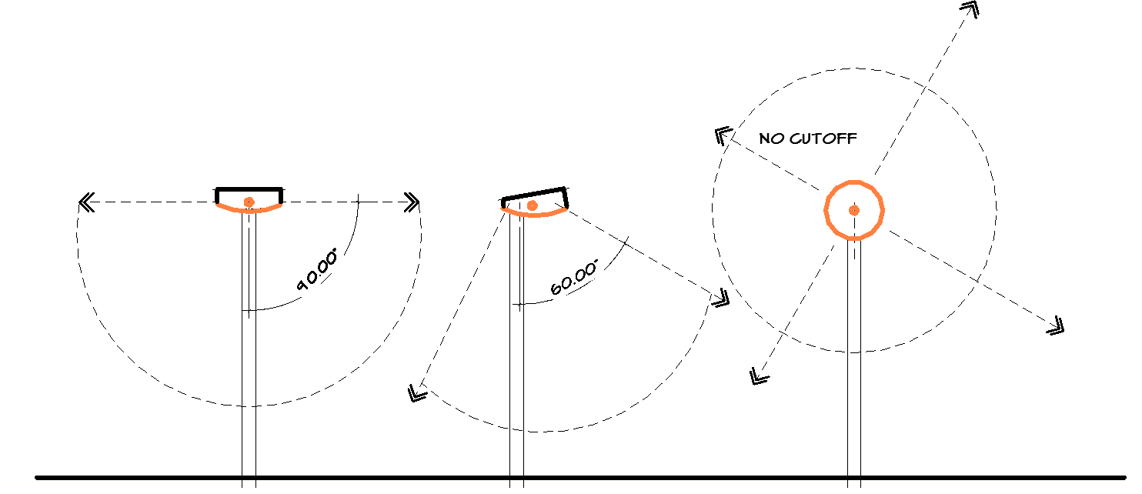
Full cutoff fixtures qualify with a cutoff angle to or less than 90-degress with no light projecting skyward.

- Fixture Height.
  - The fixture height in the parking lots shall not exceed twenty (20) feet.
  - Lighting located under canopies shall be flush mounted or recessed within the canopy.
  - Fixture height shall be measured from the finished grade to the topmost point of the fixture.

- Kelvin Temperature. The color temperature for all lights shall not exceed 4,000K or be cooler than natural white.

- Exterior lighting shall be designed and located to have the following maximum illumination levels. The levels shall be measured at the finished grade at the Lot Line as demonstrated by a lighting plan:
  - The maximum illumination at a Lot Line that abuts a lot within an existing Residential District or is zoned or designated for residential uses shall be 0.4 foot-candles.
  - The maximum illumination at a Lot Line that abuts any other use shall be 1.0 foot-candles.
  - The maximum illumination at a Lot Line for properties used for outdoor sports and recreation shall be reviewed for compliance with regard to the intent of these guidelines to minimize the impact of light trespass and glare on all surrounding properties and public rights-of-way.
The illumination across any property shall be designed to not create excessive dark spots that may create safety issues.

- Automobile Oriented Uses – Canopy Lighting. Automobile Oriented Use canopy lighting must be recessed within the canopy and use an opaque shield around the sides of the light.

16.25 LUMBERYARDS

- Purpose. It is the purpose of this Resolution to regulate Lumber Yards, as defined in Article II, in order to promote the health, safety, and general welfare for the citizens of the Township.

- Applicability. Lumber Yards shall be conditionally approved within the Districts wherein they require conditional approval following the assessment of the required site plan as found in Article V - Conditional Use Permits – and the following conditions:
  - Such Uses shall be located at least five hundred (500) feet from the boundary of any residential District and shall otherwise comply with the Setback requirements of the applicable District.
  - Sufficient Landscaping shall be provided along any adjacent public rights-of-way and along the boundary of any adjacent residential District to reduce the visual impacts of such Uses. The Landscaping shall include hardy evergreen shrubbery and shall be placed in a manner that creates a visual Buffer from the adjacent parcels. At a minimum, the standards in Section 19.08 shall apply.
  - The site shall be located so as to minimize the potential effect of winds carrying objectionable odors to adjacent residential areas.
  - The owner or operator shall employ every reasonable means of reducing the encroachment of dust upon surrounding properties.

16.26 MAKER SPACE

- Purpose. It is the purpose of this Resolution to regulate Maker Space, as defined in Article II, in order to promote the health, safety, and general welfare for the citizens of the Township.

- Applicability. Maker Spaces shall be conditionally approved within the Districts wherein they require conditional approval following the assessment of the required site plan as found in Article V - Conditional Use Permits – and the following conditions:
  - Such uses shall be conducted a minimum of one hundred (100) feet from any residential district boundary and said operations will not be materially injurious or offensive to the occupants of adjacent premises or community by reason of the emission or creation of noise, vibration, electrical or other types of interference, materials, odors, fire, explosive hazards, glare or heat.
  - Sufficient landscaping around the perimeter of the site shall be provided to reduce any potential noise, visual, and environmental impacts associated with the proposed use. The landscaping shall follow the regulations found in Article XIX and shall be placed in a manner that creates a visual buffer from the adjacent parcels. In no case shall the landscaping be less than that required in Article XIX.
  - The proposed site shall have adequate ingress/egress for the type of vehicles utilized for transporting such materials, goods, or products, and proper on-site circulation shall be provided within the development, including appropriate loading/unloading areas.

16.27 NURSING HOMES

- Purpose. It is the purpose of this Resolution to regulate Nursing Homes, as defined in Article II, in order to promote the health, safety, and general welfare for the citizens of the Township.

- Applicability. Nursing Homes shall be conditionally approved following the assessment of the required site plan as found in Article V - Conditional Use Permits – and the following conditions:

  - The proposed facility maintains a setback to all Lot Lines in a distance equal to the height of the Building.
  - Adequate ingress/egress has been provided for the facility and the proposed facility will generate no traffic unreasonably greater in volume or different in nature than would otherwise normally occur in the district in which the use is proposed.
  - The proposed architecture is compatible with the surrounding neighborhood.

16.28 OUTDOOR RECREATION FACILITIES

- Purpose. It is the purpose of this Resolution to regulate Outdoor Service Facilities, as defined in Article II, in order to promote the health, safety, and general welfare for the citizens of the Township.

- Applicability. Outdoor Recreation Facilities shall be conditionally approved following the assessment of the required site plan as found in Article V - Conditional Use Permits – and all requirements are met for landscaping, buffering, and parking are met under Articles XIX and XX, respectively, as well as the following conditions:
  - All outdoor service facilities shall be located a minimum of 300 feet from any residential district boundary.
  - Sufficient landscaping around the perimeter of the site shall be provided to reduce the noise and visual impacts typically associated with Outdoor Service Facilities. The landscaping shall include hardy evergreen shrubbery and shall be placed in a manner that creates a visual buffer from the adjacent parcels.

16.29 OUTDOOR SERVICE FACILITIES

- Purpose. It is the purpose of this Resolution to regulate Outdoor Service Facilities, as defined in Article II, in order to promote the health, safety, and general welfare for the citizens of the Township.

- Applicability. Outdoor Service Facilities shall be conditionally approved following the assessment of the required site plan as found in Article V - Conditional Use Permits – and the following conditions:
  - All outdoor service facilities shall be located a minimum of 100 feet from any residential district boundary.
  - Sufficient landscaping around the perimeter of the site shall be provided to reduce the noise and visual impacts typically associated with Outdoor Service Facilities. The landscaping shall include hardy evergreen shrubbery and shall be placed in a manner that creates a visual buffer from the adjacent parcels.

16.30 PLACES OF ASSEMBLY

- Purpose. It is the purpose of this Resolution to regulate Places of Assembly, as defined in Article II, in order to promote the health, safety, and general welfare for the citizens of the Township.

- Applicability. Places of Assembly shall be conditionally approved following the assessment of the required site plan as found in Article V - Conditional Use Permits – and the following conditions:
  - These uses should have direct access to an Arterial Street or be located at the intersections of an Arterial and/or a Collector Street so that significant amounts of traffic are not channeled through local residential streets.
  - The Lot Area shall be adequate to accommodate the required off-street parking requirements of the Place of Assembly.
  - The Place of Assembly shall be setback from any adjacent residential property line a minimum for hundred (100) feet. Any Outdoor Recreation Area associated with the Place of Assembly shall be located at least three hundred (300) feet away from an adjoining Lot Line in a Residential District.
  - Parking shall not be permitted within fifty (50) feet of any Side or Rear Lot Line.

16.31 PORTABLE HOME STORAGE UNITS AND SHIPPING CONTAINERS

- Purpose. It is the purpose of this Resolution to regulate Portable Home Storage Units and Shipping Containers, as defined in Article II, in order to promote the health, safety, and general welfare for the citizens of the Township.

- Portable Home Storage Units shall be a Permitted Use within the PR District provided the following regulations are met. A Zoning Permit shall be obtained for any Portable Home Storage Unit.
  - Portable Home Storage Units shall be prohibited from being located within any right-of-way.
  - Portable Home Storage Units shall be kept in the driveway of the property at the furthest accessible point from the street.
  - Only two (2) Portable Home Storage Units shall be permitted on any residential property at any one time.
  - Portable Home Storage Units shall be permitted for thirty (30) consecutive calendar-days within any 365 calendar-day period.
  - The Zoning Inspector may grant a one-time extension of up to 30 consecutive calendar days. Any additional extensions would require action by the Board of Zoning Appeals, which would be processed as a variance from these regulations.
  - Portable home storage units and roll-off containers shall not be utilized for living purposes.

- Shipping Containers, as defined in Article II, may be used as Accessory Structures on residential property located within the PR District, only in accordance with the following:
  - Shipping Containers fabricated for the purpose of transporting freight or goods on a truck, train, or ship shall be allowed to be set up as an Accessory Structure and shall comply with the requirements of Section 16.02
  - Purchaser, owners, or users of Shipping Containers shall obtain a Zoning Permit from the Township for each Container prior to placing or moving the Container onto their property.
  - The exterior of the Shipping Container shall be painted or altered to cover any advertising, lettering, or numbers.
  - Shipping Container stacking shall be prohibited.
  - All Shipping Containers shall be located at ground level for safety.
  - Shipping Containers shall be prohibited as Dwelling Units.

- Shipping Containers may be used as Accessory Dwelling Units as a Conditional Use on property located within the A District.

16.32 PLANTS FOR MIXING AND/OR PROCESSING CONCRETE AND/OR ASPHALT

- Purpose. It is the purpose of this Resolution to regulate Asphalt and Concrete Plants, as defined in Article II, in order to promote the health, safety, and general welfare for the citizens of the Township.

- Applicability. Asphalt and Concrete Plants shall be conditionally approved following the assessment of the required site plan as found in Article V - Conditional Use Permits – as well as meeting any additional requirements set by the Ohio Environmental Protection Agency, and the following conditions:
  - Such uses shall be setback a minimum of five hundred (500) feet from an occupied Dwelling unless written permission is given by the owner of the Dwelling and is presented to the Board of Zoning Appeals. The Setback requirements of the applicable District shall otherwise apply.
  - The area of use shall be completely enclosed by a chain link fence (minimum of 6 feet in height). An earthen mound at least six (6) feet in height with a maximum side slope of 3:1 shall be provided on the inside of the fence. Landscaping shall be provided on the earthen mound and shall include hardy evergreen shrubbery and shall be placed in a manner that creates a visual buffer from the adjacent parcels. In no case shall the landscaping be less than that required in Article XIX.
  - Truck routes shall be established for movement in and out of the development in such a way that it will minimize the wear on public streets and prevent hazards and damage to other properties in the community.
  - Sufficient evidence shall be provided to the Board of Zoning Appeals indicating that all applicable licenses and/or permits have been obtained from the State of Ohio.

16.33 RECREATIONAL VEHICLES

- Purpose. It is the purpose of this Resolution to regulate Recreational Vehicles, as defined in Article II, within Residential Districts in order to promote the health, safety, and general welfare for the citizens of the Township while also respecting the Township’s rural character.

- Recreational Vehicles in the PR District. Residents shall be permitted to park a Recreational Vehicle on a Lot located in the PR District provided the following criteria are met:
  - There shall be a maximum of one Recreational Vehicle per dwelling unit permitted on said lot. For purposes of this Code, a boat stored on a boat trailer is considered one Recreational Vehicle. Said Recreational Vehicle shall not exceed thirty (30) feet in length, nine (9) feet in width, and twelve (12) feet in height.
  - Recreational Vehicles shall be parked on a paved or gravel surface located behind or beside the primary structure and shall not be parked in the grass.
  - Recreational Vehicles shall be parked no closer than three (3) feet from any side property line.
  - Recreational Vehicles shall not be located forward of the front plane of the main dwelling, except however, the Recreational Vehicle may be parked on the paved driveway in front of the main dwelling for a period not to exceed forty-eight (48) hours for loading and unloading. In no case shall said Recreational Vehicle be parked, stored, or displayed for sale in a manner that blocks any sidewalk or obstructs sight lines for any vehicle entering or exiting the right-of-way.
  - In no case, shall a Recreational Vehicle, or any motor vehicle be utilized for living, sleeping, housekeeping, business, or storage purposes.

- Recreational Vehicles in the A District – Residents shall be permitted to park a Recreational Vehicle on a Lot located in the A District provided the following criteria are met:
  - The Recreational Vehicle shall be located in a location on the Lot that is not visible from the Street Right-of-Way.

16.34 SCHOOLS

- Purpose. It is the purpose of this Resolution to regulate Schools, as defined in Article II, in order to promote the health, safety, and general welfare for the citizens of the Township.

- Applicability. Schools shall be conditionally approved following the assessment of the required site plan as found in Article V - Conditional Use Permits – and the following conditions:
  - Outdoor play/recreation areas may be required by the Board of Zoning Appeals to be fenced.
  - The site and structure shall meet applicable state code requirements, including licensing requirements.
  - A drop-off/pick-up location that will not impede traffic on and off the site shall be provided to ensure the safety of the adults and children. This location shall contain a minimum stacking requirement to accommodate traffic in a manner that does not adversely affect public roads, which shall be made evident upon submission of the Conditional Use Permit.

16.35 SELF-SERVICE STORAGE FACILITY

- Purpose. It is the purpose of this Resolution to regulate Self-Service Storage Facilities, as defined in Article II, in order to promote the health, safety, and general welfare for the citizens of the Township.

- Self Service Storage Facility shall be permitted within an enclosed structure, provided the following regulations are met. Outdoor storage is not permitted.
  - All storage buildings shall be setback a minimum of five hundred (500) feet from any adjacent residential Lot Line and forty (40) feet from all other Lot Lines.
  - The storage area shall be completely enclosed by buildings, Walls or Fences, or a combination thereof.
  - Storage spaces shall be used only for the storage of personal property.
  - No outdoor storage shall be permitted.
  - No explosive, flammable, or hazardous materials or chemicals shall be permitted except as authorized by the Ohio Fire Code.
  - No sale, repair, fabrication, or servicing of goods, motor vehicles, appliances, equipment, or materials or similar activities shall be permitted.
  - Self-Storage Facilities shall not be used for living purposes or commercial business activity.
  - At least forty (40) feet of clear, unobstructed driveway depth will be provided from the road to the primary access gate or principal entry point of the Facility.
  - All driveways, parking areas, loading zones, and storage units shall be paved with impervious materials such as asphalt or concrete.
  - All storage buildings/facilities must be constructed with building materials, and colors that align with the general aesthetic of the surrounding area determined by the Board of Zoning Appeals.

16.36 SHOOTING RANGES

- Purpose. It is the purpose of this Resolution to regulate Indoor and Outdoor Shooting Ranges, as defined in Article II, in order to promote the health, safety, and general welfare for the citizens of the Township.

- Applicability. Indoor and Outdoor Shooting Ranges shall be conditionally approved following the assessment of the required site plan as found in Article V - Conditional Use Permits – as well as meeting any regulations set by the Ohio Division of Wildlife, the National Rifle Association (NRA), and the Ohio Revised Code.

16.37 SHORT-TERM RENTALS

- Purpose. The purpose of this section is to adapt to new rental market trends that include online platforms, such as Airbnb and VRBO, while also protecting residential neighborhoods from disruption that could result from Short-Term Rentals and to create a convenient, safe, and harmonious environment in which Short-Term Rentals can be permitted and consistent with neighborhood tranquility.

- Applicability. Short-Term Rentals are considered Conditional Uses in Residential Districts. If the Ohio Revised Code (ORC) is amended to contradict with any portion of the standards of this section, then said contradicting standards shall become null and void. All other standards in this section that are consistent with state law shall remain in full force and effect.

- Registration. An application for a Short-Term Rental permit, and/or renewal of a permit, shall be made to Union Township, with an application fee listed in the separate Fee Schedule adopted by the Township.

- Requirements. Prior to issuing a Conditional Use Permit, the BZA must determine that the specific criteria for Article V - Conditional Use Permits – are met in addition to the following regulations:
  - Short-Term Rentals shall be wholly within the Principal or Accessory Dwelling Unit The Accessory Structure shall be no larger than one thousand (1,000) square feet.
  - The principal or accessory residential structure, in which the Short-Term Rental is conducted, shall maintain the appearance of a Single-Family Dwelling Unit and be compatible with surrounding residences, in size and scale.
  - The Short-Term Rental establishment shall be operated by the occupant or owner of the premises and may be a Hosted or Unhosted Short-Term Rental as defined in Article II.
  - Exterior Signs shall be limited to a single nameplate not more than twelve (12) square feet in size. No Signs shall be internally illuminated.
  - Short-Term Rentals cannot be used for commercial uses such as parties, banquets, weddings, receptions, meetings, or advertising activities.
  - The applicant must submit proof of compliance with all applicable building and fire codes.
  - Adequate Off-Street Parking shall be provided as determined by the Board of Zoning Appeals. Off-Street Parking shall not be allowed in the Front Yard.
  - There shall be a limit of one (1) Short-Term Rental per Dwelling Unit on a parcel.
  - The Zoning Inspector may revoke the Conditional Use Permit if the property is delinquent in filing or payment of any Licking County or Union Township tax.

16.38 SOLAR ENERGY SYSTEMS

- Establishment and Purpose. The purpose of this article is to provide a regulatory framework for the installation and construction of solar energy systems (SES), subject to reasonable restrictions, which will preserve the public health, safety, and welfare, while also maintaining the character of the Township. This section applies to SES to be installed and constructed on any property in any Zoning District for systems generating up to 50 MW per the Ohio Revised Code. Any SES producing more than 50 MW is exempt from the requirements of this section and are subject to the jurisdiction of the Ohio Siting Board.

- Standards. All SES are required to meet the standards of the Licking County Building Code and the National Electric Code and are subject to inspection by the Licking County Building Code inspector.
  - Roof Mounted and Integrated SES Standards.
    - Roof Mounted and Integrated SES shall be considered an Accessory Use and permitted by right within all Zoning Districts if mounted to an existing structure subject to the standards for Accessory Uses in the applicable Zoning District and the specific criteria set forth in this Code.
    - All SES must comply with all bulk, area, and setback requirements for the corresponding Zoning District.
    - On a pitched/sloped roof, the SES shall be installed parallel to the roof surface and shall not extend beyond the roof peak or roof edge.
    - On a flat roof, the SES is permitted to exceed the respective Zoning District height limit by up to five (5) feet.
    - Screening shall not be required for Roof Mounted or Integrated SES.
  - Ground Mounted SES Standards.
    - Small Ground Mounted SES shall be considered a Conditional Use in the GC, TI, and I Districts.
    - Individual Ground Mounted SES shall be considered a Conditional Use in the A and PR Districts.
    - All SES must comply with all bulk, area, and setback requirements for the corresponding Zoning District.
    - Screening shall be required for Ground Mounted SES.
    - A landscaping plan shall be required and shall integrate native vegetation in line with the rural character of the Township and shall meet all landscaping requirements of Article XIX of this Code.

16.39 TELECOMMUNICATION TOWERS

- Intent. The intent of this section is to regulate the placement and construction of Telecommunication Towers in Residential Districts in order to protect the public, health, and safety of the Township residents without interfering with the competitiveness in the telecommunications industry. It is further the purpose of this section to encourage Co-Location of antennas on existing towers in order to minimize tower locations and to protect residential areas through the use of height, Setback, and Lot Area requirements.

- Applicability. The following regulations shall apply, through the Conditional Use process, to Free-Standing Telecommunication Towers located within the A and PR Districts. These regulations shall not apply to Telecommunication Towers proposed in Districts that list such structures as Permitted Uses.

- Conditions. The Board of Zoning Appeals shall issue a Conditional Use Permit when a proposed Free-Standing Telecommunication Tower in a Residential District complies with all of the conditions listed below. When measuring Setbacks and Lot Areas, the dimension of the entire Lot shall control, even though the tower may be located on a leased area within such Lot.
  - The minimum Lot Area shall comply with the minimum Lot Area for the applicable Zoning District.
  - The minimum Setback shall be a 1:1.1 ratio (for every foot in tower height there shall be 1.1 feet distance from the tower base to the nearest Lot Line). No new residential structures shall be permitted within the Setback area.
  - The maximum height of the Free-Standing Telecommunication Tower shall be as follows:

# of Users for Which the  Tower is Designed | Maximum Height
1 | 150 feet
2 | 165 feet
3 | 180 feet
4 | 195 feet

  - The applicant shall demonstrate that the proposed tower is the least aesthetically intrusive facility for the neighborhood and function. Guy wires and lattice designs shall not be permitted. Towers shall be a non–contrasting gray or similar color or a galvanized steel finish, unless these color requirements conflict with any FAA or FCC regulation. In such cases, the tower shall comply with those color requirements. Alternative tower designs that camouflage the tower and/or antenna, such as man–made trees, may also be permitted as approved by the Board of Zoning Appeals. The proposed tower must comply with Article V - Conditional Use Permits.
  - A fence (minimum six (6) feet in height) shall fully enclose the tower. Gates shall be locked at all times when unattended by an agent of the telecommunication provider. All towers must be un-climbable by design or protected by anti-climbing devices.
  - A landscaped Buffer of not less than fifteen (15) feet in depth shall be placed between the fence surrounding the tower and any adjacent public right-of-way and any adjacent properties. The 15–foot Buffer shall consist of hardy evergreen shrubbery, not less than six (6) feet in height, and of a density to obstruct the view. The Board of Zoning Appeals may require additional Landscaping upon review of an individual application. All required Landscaping shall be continuously maintained and promptly restored, if necessary.
  - No signage shall be permitted anywhere on the Telecommunication Tower, antenna, or fence, except for a Sign, not to exceed four (4) square feet, containing emergency contact information and no trespassing language, which shall be attached to the gate of the required fence. Any other signage required by Federal regulations shall be permitted.
  - No lighting shall be permitted, except as required by Federal regulations.
  - One point of access from a public road to the Free-Standing Telecommunications Tower shall be provided. The Board of Zoning Appeals may require review by the Fire Department to ensure the proposed drive is suitable for emergency access. The use of existing access points is preferred.
  - The tower shall be designed and certified by a professional engineer to be structurally sound and, at a minimum, in conformance with the Ohio Basic Building Code.
  - The applicant shall demonstrate that Co–Location on an existing tower is not feasible, by submitting a report, prepared by a qualified Radio Frequency (R.F.) Engineer, inventorying all existing Telecommunication Towers in Union Township. Unless the applicant can demonstrate that Co–Location is not feasible, the Board of Zoning Appeals may deny the Conditional Use permit and require the proposed antenna be placed on the available, existing tower. The Board of Zoning Appeals shall use the following criteria to determine if Co–Location is not feasible:
    - Written documentation from the Owner of the existing tower(s) refusing to allow Co–Location;
    - The proposed antenna would exceed the structural capacity of the existing tower and the existing tower cannot be reinforced, modified, or replaced to accommodate the proposed antenna at a reasonable cost, as documented by a professional engineer who is licensed in the State of Ohio and hired by the applicant.
    - The proposed antenna would cause interference impacting the usability of other existing equipment at the tower and the interference cannot be prevented at reasonable cost, as documented by a professional engineer who is licensed in the State of Ohio and hired by the applicant.
    - Existing towers cannot accommodate the proposed antenna at a height necessary to function reasonably, as documented by a qualified R. F. engineer who is licensed in the State of Ohio and hired by the applicant.
  - The tower owner shall be required to submit an annual notice of operation on or before January 31st of each year. In the event that the tower is no longer being operated or utilized, it shall be removed within 180–days after the Use of the tower is discontinued.
  - The applicant shall provide a signed statement indicating that the applicant agrees to allow for the potential Co–Location of other antenna to the extent to which the tower is designed.
  - Any other conditions as warranted by the Board of Zoning Appeals and in accordance with Article V - Conditional Use Permits.

- Exemptions. In the event a Telecommunication Tower is proposed within a Residential District, the Telecommunication Tower may be exempt from all Telecommunication Tower regulations and may be considered to be a permitted Use, if criteria listed in all subsections of Section 16.39(d) below have been met:
  - The telecommunication provider provides each of the following by certified mail:
    - Written notice to each Owner of property, as shown on the County Auditor’s then current tax list, whose land is contiguous to or directly across a Street or roadway from the property on which the Telecommunication Tower is proposed to be constructed, stating all of the following in clear and concise language:
      - The Person’s intent to construct the tower.
      - A description of the property sufficient to identify the proposed location;
      - That, no later than fifteen days after the date of mailing of the notice, any such property Owner may give written notice to the Board of Trustees requesting that the telecommunication regulations of the Zoning Resolution apply to the proposed location of the tower.
    - Written notice to the Board of Trustees of the information specified in Sections 16.39(d)(1(i)(A)-(B). The notice to the Board of Trustees shall also include verification that the Person has complied with Section 16.39(d)(1)(i). Within fifteen (15) days of a telecommunications provider mailing the notices, a Township Trustee may object to the proposed location of the telecommunications tower.
  - If the Board of Trustees does not receive any notice from a notified property Owner nor any objection from a Township Trustee is provided within fifteen (15) days of a provider mailing the notices, then the proposed Telecommunication Tower is exempt from all telecommunication regulations within the Zoning Resolution.
  - If a notice from a notified property Owner or an objection from a Township Trustee is made, then all applicable Telecommunication Tower regulations within the Zoning Resolution shall apply. The Township Fiscal Officer, within five (5) days of receiving the first objection from a property Owner or Trustee, shall notify the telecommunications provider that the telecommunication regulations within the Township Zoning Resolution apply.
  - If a provider fails to send proper notices, then the regulations within this section shall apply.

16.40 TEMPORARY STRUCTURES

- Temporary Construction Trailers/Offices. Temporary construction trailers/offices may be permitted in any District during the construction of building(s) and site improvements provided the following regulations are met. A Zoning Permit shall be obtained prior to installing and utilizing the temporary construction trailer/office.
  - The temporary trailer/office shall be prohibited from being located in the right-of-way and shall be setback a minimum of ten (10) feet from the right-of-way line.
  - In all Districts, except the Residential Districts, the temporary trailer/office shall only be permitted for a period of two (2) years. If additional time is necessary due to a delay in construction, the applicant shall seek an extension from the Zoning Inspector. Due to the intensity of use and length of construction time for sites within the I District; this time frame does not apply to temporary construction trailers/offices in the I District.

16.41 VEHICULAR SALES

- Applicability. The following standards shall apply to all uses associated with facilities that are engaged in vehicle sales, which includes, new and used cars; motorcycles; and Recreational Vehicles, as defined in Article II under the category of Vehicular Sales:
  - Any lighting transmissions shall comply with Article V - Conditional Use Permits – and the Township's Nuisance regulations.
  - All driveways, parking areas, loading zones, and storage units shall be paved with impervious materials such as asphalt or concrete.
  - Any service facilities located on the property shall be clearly incidental to the vehicle sales operation and shall comply with the standards set forth in Section 16.02.

16.42 VISIBILITY AT INTERSECTIONS

- Sight Triangle. There shall be a sight triangle established at every intersection of two public rights-of-way. The sight triangle is the triangular area where two (2) streets intersect, bounded by the edge of the street and a line joining the points on the rights-of-way from their point of intersection for a distance equal to half the width of each street right-of-way. The vision triangle shall be measured along the right-of-way within the boundaries of the property.

- Visibility Maintained. There shall be no visual obstructions within the defined sight triangle. A visual obstruction is any object between the height of no more than three (3) feet measured relative to the elevation to the nearest pavement crown. This is based on a driver eye height of three feet (based on the American Association of State Highway and Transportation Official standards). Overhanging branches or other elevated obstructions shall not be any lower than ten (10) feet measured relative to the elevation of the nearest pavement crown.

- Non-Signalized, Arterial, and Collector Road Intersection Sight Distances. In order to properly calculate the intersection sight distance for cars turning left and right onto non-signalized Arterial or Collector Roads, look to the equation and table provided in Section 201.3.2 of the ODOT Location & Design Manual, Volume 1 – Roadway Design. These standards for sight distances shall additionally be met during the application procedures for PUDs found in Article XV.

- Example where Right-of-Way = Lot Line
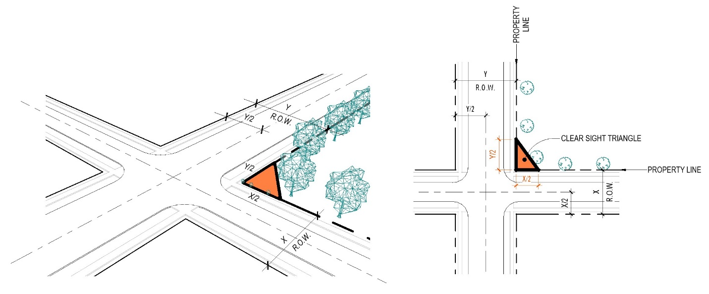

- Example where Lot Line is the Centerline of the Road:
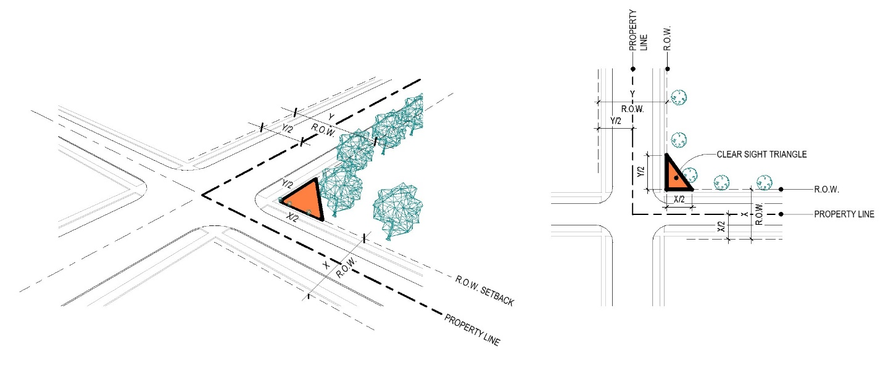

16.43 WASTE AND WASTEWATER FACILITIES

- Purpose. It is the purpose of this Resolution to regulate Waste and Wastewater Facilities, as defined in Article II, in order to promote the health, safety, and general welfare for the citizens of the Township.

- Applicability. Waste and Wastewater Facilities shall be conditionally approved following the assessment of the required site plan as found in Article V - Conditional Use Permits – and the following conditions:
  - Such uses shall be conducted a minimum of five hundred (500) feet from any residential district boundary and said operations will not be materially injurious or offensive to the occupants of adjacent premises or community by reason of the emission or creation of noise, vibration, electrical or other types of interference, materials, odors, fire, explosive hazards, glare or heat.
  - Such uses should be located on an Arterial or Collector Street or have direct access to such a street without going through a residential neighborhood.
  - All permanent buildings shall be constructed and designed so as to be harmonious with the setback and building design of existing uses in the neighborhood.
  - Sufficient landscaping around the perimeter of the site shall be provided to reduce any potential noise, visual, and environmental impacts associated with the proposed use. The landscaping shall follow the regulations found in Article XIX and shall be placed in a manner that creates a visual buffer from the adjacent parcels. In no case shall the landscaping be less than that required in Article XIX.
  - The site shall be located so as to minimize the potential effect of winds carrying objectionable odors to adjacent residential areas.

16.44 WIND ENERGY SYSTEMS

- Intent. The intent of this section is to regulate the placement and construction of Small Wind Farms, as defined in Article II, in order to protect the health and safety of Township residents without interfering with the expansion of clean, sustainable, and renewable energy sources.

- Applicability. The following regulations shall apply, through the Conditional Use process, to Small Wind Farms and individual Wind Energy Conversion Systems when proposed to be located within a Zoning District where such use is listed as a Conditional Use, unless otherwise exempted by state or federal law.
  - Small Wind Farms shall be considered a Conditional Use across all Zoning Districts.
  - Individual Wind Energy Conversion Systems shall be considered a Conditional Use in the Gateway Overlay District.

- Conditions. The Board of Zoning Appeals shall issue a Conditional Use permit when a proposed Small Wind Farm complies with all of the conditions listed below.
  - In no case shall any tower within a Small Wind Farm be located closer than two (2) times the tower height to any residential Structure, public road/right-of-way, third party transmission lines, or adjacent property lines. New residential structures shall not be permitted within this Setback area.
  - Small Wind Farms shall conform to applicable industry standards, including those of the American National Standards Institute (ANSI). Applicants shall submit certificates of design compliance that equipment manufacturers have obtained from Underwriters Laboratories (UL) or an equivalent third party.
  - Once a Conditional Use permit is granted per the requirements of this Section, a licensed Ohio professional engineer shall certify, as part of the Zoning Permit application, that the foundation and tower design of the Small Wind Farm, including substation, transformer, underground cabling, or parts thereof and the access road, is within the accepted professional standards, given local soil and climate conditions.
  - All Small Wind Farms shall be equipped with a redundant braking system. This includes both aerodynamic and over speed controls (including variable pitch, tip, and other similar systems and mechanical brakes). Mechanical brakes shall be operated in a fail–safe mode. Stall regulations shall not be considered a sufficient braking system for overspeed protection. The applicant shall provide sufficient information to assure the Board of Zoning Appeals that this requirement will be met.
  - All electrical components of the Small Wind Farm shall conform to applicable local, state, and national codes, and relevant national and international standards (ANSI).
  - Towers and blades shall be a non–contrasting gray or similar color or a galvanized steel finish unless these color requirements conflict with any FAA regulation. In such cases, the tower shall comply with those color requirements.
  - All towers within a Small Wind Farm are unclimbable by design or protected by anticlimbing devices.
  - No signage shall be permitted within any portion of a Small Wind Farm except for a Sign, not to exceed six (6) square feet, containing emergency contact information and no trespassing language.
  - One point of access from a public road to the Small Wind Farm shall be provided. The Board of Zoning Appeals may require review by the Township Fire Department to ensure the proposed drive is suitable for emergency access. The use of existing access points is preferred.
  - The applicant shall be responsible for obtaining all required approvals/permits for transporting on a public road the towers, blades, substation parts, and or equipment for construction, operation, or maintenance of the Small Wind Farm.
  - The applicant shall demonstrate that the noise levels associated with the Small Wind Farm will not be disruptive to any adjacent residential areas. Noise shall not create a nuisance as determined by separate resolution as adopted by the Township.
  - No lighting shall be permitted, except as required by Federal regulations.
  - The applicant shall provide the applicable microwave transmission providers and local emergency service providers/911 operators copies of the project summary and site plan as set for in this Section. To the extent that the above providers demonstrate a likelihood of interference with its communications resulting from the Small Wind Farm, the applicant shall take reasonable measures to mitigate such anticipated interference. If, after construction of the Small Wind Farm, the Owner or operator receives a written complaint related to the above–mentioned interference, the Owner shall take reasonable steps to respond to the complaint or shall be in violation of said Conditional Use permit, which shall be punishable per Article VIII – Enforcement.
  - The Owner or operator of the Small Wind Farm shall be required to submit an annual notice of operation on or before January 31st of each year. In the event that the Small Wind Farm is no longer being operated or utilized (unless due to documented maintenance or electrical grid issues and written notice has been provided to the township), the Small Wind Farm shall be removed within one hundred eighty (180) days after the Use has been discontinued. In addition to removing all towers within the system, the Owner/operator shall restore the site to its original condition prior to the location of such system on said property. Any foundation associated with a Small Wind Farm shall be removed from the site to a depth which is at least forty–eight (48) inches below restored ground level and the site restored to its original state including the planting of any grasses or cover crops. All transmission equipment, Buildings and fences shall also be removed.

- Submittal Requirements. The following information must be submitted with the Conditional Use application (in addition to the items required in Article V – Conditional Use Permits).
  - A Small Wind Farm project summary including to the extent available the following items:
    - A general description of the project, including its approximate name plate generating capacity; the potential equipment manufacturer(s) type(s) of the Small Wind Farm, the number of towers within the proposed Small Wind Farm, and the name plat generating capacity of each tower, and the maximum height proposed for each tower.
    - A description of the applicant, Owner and operator, including their respective business Structures.
  - The name(s), address(es), and phone number(s) of the applicant(s), Owner and operator, and all property Owner(s), if known.
  - The site plan required in Section 5.01 shall also include: guy lines and anchor bases (if any), primary Structure(s), property lines (including identification of adjoining properties), set back lines, public access roads and turnout locations, substation(s), ancillary equipment, third party transmission lines, and layout of all Structures within the geographical boundaries of any Setback.
  - All required studies, reports, certifications, and approval demonstrating compliance with the provisions of this Zoning Resolution.

ARTICLE XVII
Adult Entertainment Facilities

17.01 Rationale and Findings
17.02 Definitions
17.03 Criteria
17.04 Severability

17.01 RATIONALE AND FINDINGS

- Purpose. In enacting this Code, pursuant to Sections 503.51 and 503.52 of the Ohio Revised Code, the Township Board of Trustees makes the following statement of intents and findings:
  - That Adult Entertainment Businesses require special supervision from the public safety agencies of the Township in order to protect and preserve the health, safety, and general welfare of the patrons and employees of the business as well as the citizens of the Township.
  - That Adult Entertainment Businesses are frequently used for unlawful sexual activities, including prostitution and sexual liaisons of a casual nature.
  - That the concern over sexually transmitted diseases is a legitimate health concern of the Township which demands reasonable regulation of Adult Entertainment Businesses by the Township in the specified manner, and expanded authority for reasonable regulation of Adult Entertainment Businesses by local governments, in order to protect the health and well-being of the citizens.
  - That minimal regulations enacted by the Township are a legitimate and reasonable means of accountability to ensure that operators of Adult Entertainment Businesses comply with reasonable regulations and to ensure that operators do not knowingly allow their establishments to be used as places of illegal sexual activity or solicitation.
  - There is convincing documented evidence that Adult Entertainment Businesses, because of their very nature, have a deleterious effect on both the existing businesses around them and the surrounding residential areas adjacent to them, cause increase crime – particularly in the overnight hours, and downgrade property values.
  - The Township Board of Trustees desires to minimize and control these adverse effects by regulating Adult Entertainment in the specified manner. And by minimizing and controlling these adverse effects, the Township Board of Trustees seeks to protect the health, safety, and welfare of the citizenry; protect the citizens from increased crime; preserve the quality of life; preserve the property values and character of surrounding neighborhoods; and deter the spread of urban blight.
  - It is determined that the current local zoning and other locational criteria do not adequately protect the health, safety, and general welfare of the people and that expanded regulation of Adult Entertainment Businesses is necessary.
  - It is not the intent of the Township Board of Trustees in enacting this act to suppress or authorize the suppression of any speech activities protected by the First Amendment, but to enact content-neutral statutes that address the secondary effects of Adult Entertainment Businesses.
  - It is not the intent of the Township Board of Trustees to condone or legitimize the distribution of obscene material, and the Township Board of Trustees recognizes that state and federal law prohibits the distribution of obscene materials and expects and encourages state law enforcement officials to enforce state obscenity statutes against any such illegal activities in this state.

- It is the intent of the Township Board of Trustees in enacting this Code to regulate Adult Entertainment Businesses in the specified manner in order to promote the health, safety, and general welfare of the citizens of the Township and establish reasonable regulations to prevent the deleterious secondary effects of Adult Entertainment Businesses within the Township. The provisions of this Code have neither the purpose nor effect of imposing a limitation or restriction on the content of any communicative materials, including Sexually Oriented Materials. Similarly, it is not the intent of the Township Board of Trustees in enacting this Code to restrict or deny, or authorize the restriction or denial of, access by adults to Sexually Oriented Materials protected by the First Amendment, or to deny, or authorize the denial of, access by the distributors and exhibitors of Adult Entertainment and Sexually Oriented Materials to their intended market. Neither is it the intent nor the effect of the Township Board of Trustees in enacting this Code to condone or legitimize the distribution or exhibition of obscene material.

- Findings and Rationale. Based on evidence concerning the adverse secondary effects of adult uses on communities presented in hearings and in reports made available to the legislature and subsequently adopted by the Ohio General Assembly as findings under Section 3 of House Bill 23 (and on findings incorporated in the cases of Township of Littleton, Colorado v. Z.J. Gifts D4, L.L.C. (2004), 541 U.S. 774; Township of Erie v. Pap's A.M. (2000), 529 U.S. 277; Barnes v. Glen Theatre, Inc. (1991), 501 U.S. 560; Township of Renton v. Playtime Theatres, Inc. (1986), 475 U.S. 41; Young v. American Mini Theatres (1976), 426 U.S. 50; California v. LaRue (1972), 409 U.S. 109; DLS, Inc. v. Township of Chattanooga (6th Cir. 1997), 107 F.3d 403; East Brooks Books, Inc. v. Township of Memphis (6th Cir. 1995), 48 F.3d 220; Harris v. Fitchville Township Trustees (N.D. Ohio 2000), 99 F. Supp.2d 837; Bamon Corp. v. Township of Dayton (S.D. Ohio 1990), 730 F. Supp. 90, aff'd (6th Cir. 1991), 923 F.2d 470; Broadway Books v. Roberts (E.D. Tenn. 1986), 642 F. Supp. 486; Bright Lights, Inc. v. Township of Newport (E.D. Ky. 1993), 830 F. Supp. 378; Richland Bookmart v. Nichols (6th Cir. 1998), 137 F.3d 435; Deja Vu v. Metro Government (6th Cir. 1999), 1999 U.S. App. LEXIS 535; Threesome Entertainment v. Strittmather (N.D. Ohio 1998), 4 F.Supp.2d 710; J.L. Spoons, Inc. v. Township of Brunswick (N.D. Ohio 1999), 49 F. Supp.2d 1032; Triplett Grille, Inc. v. Township of Akron (6th Cir. 1994), 4 40 F.3d 129; Nightclubs, Inc. v. Township of Paducah (6th Cir. 2000), 202 F.3d 884; O'Connor v. Township and County of Denver (10th Cir. 1990), 894 F.2d 1210; Deja Vu of Nashville, Inc., et al. v. Metropolitan Government of Nashville and Davidson County (6th Cir. 2001), 2001 U.S. App. LEXIS 26007; State of Ohio ex rel. Rothal v. Smith (Ohio C.P. 2002), Summit C.P. No. CV 01094594; Z.J. Gifts D-2, L.L.C. v. Township of Aurora (10th Cir. 1998), 136 F.3d 683; Connection Distrib. Co. v. Reno (6th Cir. 1998), 154 F.3d 281; Sundance Assocs. v. Reno (10th Cir. 1998), 139 F.3d 804; American Library Association v. Reno (D.C. Cir. 1994), 33 F.3d 78; American Target Advertising, Inc. v. Giani (10th Cir. 2000), 199 F.3d 1241; and other cases and on reports of secondary effects occurring in and around adult entertainment establishments in Phoenix, Arizona (1984); Minneapolis, Minnesota (1980); Houston, Texas (1983); Indianapolis, Indiana (1984); Amarillo, Texas (1977); Garden Grove, California (1991); Los Angeles, California (1977); Whittier, California (1978); Austin, Texas (1986); Seattle, Washington (1989); Oklahoma Township, Oklahoma (1986); Cleveland, Ohio (1977); Dallas, Texas (1997); St. Croix County, Wisconsin (1993); Bellevue, Washington (1998); Newport News, Virginia (1996); Tucson, Arizona (1990); St. Paul, Minnesota (1988); Oklahoma Township, Oklahoma (1986 and 1992); Beaumont, Texas (1982); New York, New York (1994); Ellicottville, New York (1998); Des Moines, Iowa (1984); Islip, New York (1980); Adams County, Colorado (1987); Manatee County, Florida (1987); New Hanover County, North Carolina (1989); Las Vegas, Nevada (1978); Cattaraugas County, New York (1998); Cleburne, Texas (1997); Dallas, Texas (1997); El Paso, Texas (1986); New York Times Square study (1994); Report to ACLJ on the Secondary Impacts of Sex Oriented Businesses (1996); findings from the Report of the Attorney General's Working Group On The Regulation Of Sexually Oriented Businesses (June 6, 1989, State of Minnesota); and on testimony to Congress in 136 Cong. Rec. S. 8987; 135 Cong. Rec. S. 14519; 135 Cong. Rec. S. 5636, 134 Cong. Rec. E. 3750; and also on findings from the paper entitled “Stripclubs According to Strippers: Exposing Workplace Sexual Violence,” by Kelly Holsopple, Program Director, Freedom and Justice Center for Prostitution Resources, Minneapolis, Minnesota; and from “Sexually Oriented Businesses: An Insider's View,” by David Sherman, presented to the Michigan House Committee on Ethics and Constitutional Law, Jan. 12, 2000; and from various other police reports, testimony, newspaper reports, and other documentary evidence), and subsequent findings in Sensations, Inc. v. City of Grand Rapids, Michigan Decency Action Council (6th Cir. 2008), 526 F.3d 291; 729, Inc. v. Kenton County Fiscal Court (6th Cir. 2008), 515 F.3d 485; and Andy's Rest. & Lounge, Inc. v. City of Gary (7th Cir. 2006), 466 F.3d 550, and the Township Board of Trustees’ independent review of the same), the Township Board of Trustees finds:
  - Adult Entertainment Businesses lend themselves to ancillary unlawful and unhealthy activities that are presently uncontrolled by the operators of the establishments.
  - Certain employees of Adult Entertainment Businesses, as defined in this Ordinance as adult theaters and cabarets, engage in a higher incidence of certain types of illicit sexual behavior than employees of other establishments.
  - Sexual acts, including masturbation and oral and anal sex, occur at Adult Entertainment Businesses, especially those that provide private or semiprivate booths or cubicles for viewing films, videos, or live sex shows. The “couch dances” or “lap dances” that frequently occur in Adult Entertainment Businesses featuring live nude or seminude dancers constitute or may constitute the offense of “engaging in prostitution” under Section 2907.25 of the Ohio Revised Code.
  - Offering and providing private or semi-private booths or cubicles encourages such activities, which create unhealthy conditions.
  - Persons frequent certain adult theaters, adult arcades, and other adult entertainment establishments for the purpose of engaging in sexual activity within the premises of those Adult Entertainment Businesses.
  - Numerous communicable diseases may be spread by activities occurring in sexually oriented businesses, including, but not limited to, syphilis, gonorrhea, human immunodeficiency virus infection (HIV-AIDS), genital herpes, hepatitis salmonella, campylobacter and shigella infections, chlamydial, myoplasmal an ureoplasmal infections, trichomoniasis, and chancroid.
  - Since 1981 and to the present, there has been an increasing cumulative number of reported cases of AIDS caused by the human immunodeficiency virus (HIV) in the United States: 600 in 1982, 2,200 in 1983, 4,600 in 1984, 8,555 in 1985, and 253,448 through December 31, 1992.
  - A total of 10,255 AIDS cases had been reported in Ohio as of January 1999. Ohio has required HIV case reporting since 1990, and the reported information shows 7,969 people living with (HIV) (4,213) and (AIDS) (3,756) in the state.
  - Since 1981 and to the present, there have been an increasing cumulative number of persons testing positive for the HIV antibody test in Ohio.
  - The number of cases of early (less than one year) syphilis in the Unites States reported annually has risen. 33,613 cases were reported in 1982, and 45,200 cases were reported through November 1990.
  - The number of cases of gonorrhea in the United States reported annually remains at a high level, with over one-half million cases being reported in 1990.
  - The Surgeon General of the United States in his report of October 22, 1986, has advised the American public that AIDS and HIV infection may be transmitted through sexual contact, intravenous drug abuse, and exposure to infected blood and blood components, and from an infected mother to her newborn.
  - According to the best scientific evidence, AIDS and HIV infection, as well as syphilis and gonorrhea, are principally transmitted by sexual acts.
  - Sanitary conditions in some Adult Entertainment Businesses are unhealthy, in part, because the activities conducted there are unhealthy, and, in part, because of the unregulated nature of the activities and the failure of the owners and the operators of the facilities to self-regulate those activities and maintain those facilities.
  - The findings noted in divisions (c)(1) to (14) of this section raise substantial governmental concerns.
  - Adult Entertainment Businesses have operational characteristics that require or mandate subject them to reasonable government regulation in order to protect those substantial governmental concerns.
  - The enactment of this Ordinance will promote the health, safety, and general welfare of the citizens of the Township.

17.02 DEFINITIONS

The words in this Article shall have the meanings therein respectively ascribed to them by Article II of this Code unless a different meaning is clearly indicated by the context.

17.03 CRITERIA

- Adult Entertainment Businesses shall be considered a Conditional Use in the District, subject to the following conditions:
  - No Adult Entertainment Business shall be established within 500 feet of any Residential District or any single or multi-family use.
  - No Adult Entertainment Business shall be established within a radius of 500 feet of any school, library, or teaching facility, whether public or private, when such school, library, or teaching facility is attended by persons under eighteen (18) years of age.
  - No Adult Entertainment Business shall be established within a radius of 500 feet of a nursery, preschool or daycare facility.
  - No Adult Entertainment Business shall be established within a radius of 500 feet of any park or recreational facility attended by persons under eighteen (18) years of age.
  - No Adult Entertainment Business shall be established within a radius of 500 feet of any church, synagogue, or worship facility.
  - No Adult Entertainment Business shall be established within a radius of 500 feet of any other Adult Entertainment Business.
  - Lighting on the exterior of the building shall be arranged to illuminate the entire off-street parking area with sufficient intensity to provide illumination of not less than one (1.0) foot candles as measured at the floor level.

- The distances as cited in this section above shall be measured by following a straight line, without regard to intervening buildings, from the nearest point of the building in which the proposed Adult Entertainment Business is to be located, to the nearest point of the property line, or District from which the proposed Adult Entertainment Business is to be separated.

17.04 SEVERABILITY

This Resolution and each section and provision of said Article hereunder, are hereby declared to be independent divisions and subdivisions and, not withstanding any other evidence of legislative intent, it is hereby declared to be the controlling legislative intent that if any provisions of said article, or the application thereof to any person or circumstance is held to be invalid, the remaining sections or provisions and the application of such sections and provisions to any person or circumstances other than those to which it is held invalid, shall not be affected thereby, and it is hereby declared that such sections and provisions would have been passed independently of such section or provision so known to be invalid.

ARTICLE XVIII
Extraction of Natural Resources

18.01 General Requirements
18.02 Applicant – Financial Ability
18.03 Application, Contents, Procedure

18.04 Public Hearing
18.05 Rehabilitation
18.06 Additional Requirements

18.01 GENERAL REQUIREMENTS

Any owner, lessee, or other person, firm, or corporation having an interest in mineral lands in any A District may file with the Board of Zoning Appeals an application for authorization to mine minerals therefrom, provided, however, that he or she shall comply with all requirements of the District in which said property is located, and with the following additional requirements:

- Distance from Property Lines. No quarrying operation shall be carried on or any stockpile placed closer than 100 feet to any property line unless a greater distance is specified by the Board of Zoning Appeals where such is deemed necessary for the protection of adjacent property, provided that this distance requirement may be reduced to twenty-five (25) feet by written consent of the owner or owners of the abutting property.

- Distance from Public Right-of-Way. In the event that the site of the mining or quarrying operations is adjacent to the right-of-way of any public street or road, no part of such operation or any stockpile from such operation shall take place closer than one hundred (100) horizontal feet to the nearest line of such right-of-way.

- Fencing. Fencing shall be erected and maintained at a height of six (6) feet around the entire site or portions thereof where in the opinion of the Board of Appeals such fencing is necessary for the protection of public safety and shall be of a type specified by the Board.

- Equipment. All equipment and machinery shall be operated and maintained in such manner as to minimize dust, noise, and vibration. Access roads shall be maintained in dust-free condition by surfacing or other treatment.

- Processing. The crushing, washing, and refining or other similar processing may be authorized by the Board of Zoning Appeals as an accessory use, provided, however, that such accessory processing shall not be in conflict with the use regulations or the district in which the operation is located.

18.02 APPLICANT – FINANCIAL ABILITY

In accepting such plan for review, the Board of Zoning Appeals must be satisfied that the proponents are financially able to carry out the proposed mining operation in accordance with the plans and specifications submitted.

18.03 APPLICATION – CONTENTS, PROCEDURE

An application for such an extraction operation shall set forth the following information:

- Name of the owner(s) of land from which removal is to be made;

- Name of the applicant making request for such permit;

- Name of the person or corporation conducting the actual extraction operation;

- Location, description, and size of the area from which removal is to be made;

- Location of processing plant used, if applicable;

- Type of resources or minerals to be removed;

- Proposed method of removal and whether or not blasting or other use of explosives will be required;

- Description of equipment to be used; and

- Method of rehabilitation and reclamation of the extraction area.

18.04 PUBLIC HEARING

Upon receipt of such application, the Board of Appeals shall set the matter for a public hearing in accordance with the provisions of Section 4.09.

18.05 REHABILITATION

To guarantee the restoration, rehabilitation, and reclamation of a mined-out area, every applicant granted a mining permit as herein provided shall furnish a performance bond running to the township in an amount of not less than $1,000 and not more than $10,000 as a guarantee that such applicant, in restoring, reclaiming, and rehabilitating such land, shall within a reasonable time and to the satisfaction of the Board meet the following minimum requirements:

- Surface Rehabilitation. All excavation shall be made either to a water-producing depth, such depth to be not less than five (5) feet below the low water mark, or shall be graded or backfilled with non-noxious, noninflammable, and noncombustible solids, to secure:
  - That the excavated area shall not collect and permit to remain therein stagnant water.
  - That the surface of such area which is not permanently submerged is graded or backfilled as necessary so as to reduce the peaks and depressions thereof - so as to produce a gently running surface that will minimize erosion due to rainfall and which will be in substantial conformity to the adjoining land area.

- Vegetation. Vegetation shall be restored by appropriate seeds of grasses or planting of shrubs or trees in all parts of said mining area where such area is not to be submerged under water as hereinabove provided.

- Banks of Excavations Not Backfilled. The banks of all excavations not backfilled shall be sloped to the waterline at a foot vertical, and shall not be less than three feet horizontal to one foot vertical; said bank shall be seeded.

18.06 ADDITIONAL REQUIREMENTS

In addition to the foregoing, the Board may impose such other conditions, requirements, or limitations concerning the nature, extent of the use and operation of such mines, quarries or gravel pits as the Board may deem necessary for the protection of adjacent properties and the public interest. Prior to issuance of the permit, the Board shall determine the said conditions and the amount of the performance bond.

ARTICLE XIX
Landscaping

19.01 Purpose
19.02 Sites Affected
19.03 Minimum Landscape Standards
19.04 Permitted and Prohibited Tree Species
19.05 Parking Lots, Generally

19.06 Landscaping of Parking Lot Islands
19.07 Right-Of-Way Setback Landscaping
19.08 Buffer Yards and Screening Requirements

19.01 PURPOSE

The purpose of this Article is to improve and preserve the rural aesthetic of the Township increasing the quality of life for residents. It is further the intent of this Article to promote the reasonable preservation and replacement of valued trees and landscaping, to aid in the establishing of ecological balance by contributing to air purification, oxygen regeneration, ground water recharge, and stormwater runoff retardation, and to promote public health and safety through the reduction in noise, air, and visual pollution.

19.02 SITES AFFECTED

- Zoning Districts.
  - This Article shall apply to the General Business (GB) District, Sports Entertainment (SE) District, Transitional Industrial (TI) District, and Heavy Industrial (HI) Districts.
  - Additionally, this Article shall apply to developments subject to a plat in accordance with the Licking County Subdivision Regulations within the Preservation Residential (PR) District.
  - Lots in the Agriculture (A) District and not within a platted development in the PR District are not subject to the regulations of this Article.

- Individual One Dwelling Unit Lots Exempted. Lots for individual One Unit Dwellings within a development subject to a plat are exempt from the requirements of this Article following the transfer of ownership from a developer or builder to the homeowner except that one dwelling unit lot owners must maintain and replace street trees and plantings within the platted buffers trees on the approved tree list under Section 19.04 and must comply with vegetative cover requirements in Section 19.03.

- New Construction. No Zoning Permit shall be granted for any new construction of any building, structure or parking lot, unless the landscaping standards in this Article are met.

- GCO District Development Sites. Landscaping for sites located within the GCO shall comply with Article XIV.

- Agriculture Exemption. Agricultural Uses as defined in ORC 519.21 are exempt from these requirements.
19.03 MINIMUM LANDSCAPE REQUIREMENTS
This section describes the minimum requirements that shall be met in regard to perimeter landscape for non-compatible land use areas, landscape for service areas, and interior landscape for businesses, buildings, structures or other new developments of land.

- Grass (seed or sod), shrubs, trees, garden planting areas or other appropriate landscaping materials shall be planted in all exterior areas. Other groundcover, such as ivy, may be planted in exterior areas which are not occupied by required landscaping material or required for drainage.

- All trees required by these regulations, or other applicable standards, shall be live plants and meet the following minimum tree sizes at the time of planting:

Tree Types | Minimum Size at Time of Planting
Deciduous Trees | 2-inch caliper
Coniferous Trees | 5-feet in height
Shrubs and Hedges | 3-feet in height

- All plants shall meet or exceed American Standards for nursery stock as set forth by the American Association of Nurserymen.

- Artificial plant materials shall be prohibited.

- All trees and landscaping shall be well maintained. Dead trees, shrubs and other landscaping material shall be promptly removed and, when explicitly required, shall be replaced within six (6) months.

- Landscaping shall be planted in a manner so that it does not extend beyond a property line at full growth.

- New trees installed under power lines shall be maintained so that there is a minimum overhead clearance of thirty (30) feet.

- Landscaping shall be planted and kept trimmed so that it complies with the Visibility at Intersection requirements in Section 16.42.

19.04 PERMITTED AND PROHIBITED TREE SPECIES

The Township shall establish and adopt an Approved and Prohibited Tree Species List. This list may be amended from time to time and maintained by the Zoning Inspector. All trees required by this Article shall adhere to the current Approved and Prohibited Tree Species List as found on the Township’s website.

19.05 PARKING LOTS, GENERALLY

All parking lots within all Districts shall comply with the following parking lot screening requirements:
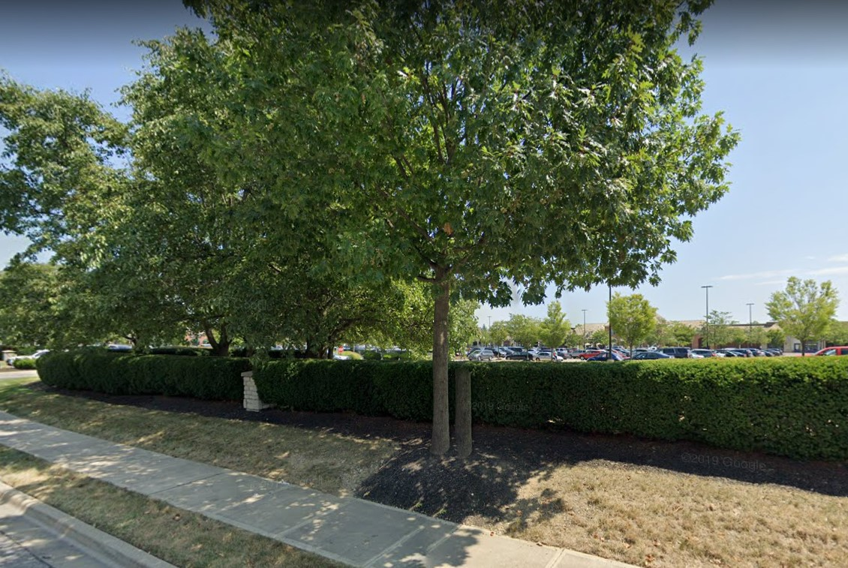
- Any surface parking areas adjacent to an existing or planned public right-of-way shall be screened from the respective right-of-way with a minimum of a thirty-six (36) inch continuous planting hedge and tree combination.
- The height of the required hedge or wall shall be measured from the elevation of the adjacent parking area.

- The Zoning Inspector, or designee, may waive the parking lot screening requirement when there is a natural separation of at least five (5) feet between the elevation of an existing road and the existing grade of the lot where the parking lot will be located for at least seventy-five (75) percent of the property's frontage along the public right-of-way. This natural separation is deemed to be sufficient to effectively screen parking from the public right-of-way.

19.06 LANDSCAPING IN PARKING LOTS ISLANDS

All parking islands required in Section 20.05 shall have a minimum of one shade tree with a minimum of two (2) inch caliper. The remaining area of the landscaped island shall be planted with grass or covered with stone.
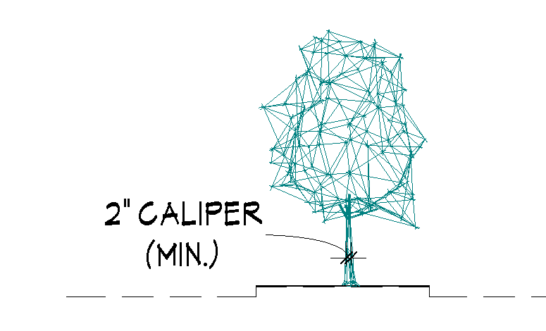
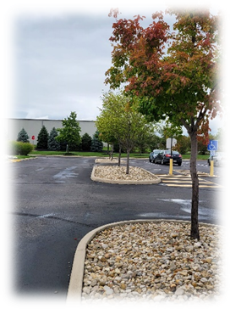
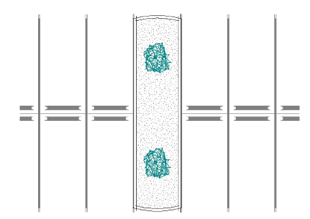

Example: Parking Island with stone material

19.07 RIGHT-OF-WAY SETBACK LANDSCAPING

Right-of-way setback landscaping is required for all new sites abutting an arterial or collector road, except for those located within the GB District. Throughout the setback area along an existing or planned public right-of-way, there shall be a minimum of four (4) trees per one hundred (100) linear feet. Trees may be deciduous, coniferous or a combination thereof. This requirement shall not apply in the areas of ingress and egress, or to existing trees which are undisturbed by the project.

19.08 BUFFER YARD AND SCREENING REQUIREMENTS

- Buffer Yard and Screening Requirements. The following buffer yard and screening requirement apply as follows:
 |  |  |  | Min. # of trees per 50 lineal feet*** adjoining lot lines must include the following:
District of Proposed Use | Abutting District | Yard | Buffer Yard Width (Feet)* | # of Large Trees (a) | # of Small Trees (b) | # of Shrubs (c)
GB | PR | Side or Rear | 10 | 2 | 3 | 17
SE | AG, GB, PR | Side or Rear | 20 | 3 | 5 | 25
TI | AG, PR, SE | Side or Rear | 20 | 3 | 5 | 25
I | AG, PR, SE | Side or Rear | 45 | 4 | 10 | 33
I | GB, TI | Side or Rear | N/A | N/A | N/A | N/A
Minimum Spacing Requirement:
- Planted 25 feet on center
- Planted 10 feet on center
- Planted 3 feet on center
* A six-foot tall buffer fence may be utilized to take the place of shrubs. For purposes of this section, a “Buffer Fence” is a fence constructed of bricks, stone, treated wood, or other commercially produced synthetic fencing material so long as it is durable, uniform, and attractive. Opaque gates matching the type, height, etc. of the fence shall be provided for access. The use of chain link fencing or gates with mesh screening, tarps, and similar materials shall not be considered as Buffer Fences.
*** If adjoining lots have less than 100 lineal feet, utilize the spacing standards above to determine the number of plantings required on a prorated basis. For lots with more than 100 lineal feet, all units of 100 lineal feet must meet the buffer standard in the chart, and the fractional remainder will be determined using the minimum spacing requirements above.

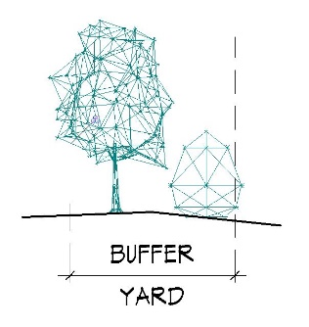
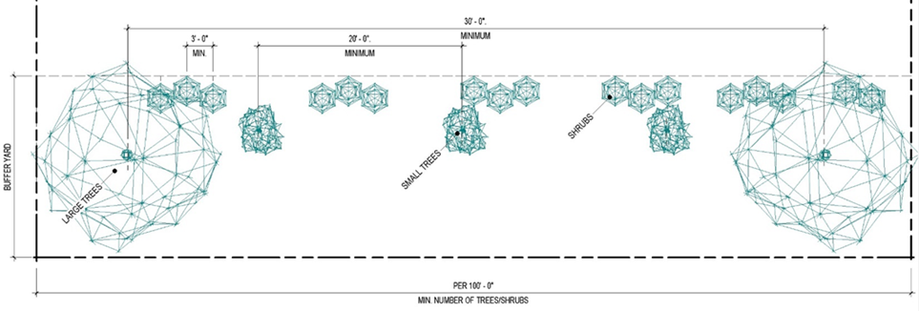
- Example of a Buffer Yard.
- Screening of Trash Containers. Trash containers and storage areas shall be screened on three (3) sides with a solid wall or fence that is a minimum of one foot taller than the trash container or the material within the storage area to be screened. Said wall or fence must be constructed with the same or similar materials as those used on the principal building and must be accented with landscaping for the entire screening perimeter. So that the trash container or storage area can be accessed, a solid, decorative gate of the same height as the Wall/Fence shall be utilized as screening on the fourth side of said trash container or storage area. These standards shall apply to all Commercial Districts.
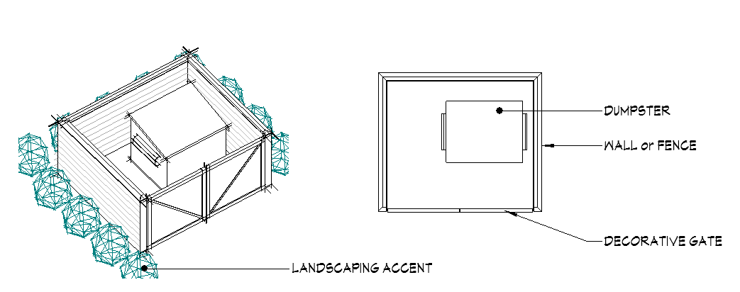

ARTICLE XX
Parking and Off-Street Loading Requirements

20.01 Purpose.
20.02 Applicability of Requirements.
20.03 General Requirements.
20.04 Parking Lot Location.
20.05 Parking Bays.
20.06 Design Standards for Off-Street Parking Areas.
20.07 Special Event Parking.
20.08 Design Standards for Off-Street Loading Areas.
20.09 Parking in the GCO District.

20.10 Shared Parking.
20.11 Schedule of Required Off-Street Parking Spaces.
20.12 Parking of Commercial Vehicles in Residential Districts.
20.13 Electrical Vehicle Charging Stations.
20.14 Access and Connectivity for Vehicles and Pedestrians.

20.01 PURPOSE.

Parking Lot Areas shall be designed and constructed to minimize the visual impact of the parking area, minimize production of excess heat, and prohibit any adverse effects on drainage. Appropriately sized landscaped areas shall be provided within each Parking Lot Area allowing for a variety of shade trees to be planted. In order to accomplish these goals, all Off-Street Parking Lot Areas shall be designed and constructed using the "Parking Bay" concept, which consists of parking spaces grouped together, with each Parking Bay separated by landscaped tree islands.

20.02 APPLICABILITY OF REQUIREMENTS.

- Unless otherwise noted, these parking standards apply to all uses in all Districts. The Off-Street Parking and Off-Street Loading Spaces, whether they are principal uses, Accessory Uses, or a change of use, shall meet the requirements of this article as follows, unless modified by Section 20.10 – Shared Parking – or Section 4.05 – Variances.
  - For all buildings and structures erected and all uses of land established after the effective date of this Code, Parking and Loading Spaces shall be provided as required by the applicable use unit.
  - When the intensity of use of any building, structure, or premises shall be increased through the addition of Dwelling Units, floor seating capacity, or other units of measurement specified herein for required Parking or Loading Spaces, Parking and Loading Spaces shall be provided for such increases in intensity.
  - Except as noted herein, whenever the existing use of a building or structure shall hereafter be changed to a new use, parking and loading facilities shall be provided as required for such new use. However, if the existing use is non-conforming as to parking requirements, then parking requirements for the change in use shall be established by the Board of Zoning Appeals.
  - Accessory Off-Street Parking and Loading Spaces in existence on the effective date of this Code and located on the same lot as the building or use served shall not hereafter be reduced below or if already less than, shall not be further reduced below the requirements for a similar new building or use under the provisions of this Code.

20.03 GENERAL REQUIREMENTS.

- Off-Street Parking and Off-Street Loading Spaces shall not occupy required livability space. Space allocated to any required off-street loading berth shall not be used to satisfy the space requirements for any Off-Street Parking Spaces. Space allocated to any required Off-Street Parking Spaces shall not be used to satisfy the space requirements for any Off-Street Loading Spaces.

- Required Off-Street Parking Spaces and required Off-Street Loading Spaces shall not be used for the storage, sale, dismantling, or servicing of any vehicle, equipment, materials, or supplies.

- Required Off-Street Parking Spaces and required Off-Street Loading Spaces shall be located on the Lot containing the use for which the required spaces are to be provided except as modified by Section 20.10 – Shared Parking.

- In the GB, TI, and I Districts, all Off-Street Parking Spaces shall be designed in a manner that allows each space to be entered and exited without passing through another parking space.

- Parking spaces provided inside of a garage that are dedicated to the principal use of the property shall count towards the parking space requirements.

- Any lighting used to illuminate any Off-Street Parking Space shall adhere to the regulations provided in Section 16.24 – Lighting – to reflect light away from any adjoining Residential Districts.

- In all Districts, a five (5) foot clear zone shall be maintained between the Street right-of-way line, and any parking space.

20.04 PARKING LOT LOCATION.

All parking lots shall be located in accordance with the parking lot location requirements as noted in the development standards table for each District found in their respective Section.

20.05 PARKING BAYS.

- All new sites shall provide parking bays within the parking lots. No parking bay shall contain more than twenty-four (24) parking spaces, with a maximum of twelve (12) spaces in a single row in the GB District. In the LI District, no parking bay shall contain more than forty-eight (48) parking spaces, with a minimum of twenty-four (24) spaces in a single row. Each parking bay shall be separated by a parking lot island on each side.

- Parking Lot Island. Each landscape island in a single loaded parking stall design shall have a minimum area of one hundred sixty-two (162) square feet with a minimum width of nine (9) feet. Each landscape island in a double loaded parking stall design shall have a minimum of three hundred twenty-four (324) square feet with a minimum width of nine (9) feet and shall be landscaped in accordance with Section 19.06.

- Parking bays are not required for property being redeveloped. For purposes of this section, redeveloped means the expansion of more than twenty-five (25) percent of a building or parking lot or the alteration of more than twenty-five (25) percent of the interior or exterior of the building.

20.06 DESIGN STANDARDS FOR OFF-STREET PARKING AREAS.

The following standards apply:

- All Off-Street Parking Spaces shall have a vertical clearance of at least six (6) feet six (6) inches;

- All parking areas, common areas, and adjacent driveways in all Districts shall be paved with asphalt material, cement, cobblestone, or brick pavers. All parking spaces shall be striped. The use of gravel or asphalt grindings for parking lots or driveways shall be prohibited. All vehicles in all Districts shall be parked on paved driveways or parking areas and shall be prohibited from being parked in grass or other unpaved areas of lots. Required Off-Street Parking Space material shall be installed prior to the initiation of the use, unless an extension is granted based upon weather or unusual circumstances as determined by the Zoning Inspector, or designee. This requirement does not apply to "Special Events Parking" as regulated in Section 20.07.

- Off-Street Parking Spaces shall be at least nine (9) feet in width and eighteen (18) feet in length exclusive of access drives and aisles.

- All Off-Street Parking Spaces shall be designed in accordance with Parking Table – 1 below.

- Handicap accessible parking spaces shall be provided in accordance with the Americans with Disabilities Act requirements and Ohio Building Code.

Remainder Intentionally Left Blank
Parking Table - 1
Angle | Parking Row Depth | Drive Aisle Width |  | Space Width | Space Length
Angle | Parking Row Depth | One-Way | Two-Way | Space Width | Space Length
 | (A) | (B) | (C) | (D) | (E)
Parallel | 9' | 12' | 20' | 9' | 23'
45° | 20' | 13' | 24' | 12' | 19'
60° | 21' | 18' | 24' | 10' | 19'
Perpendicular | 18' | 24' | 24' | 9' | 19'
Tandem (two spaces) | 18' | 14' | 24' | 9' | 36'

20.07 SPECIAL EVENT PARKING.

Special event parking areas shall comply with the following conditions:
- Special event parking shall not be used for more than thirty (30) days in any calendar year.

- Special event parking cannot occur more than fifteen (15) consecutive days during any thirty (30) day period.

- Special event parking shall be set back at least fifty (50) feet from any off-site lot in any Residential District or any residential development area in a PUD.

- Special event parking areas shall be on the same lot(s) approved for the principal use to which they are accessory.

20.08 DESIGN STANDARDS FOR OFF-STREET LOADING AREAS.

- All Off-Street Loading Spaces must be located to the side or rear of the principal structure and screened in accordance with Section 19.08 and are prohibited within any Front Yard.

- Required Off-Street Loading Spaces shall be provided access to and from a Public Street or Alley by an access drive of at least ten (10) feet in width designed to permit convenient access by semi-trailer trucks.

- An Off-Street Loading Space shall consist of a rectangular area adequate for loading and unloading and be accessible from a maneuvering area.

- All Off-Street Loading Spaces and maneuvering areas shall be located on the same lot as the use for which they are intended to serve.

- A required Off-Street Loading Space shall have a clearance height of not less than fifteen (15) feet and shall have minimum dimensions of not less than twelve (12) feet in width and fifty (50) feet in length, exclusive of any driveway, aisle, or other circulation area.

- All unenclosed Off-Street Loading Areas, common areas, and adjacent driveways shall be paved with asphalt material, cement, cobblestone, or brick pavers, and parking spaces shall be striped.

- The number of Off-Street Loading Spaces required for various types of uses shall be no less than as set forth in the following Districts:
  - GB and TI Districts: Each use in these Districts shall provide loading spaces based on gross floor area as follows:
    - Less than 5,000 square feet = None Required.
    - 5,000 to 250,000 square feet = One Off-Street Loading Space.
    - Over 250,000 square feet = One Off-Street Loading Space for every 250,000 square feet or portion thereof.
  - I District: Each use in this District shall provide loading spaces based on gross floor area as follows:
    - Under 10,000 square feet = None Required.
    - 10,000 square feet or more but less than 75,000 square feet = One Space.
    - 75,000 square feet or more but less than 150,000 square feet = Two Spaces.
    - 150,000 square feet or more but less than 300,000 square feet = Three Spaces
    - Over 300,000 square feet = one space for each 100,000 square feet or portion thereof.

- The loading space requirements for buildings with multiple uses or tenants shall be determined based on the aggregate total of gross floor area for all uses or tenants.

20.09 PARKING IN THE GATEWAY CORRIDOR OVERLAY (GCO) DISTRICT.

Refer to Section 14.07(d) for specific information regarding the GCO District.

20.10 SHARED PARKING.

- In any District, when a mix of uses creates staggered peak periods of parking (see, "Parking Table – 2" below), the total parking requirements for the uses may be reduced provided a shared parking plan is submitted and approved as a Conditional Use by the Board of Zoning Appeals.

- The shared parking plan must be based upon the number of originally required spaces for differed uses or facilities sharing the same parking area and documentation that the required parking needed for different uses is at different days and times generally based on Parking Table-2.

- Parking spaces included in the shared parking plan must be distributed in a manner that provides parking spaces within a reasonable distance from all proposed uses as determined by the applicable reviewing entity.

- Shared parking must remain under common ownership providing access to all users of the shared parking. If common ownership is not proposed, the applicable approving authority may require documentation of shared access agreements to be provided.

Parking Table-2
Weekday Peaks | Evening Peaks | Weekend Peaks
Banks | Bars | Retail Uses
Professional Offices | Ice Cream Shops | Movie Theaters
Medical Offices | Restaurants | Residential
Library | Movie Theaters
Daycare | Residential
Coffee Shops
Restaurants

20.11 SCHEDULE OF REQUIRED OFF-STREET PARKING SPACES.

- All uses within all Districts shall comply with the number of Off-Street Parking Spaces requirements specified herein. These standards are being established to encourage efficient use of parking areas by establishing a maximum number of spaces required and permitting sensible shared parking to reduce impervious surfaces and increase Open Space.

- The total number of required parking spaces shall be calculated for each separate use on the Lot. In no case shall the total number of parking spaces for a particular use be less than the minimum nor more than the maximum number of required parking spaces for said use based upon the below chart. When calculating the required number of spaces, fractional numbers shall be increased to the next whole number.

Parking Table – 3: Required Off-Street Parking Spaces
USE | Minimum Number of Required Parking Spaces | Maximum Number of Required Parking Spaces
General Business – Personal Services – Institutional – Office not otherwise specified herein | 1 space per 500 square feet | 1 space per 225 square feet
General Business – Personal Services – Institutional – Office not otherwise specified herein | 1 space per 400 square feet | 1 space per 225 square feet
Daycare/School | 1 space for every 7 children and 1 space for each employee on the largest shift | 1 space for every 5 children and 1 space for each employee on the largest shift
Hospital/Nursing Home/Hospice – other than medical offices | 1 space per room | 1.5 spaces per room
Hotel/Motel | 1 space per room | 1.5 spaces per room
Movie Theater – Places of Assembly | .25 spaces per seat or 1 space per 40 square feet | .3 spaces per seat or 1 space per 30 square feet
Restaurants, Bars, Coffee, and Ice Cream Shops (with Drive-Thrus) | 1 space per 100 square feet, plus additional space in the drive-thru lanes equal to 25 percent of the required number of parking spaces | 1 space per 72 square feet, plus additional space in the drive-thru lanes equal to 25 percent of the required number of parking spaces
Restaurants, Bars, Coffee, and Ice Cream Shops (without Drive-Thrus) | 1 space per 100 square feet | 1 space per 75 square feet
RECREATIONAL USES
Mini-Golf, Batting Cage | 1 per tee or cage | 1.5 per tee or cage
Bowling Alley | 3 per lane | 4 per lane
Recreation/Fitness Center | 7 spaces per 1,000 square feet | 8 spaces per 1,000 square feet
Outdoor Recreation Fields | 50 per field | 75 per field
Tennis, Handball, Racquetball, or Pickleball Courts | 3 per court | 4 per court
Ice Skating Rink, or other recreational use not specified herein | 1 per 200 square feet | 1 per 150 square feet
Industrial Uses not otherwise defined below | 1 space per 2,500 square feet | 2 spaces per 2,500 square feet
Flex-Office/Flex-Warehouse/Data Processing Center/ Contractor's Office/ Machine Shop/ Equipment Repair | 2 spaces per 1,000 square feet | 2.5 spaces per 1,000 square feet
Residential, One- and Two- Family Units | 1 space per unit | 2 spaces per unit
Assisted Living Facilities | 1 space for every 2.5 Dwelling Units plus 1 space for every 2 employees | 1 space for 2 Dwelling Units plus 1 space for every 2 employees on largest shift
Independent Senior Living Facilities/Adult Home Group Homes | .85 spaces per Dwelling Unit | 1 space per Dwelling Unit
Multi-Family Dwelling Units, Townhomes | 1 spaces per Dwelling Unit | 3 spaces per Dwelling Unit
NOTE: Utilize gross square footage whenever there is a reference to square feet.

Remainder Intentionally Left Blank

20.12 PARKING OF COMMERCIAL VEHICLES IN RESIDENTIAL DISTRICTS.

- No commercial tractor, truck, trailer, or commercial automobile weighing more than 8,000 pounds shall be parked, stored, or allowed on any lot or parcel of land or on the Street in any Residential District.

- This section shall not apply to such vehicles used for conveying the necessary tools and materials to premises where labor using such tools and materials is to be performed during the actual time of parking of such vehicles, nor to the actual time during which such vehicles are being loaded or unloaded or used to deliver or hoist property or merchandise for completion of delivery as long as such activities referred to in this provision are conducted diligently and without unnecessary delay.

20.13 ELECTRICAL VEHICLE CHARGING STATIONS.

- The purpose of this section is to encourage electrical vehicle charging stations but not require them.

- To promote the installations of these stations, the total number of required automobile Off-Street Parking Spaces required by this Code shall be reduced by two (2) automobile Off-Street Parking Spaces for every one (1) electric vehicle space with a charger provided.

20.14 ACCESS, VEHICULAR, AND PEDESTRIAN/BIKEWAY CONNECTIVITY.

- New sites shall be designed to provide for vehicular and pedestrian connectivity between adjoining properties.

- Vehicular Connectivity.
  - Parking lots for new sites in the GB, TI, and I Districts shall provide a future connection point to each adjacent parcel that has the potential to develop or redevelop in the future, as determined by the Zoning Inspector, or designee. If an adjacent parcel has an established connection point, the new site shall be required to connect to it. Cross access easements shall be provided when adjacent parking lots are connected.
  - New roads established for residential development in the PR District shall provide for the future extension and connection to adjoining properties in accordance with Article XV – Planned Unit Developments.

ARTICLE XXI
Signs

21.01 Statement of Purpose
21.02 Zoning Permit and Administration for Signs
21.03 General Requirements for All Signs
21.04 Prohibited Signs
21.05 Signs Along State Primary Highways
21.06 Types of Signs
21.07 Ground-Mounted Signs
21.08 Wall Signs
21.09 Pole Signs
21.10 Projecting Signs
21.11 Canopy Signs
21.12 Window Signs
21.13 Drive-Thru Signs
21.14 Billboards
21.15 Maximum Square Footage of All Signs
21.16 Sign Lighting
21.17 Temporary Signs

21.01 STATEMENT OF PURPOSE

The purpose of these Sign regulations is to encourage the effective use of signs as a means of communication in the Township; to maintain and enhance the aesthetic environment and the Township's ability to attract sources of economic development and growth; to improve pedestrian and traffic safety; and to provide for public health and safety by minimizing the possible adverse effects (including but not limited to the obstruction of sight distance to motorists entering and exiting a roadway and distracting motorists of signs on nearby public and private property; to control litter; to maintain property values; to maintain character of the community; and to enable the fair and consistent enforcement of these Sign regulations. This Sign resolution is adopted under the zoning authority of the Township in furtherance of the more general purposes set forth in the Code.

21.02 ZONING PERMIT AND ADMINISTRATION FOR SIGNS

- Permit Exemptions. Unless otherwise exempted, a Zoning Permit shall be obtained prior to erecting any Sign in any District. The following types of Signs are exempt from obtaining a Sign Permit.
  - Signs not exceeding two (2) square feet in area that are customarily associated with a residential use and are not of a commercial nature, including the address and/or the name of the occupants.
  - Signs erected by a governmental entity for a recognized public purpose and duly authorized by any law, statute, or Resolution. Such Signs include legal notices and traffic control devices, provided such signs carry no supplementary materials.
  - Signs that are on the inside of a structure or building that are designated or located so as to be typically visible from outside the window.
  - Temporary Signs clearly in the nature of decorations customarily associated with a national, local, or religious holiday. Such Signs shall be of any illumination or animation provided that a safety and/or visibility hazard is not created.
  - Temporary on-premise Signs not to exceed four (4) square feet of Sign face shall be permitted in any District.
  - Fuel island canopy Signs in the Gateway Corridor Overlay, GC, TI, and I Districts.
  - Entrance and exit Signs providing Way-Finding information that shall not exceed a height of two and a half (2.5) feet and shall not have a Sign area of three (3) square feet on any face.
  - In the SE District, such signs shall not exceed a height of fifteen (15) feet and shall not have a Sign area greater than fifty (50) square feet on any face.
  - On-site traffic control Signs, including but not limited to stop signs, yield signs, or other Way-Finding signs that shall not exceed a height of eight (8) feet.
  - Inner track/field/court/stadium signs, as defined in this section as those Signs located within and directed towards the concession, food court, bleacher/seating, pathways, playing, and restroom facility areas of the sport entertainment facility.
  - Flags or insignias of any governmental entity.

- Variances. Any property owner may apply for a variance from the requirements in this Article, Article III – Administration, and the Variance Application Procedures in Section 4.05 – Variance.

21.03 GENERAL REQUIREMENTS FOR ALL SIGNS

The regulations contained in this section shall apply to all Signs and all Districts.

- All Signs shall be constructed of durable materials, anchored to the ground or principal structure as permitted by the regulations herein, and braced so that the Sign will not sway, flap, or otherwise move or be blown out. Signs shall be Post and Panel Sign construction. A Post and Panel Sign is constructed of either wood post or metal post (not wire frames) that provide support at each side of the Sign. The Sign face shall be constructed of wood, metal, or corrugated polycarbonate. Said Sign face shall be substantially secured to the support post by being nailed, screwed, or bolted to the supporting wood or metal post. No Sign shall be stapled, taped, tied, or fastened by plastic or metal ties or the like. No Temporary Sign shall be converted to a Permanent Sign by simply anchoring it to the ground.
- Any illuminated Sign or lighting device shall employ only light emitting a constant intensity with fully shielded fixtures so as to prevent light trespass and distraction. No Sign shall be illuminated by or contain flashing, intermittent, rotating, or moving light or lights. In no event shall an illuminated Sign or lighting device be placed or directed so as to permit the beams and illumination therefrom to be directed or beamed upon a public thoroughfare, highway, sidewalk, or adjacent premises so as to cause glare or reflection that may constitute a traffic hazard or nuisance.
- All wiring, fittings, and materials used in the construction, connection, and operation of electrically illuminated Signs shall be in accordance with the provisions of the local or state electric code.
- No Sign of any classification shall be installed, erected, or attached in any form, shape, or manner to a fire escape or any door or window giving access to any fire escape.
- Should any Sign be or become unsafe or be in danger of falling or structurally failing, the owner thereof or the person maintaining the same shall upon receipt of written notice from the Zoning Inspector proceed at once to put such Sign in a safe and secure condition or remove the Sign.
- No Sign shall be placed in any public right-of-way except publicly-owned Signs, such as traffic control Signs and Way-Finding Signs as required by law.
- All off-premise Signs erected or maintained under Chapter 5516.10 of the Ohio Revised Code shall be in compliance with this stated chapter of the Ohio Revised Code and this Code.
- No Sign shall be located any closer than ten (10) feet from any public road right-of-way or property line, unless otherwise specifically stated herein. If a larger setback standard is required herein, said standard shall apply.

21.04 PROHIBITED SIGNS

- All Signs not expressly permitted under this Code or exempt from regulation hereunder in accordance with the previous sections are prohibited in the Township. Such signs include, but are not limited to:
  - Beacon Signs;
  - String lights not permanently mounted to a rigid background, except those exempt under the previous section;
  - The parking of vehicles of any type with signage affixed to or resting upon the vehicle in a manner as to act as a Sign for the premises upon which it is parked. This does not include vehicles with company names that belong to a company being used on a daily basis and does not include vehicles that are patrons of a business which are at the business for less than twenty-four (24) hours.
    - Said vehicle is located in a location for an extended period of time during a business day (a business day shall be deemed as normal or posted business operating hours, and repeatedly over two or more business days). Said business days shall not be required to be consecutive for the purpose of this section.
    - Said vehicle is parked or positioned in a manner as to present the face of the sign to motorist or pedestrians.
    - Said vehicle has a Sign resting in the bed of a truck, on a roof top, or hood of a vehicle and/or has a Sign strapped to the vehicle by means of a rope, chain, bungee cord, and the like.
  - Signs erected or maintained on trees, painted on fences, or painted on other natural features, except for Signs painted or etched upon rocks as approved by the Zoning Administrator.
  - Signs that prevent the driver of a vehicle from having a clear and unobstructed view of official Signs (traffic control signs, Way-Finding signs, etc.) and approaching or merging traffic.
  - Signs illuminated so as to interfere with the effectiveness of or obscure an official Sign(s) or device.
  - No Sign shall be placed within a road right-of-way or allowed to encroach upon a road right-of-way unless otherwise specified within this article. No person shall stand within the road right-of-way with a Sign, including Signs that are held or worn by an individual.
  - The following Permanent Signs shall be prohibited: portable displays or mobile display (except sandwich board signs), gas or air-filled devices, revolving or rotating Signs, exposed neon Signs, exposed LED Signs, rotating Signs, Flashing Signs or bare bulbs, Signs on backlit awnings, video Signs, Signs with moving text or pictures, and bench Signs.
  - No Sign or part thereof shall contain or consist of posters, ribbons, streamers, spinners, or other similar moving devices.
  - No Roof Signs or roof-mounted Signs shall be permitted. No part of any Sign shall extend higher than the eave of any building, except when placed on the parapet of a building.
  - No banners, flag Signs, or feather Signs shall be permitted.
  - Any Sign not expressly permitted shall be prohibited, unless added to this Code as a Permitted or Conditional Use.

21.05 SIGNS ALONG STATE PRIMARY HIGHWAYS

- Signs Adjacent to Interstate/Primary Highways. Larger Signs for businesses or industries adjacent to the interstate and primary highway as regulated by the Ohio Revised Code, Chapter 5516, as amended, shall be permitted in accordance with those state laws in addition to the requirements of this Code. The owner, or agent, of such sign must show proof of having obtained the required State of Ohio approval prior to the Zoning Inspector issuing a Zoning Permit.

- Placement of Signs. No Sign shall be erected or maintained within six hundred sixty (660) feet of the edge of the right-of-way of a highway on the primary system as defined by the State of Ohio under Section 5516.06 of the Ohio Revised Code (ORC), exceptions listed in Section 5516.06 of the ORC.
  - General. Signs located in zoned industrial or commercial areas adjacent to highways on the primary system that conform to rules adopted by the director of the Ohio Department of Transportation;
  - Lawfully Existing Signs. Signs lawfully in existence on Oct. 22, 1965, that the director, subject to the approval of the secretary of the United States Department of Transportation, has determined to be landmark signs, including signs on farm structures or natural surfaces, which are of historic or artistic significance;
  - Sports Facilities. Signs that are located on the premises of a professional sports facility and that conform to rules adopted by the director of the Ohio Department of Transportation.

21.06 TYPES OF SIGNS

- The following Sections 21.06-14, detail regulations regarding:
  - Ground-Mounted Signs;
  - Wall Signs;
  - Pole Signs;
  - Projecting Signs;
  - Canopy Signs;
  - Window Signs;
  - Drive-Thru Signs;
  - Changeable Copy and Digital Signs; and
  - Billboards

Remainder Intentionally Left Blank

21.07 GROUND-MOUNTED SIGNS

- Sign Table – 1 lists all Zoning Districts in which Ground-Mounted Signs are permitted. If a District is not listed, Ground-Mounted Signs are considered prohibited in said District. All Ground-Mounted Signs shall comply with the time, place, and manner regulations in Sign Table – 1.

- The maximum square footage in Sign Table – 1 is per Sign face. Each Sign face shall count towards the maximum size of the Sign and total maximum square footage of all Signs. There shall be a maximum of two (2) Sign faces per Sign.

- All Ground-Mounted Signs shall have a solid base consistent with the primary building material and have a minimum of fifty (50) square feet of landscaping around all sides of the Ground-Mounted Sign. The Sign shall be affixed directly to a base having a width at least equal to that of the Sign.

- Monument Signs shall not be permitted along rear access roads.

- Sign Table – 1 – Ground-Mounted Signs

 | Districts
 | GB, SE, TI, I | A, PR*
Maximum Number of Signs Permitted Per Public Road Frontage | 1 | 1
Maximum Square Footage | 32 | 6
Maximum Height (Feet) | 6 | 6
Minimum Distance from ROW (Feet) | 10 | 10
* Ground-Mounted Signs in the A and PR Districts shall be a Conditional Use, contingent upon a non-residential use requesting a Sign.

  - Any platted residential development shall be permitted one on-premise Ground-Mounted Sign at each entrance to the development in accordance with the standards stated within this section.
  - In a Residential District or on any property with a residential use within a Residential District, a Ground-Mounted Sign shall have a maximum of two (2) Sign faces; no single face shall have an area greater than six (6) square feet.

- Multiple Business Ground Sign Option. Groups of establishments of four (4) or more businesses shall be permitted one larger Ground-Mounted Sign for all businesses. Sign Table – 2 lists all Zoning Districts in which multiple business Ground-Mounted Signs are permitted. If a Zoning District is not listed, multiple business Ground-Mounted Signs are prohibited. All multiple business Ground-Mounted Signs shall comply with time, place, and manner regulations in Sign Table – 2.

- Sign Table – 2 – Multiple Business Ground-Mounted Signs

 | Districts
 | GB, SE, TI, I
Maximum Number of Signs Permitted Per Group of Businesses | 1
Maximum Square Footage | 80
Maximum Height (Feet) | 20
Minimum Distance from ROW (Feet) | 10

- Measurement of Ground-Mounted Sign Area and Height

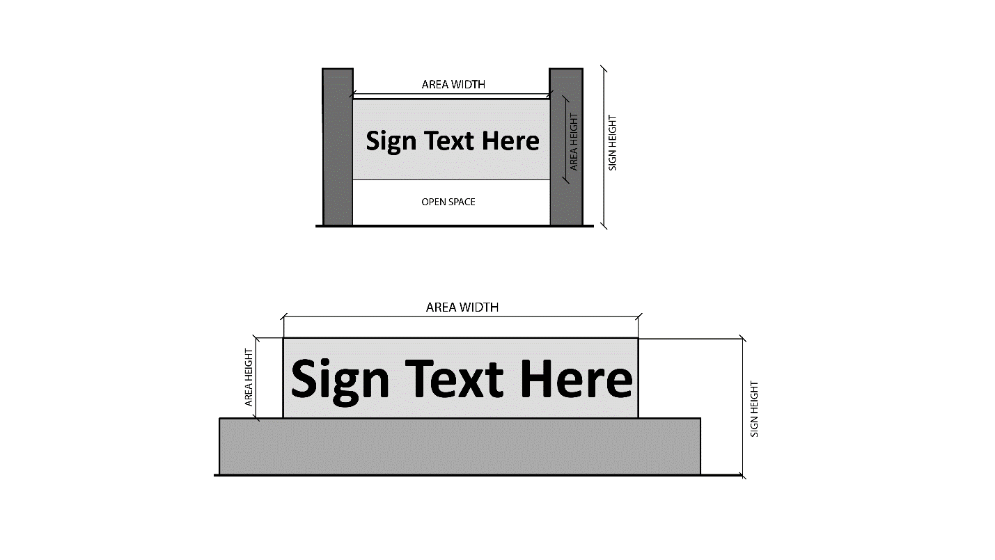

21.08 WALL SIGNS

- Sign Table – 3 lists all Zoning Districts in which Wall Signs are permitted. If a Zoning District is not listed, Wall Signs are considered prohibited in said District. All Wall Signs shall comply with the time, place, and manner regulations in Sign Table – 3.

- The maximum square footage in Sign Table – 3 is per Sign face. Each Sign face shall count towards the maximum size of the Sign and total maximum square footage of all Signs.

- Wall Signs may be erected on any building wall or extension of a building wall (i.e., Parapet) which faces a street, parking lot, or service drive.

- Wall Signs shall be attached parallel to the building face and may be extended outward perpendicular from the building face a maximum of fifteen (15) inches more than twenty-four (24) inches from the wall surface, provided such distance is required for enclosure of the necessary electrical components.

- Sign Table – 3 – Wall Signs

 | Districts
 | GB, TI, I | SE
Maximum Number of Signs Permitted Per Tenant Space | 1 | 1
Maximum Square Footage | 1 sq. foot per 1 lineal foot of tenant space | 1 sq. foot per 1 lineal foot of tenant space
Maximum Height (Feet) | 20 | 25

- Measurement of Wall Sign Area and Height
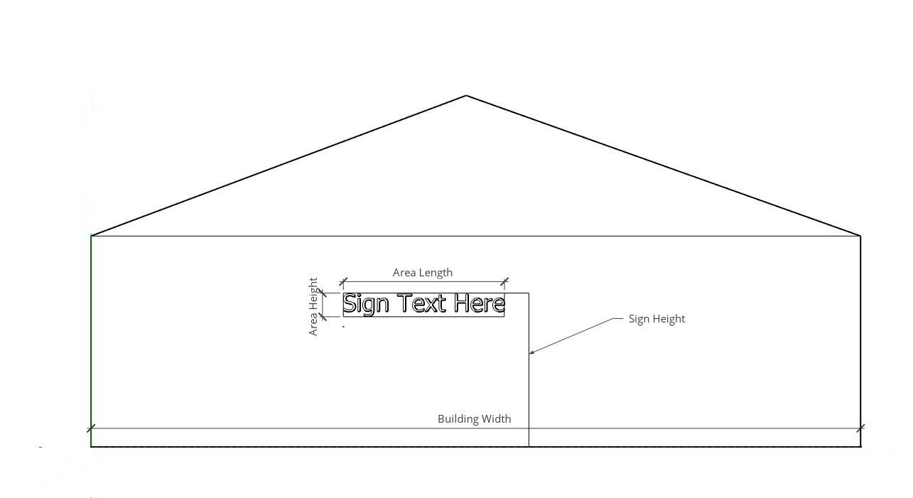

Remainder Intentionally Left Blank

21.09 POLE SIGNS

- Sign Table – 4 lists all Zoning Districts in which Pole Signs are permitted. If a Zoning District is not listed, Pole Signs are considered prohibited in said District. All Pole Signs shall comply with the time, place, and manner regulations in Sign Table – 4.

- The maximum square footage in Sign Table – 4 is per Sign face. Each Sign face shall count towards the maximum size of the Sign and total maximum square footage of all Signs. There shall be a maximum of two (2) Sign faces per Sign.

- Sign Table – 4 – Pole Signs

 | Districts
 | GB, SE, TI, I
Maximum Number of Signs Permitted Per Business | 1
Maximum Square Footage | 50
Maximum Height (Feet) | 15
Minimum Distance from ROW (Feet) | 10

- See, Section 21.07 for the Ground-Sign alternative for developments with multiple businesses.

Remainder Intentionally Left Blank

- Measurement of Pole Sign Area and Height
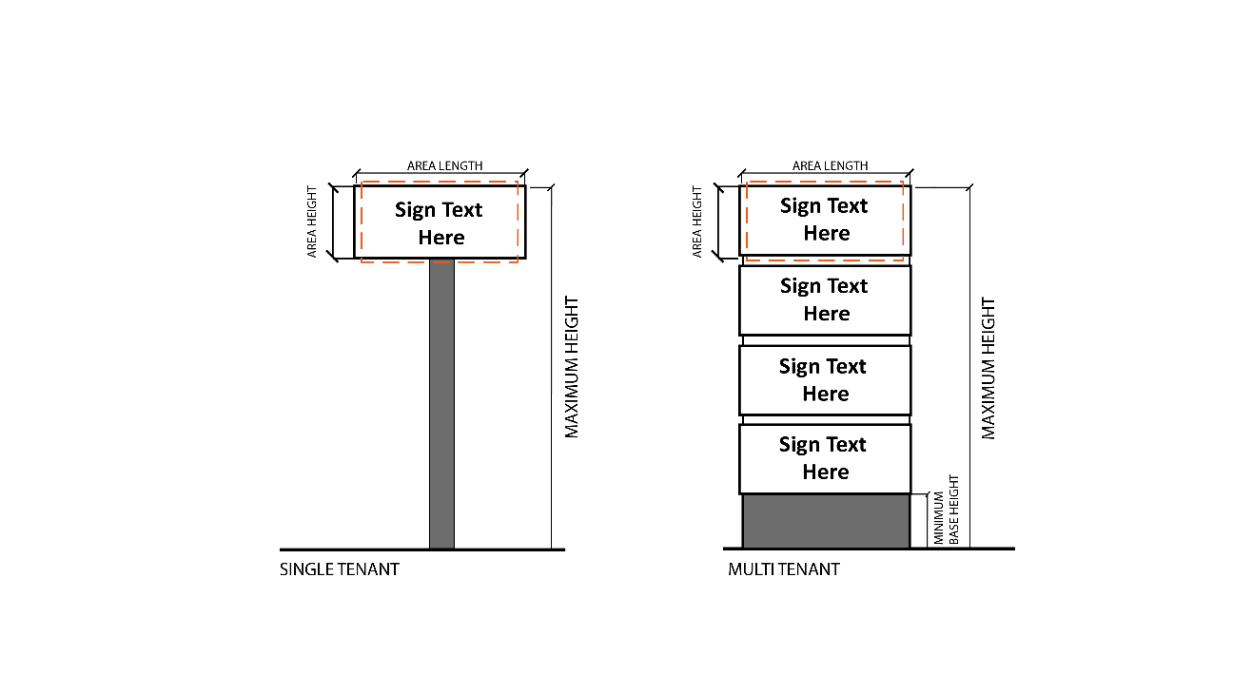

Remainder Intentionally Left Blank

21.10 PROJECTING SIGNS

- Sign Table – 5 lists all Zoning Districts in which Projecting Signs are permitted. If a Zoning District is not listed, Projecting Signs are considered prohibited in said District. All Projecting Signs shall comply with the time, place, and manner regulations in Sign Table – 5.
- The maximum square footage in Sign Table – 5 applies to each Sign face, and each Sign face shall count towards the maximum size of the Sign and total maximum square footage of all Signs. There shall be a maximum of two (2) Sign faces per Sign.

- Projecting Signs shall be scaled with the building design and shall blend with the architectural design of the building to which it is attached.

- Sign Table – 5 – Projecting Signs

 | Districts
 | GB, TI, I | SE
Maximum Number of Signs Permitted Per Business Frontage | 1 | 1
Maximum Square Footage | 10 | 5% of façade
Minimum Height (Feet) | 8 | 8
Maximum Height (Feet) | 15 | 15
Maximum Projection from Edge of Building (Feet) | 4* | 4*
Minimum Distance from ROW (Feet) | 10 | 10
* No Projecting Sign shall extend into the Right of Way

- Measurement of Projecting Sign Area and Height
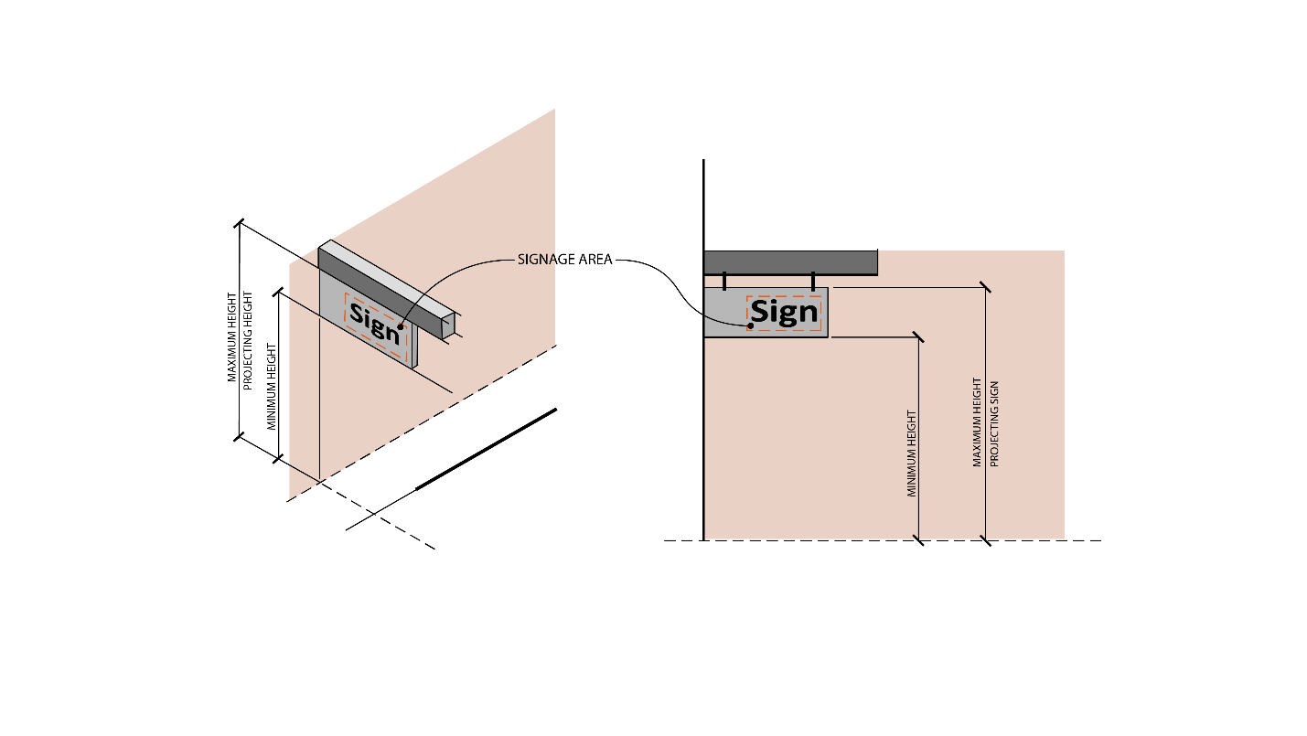
Remainder Intentionally Left Blank

21.11 CANOPY SIGNS

- Sign Table – 6 lists all Zoning Districts in which Canopy Signs are permitted. If a Zoning District is not listed, Canopy Signs are considered prohibited in said District. All Projecting Signs shall comply with the time, place, and manner regulations in Sign Table – 6.

- Sign Table – 6 – Canopy Signs

 | Districts
 | GB
Maximum Number of Signs Permitted Per Building | 2
Maximum Square Footage | 10
Maximum Height (Feet) | 15

- Measurement of Canopy Sign Area and Height
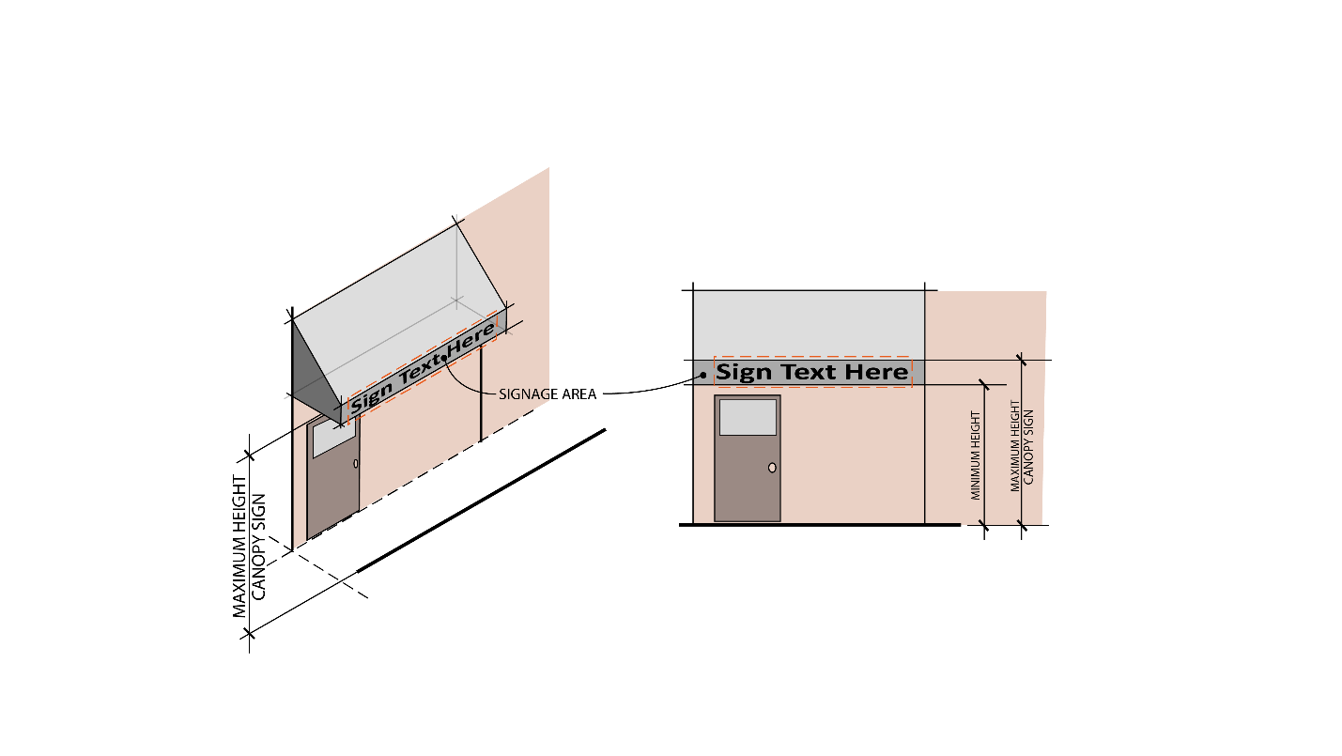

21.12 WINDOW SIGNS

- All Window Signs shall comply with the following requirements and shall not contribute toward the total square footage of all Signs on a property.

- Sign Table – 7 – Window Signs

 | Districts
 | A, PR, GB, SE, TI, I
Maximum Square Footage | 25 percent of window area
Maximum Height (Feet) | 15

Remainder Intentionally Left Blank

21.13 DRIVE-THRU SIGNS

- Signs accessory and adjacent to Drive-Thru food and beverage establishments, car washes, and other similar uses are subject to the following standards:
  - One large Drive-Thru Sign Board shall be permitted per Drive-Thru lane. Said Sign shall not exceed fifty (50) square feet must be located a minimum of one (1) foot and a maximum of five (5) feet from the edge of pavement of the Drive-Thru lane. Said Sign shall not exceed fifteen (15) square feet in area, must be located a minimum of one (1) foot and a maximum of five (5) feet from the edge of pavement of the Drive-Thru lane to which it serves and shall not exceed eight (8) feet in height.
  - One medium Drive-Thru Sign Board shall be permitted per Drive-Thru lane. Said Sign shall not exceed fifteen (15) square feet in area, must be located a minimum of one (1) foot and a maximum of five (5) feet from the edge of the pavement of the Drive-Thru lane to which it serves and shall not exceed eight (8) feet in height.
  - One small Drive-Thru Sign Board shall be permitted per drive-thru lane shall be permitted. Said Sign shall not exceed two and a half (2.5) square feet in area, must be located on the Drive-Thru speaker and shall not exceed five (5) feet in height.
  - Drive-Thru Boards shall be permitted to have changeable copy electronic display messages provided the graphics and/or words on the Sign change no more than once per the average single car service time to pass through the Drive-Thru. Flashing images or effects shall be prohibited.
  - Each Sign face shall count towards the maximum size of the Sign and total maximum square footage of all Signs.

- Measurement of Drive-Thru Sign Area and Height
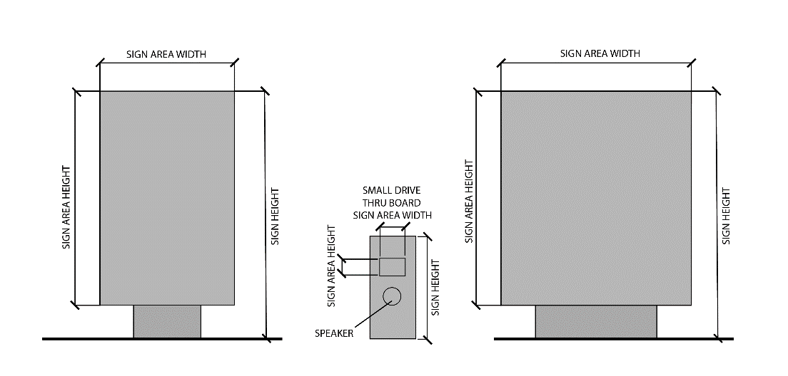

21.14 BILLBOARDS

- Sign Table – 8 lists all Zoning Districts in which Billboards are permitted. If a Zoning District is not listed, Billboards are considered prohibited in said District. All Billboards shall comply with the time, place, and manner regulations found in Sign Table – 8.

- Billboards shall have a maximum of two (2) faces per Billboard.

- Billboards shall be back-to-back and shall not have more than one (1) face visible from each direction of the road to which it faces.

- Sign Table – 8 – Billboards

 | Districts
 | A, GB, SE, TI, I
Maximum Square Footage Per Face | 125
Minimum Setback from any Structure or Sign (Feet) | 1,000
Minimum Spacing from Other Billboards (Feet) | 3,000
Maximum Height (Feet) | 15
Minimum Distance from ROW (Feet) | 75

- Relation to Other Laws. Signs adjacent to the interstate and primary highways as regulated by the Ohio Revised Code, Chapter 5516 and Section 5531.07, as amended, shall be permitted in accordance with those state laws. The Zoning Inspector shall only issue a Zoning Permit when the applicant produces a permit from the state, and the proposed Billboard meets the requirements of this section.

21.15 MAXIMUM SQUARE FOOTAGE OF ALL SIGNS

- Window Signs shall not count toward the maximum square footage of all Signs.

- Sign Table – 9 – Total Maximum Square Footage for All Signs

Districts | Maximum Square Footage
GB, SE | 400 Internal Lot  500 Corner Lot
TI, I | 400 Internal Lot  500 Corner Lot

21.16 SIGN LIGHTING

- Sign lighting shall be consistent, understated, and properly disguised. One of the following methods may be employed:
  - A white, steady, stationary light that does not glare onto surrounding areas, is directed solely at the Sign, and is otherwise prevented from beaming directly onto adjacent properties or rights-of-way.
  - A white interior light with primary and secondary images lit or silhouetted on an opaque background. The background must be opaque. No additional background lighting or illuminated borders or outlines shall be permitted.
  - The color temperature of the sign lighting shall not exceed 4,000K.
  - The level of illumination emitted or reflected from a Sign shall not be of an intensity sufficient to constitute a demonstrable hazard to vehicular traffic on any right-of-way or parking lot from which the Sign can be viewed.
  - Light fixtures shall be screened from view by site grading or landscaping.

21.17 TEMPORARY SIGNS

- The following Temporary Sign regulations apply to all uses within all Districts:
  - Temporary Signs shall be prohibited within the right-of-way.
  - In all Residential Districts, two (2) Small Temporary Signs shall be permitted per parcel per street frontage without a Permit. In all other Zoning Districts, up to three (3) Small Temporary Signs shall be permitted per parcel per street frontage without a Permit. Each Small Temporary Sign shall be seven (7) square feet in area or less and less than three (3) feet in height.
  - In the GB, SE, TI, and I Districts, two (2) Large Temporary Signs shall also be permitted per parcel provided a Sign Permit is issued in accordance with the following regulations. Large Temporary Signs shall not:
    - Exceed eight (8) feet in height;
    - Exceed thirty-two (32) square feet in area (per Sign face);
    - On parcels of five (5) acres or less, such signs shall be displayed for no more than thirty (30) consecutive days and no more than three (3) times per calendar year. A new Permit must be obtained for each thirty (30) day or less period. After said Permits have been exhausted, the Zoning Inspector may grant one (1) extension for up to ninety (90) days per Sign. No other extensions may be administratively approved and must be approved by the Board of Zoning Appeals. On parcels that are greater than five (5) acres, such Signs may be displayed for up to one-hundred eighty (180) days. Upon the expiration of this Permit, the Zoning Inspector may grant one (1) extension up to an additional one-hundred eighty (180) days. No other extensions may be administratively approved and must be approved by the Board of Zoning Appeals. In no case, shall such signs be erected for more than three hundred sixty-five (365) days.
  - Small and Large Temporary Signs shall not count toward the total maximum square footage of Signs permitted on a Lot.
  - The Sign Permit number for Large Temporary Signs must be printed on the Sign in a visible location.

